National Health And Nutrition
Attachment 17a

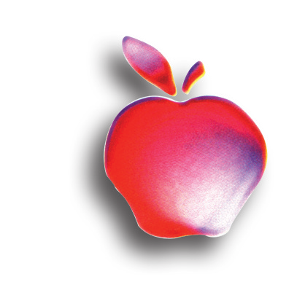
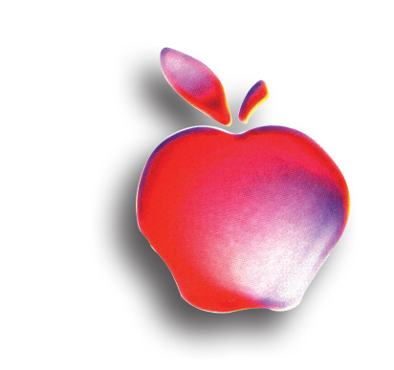
How healthy are Americans?
•

How are we dealing with chronic health problems such as asthma, diabetes, and high blood pressure?
•

Are health promotion and disease prevention efforts working?
•

Are Americans eating the right
•

Survey provides answers
We all need answers to these and other key health questions. One of the most important ways we can find answers is through the National Health and Nutrition Examination Survey (NHANES).

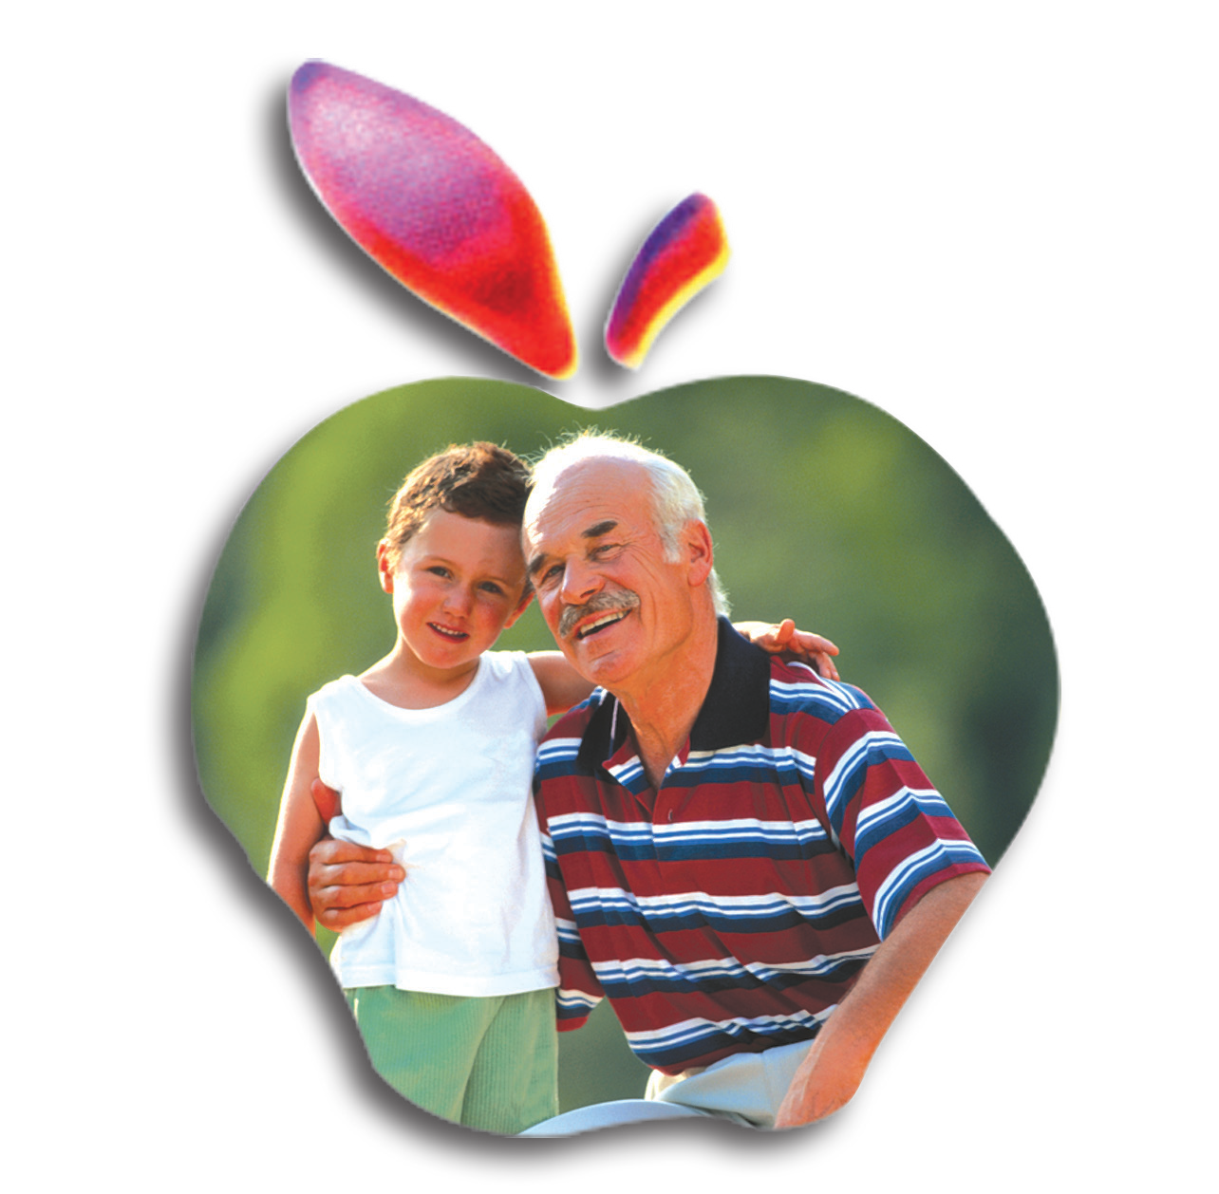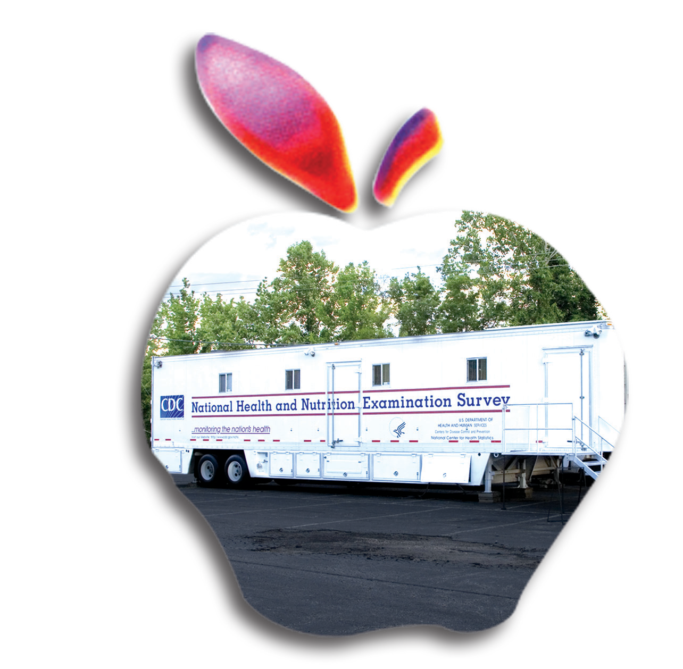This unique study gathers information from people all over the United States to learn more about the health of the Nation. It is the only survey that combines health interview and examination data to produce an in-depth picture of the health of the U.S. population.

The National Center for Health Statistics (NCHS) conducts the study. NCHS is part of the Centers for Disease Control and Preven- tion (CDC). NCHS monitors the health of the

NHANES teams travel across the United States
The first of these national studies was con- ducted in the early 1960s. Today, the government sends teams of doctors, dentists, nutritionists, and other trained medical personnel to 15 communities across the country each year. At each location, NHANES health representatives knock on people’s doors and ask them questions about their

When NHANES comes to your town
We always notify local and state health offi- cials before each study begins. And you may hear about us on local television and radio or read about NHANES in your newspaper be- fore anyone knocks on your door. The Direc- tor of the National Center for Health Statistics also sends a letter to every household we select before our arrival.

Provide Important

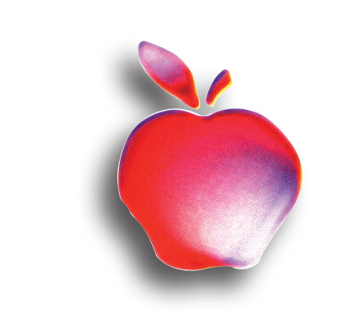
Participation is easy
We can schedule the health interview in your home at your convenience. The tests are free, and all who take part receive a cash payment in appreciation for their time and effort. You will also receive a report of your test results if you choose. We even arrange for travel to the mobile center and pay for babysitting for those who need it. Your appointment can also be set at a time convenient for you.
Along with the cash payment and test results

Interview asks about diet and health
At your home, our health representative asks questions about your health care, health conditions, and diet. Questions at the mobile center include information about physical fit- ness, weight, and eating habits.

Enjoy a Healthier

Examination
Survey
Let’ s Improve Our
Health

foods, or do we need more vita-
mins or minerals in our diet?

How can we continue to improve the health of our children?
•
Nation through NHANES and other vital
studies.
health and diet.

We invite about 7,000 people each year to come to the NHANES mobile exam center for a health exam. Highly trained profession- als staff these traveling health centers where they use state-of-the-art medical equipment.

Join This Vital Study
Information
comes the satisfaction of knowing that your
joining in can help all people enjoy a healthi- er future.

We do not ask everyone in a community or everyone in a household to volunteer. Our survey experts use scientific techniques to help find a sample of people who represent the Nation. To ensure the accuracy of the results, we need to reach as many homes selected for the sample as possible. Once selected, we cannot replace you with anyone else. We need you.

Over the years, more than 160,000 people have taken part in NHANES.

Future

Help us learn more about our Nation’s health

Represent
Your Community
Exam includes many familiar and state-of the- art tests
Those invited to the mobile center will have medical and dental tests. These may in- clude checking hearing, height and weight, blood pressure and pulse, analyzing labora- tory work, assessing muscle strength, bone composition, and other tests—all done by a skilled medical staff.

The tests can take 1 to 4 hours depending on your age—past participants have considered this time well spent. The health measure- ments are taken using the most up-to-date methods. You may learn important facts that can help you and your doctors take steps to improve your health.

We respect your privacy
We take your privacy very seriously. All information that relates to or describes identifiable characteristics of individuals, a practice, or an establishment will be used only for statistical purposes. NCHS staff, contractors and agents will not disclose or release responses in identifiable form without the consent of the individual or establishment in accordance with section 308(d) of the Public Health Service Act (42 USC 242m) and the Confidential Information Protection and Statistical Efficiency Act of 2002 (CIPSEA, Title 5 of Public Law l 07-347). In accordance with CIPSEA every NCHS employee, contractor and agent have taken an oath and is subject to a jail term of up to five years, a fine of up to $250,000, or both if he or she willfully discloses ANY identifiable information about you.

Everyone Benefits

NHANES findings benefit all
You won’t be the only one who benefits from the results. The study’s record of success for more than 50 years is remarkable. Here are just a few of the ways that everyone’s willing- ness to take part has helped us all:

The growth charts that doctors use to track children’s development from infancy to teenage years grew out of the first NHANES programs. These charts now are used world- wide.

Our studies showed widespread high levels of lead in people’s blood. These findings laid the groundwork for getting lead banned from gasoline and from food and soft drink cans. Blood lead levels now are down more than 70 percent from the 1970s.

NHANES provided warning signals about the growing health problems linked with over- weight among Americans young and old.

The study has shown the number of prob- lems caused by undiagnosed diabetes. In response, the government and health groups expanded efforts to increase awareness about diabetes, especially among minority populations.

Vitamins, calcium, and minerals have been added to foods to help prevent poor nutrition identified by NHANES.

Cholesterol levels and high blood pressure have been reduced because of programs based on NHANES data.

We expect the latest NHANES to continue this record of success and to enhance the health of the Nation.

Participate
Now

Good reasons you should take part in NHANES:

Obtain free health measurements
•

Receive payment for your participation
•

Receive a report of your findings Learn more about your health
•
•
•
All information is kept confidential Add to Nation’s health knowledge
•

When you go to the mobile exam center, you are doing the right thing for yourself—and doing a good turn for your family, neighbors, community, and the Nation as a whole. This study is vital to our health. Thank you for making it possible.

Our health representative will answer any questions you have about the survey, or you may call our headquarters toll free at 1-800- 452-6115. You may also visit our
Web site at: http://www.cdc.gov/nhanes.

Thank
You

CS222423

