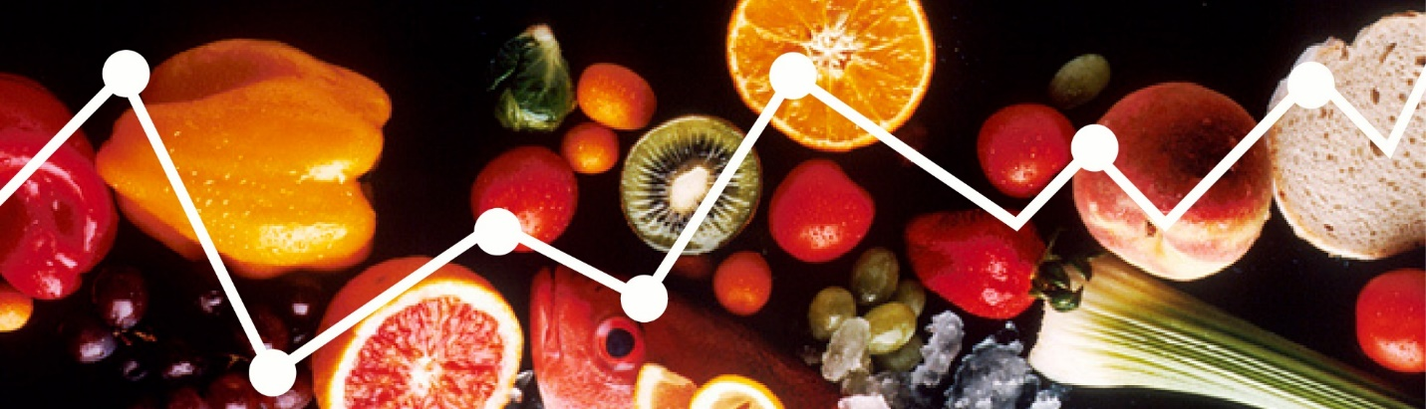
Calling nutrition researchers!

The National Cancer Institute is looking for feedback on the Dietary Assessment Primer. The survey will take no more than 10 minutes!

We are looking to convert the Primer from the current iteration on a webpage to a downloadable e-book. There is also the opportunity to comment on the Primer content since we are in the process of updating the Primer based on changes in the field of nutrition research.

If you are interested in providing feedback, please click the survey link [survey link].

The purpose of the Primer is to help researchers determine the best way to assess diet for any study in which estimates of group intakes are required. Understanding the key features of self-report instruments and the benefits and drawbacks of potential approaches to collecting and analyzing dietary intake data can help you make the best choices given your research question and resources.

Thank you for your time and consideration. We appreciate your contribution.

Sincerely,
Jill Reedy

