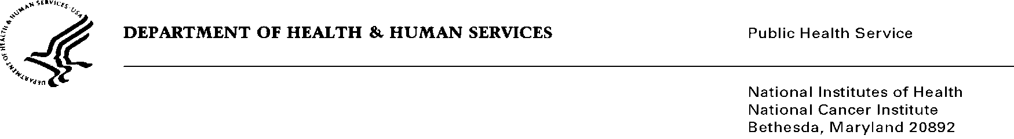

Date: May 2, 2019

To: Office of Management and Budget (OMB)

Through: Mikia Currie, Project Clearance Officer, NIH

Subject: Nonmaterial/Non-substantive change request for “Generic Clearance for the Collection of Qualitative Feedback on Agency Service Delivery”
(OMB#: 0925-0642, Expiration Date: 05/31/2020)

This is a request for OMB to approve a nonmaterial/non-substantive change to the Cancer Trials Support Unit Program (CTSU), a previously approved sub-study submitted under OMB#0925-0642 with a NOA approved date 2/15/2018.

There are no substantial changes to either of the surveys in that there are no new questions, but instead there are updates to existing questions. We do not believe these changes alter the current levels of burden for responding to these surveys.

Summary of Changes:

The requested changes to the MGA Feedback Survey – Site Staff:
- Addition of parenthetical content to the third response option in Question 3 that requests additional information if available.
- Addition of a third response to Question 6 and making that question mandatory.

The requested changes to the MGA Feedback Survey – Audit Staff:
- Addition of parenthetical content to the second response option in Question 3 that requests additional information if available.
  - between the Groups, please describe them under the Other option in this question or under the final question on the next screen.)
- Addition of a third response to Question 6, and making that question mandatory.

