OFFICE OF REFUGEE RESETTLEMENT
Services for Survivors of Torture
Program Data Points

USER GUIDE

TABLE OF CONTENTS
OVERVIEW 2

PROGRAM INDICATORS 2
01. CLIENT COUNT DURING REPORTING PERIOD 2
02. AGE WHEN FIRST SUBJECTED TO TORTURE 3
03. TYPE(S) OF TORTURE SUFFERED 4
04. REASON(S) FOR TORTURE 5
05. COUNTRY WHERE TORTURE OCCURRED 6
06. CLIENT GOAL(S) AT INTAKE 6
07. GENDER 7
08. IMMIGRATION CATEGORY/STATUS AT INTAKE 8
09. AGE AT INTAKE 9
10. EDUCATION PRIOR TO ARRIVAL 9
11. EMPLOYMENT IN THE U.S. AT INTAKE 10
12. LENGTH OF TIME IN THE U.S. AT INTAKE 10
13. COUNTRY OF ORIGIN 11
14. ETHNICITY 11
15. RELIGION _____ 12
16. LANGUAGES USED 12
17. CLIENTS SERVED BY SERVICE CATEGORY 13
18. PEOPLE TRAINED BY PROFESSION 14
19. HOURS CONTRIBUTED BY PRO BONO SERVICE 15

OUTCOME INDICATORS 16
20. LEGAL-IMMIGRATION 17
21. HOUSING 18
22. PHYSICAL HEALTH 18
23. MENTAL HEALTH 19
24. ACCESS TO COMMUNITY RESOURCES 19
25. SUPPORT SYSTEMS IN THE U.S: 20

APPENDIX A: LIST OF ETHNIC GROUPS COMMON TO SOT PROGRAMS 22
APPENDIX B: SURVIVOR OF TORTURE: PSYCHOSOCIAL WELL-BEING INDEX-SHORT 23

OVERVIEW:

All grantees are required to collect and report aggregate program data for clients served through the ORR-funded Services for Survivors of Torture program. If a program has multiple funding sources, only clients served with ORR funding should be included. Client data, including levels of need in six domains, are captured at intake; levels of need in the six domains are also measured at follow-up assessments, forming the basis of program outcome indicators. If programs conduct multiple follow-up assessments, they are only required to report on comparing the levels of need between the first and last assessment (i.e., between intake and the last follow-up assessment). Program data points include both new and continuing clients, unless instructed otherwise.

The Program Data Points are reported on an annual basis and are to be submitted along with the second Performance Progress Report (PPR) each year of the project period. For more information on reporting requirements, please refer to the current funding announcement.

PROGRAM INDICATORS (Data Points 1–19)

CLIENT COUNT DURING REPORTING PERIOD:

Definitions:
New client: An individual who has completed the intake process, has been determined eligible, has been accepted into the ORR-funded Survivors of Torture program, and was provided service(s) during the reporting period, OR a client who returns to the program after not being served for more than three years and received services during the current reporting period.

Continuing client: An individual who became a client prior to this reporting period and has received services during the current annual reporting period, OR a client who exited the program and has returned to the program within three years of exiting and has received services during the current reporting period.

Primary survivor: An individual who is determined eligible for services based on a direct experience of torture including being forced to witness the torture of another individual. Clients who also qualify as secondary survivors should only be reported once as primary survivors.

Secondary survivor: An individual who is a member of the same family as or a close intimate of a primary survivor and has been adversely affected by the torture experience of the primary survivor, but did not witness the torture of another individual.

Clients exiting the program: A client is considered to have exited the program when they are discharged from the program, move out of the service area, or have not received services for three years.

Reporting:
Indicate the total number of clients served during the reporting period, including new primary, new secondary, continuing primary, and continuing secondary clients. These four unduplicated client counts should equal the number of total clients served during the annual reporting period for which you are reporting. Indicate the total number of clients known to exit the program during the reporting period. This count includes those clients who were served during the reporting period or previously. A client can be counted as both active and as exiting during any given annual reporting period.

02. AGE WHEN FIRST SUBJECTED TO TORTURE:

Definition:
Age when first subjected to torture: The age at which the client self-reports first being subjected to torture. If the client is a child and is unable to provide this information, the child’s parent or other collateral source may provide the information.

Reporting:
For each age range, indicate only the number of new and continuing primary clients who report first being subjected to torture at that age. These counts should be unduplicated.

03. TYPE(S) OF TORTURE SUFFERED:
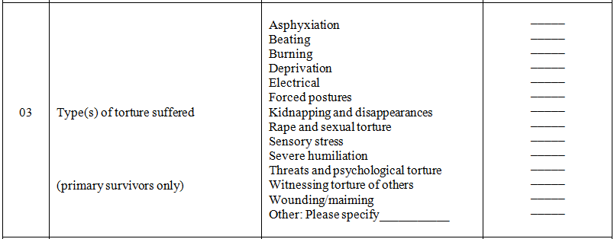

Definitions:
Beating: Hitting, kicking or punching; blows with objects (e.g., rifle butts, whips, straps or heavy sticks).

Wounding/maiming: Attacks with knives or other sharp instruments, forced jumping, or being thrown from heights; nail removal or amputation; use of animals (e.g., rats, spiders, etc.) to wound or maim; physical experimentation.

Burning: Burns through boiling water, cigarettes, chemicals, burning sticks, or live fire.

Rape and sexual torture: Forced performance of specific sexual acts; introduction of inanimate or animate objects into the genitalia or anus; rape by someone opposite sex or same sex; sexual threats and other forms of sexual harassment; touching certain parts of the body as a form of sexual molestation.

Asphyxiation: Strangulation or suffocation; suffocation may involve water, filthy fluids, cloths, or plastic bags.

Forced Posture: Includes forced standing, kneeling (often under the elements, for many hours), or straddling of a metal or wooden bar; stretching of limbs or trunk; suspension, including hanging by thumbs, arms, or legs.

Deprivation: Deprived of food, water, sleep, needed medication, or personal hygiene; placed in prolonged isolation.

Sensory stress: Exposure to extreme heat or cold; being bound or tied up as a form of immobilization; forced feeding; stress to the senses, including through loud/disagreeable noises, powerful lights, blindfolding.

Threats and psychological torture: Psychological games to inflict pain and suffering, including simulated execution or a change in roles to disorient (e.g., from oppressor to ally); verbal abuse; threats (with or without death threats) against the victim, his or her family, and/or his or her friends and colleagues; forced to kill or torture another; use of hypnosis to cause psychological harm.

Witnessing torture of others: Includes witnessing any physical, mental, or sexual torture of others (e.g., family, or friends, or other prisoners).

Electrical: Use of electric shocks (e.g., through electrodes, cattle probes, stun guns), often on sensitive body parts, to inflict severe pain and suffering. .

Severe humiliation: Acts that are intended to undermine human dignity and evoke a deep sense of shame, passivity, loss of self-respect; being made helpless and then acted upon in a humiliating way (e.g., abuse with excrement or urine); being treated or forced to act in a degrading way (e.g., being stripped naked); acts that violate cultural or religious taboos (e.g., in a culture where homosexuality is taboo, being forced into positions suggestive of homosexual acts).

Kidnapping and disappearances: This includes the kidnapping of the individual and/or the kidnapping/disappearances of people who are important or valued to the individual (family members, loved ones, and others) for the purpose of inflicting severe pain and suffering.

Reporting:
Indicate only the number of new and continuing primary clients that self-report being subjected to the type of torture. These counts can be duplicated if a client reports multiple types of torture. If one reported type of torture significantly overlaps with another type list, indicate only the primary type of torture. If clients report torture that cannot be categorized into any of the types listed, please specify the type(s) under “Other” and provide a count for each type that is specified.

04. REASON(S) FOR TORTURE:
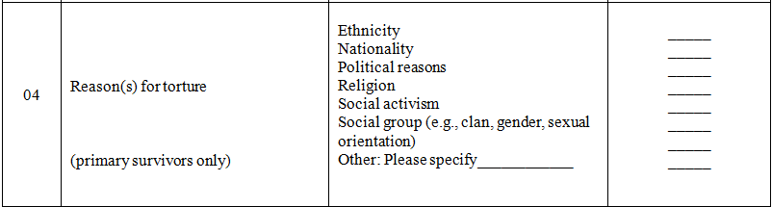

Definitions:
Ethnicity: Shared cultural practices, perspectives, and distinctions that set apart one group of people from another, which are associated with the client and led to the torture.

Nationality: The citizenship or country of origin associated with the client, which led to the torture.

Political reasons: Political opinions (including perceived or imputed opinions), organizations, affiliations, activities, or positions associated with the client, which led to the torture.

Religion: The religious tradition, faith community, or set of spiritual beliefs and practices (including perceived or imputed affiliation) associated with the client, which led to the torture.

Social activism: Social movements, organizations, affiliations, activities, or positions associated with the client, which led to the torture.

Social group: An identity that cannot or should not be changed (e.g., clan, gender, gender identity, sexual orientation, etc.) associated with the client, which led to the torture.

Reporting:
Indicate only the number of new and continuing primary clients who report being tortured for one or more of the reasons listed. These counts can be duplicated if a client reports multiple reasons for torture. If one reason significantly overlaps with another, list only the primary reason. If clients report a reason for torture that cannot be categorized into any of the options listed, please specify the reason(s) under “Other” and include a count for each reason specified.

05. COUNTRY WHERE TORTURE OCCURRED:

Definition:
Country where torture occurred: The foreign country (or countries) where a client experienced torture prior to his or her arrival in the United States.

Reporting:
List the country (or countries) as reported by new and continuing primary survivors. The country counts can be duplicated if a client was tortured in more than one country.

06. CLIENT GOAL(S) AT INTAKE:

Definitions:
Emotional/Psychological: Goals related to improving mental health. Activities to accomplish these goals may include psychological testing and evaluation, psychotherapy/counseling, psychopharmacology, and other forms of psychiatric/psychological treatment.

Interpersonal/Social: Goals related to improving personal, social, or environmental situations. Activities to accomplish these goals may include assistance with education (other than occupational), housing, clothing, transportation (e.g., access to services), interpretation/translation, case management, or other forms of interpersonal and social support.

Legal: Goals that seek to address the specific legal needs of the individual. Activities to accomplish these goals may involve legal counseling or representation by a lawyer, Board of Immigration Appeals (BIA) accredited representative, paralegal, or other person(s) under the supervision of a lawyer.

Occupational: Goals related to helping the client become more employable, self-sufficient and productive. Activities to accomplish these goals may include work-related ESL, vocational or professional skills training, or career or college counseling.

Physical/medical: Goals related to improving medical or dental health involving medical or dental practitioners; subspecialty medical services may include neurology, orthopedics, rehabilitative services, and other modalities such as physical therapy, massage therapy, and acupuncture.

Substance Abuse: Goals related to recovery from substance abuse. Activities to accomplish these goals may include both medical and behavioral treatment, including support groups for those affected by substance abuse.

Reporting:
Indicate the number of new and continuing clients, both primary and secondary, with goals that were identified at intake in each given service category. Include all categories that apply. These counts may be duplicated if multiple client goals were identified.

07. GENDER:
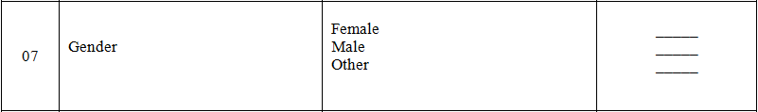

Definition:
Female: The client identifies as female.

Male: The client identifies as male.

Other: The client reports a gender that is non-conforming or does not identify as either male or female. .
Reporting:
Indicate the number of new and continuing clients, primary and secondary, for each category. These counts should be unduplicated.

08. IMMIGRATION CATEGORY/STATUS AT INTAKE:
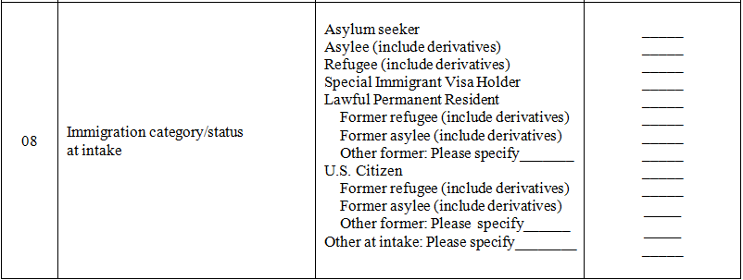

Definitions:
Asylum seeker: The client is planning to apply for asylum, has already filed for asylum, or is in any stage of the interview, hearing, or appeals process at the time of intake. If the individual person is still seeking asylum in the United States at the time of intake, this person is considered an asylum seeker.

Asylee: The client filed for asylum after entering the United States and was granted asylum by the time of intake. This also includes derivatives (family members) who were granted asylum status (Visa 92) as the spouse or unmarried child under age 21 of a principal asylee.

Refugee: The client was granted refugee status before entering the United States and was admitted to the United States as a refugee. This also includes derivative (family member) refugees who were granted refugee status (Visa 93) as the spouse or unmarried child under age 21 of a principal refugee.
Special Immigrant Visa holder: Individuals who enter to the U.S. through the Special Immigrant Visa (SIV) program which grants visas to nationals from Iraq and Afghanistan who have provided faithful and valuable service to the U.S. government, while employed by or on behalf of the U.S. government, and who have experienced or are experiencing an ongoing serious threat as a consequence of that employment.

Lawful permanent resident: Any person not a citizen of the United States who is residing in the U.S. under legally recognized and lawfully recorded permanent residence as an immigrant. This category is also known as "Permanent Resident Alien," "Resident Alien Permit Holder," and "Green Card Holder."

U.S. citizen: Any person who is a citizen of the U.S., including natural born and naturalized citizens.

Other former: Includes any former immigration category/status for Lawful Permanent Residents and U.S. Citizens besides refugee and asylee. Please specify the category(ies)/status(es).

Other at intake: Includes any immigration category/status for current clients not listed above. Please specify the category(ies)/status(es).

Reporting:
Indicate the number of new and continuing clients, primary and secondary, who fall into each of the immigration categories/statuses at intake. Indicate the latest (most recent) category/status for each client at intake. For example, a refugee generally becomes a lawful permanent resident (LPR) after one year and would be listed as an LPR if he or she were an LPR at intake. Also, indicate the former immigration category(ies)/status(es) for clients who are Lawful Permanent Residents and U.S. Citizens at intake. These counts should be unduplicated.

09. AGE AT INTAKE:
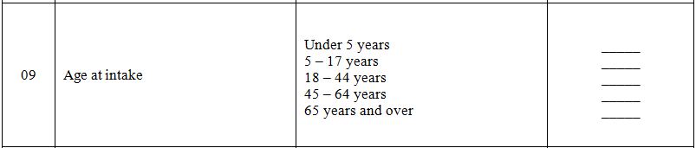

Reporting:
Indicate the number of new and continuing clients, primary and secondary, whose age falls within each age range at the time of intake. This count should be unduplicated.

10. EDUCATION PRIOR TO ARRIVAL:
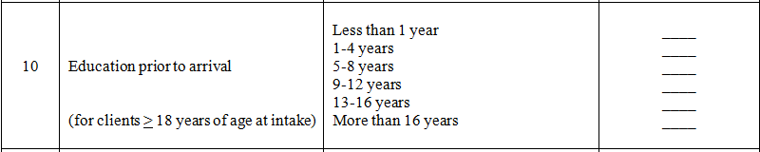

Definition:
Education prior to arrival: Years of education the client completed in a formal classroom or on-line education program in their home country, country of first asylum, or other country prior to arrival in the United States. This does not include short-term educational programs related to resettlement (e.g., cultural orientation, ESL etc.), nor does it include technical skills training, intensive language studies, monastic studies or Qur’anic schools (duksi) unless they are part of programs that lead to a degree.

Reporting:
Indicate the number of years of formal education that new and continuing clients, primary and secondary, completed prior to arrival in the United States. These counts should be unduplicated.

11. EMPLOYMENT STATUS IN THE U.S. AT INTAKE:
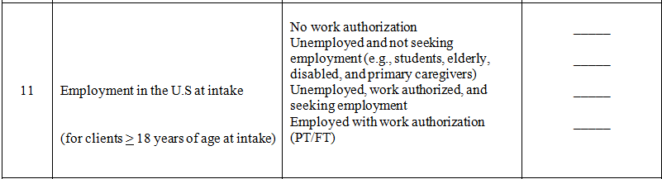

Definitions:
Work Authorization (and Work Authorized): An individual has permission/is eligible to work in the U.S. based on his or her immigration category/status or has been issued an employment authorization document (EAD card).

Unemployed: An individual is not working on a part-time or full-time basis as an employee or contractor, is not self-employed, and does not receive an income from a job.

Employed: An individual is being compensated for work performed on a part-time or full-time basis. This includes individuals who are employees, contractors, or self-employed.

Reporting:
Indicate the number of new and continuing clients, primary and secondary, who fall into one of the categories. This count should be unduplicated.

12. LENGTH OF TIME IN THE U.S. AT INTAKE:

Definition:
Length of time in the U.S at intake: The total amount of time the client has lived in the U.S. at the time of intake, including prior stays of significant duration (i.e., more than 6 months).

Reporting:
Enter the corresponding number of new and continuing clients, primary and secondary, for each category. These counts should be unduplicated.

13. COUNTRY OF ORIGIN:

Definition:
Country of origin: As self-reported by the client. The client’s country of origin may be different than the client’s country of birth, nationality, or country of residence prior to coming to the United States
(e.g., a Somali refugee who was born and lived in Kenya who reports Somalia as his country of origin).

Reporting:
List all of the countries of origin reported by new and continuing, primary and secondary clients. These numbers should be unduplicated. Include territories, autonomous regions, and states not universally recognized as sovereign (e.g., Tibet, Palestine, etc.).

14. ETHNICITY:

Definition:
Ethnicity: The client’s ethnic origin, understood as the shared cultural practices, perspectives, and distinctions that set apart one group of people from another.

When ethnic identity is different in the U.S. than in the country of origin, indicate the ethnic identity in the home country (e.g., report as Lhotshampa a Nepali-speaking Bhutanese refugee who identified as Lhotshampa in Bhutan and now identifies as Nepali in the U.S.)

Reporting:
List all ethnicities as reported by new and continuing clients, primary and secondary. Include the number of clients for each ethnicity listed. These counts should be unduplicated. Please refer to Appendix A: List of Ethnic Groups Common to SOT Programs. This list is not all-inclusive.

15. RELIGION:

Definition:
Religion: The religious tradition, faith community, or set of spiritual beliefs and practices to which the client reports an affiliation.

None: Refers to people who self-identify as atheists or agnostics, as well as those who say their religion is “nothing in particular”.

Reporting:
Indicate the number of new and continuing clients, primary and secondary, that identify with the religions listed, or identify as “None.” These counts should be unduplicated. Also include the number of clients for each religion specified under “Other.”

16. LANGUAGES USED:

Definition:
Languages Used: The languages that staff and interpreters used to communicate with clients in order to conduct assessments and provide services.

Reporting:
List all languages used by staff and interpreters to communicate with new and continuing clients, primary and secondary. These counts should be unduplicated.

17. CLIENTS SERVED BY SERVICE CATEGORY:
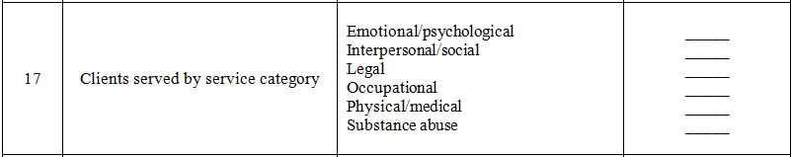

Definitions:
Emotional/psychological: Psychiatric or psychological services provided by psychiatric nurses, psychiatrists, clinical social workers, psychologists, licensed professional counselors, or other certified/licensed professionals acting within the scope of their practice according to state law. These services may involve diagnostic, treatment, and preventive care services including psychological testing and evaluation, psychotherapy/counseling, psychopharmacology, and other forms of psychiatric/psychological treatment, with the exception of substance abuse treatment

Interpersonal/social: Services provided by a wide range of professional and paraprofessional personnel that address personal, social, and environmental problems, with the exception of employment-related issues. These services include assistance with education, housing, clothing, transportation (including access to health services), case management, interpretation/translation, or other forms of direct assistance.

Legal: Services provided by a lawyer, Board of Immigration Appeals (BIA) accredited representative, paralegal, or other person(s) under the supervision of a lawyer, to assist with the specific legal needs of torture survivors.

Occupational: Services to help the client become more employable, self-sufficient and productive, such as work-related ESL, vocational or professional skills training, or career or college counseling.

Physical/medical: Medical and dental services provided by medical/dental practitioners (e.g., medical doctors, nurse practitioners, registered nurses, licensed practical nurses, physician assistants, dentists, dental technicians). Also includes subspecialty medical services such as neurology, orthopedics, rehabilitation medicine, etc., with the exception of psychiatry.

Substance Abuse: Treatment, both medical and behavioral, for issues related to alcohol, drug, prescription or illegal drug, or other form of substance abuse.

Reporting:
Report the number of new and continuing primary and secondary clients who received a service in the given service category. A given service may not count toward more than one type of service. However, a client may be represented in multiple service types if that client received respective multiple services, so these counts may be duplicated.

18. PEOPLE TRAINED BY PROFESSION:
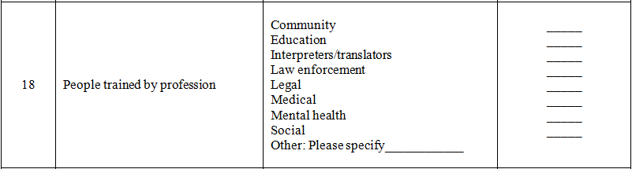

Definitions:
Community: Refugee or immigrant community leaders, or other members of the community that can assist in identifying, referring, and serving survivors.

Education: Teachers, education administrators, post-secondary faculty and staff, or other professionals associated with institutions of education.

Interpreters/Translators: Trained and certified individuals or volunteers who convert spoken or written material from one language (the source language) into a different language (the target language).

Law Enforcement: Police officers, immigration officers, or other professionals employed in some law enforcement capacity.

Legal: Attorneys, accredited representatives, paralegals, or other professional that address legal needs.

Medical: Nurses (with the exception of psychiatric nurses), physical therapist, massage therapists, medical doctors (with the exception of psychiatrists), dentists, or other medical service providers that specifically address medical or physical issues.

Mental Health: Psychologists, psychiatrists, clinical social workers (providing explicit mental health treatment), psychiatric nurses, or other qualified mental health professional that address specific mental health, psychiatric, or psychological issues.

Social: Social workers (with the exception of licensed clinical social workers or equivalent who provide explicit mental health treatment) or other social service providers that address housing, clothing, employment, transportation, case management, or other specific social service issues.

Reporting:
Indicate the number of people trained, by profession or as a community member, in some area of torture-related service or issue, during the reporting period. If a profession does not fit into any of the preceding categories, please specify and include a count for each type of profession under “Other.”

19. HOURS CONTRIBUTED BY PRO BONO SERVICE:
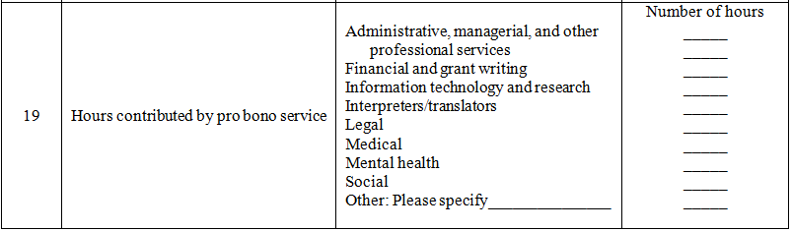

Definitions:
Administrative, managerial, and other professional services: All services related to the planning, direction, and coordination of organizational supportive services.

Financial and grant writing: All services provided in accounting, grant writing, or other financial services.

Information technology and research: All professional services provided by information technology professionals or by trained research professionals (e.g., scientists, statisticians, psychologists, graduate students).

Interpreters/Translators: Trained and certified individuals or volunteers who convert spoken or written material from one language (the source language) into a different language (the target language).

Legal: All services provided by attorneys, accredited representatives, paralegals, or other professionals that address the specific legal needs of torture survivors.

Medical: All services provided by nurses (with the exception of psychiatric nurses), physical therapists, massage therapists, medical doctors (with the exception of psychiatrists), dentists, or other medical service providers that specifically address medical or physical issues.

Mental health: All services provided by psychologists, psychiatrists, licensed clinical social workers (providing explicit mental health treatment), psychiatric nurses, or other qualified mental health professionals that address specific mental health, psychiatric, or psychological issues.

Social: All services provided by social workers (with the exception of licensed clinical social workers or equivalent who provide explicit mental health treatment) or other service providers or services that address housing, clothing, employment, transportation, case management, or other specific social issues.

Reporting:
For each service area, indicate the total number of pro-bono (i.e., free) hours contributed by providers during the reporting period. This does not include general volunteer hours or any hours provided at a reduced fee, but only professional services provided at no cost. If a service does not fit into any of the preceding categories, please specify and include a count for each type of service under “Other.”

OUTCOME INDICATORS (Data Points 20–25)
Overview:
Reporting these indicators will help to provide important aggregate client outcome data for the SOT program. The expectation is that the holistic services provided to survivors will lead to an increase in the psychosocial well-being for many clients. However, ORR recognizes that several factors that influence client well-being are neither in the control of survivors nor service providers. Levels of need for some clients may increase during the reporting period. These data can be useful for evaluating program effectiveness and will not necessarily have a negative impact on program performance reviews.

Assess the Client:
A staff member assesses clients’ level of need in each of six domains (legal, housing, medical, mental health, community resource, and support system needs) and determines a score based on observations and/or case notes from a session with the client. At a minimum, client-level outcome data should be assessed and recorded 1) during intake, 2) at some point during the project year (around 3–6 months), and 3) when the client exits the program, if possible. If programs assess levels of need at multiple times during the project year, the first and last collection points in the project year are to be used to arrive at the Outcome Indicators.

Record Client Data:
To record client-level outcome data for each domain (area of need) , use your own program tool, or if you wish to use the Survivor of Torture Psychosocial Well-being Index–Short version (SOT-PWI-S), please contact Dr. Michaela Farber (farber@cua.edu) to make arrangements. Otherwise, the SOT-PWI-S is meant to be used as an aggregate data collection tool to determine Outcome Indicators. If using your own program tool, make sure it measures levels of need in at least the six domains of legal, housing, medical, mental health, community resource, and support system needs. The SOT-PWI-S can be used with case file reviews or during client sessions/assessments. Compare the first and last collection points for each domain by each client to determine individual changes in the level of need. These collection points should be at least 3 months apart.

Aggregate Client Data:
If using your own program tool, convert its assessment scale to best fit into the four levels of need in the SOT-PWI-S (In Crisis, Vulnerable, Stable, Safe) for each of the six domains (see Appendix D). Using the SOT-PWI-S scale, aggregate the client-level changes in the level of need for each domain in order to obtain program-level data for the Outcome Indicators. Do not include data for clients with only one collection point. If there are several clients who have been enrolled for more than 6 months but have not had a second assessment please provide an explanation in the program narrative report.

Report the Aggregated Data:
Transfer the scores from the SOT-PWI-S to the corresponding Outcome Indicator. Using the matrix for each domain, 1) enter the number of clients (N=) in the START column for each level of need at intake and 2) enter the number of clients in the END row that reflects their level of need at the last time they were assessed during the reporting period, making sure the level of need box in the END row corresponds to level of need box in the START column. Do not include data for clients with only an intake data collection point.

OUTCOME INDICATOR PREFACE:
Provide the following information regarding client-level data at the top of the Outcome Indicators section.
- Enumerate the number of clients receiving services for each timeframe.
- Mark the client-level data collection tool used. If using a program tool, please provide the name of the tool.

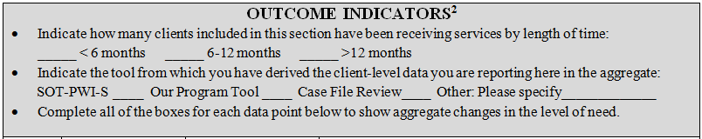

20. LEGAL (IMMIGRATION): Assesses whether or not the client has any unresolved immigration
legal issues and, if so, whether or not the client has the knowledge, skills and resources to represent themselves or access legal services and work with an attorney to pursue their immigration legal case. Use the SOT-PWI-S or convert your program tool’s assessment measure to the SOT-PWI-S levels of need for this domain.

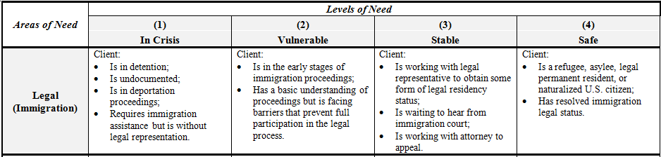

EXAMPLE:
Data Point | Description | Level of Need |  | END
 |  |  |  | 1  Crisis | 2  Vulnerable | 3  Stable | 4  Safe
20 | Legal (Immigration) | S  T  A  R  T | 1  Crisis  N= 15 |  | 3 | 10 | 2
 |  |  | 2  Vulnerable  N= 30 |  | 5 | 22 | 3
 |  |  | 3  Stable  N= 27 |  |  | 15 | 12
 |  |  | 4  Safe  N= 28 |  |  |  | 28

In this example the program recorded the Legal (immigration) levels of need for clients at intake (N= ). Fifteen were at the crisis level, 30 were at the vulnerable level, 27 were at the stable level, and 4 were at the safe level at intake. At the end of the reporting period, the program reassessed the clients’ level of need. Three clients moved from crisis to vulnerable, 10 moved from crisis to stable, and 2 from crisis to safe; 5 clients stayed vulnerable, 22 moved from vulnerable to stable, and 3 moved from vulnerable to safe; 15 clients stayed stable and 12 moved from stable to safe; 28 clients stayed at the safe level. The total number of clients that moved from crisis and vulnerable to stable and safe was 37.

21. HOUSING: Assesses the client’s ability to obtain safe housing based on individual circumstances and local housing availability. Use the SOT-PWI-S or convert your program tool’s assessment measure to the SOT-PWI-S levels of need for this domain.

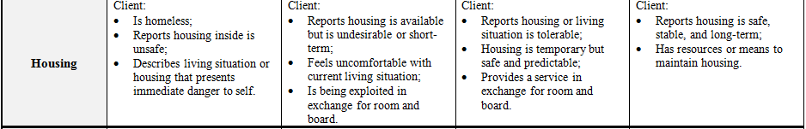

22. PHYSICAL HEALTH: Assesses the general physical well-being of the client. Use the SOT-PWI-S or convert your program tool’s assessment measure to the SOT-PWI-S levels of need for this domain.

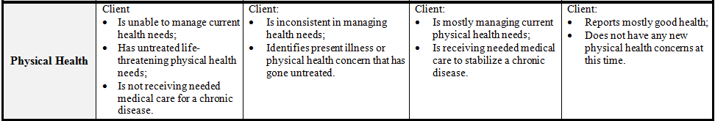

EXAMPLE:
Data Point | Description | Level of Need |  | END
 |  |  |  | 1  Crisis | 2  Vulnerable | 3  Stable | 4  Safe
22 | Physical Health | S  T  A  R  T | 1  Crisis  N= 15 | 2 | 3 | 7 | 3
 |  |  | 2  Vulnerable  N= 60 | 4 | 10 | 36 | 10
 |  |  | 3  Stable  N= 17 | 2 | 4 | 8 | 3
 |  |  | 4  Safe  N= 8 | 1 | 2 | 5

In this example, the program recorded the level of Physical Health needs of clients at intake (N= ). Fifteen were at the crisis level and 60 at the vulnerable level, while 17 were at the stable level and 8 were at the safe level. At the end of the reporting period, 7 clients moved from crisis to stable, 3 from crisis to safe, 36 moved from vulnerable to stable, and 10 from vulnerable to safe. The total number of clients that moved from crisis and vulnerable to stable and safe was 56. However, 9 clients moved from stable and safe to crisis and vulnerable.

23. MENTAL HEALTH: Assesses the general emotional well-being of the client. Use the SOT-PWI-S or convert your program tool’s assessment measure to the SOT-PWI-S levels of need for this domain.

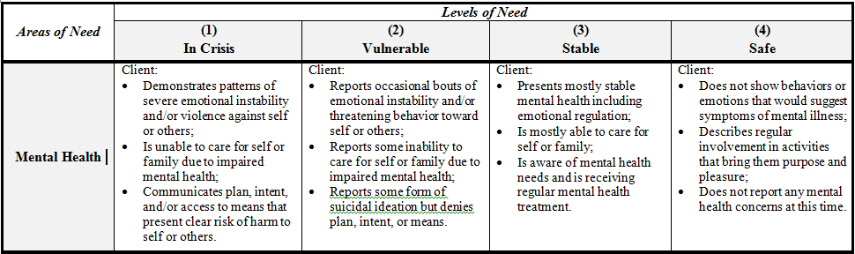

24. ACCESS TO COMMUNITY RESOURCES: Assesses the client’s knowledge and ability to access
the type of services they need to meet their needs. Use the SOT-PWI-S or convert your program tool’s assessment measure to the SOT-PWI-S levels of need for this domain.

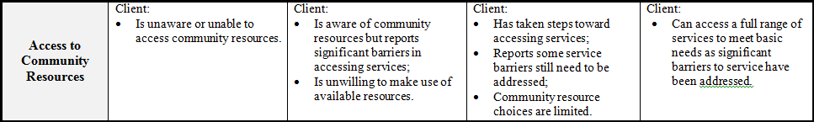

25. SUPPORT SYSTEM IN U.S.: Assesses the nature of the individual’s interpersonal relationships in the U.S., especially the extent to which these relationships sustain the client during times of crisis. Use the SOT-PWI-S or convert your program tool’s assessment measure to the SOT-PWI-S levels of need for this domain.

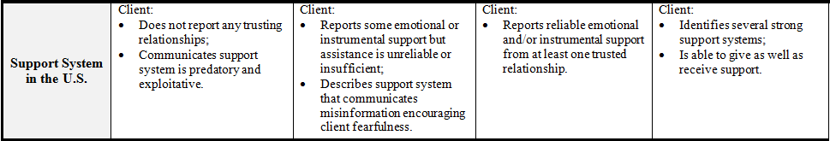

EXAMPLE:
Data Point | Description | Level of Need |  | END
 |  |  |  | 1  Crisis | 2  Vulnerable | 3  Stable | 4  Safe
25 | Support System in the U.S. | S  T  A  R  T | 1  Crisis  N= 20 | 2 | 3 | 10 | 5
 |  |  | 2  Vulnerable  N= 40 | 1 | 4 | 25 | 10
 |  |  | 3  Stable  N= 30 |  |  | 15 | 15
 |  |  | 4  Safe  N= 10 |  |  | 2 | 8

In this example, the program recorded the Support System in the U.S. level of need for clients at intake (N= ). Twenty were at the crisis level and 40 were at the vulnerable level. At the end of the reporting period, the program reassessed the clients’ level of need. Ten clients moved from crisis to stable, 5 from crisis to safe, 25 from vulnerable to stable, and 10 moved from vulnerable to safe. The total number of clients that moved from crisis and vulnerable to stable and safe during the reporting period was 50.

If you have questions about collecting or reporting the Psychosocial Well-being indicators please contact the program officer for the ORR Services for Survivors of Torture grant program.

APPENDIX A: LIST OF ETHNIC GROUPS COMMON TO SOT PROGRAMS

ARAB
ARMENIAN
ASHARAF
BAMILEKE
BANTU
BANYAMULENGE, BANYAMULENGUE
BEMBE, BEMBA, MBEMBE
BURMESE
CHALDEAN
CHIN
CUBAN
DAROD
DUALA
FARS
FUR
GREAT RUSSIAN
HAWIYE
HAZARA
HUTU
JEWISH
KACHIN
KAREN
KAREN NI (KAYAR)
KUNAMA
KURD (INCLUDES YAZIDI)
LATINO
LHOTSAMPA
MASSALIT
MAYAN (INCLUDES SUB-ETHNIC GROUPS)
MESTIZO
OROMO
PASHTOON
PERSIAN
ROHINGYA
SAHO
SIRYAC
TAJIK
TIGRINYA
TUTSI
WOLOF
YORUBA
ZAGAWA

APPENDIX D: SURVIVOR OF TORTURE: PSYCHOSOCIAL WELL-BEING INDEX-SHORT (SOT-PWI-S)¹

Areas of Need | Levels of Need
 | (1) | (2) | (3) | (4)
 | In Crisis | Vulnerable | Stable | Safe
Legal (Immigration) | Client:  - Is in detention;  - Is undocumented;  - Is in deportation proceedings;  - Requires immigration assistance but is without legal representation. | Client:  - Is in the early stages of immigration proceedings;  - Has a basic understanding of proceedings but is facing barriers that prevent full participation in the legal process. | Client:  - Is working with legal representative to obtain some form of legal residency status;  - Is waiting to hear from immigration court;  - Is working with attorney to appeal. | Client:  - Is a refugee, asylee, legal permanent resident, or naturalized U.S. citizen;  - Has resolved immigration legal status.
Housing | Client:  - Is homeless;  - Reports housing inside is unsafe;  - Describes living situation or housing that presents immediate danger to self. | Client:  - Reports housing is available but is undesirable or short-term;  - Feels uncomfortable with current living situation;  - Is being exploited in exchange for room and board. | Client:  - Reports housing or living situation is tolerable;  - Housing is temporary but safe and predictable;  - Provides a service in exchange for room and board. | Client:  - Reports housing is safe, stable, and long-term;  - Has resources or means to maintain housing.
Physical Health | Client  - Is unable to manage current health needs;  - Has untreated life-threatening physical health needs;  - Is not receiving needed medical care for a chronic disease. | Client:  - Is inconsistent in managing health needs;  - Identifies present illness or physical health concern that has gone untreated. | Client:  - Is mostly managing current physical health needs;  - Is receiving needed medical care to stabilize a chronic disease. | Client:  - Reports mostly good health;  - Does not have any new physical health concerns at this time.

Use the Survivors of Torture Psychosocial Well-being Index (Short Version) (SOT-PWI-S) © 2016 Hodges-WU & Zajicek-Farber to aggregate the data for these indicators.

Areas of Need | Levels of Need
 | (1)  In Crisis | (2)  Vulnerable | (3)  Stable | (4)  Safe
Mental Health | Client:  - Demonstrates pattern of severe emotional instability or violence against self or others;  - Is unable to care for self or family due to impaired mental health;  - Communicates plan, intent, and/or access to means that present clear risk of harm to self or others. | Client:  - Shows occasional bouts of emotional instability and/or threatening behavior toward self or others;  - Reports some inability to care for self or family due to impaired mental health;  - Reports some form of suicidal ideation but denies plan, intent, or means. | Client:  - Presents mostly stable mental health including emotional regulation;  - Is mostly able to care for self or family;  - Is aware of mental health needs and is receiving regular mental health treatment. | Client:  - Does not show behaviors or emotions that would suggest symptoms of mental illness;  - Describes regular involvement in activities that bring them purpose and pleasure;  - Does not report any mental health concerns at this time.
Access to Community Resources | Client:  - Is unaware or unable to access community resources. | Client:  - Is aware of community resources but reports significant barriers in accessing services;  - Is unwilling to make use of available resources. | Client:  - Has taken steps toward accessing services;  - Reports some service barriers still need to be addressed;  - Community resource choices are limited. | Client:  - Can access a full range of services to meet basic needs as significant barriers to service have been addressed.
Support System  in the U.S. | Client:  - Does not report any trusting relationships;  - Communicates support system is predatory and exploitative. | Client:  - Reports some emotional or instrumental support but assistance is unreliable or insufficient;  - Describes support system that communicates misinformation encouraging client fearfulness. | Client:  - Reports reliable emotional or instrumental support from at least one trusting relationship. | Client:  - Identifies several strong support systems;  - Is able to give as well as receive support.

© 2016 Hodges-Wu & Zajicek-Farber. This version of the SOT-PWI (Short) has been specifically adapted for ORR to assist in its efforts to collect aggregate program data.

See Appendix D for a copy of the Survivor of Torture Psychosocial Well-being Index–Short version (SOT-PWI-S) © 2016 Hodges-Wu & Zajicek-Farber

