MAJORITY MEMBERS: ROBERT C. “BOBBY” SCOTT, VIRGINIA,  Chairman  SUSAN A. DAVIS, CALIFORNIA RAÚL M. GRIJALVA, ARIZONA JOE COURTNEY, CONNECTICUT MARCIA L. FUDGE, OHIO  GREGORIO KILILI CAMACHO SABLAN, NORTHERN MARIANA ISLANDS  FREDERICA S. WILSON, FLORIDA SUZANNE BONAMICI, OREGON MARK TAKANO, CALIFORNIA  ALMA S. ADAMS, NORTH CAROLINA MARK DESAULNIER, CALIFORNIA DONALD NORCROSS, NEW JERSEY PRAMILA JAYAPAL, WASHINGTON JOSEPH D. MORELLE, NEW YORK SUSAN WILD, PENNSYLVANIA JOSH HARDER, CALIFORNIA  LUCY MCBATH, GEORGIA KIM SCHRIER, WASHINGTON  LAUREN UNDERWOOD, ILLINOIS JAHANA HAYES, CONNECTICUT DONNA E. SHALALA, FLORIDA ANDY LEVIN, MICHIGAN  ILHAN OMAR, MINNESOTA DAVID TRONE, MARYLAND HALEY M. STEVENS, MICHIGAN SUSIE LEE, NEVADA  LORI TRAHAN, MASSACHUSETTS JOAQUIN CASTRO, TEXAS | COMMITTEE ON EDUCATION AND LABOR  U.S. HOUSE OF REPRESENTATIVES 2176 RAYBURN HOUSE OFFICE BUILDING  WASHINGTON, DC 20515-6100 | MINORITY MEMBERS: VIRGINIA FOXX, NORTH CAROLINA,  Ranking Member  DAVID P. ROE, TENNESSEE  GLENN THOMPSON, PENNYSLVANIA TIM WALBERG, MICHIGAN  BRETT GUTHRIE, KENTUCKY BRADLEY BYRNE, ALABAMA GLENN GROTHMAN, WISCONSIN ELISE M. STEFANIK, NEW YORK RICK W. ALLEN, GEORGIA  LLOYD K. SMUCKER, PENNSYLVANIA JIM BANKS, INDIANA  MARK WALKER, NORTH CAROLINA JAMES COMER, KENTUCKY  BEN CLINE, VIRGINIA RUSS FULCHER, IDAHO  STEVEN C. WATKINS, JR., KANSAS RON WRIGHT, TEXAS  DAN MEUSER, PENNSYLVANIA DUSTY JOHNSON, SOUTH DAKOTA FRED KELLER, PENNSYLVANIA  GREGORY F. MURPHY, NORTH CAROLINA JEFFERSON VAN DREW, NEW JERSEY

May 4, 2020

The Honorable Betsy DeVos Secretary
U.S. Department of Education 400 Maryland Avenue, SW Washington, D.C. 20202

Dear Secretary DeVos:

We are writing to comment on the Department of Education’s (“Department’s”) proposed changes to the “Borrower Defense to Loan Repayment Universal Form.”1 Specifically, we raise two critical concerns; that is, the Department may be incorrectly applying the rules for students who borrow after July 1, 2020 to all borrowers; and, it has proposed questions that are unnecessary and may deter applicants.

On March 4, 2020, the Department published a list of proposed elements that could be used when replacing the form that expired on December 31, 2019 (referred to as “list of proposed elements”).2 Some of the proposed elements could be helpful to borrowers, such as providing examples of institutional misconduct that could lead to discharge, and including additional types of claims that the Department may consider, such as instances where the college misrepresented itself to third parties including states, accreditors, or the Department.3 Some sections, however, appear to incorrectly apply the regulations promulgated in 2019 to all borrowers.4 Other elements may deter a borrower with a valid claim from completing or submitting the application. Finally, some elements of the proposed form may contain incorrect information.

The Department may incorrectly apply rules for students who borrow after July 1, 2020 to all borrowers.

A borrower is subject to one of three different sets of Borrower Defense regulations depending on when he or she took out a federal student loan and attended school.5 However, the list of proposed elements does not always clearly delineate which questions are relevant to each set of borrowers. These regulations were promulgated in 1995, 2016, and 2019, and each set of regulations contains different elements and data required to adjudicate a claim and determine

relief.6 But the list of proposed elements includes some information relevant only to the 2019 regulation, with no indication that this information will be asked solely of borrowers applying under the 2019 standard.7 For instance, the proposed list asks the applicant whether he or she is involved in arbitration.8 The same list asks the applicant to acknowledge that if he or she receives a 100 percent discharge the institution may refuse to verify or to provide an official transcript that certifies the student’s completion of credits or a credential associated with the discharged loan. These elements should only apply to borrowers who took out loans after July 1, 2020.9

ED Response: The online application—where the overwhelming majority of borrowers apply for a borrower defense discharge—will dynamically determine which borrower defense regulation or regulations would apply to a borrower and only presents to the borrower questions and information that are/is relevant to the borrower. The document that was the subject of comment was not an application, but rather a general list of data elements. The final paper application will make clear which provisions of the application apply to borrowers subject to a specific regulation.

Second, throughout the document, borrowers are asked to indicate how they were financially affected by the school’s actions.10 The Department’s current methodology awards relief based on financial harm at the program level, not harm experienced by each individual, meaning that all borrowers who attended the same program will receive the same amount of relief. Therefore, questions about an individual’s financial experiences are unnecessary.11

ED Response: As mentioned in the Department’s policy statement in December 2019 and its communications to borrowers, the partial relief methodology that is applied to a borrower is a rebuttable presumption about the discharge a borrower should receive. Information provided by borrowers in their applications may be used to rebut the presumption that the partial relief methodology should apply and instead cause the Department to apply a different standard of relief.

Finally, many of the large closures that resulted in borrower defense claims, such as Corinthian Colleges, Inc. and ITT Technical Institute, are subject to the 1995 regulations.12 In these cases a borrower defense claim would be adjudicated under the relevant state law. Many of the Department’s proposed elements are based on a federal standard, including the lists of reasons a borrower may seek borrower defense, and therefore may have no applicability. When it is fully developed, it will be important that the form clearly explains that for borrowers under the 1995 regulations, many of the questions in the form may not apply. Given the differences across the three sets of regulations, it could be helpful to develop three separate forms, or ensure the skip- logic is clear, depending on when the borrower took out the loans.13

ED Response: After multiple internal discussions, we declined to develop three separate forms. As mentioned above, the online application—where the overwhelming majority of borrowers apply for a borrower defense discharge—will dynamically determine which borrower defense regulation or regulations would apply to a borrower and only presents to the borrower questions and information that are/is relevant to the borrower. However, while it is true that the 1995 borrower defense regulation is rooted in violations of state law, the various types of allegations that the draft application lays out are sufficiently similar to state law-based claims. If a borrower does not believe that any of the listed types of allegations matches the type of claim they wish to make, they are free to submit an “other” claim. Moreover, it is important to note that a borrower will only be presented with questions in the online application that are associated to the type of allegation they wish to make. For example, if the borrower wants to file a claim associated with the transferability of credits, but not one related to job prospects, the borrower will not be presented with any questions related to job prospects. This strikes the appropriate balance between helping borrowers understand the types of conduct that can lead to a borrower defense discharge and reducing burden on borrowers who may not know whether the type of conduct that they school engaged in could lead to a successful borrower defense application.

The Department has proposed questions that are unnecessary and may deter applicants.

We are concerned that some of the information the Department is requesting is burdensome and is not necessary to establish that a borrower has a valid claim. This contradicts the goal of the Paperwork Reduction Act, which requires federal departments to “minimize the burden of the collection of information on those who are to respond.”14 For example, it is unnecessary to ask the borrower to provide the name and title of the person at the school who provided the misleading information.15 The list of elements also asks borrowers asserting a claim about misrepresentation to a third party “to describe in detail what the school misrepresented [to the third party] and why you believe it was misleading.”16 Unless a borrower is privy to a college’s internal correspondence with states, accreditors, or the Department, it stands to reason that borrowers would not have access to this information. In another section, the list of elements asks borrowers with a claim regarding a transfer of credit misrepresentation to provide evidence that he or she actually attempted to transfer them. This information has not historically been required for this type of claim.17 These types of superfluous questions may lead a borrower to believe they don’t have sufficient information to make a successful claim.

ED Response: We do not believe that the questions are superfluous, burdensome, or unnecessary. Indeed, the questions can provide critical evidence for the Department to investigate as part of its adjudication process. However, if the borrower does not have such information, they are not prohibited from proceeding with their application or allegation. The final paper application and online application will specify which fields are options, and signal to borrowers that they can enter “I don’t know” in response to specific questions. Moreover, as part of the design of the online application process, the borrower’s experience was developed using the principles of user-centered design and were user tested. We found that borrowers were not deterred from submitting applications based on any of the design elements or questions, but we do and will continue to make changes to various portions of the online application based upon actual user feedback.

The list of elements also contains information that may deter a borrower from completing the application. The introduction to the application contains a list of situations where a borrower cannot qualify for borrower defense, which may inadvertently discourage borrowers with legitimate claims from continuing to fill out the form.18 Exacerbating this problem, the list of situations is vague and incomplete. For example, the list states that “conduct that does not directly and clearly relate to enrollment or continuing enrollment” or “educational services your school provided” cannot result in a borrower defense discharge.19 However, the Department has already approved borrower defense claims if a school falsely told students their education would lead to guaranteed employment after graduation.20 As the list is currently written, a borrower may not consider this type of fraud an enrollment or educational services issue, and incorrectly assume they would not qualify for relief. Later in “Section 7: Certifications”, the Department proposes adding that a borrower may be imprisoned if he or she provides false or misleading information.21 While the Department needs to collect accurate information on each borrower’s situation, adding the threat of jail time is excessive and again may dissuade a borrower with a valid claim from filing, out of fear an innocent or clerical error on their part could result in prosecution and imprisonment.

ED Response: With regards to the elements in the introduction, the Department has received numerous applications from borrowers for situations that do not qualify for borrower defense, which slows down the processing of legitimate claims and providing relief to eligible borrowers. While we do not wish to deter eligible borrowers, it is important for those borrowers, with legitimate claims, to have their claims resolved in a timely manner. We acknowledge that the list of situations is incomplete – any truly complete list would be unmanageable – and we strongly disagree that it is vague. As it relates to the certification section, all of the Department’s forms reference to the provision of federal law, 18 USC §1001, which makes any false statement subject to punishment. We decline to make an exception for the borrower defense application.

Overall, the Department should take steps to shorten the form, better target the questions depending on when the borrower took out his or her loan, and only ask questions that are needed to establish the facts. As it stands, the list of proposed elements is 20 pages long, may misapply the 2019 regulations, and includes language that will likely deter applicants. The Department’s estimate that it will take borrowers 30 minutes to fill out the form is unrealistic.22 We request the Department consider making changes we have outlined above to improve the form’s clarity and accuracy.23

ED Response: As demonstrated in the many responses to comment above, we disagree with each of the assertions made in the prior paragraph and decline to make any of the changes outlined above. It is also important to note that the 30-minute estimate to complete the application is an average. The overwhelming majority of borrowers who submit borrower defense applications only make a single allegation, and only very few borrowers make more than two allegations. This average takes this into account. While the paper application may appear long, most borrowers will only need to interact with only a few pages of it. Moreover, the estimates takes into consideration the incorporation of “skip logic” that will be used in the online application, as well as the ability for the borrower to import their enrollment history into their online application, which will eliminate the need for nearly all borrowers to complete Section 2.

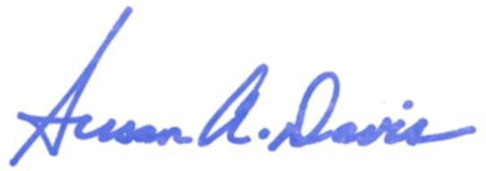
Sincerely,

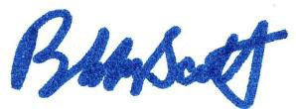
_
___________________________
ROBERT C. “BOBBY” SCOTT
Chairman

SUSAN A. DAVIS
__________________________________
Member of Congress

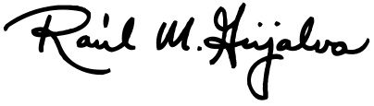
_
_________________________________
RAÚL M. GRIJALVA
Member of Congress

_
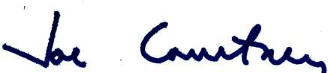
JOE COURTNEY
____________________________
Member of Congress

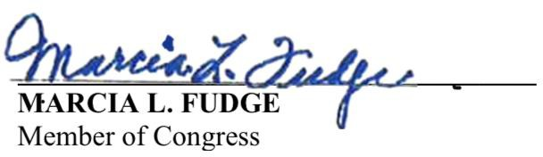 | GREGORIO KILILI CAMACHO SABLAN  Member of Congress

FREDERICA S. WILSON  Member of Congress | SUZANNE BONAMICI  Member of Congress

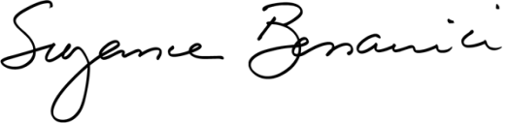
MARK TAKANO
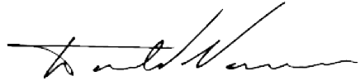
Member of Congress
_
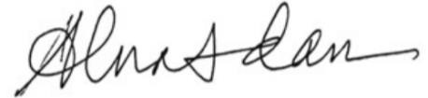
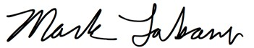
ALMA S. ADAMS, Ph.D.
_____________________________
__________________________________
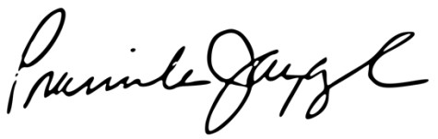
Member of Congress
______________________________

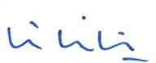
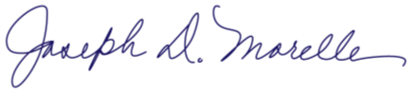
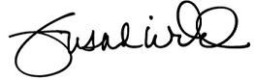
________________________
____________________________________ MARCIA L. FUDGE
Member of Congress
________________________________

DONALD NORCROSS  Member of Congress | _  PRAMILA JAYAPAL  Member of Congress

JOSEPH D. MORELLE  Member of Congress | _  SUSAN WILD  Member of Congress

JOSH HARDER
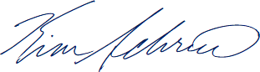
Member of Congress
____________________________
_
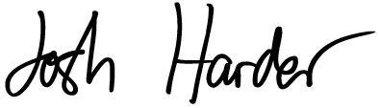
LUCY MCBATH
________________________
___________________________
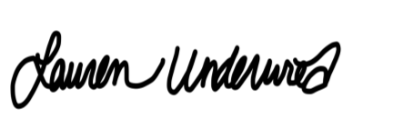
Member of Congress

_  KIM SCHRIER, M.D.  Member of Congress | LAUREN UNDERWOOD  Member of Congress

JAHANA HAYES
__________________________
Member of Congress
_

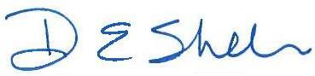
DONNA E. SHALALA
________________________________
Member of Congress

ANDY LEVIN
_____________________________
Member of Congress
ILHAN OMAR
Member of Congress

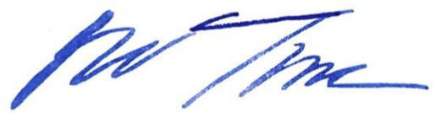
DAVID J. TRONE
____________________________________
Member of Congress
_

HALEY M. STEVENS
___________________________
Member of Congress

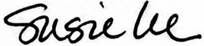
_
_______________________________
SUSIE LEE
Member of Congress

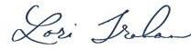
LORI TRAHAN
Member of Congress

_
__________________________
JOAQUIN CASTRO
Member of Congress

1 A “borrower defense to repayment” refers to any act or omission of the school attended by the student that relates to the making of the loan for enrollment at the school or the provision of educational services for which the loan was provided that would give rise to a cause of action against the school under applicable state law, 34 CFR § 685.206, current as of April 16, 2020. The law applies to Direct Loans; however, the implementing regulations expanded borrowers with other federal loans to assert a borrower defense claim. See Congressional Research Service, The Closure of Intuitions of Higher Education: Student Opinions, Borrower Relief, and Other Implications, February 5, 2019, R44737.
2 U.S. Department of Education, “2020 List of Elements Draft Revised,” The new proposed elements were published in the federal register on March 4, 2020, https://www.regulations.gov/document?D=ED-2020-SCC-0043- 0003. “U.S. Department of Education Application for Borrower Defense to Loan Repayment,” OMB control number 1845-0146, https://studentaid.gov/sites/default/files/borrower-defense-application.pdf.
3 “2020 List of Elements Draft Revised,” page 12, https://www.regulations.gov/document?D=ED-2020-SCC-0043- 0003.
4 The 2019 Borrower defense regulations only apply to loans taken out after July 1, 2020.
5 Section 455(h) of the Higher Education Act of 1965, as amended, allows the Department to specify in regulation which “acts or omissions of an institution of higher education . . . [qualify as] as a defense to repayment” of a Direct Loan. In 1995, the Department published regulations regarding borrower defense, 34 C.F.R. § 685.206(c). The Department revised those regulations in 2016 and 2019. See Student Assistance General Provisions, Federal Family Education Loan Program, and William D. Ford Federal Direct Loan Program, 84 FR 49,788, at 49,788, September 23, 2019, https://www.govinfo.gov/content/pkg/FR-2019-09-23/pdf/2019-19309.pdf.

6 See note 5, supra.
7 The 1995 regulations apply to loans issued before July 1, 2017, those promulgated in 2016 apply to loans issued between July 1, 2017 and July 1, 2020, and the 2019 regulations apply to loans taken out after July 1, 2020. See Student Assistance General Provisions, Federal Family Education Loan Program, and William D. Ford Federal Direct Loan Program, 84 FR 49,788, at 49,814, September 23, 2019, (codified at 34 C.F.R. § 668, 34 C.F.R. § 682, 34 C.F.R. § 685). Also, see https://ifap.ed.gov/electronic- announcements/112519implschoolnoticerequnder2016bordefensereg.
8 “2020 List of Elements Draft Revised,” for arbitration see page 3, https://www.regulations.gov/document?D=ED- 2020-SCC-0043-0003. The 2019 rule allows schools to require students to sign mandatory arbitration provisions and class action waivers as a condition of enrollment, provided the schools make certain disclosures. See 84 F.R. 49,788 at 49,840-4.
9 34 C.F.R. § 685.206(e)(8)(vi), See “Top 10 Ways The New Borrower Defense Rule Is Worse For Borrowers,” https://ticas.org/wp-content/uploads/2019/09/BD_Side-by-Side.pdf.
10 “2020 List of Elements Draft Revised,” questions about how the borrower is financially affected are asked throughout “Section 4: Basis for Borrower Defense,” https://www.regulations.gov/document?D=ED-2020-SCC- 0043-0003.
11 The Department’s policy is “based on a determination of the harm suffered by a successful BD applicant as a result of the misconduct, as determined by comparing earnings imputed to the BD applicant against earnings of a representative comparison group….Using comparative earnings, generally available data can be used to focus on the harm that is actually attributable to the program the applicant was enrolled in by comparing earnings information for that program to a group of similar comparable programs offered by other institutions that the applicant might have otherwise attended.” U.S. Department of Education, “Policy Statement: Tiered relief methodology to adjudicate certain borrowers defense claims,” December 10, 2019, https://www.ed.gov/sites/default/files/documents/borrower- defense-relief.pdf.
12 Corinthian Colleges closed in 2015 and ITT in 2016. The “state claim” standard permitted borrower defense to repayment based “only on an act or omission of the institution that would give rise to a cause of action under applicable state law,” and required the Department to measure each borrower’s claim against their state’s laws. See Student Assistance General Provisions, Federal Family Education Loan Program, and William D. Ford Federal Direct Loan Program, and Teacher Education Assistance for College and Higher Education Grant Program, 81 F.R. 75,926 at 75,927, November 1, 2016 https://ifap.ed.gov/sites/default/files/attachments/fregisters/FR110116.pdf, and Borrower Defense, National Association of Independent Colleges and Universities https://www.naicu.edu/policy- advocacy/issue-briefs/regulation/borrower-defense (last visited April 24, 2020); These standards apply to loans issued before July 1, 2017.
13 While the Department stated that it would apply skip-logic depending on when the borrower took out the loans, it has not provided enough information to determine how borrowers will be directed through the form to ensure the regulations are appropriately applied. U.S. Department of Education, “1845-New 2020 BD Universal Form Supporting Statement 60D,” page 2, https://www.regulations.gov/document?D=ED-2020-SCC-0043-0002.
14 Paperwork Reduction Act of 1995 (PRA) (44 U.S.C. 3506(c)(2)(A)). Specifically the Department asked for comments on the following issues: (1) Is this collection necessary to the proper functions of the Department; (2) will this information be processed and used in a timely manner; (3) is the estimate of burden accurate; (4) how might the Department enhance the quality, utility, and clarity of the information to be collected; and (5) how might the Department minimize the burden of this collection on the respondents, including through the use of information technology. See https://www.regulations.gov/document?D=ED-2020-SCC-0043-0001.
15 “2020 List of Elements Draft Revised,” Section 4, Basis for Borrower Defense, https://www.regulations.gov/document?D=ED-2020-SCC-0043-0003.
16 Id, page 12, https://www.regulations.gov/document?D=ED-2020-SCC-0043-0003.
17 See U.S. Department of Education, “Recommendations for Everest/WyoTech Borrowers Alleging Transfer of Credit Claims,” Under Secretary Ted Mitchell, October 24, 2016, https://apps.npr.org/documents/document.html?id=6572884-10-24-2016-Memo. According to this memo, the Borrower Defense team at the Department recommended full discharge for borrowers who attended these colleges over a certain period of time because, “Corinthian represented that credits earned at these Everest campuses were generally transferrable. These representations were false and misleading.” It also argued that students’ substantially

relied on these statements when choosing to enroll. Therefore, the Department awarded full relief if the school lied about the student’s ability to transfer credits, not whether the borrower actually attempted to do so.
18 “2020 List of Elements Draft Revised,” page 1, https://www.regulations.gov/document?D=ED-2020-SCC-0043- 0003.
19 Id.
20 U.S. Department of Education, “Recommendations for Corinthian Borrowers Alleging That They Were Guaranteed Employment,” Under Secretary Ted Mitchell, January 9, 2017, https://apps.npr.org/documents/document.html?id=6572882-1-9-2017-Memo.
21 “2020 List of Elements Draft Revised,” page 17, https://www.regulations.gov/document?D=ED-2020-SCC-0043- 0003.
22 “1845-New 2020 BD Universal Form Supporting Statement 60D,” page 5, https://www.regulations.gov/document?D=ED-2020-SCC-0043-0002.
23 The committee also identified some potential technical errors. The first question about Educational Services should read “educational services” instead of “education” (e.g. “Did your school mislead you, or fail to tell you, important information about the availability about the education you would receive at the school? Please select all that apply.”). Also, the note in the “Judgement” and “Breach of Contract” sections state that those sections apply only to “borrowers who receive a Direct Loan, including a Direct Consolidation Loan, on or after July 1, 2016 and prior to July 1, 2020.” It may need to change to read “on or after July 1, 2017.” See “2020 List of Elements Draft Revised,” pages 8 and 13, https://www.regulations.gov/document?D=ED-2020-SCC-0043-0003 and “Top 10 Ways The New Borrower Defense Rule Is Worse For Borrowers,” https://ticas.org/wp-content/uploads/2019/09/BD_Side- by-Side.pdf.

