DEPARTMENT OF ENERGY

Federal Energy Regulatory Commission

[Docket No. AD19-16-000]

Commission Information Collection Activities (FERC-922); Comment Request; Correction

(March 18, 2020)

On January 24, 2020, the Commission issued a notice soliciting public comment for 30 days on the reinstatement and revision of FERC-922 (Performance Metrics for ISOs, RTOs, and Regions Outside ISOs and RTOs; OMB Control No. 1902-0262), in Docket No. AD19-16-000. The notice was published in the Federal Register on January 30, 2020 (85 FR 5418), and the comment period ended on March 2, 2020.
This Errata Notice corrects multiple figures in the table that was included in the 30-day notice. All of the changes described here stem from the estimated number of burden hours per response in Column 5 of the table. In the 30-day notice, the burden hours per response were not differentiated sufficiently among the categories of respondents. Despite varying requirements for collecting, analyzing, and reviewing data, the 30-day notice reports 401 hours per response for each existing category of respondents, and 427 hours per response for each potential new respondent.
We have re-considered these estimates in order to describe with greater precision the burdens of each category of existing respondents in this information collection. We now estimate 97 burden hours per response for Category 1 metrics for all 11 respondents. Additional estimated burden hours per response apply to some of those respondents, and affect their burden hours as follows:
- 263 burden hours per response for Category 2 respondents (i.e., the 97 hours per response that apply to all respondents, plus an additional 166 hours per response); and
- 401 burden hours per response for Category 3 respondents (i.e., the 97 hours per response that apply to all respondents, plus the 166 hours per response that apply to Category 2 respondents, plus 138 hours per response that apply only to Category 3 respondents).
These data are included in the following corrected table and in the submittal to the Office of Management and Budget. Besides showing the number of burden hours per response for each type of response, the table shows sub-totals for each existing category of respondents, as well as for the category identified as “possible new respondents.”

Correction
In the Federal Register of January 30, 2020, in FR Doc. 2020-01692, on page 5420, correct the table to read:
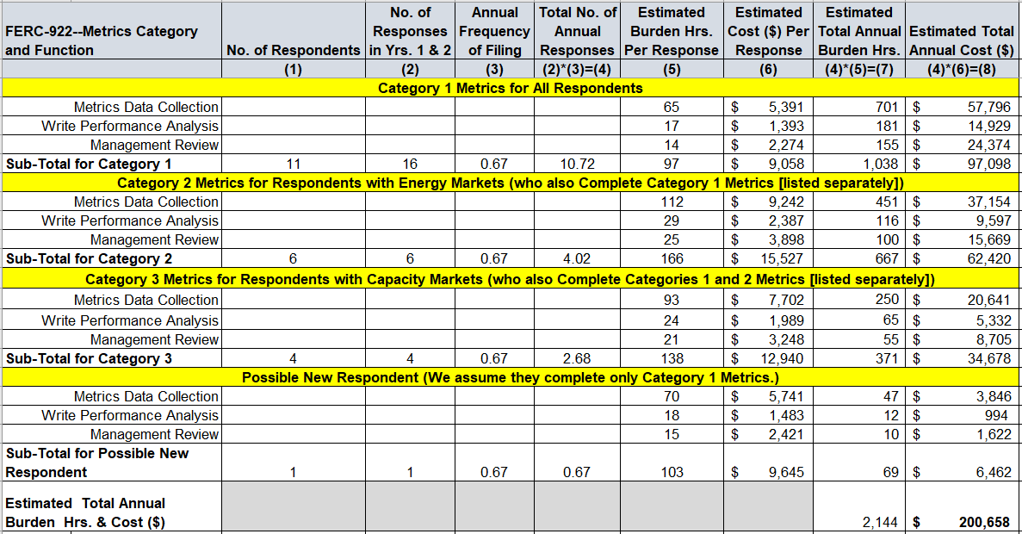

Kimberly D. Bose,
Secretary.

