Attachment B
Invitation Letter and Response Form

United States Department of the Interior

U. S. GEOLOGICAL SURVEY

New England Water Science Center—NH/VT

331 Commerce Way, Suite 2

Pembroke, New Hampshire 03275

United States Department of Health and Human Services
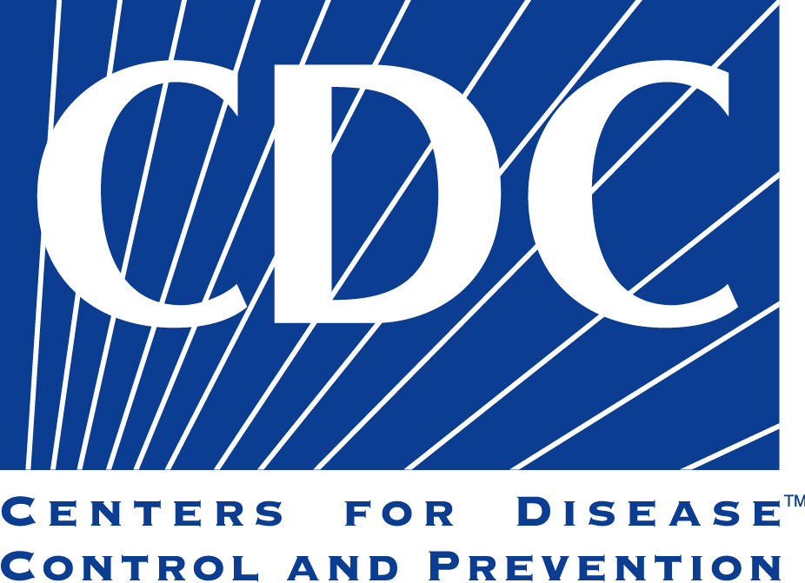
Centers for Disease Control and Prevention
National Center for Environmental Health
4770 Buford Highway
Chamblee, GA 30341

XX, 2019

Dear Property Owner:
The Centers for Disease Control and Prevention (CDC) and the U.S. Geological Survey (USGS) are working with the <state, department> to better understand exposure to naturally-occurring arsenic and uranium from private well water.
Your area has been identified by the <State department> as having limited information about naturally-occurring arsenic and/or uranium concentrations in well water. We would like to test for arsenic and uranium in the water from private wells in your area. Your participation in this investigation will greatly increase our understanding of where arsenic and uranium are in the ground water that supplies private wells. We are asking for your permission to collect and analyze a water sample from your private well and/or tap, a urine specimen from one adult in the household, and to answer survey questions.
The data we collect will be summarized in a scientific report that will not include owner names or identifying information. You will receive the results of the analysis at no cost to you.
The USGS's Water Resources Mission Area conducts scientific studies related to ground water and surface waters in the nation. We do not make or enforce laws; instead, our job is to provide unbiased and accurate scientific information to the people who make decisions about water resources.
Please look over these materials and consider being in this investigation. We need people who are over 18 years old, live in a household with a private well, know whether their drinking water is treated, use the water for drinking and cooking, will allow us to collect water samples, and are willing provide a urine specimen to be in our investigation. If you decide you would like to participate in the investigation, please fill out the attached response form and mail it to us in the enclosed postage-paid envelope. We would appreciate a response from you within 10 days of receiving this letter. Once the response form is returned, we will call you to answer any questions you may have and potentially arrange an appointment to collect the sample(s).
Please be assured that CDC will take all necessary steps to protect members of your community from COVID-19. The study will be conducted following all state, local, and CDC guidelines in place at the time the study is conducted. CDC team members will be monitored twice daily for fever and any COVID-19-related symptoms. Although we don’t anticipate face-to-face contact with study participants, if this does occur (e.g., when a study team member picks up water samples and urine specimens), study team members will wear surgical masks and gloves to ensure the protection of participants. Again, although we do not anticipate face-to-face contact with study team members, if that occurs, participants will be asked to always wear a face covering or mask. If you do not have a mask, one will be provided to you before you enter the facility. If you are unable to wear a mask for medical reasons, please let us know.

Please feel free to contact CDC (contact info); USGS (contact info); or <State contact at phone number or state contact e-mail>.

Sincerely,

<USGS contact name>

COMMON QUESTIONS

• Why was my well chosen?

Your well is one of 100 private wells randomly selected in this geographic area.

• What will this cost me?

Nothing. In fact, you will receive important information about the levels of arsenic and uranium in your well water. Arsenic and uranium tests typically cost about $200.00. It may take up to 12 months for you to receive your results. For more information on arsenic and uranium in drinking water contact:
<USGS, phone number>
<website link>

• Where will we collect the well water sample?

The sample will be collected by trained personnel at a spigot near the pressure tank. The focus of this study is to assess the sources of drinking water in the state and therefore samples must be taken as close to the well as possible, and before treatment. If it is not feasible to access your pressure tank, an untreated sample can be collected from an outside spigot. At the time of water sample collection, USGS personnel will also collect a series of physical measurements such as pH and temperature.

• Where will we collect the tap water sample?

If we collect a tap water sample, it will be collected by trained personnel from your kitchen tap.

• How will the information be used?

These data may be summarized in a scientific report, by geographic area, population density and other factors. No precise information pertaining to the well location or owner will be published. We will not share any of your personally identifiable information (e.g., name, address), even if requested to do that through a Freedom of Information Act (FOIA) request. Your information is protected under the FOIA exemption 6 (Information that, if disclosed, would invade another individual’s personal privacy). USGS will make the information about your well water analysis at the town level available on their website, but the location of your well will be masked so that your well cannot be located.
Upon completion of the analysis, you will receive a copy of the results from the water sample.

RESPONSE FORM: Declaration of Interest to Participate in USGS-CDC Collaborative Study
Form Approved
OMB No. 0920-1173
Exp. Date 03/31/2020

STUDY PARTICIPATION INFORMATION:
________________________________________________________________________ Name (Please Print)
________________________________________________________________________
Street Address
______________________________________________________________________________ Mailing Address, if different
______________________________________________________________________________
City, State, Zip Code
_____________________ __________________________ __________________
Telephone number (Day) Telephone number (evening) Email

Are you interested in participating in this study? YES _____ NO _____

May we contact you at the daytime telephone number? YES _____ NO _____Please complete this form and return it to us in the postage-paid, pre-addressed envelope. Thank you!
CDC estimates the average public reporting burden for this collection of information as 5 minutes per response, including the time for reviewing instructions, searching existing data/information sources, gathering and maintaining the data/information needed, and completing and reviewing the collection of information. An agency may not conduct or sponsor, and a person is not required to respond to a collection of information unless it displays a currently valid OMB control number. Send comments regarding this burden estimate or any other aspect of this collection of information, including suggestions for reducing this burden to CDC/ATSDR Information Collection Review Office, 1600 Clifton Road NE, MS D-74, Atlanta, Georgia 30333; ATTN: PRA (0920-1173).

Page 1 of 1

