Attachment F
Urine Collection Directions and Water Collection Log

Urine Specimen Collection Directions

Important:
- Do not eat seafood during the 3 days prior to collecting your urine specimen.
- The urine specimen must be collected first thing in the morning on Day 4 (right after you wake up).
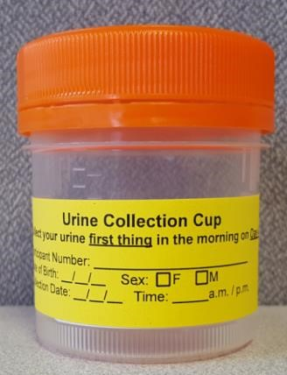

Urine Collection Directions
- Prepare to collect the specimen first thing in morning on Day 4 (right after you wake up).
- Confirm your information is on the sterile cup.
- Write the date and time of collection on the label next to your information.
- Using the sterile cup, fill halfway with urine (to the 50mL line).
- Secure lid. Wash hands with soap and water.
- Place urine specimen in the provided specimen bag (clear bag with “Urine Collection Cup” orange and black labeling).
- Place urine specimen in the refrigerator.
- Investigation staff will pick up the urine specimen during your appointment.

But wait! I have questions!
Please contact <CDC contact> with questions.

TAP WATER SAMPLE COLLECTION DIRECTIONS

Collect a sample from the kitchen faucet:

Use the sample collection kit sent to you by the study team.

Allow the cold water to run for 5 minutes to clear the pipes. Reduce flow to a gentle stream.

Please record the DATE and TIME the sample you collect the sample. Label the bottle with the date and time BEFORE you fill the bottle with water from your tap.
Date: _______________ Time: _______________

Fill sample bottle with well water to the just below the neck of the bottle. Make sure that cap is securely tightened.

Someone from the study team will make an appointment with you to pick up the following:
- The tap water sample you collect
- Your urine specimen
- Your signed consent form
- Your completed 3-day food diary

But wait! I have questions!
Please contact <CDC contact> with questions.

Form Approved
OMB No. 0920-1173
Exp. Date 03/31/2020
proved
OMB No. 0920-1173
Exp. Date 03/31/2020
Urine Specimen Collection Log

Date:_____________________________ Time:_________________AM / PM
Collector:_________________________
Study ID Number___________________

|__| Urine specimen collected

Description:_______________________________________________________________________________________________________________________________________________________________________________________________________________________________________________

___________________________________________________________________________________

Water Sample Collection Log

Date:_____________________________ Time:_____________________ AM / PM
Collector:_________________________
Study ID Number__________________

|__| Tap Water collected

Description:_______________________________________________________________________________________________________________________________________________________________________________________________________________________________________________

|__| Well Water collected

Description:_______________________________________________________________________________________________________________________________________________________________________________________________________________________________________________
CDC estimates the average public reporting burden for this collection of information as 20 minutes per response, including the time for reviewing instructions, searching existing data/information sources, gathering and maintaining the data/information needed, and completing and reviewing the collection of information. An agency may not conduct or sponsor, and a person is not required to respond to a collection of information unless it displays a currently valid OMB control number. Send comments regarding this burden estimate or any other aspect of this collection of information, including suggestions for reducing this burden to CDC/ATSDR Information Collection Review Office, 1600 Clifton Road NE, MS D-74, Atlanta, Georgia 30333; ATTN: PRA (0920-1173).

