Form Approved
OMB No. 0920-New
Expiration Date: XX/XX/XXXX

Web-based Approaches to reach black or African American and Hispanic/Latino MSM for HIV Testing and Prevention Services

Attachment 3d
Initial HIV Test Result Survey

Public reporting burden of this collection of information is estimated to average 5 minutes per response, including the time for reviewing instructions, searching existing data sources, gathering and maintaining the data needed, and completing and reviewing the collection of information. An agency may not conduct or sponsor, and a person is not required to respond to a collection of information unless it displays a currently valid OMB control number. Send comments regarding this burden estimate or any other aspect of this collection of information, including suggestions for reducing this burden to CDC/ATSDR Reports Clearance Officer; 1600 Clifton Road NE, MS D-74, Atlanta, Georgia 30333; Attn: OMB-PRA (0920-New)

HIV Test Result Reporting Survey

This survey is only for study participants who have used the rapid HIV home test (OraQuick or INSTI) that was sent from the Know@Home study to test themselves. If you gave a test kit to someone else, there is a separate survey for them to fill out.

Thank you for participating in our study! This survey includes personal questions about your OraQuick or INSTI HIV home test results. Questions marked with a red asterisk (*) are required questions that you must answer to move forward. You may choose to not answer any questions that make you feel uncomfortable.

If you have any questions, problems with using the tests, or if you test positive, you can call this toll-free study support number 24 hours a day, 7 days a week: 1-800-628-9240.
Some of the questions we will ask are a little personal and may make you feel uncomfortable. You have the option to refuse to answer any question you do not want to answer, and your participation is completely voluntary. All data you give us will be stored on a HIPAA-compliant server and will only be used for the purposes of this research study.

Paragraph Logic: If first time filling out survey:
If you complete this survey within 4 weeks of your first test delivery, report your test result, and upload a picture of your used test paddle or device, you can receive $10 through an option of your choice, such as a gift card.

Paragraph Logic: If not the first time filling out survey:
This survey will ask questions about the most recent study HIV self-tests that you have completed. If you have already reported some of the test results on a previous survey, please answer questions only relating to tests you have not already reported.

If you did not test yourself with the test from the Know@Home study, stop here and exit.

If you used the test kit on yourself, and are you ready to take the survey and upload a photo, click "Next" to continue on to the survey.
Otherwise, come back to this link when you are ready!

- Are you a participant in the Know@Home Study?*

- No
- Yes
[HOMETEST_PARTIC]
Source: Created

[ACTION: If HOMETEST_PARTIC == 0, then redirect to guest test results survey]

HIV Testing

- Did receiving these HIV test kits affect how soon you got tested for HIV?

- I tested sooner than I would have otherwise
- I tested at about the same time that I would have otherwise
- I do not know

[SOONERHOMETEST]

Source: AMIS Test Kit Upload 2017 (edited)

- After you downloaded the app and completed the survey, how long did it take you to receive the HIV test kits? __________ days

[RECEIVETIME]

Source: Created

This survey will ask questions about the most recent study HIV self-tests that you have completed. If you have already reported some of the test results on a previous survey, please answer questions only relating to tests you have not already reported.

- Of the study tests you used, how many of them were:

OraQuick (oral swab): __________ tests [OQ]
INSTI Self-Test (Fingerstick): __________ tests [INSTI]

Source: Created

[Validation: Sum(OQ, INSTI) cannot be greater than number of mailed tests
If not, then display “The total number of self tests cannot be more than the number of study HIV self-tests you used. Please carefully re-enter your response.”, and loop back to enter the number.]

Section Logic: Repeat OraQuick or INSTI sections based on the reported values in OQ and INSTI

OraQuick
We now will ask you some questions about the OraQuick (oral swab) tests that you reported that you completed as part of this study. If you completed more than one OraQuick test, you will be asked about each test.

Section Logic: If OQ > 1, iterate with [FIRST/SECOND] preceding.

- We need you to verify your test kit box number. Your box number is a total of 7 numbers and/or letters that can be found on the sticker on the top or side of your box. A sample picture is below. What is your box number? Box Number: .
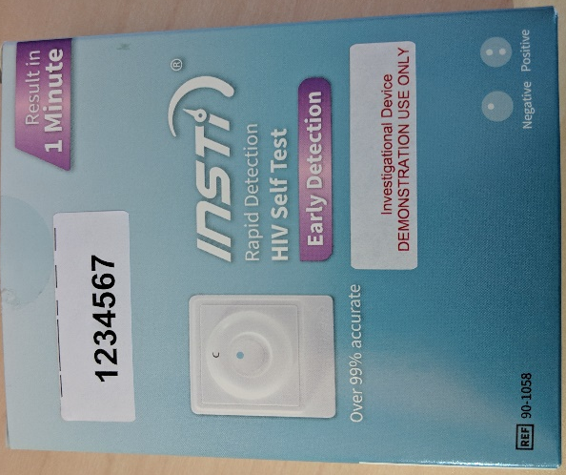
(Soft-require)
[OQ_BOXNUM]
Source: Created

- Please re-enter your box number: Box Number: .

(Soft-require)
[OQ_BOXNUM_CONFIRM]
Source: Created

- When did you test yourself for HIV using this [FIRST/SECOND] study test?

Month: [OQ_MO_FU]
Year: [OQ_YR_FU]

Source: eSTAMP (edited)

- How much time did it take you to conduct the [FIRST/SECOND] OraQuick self-test? __________ minutes

[OQ_CONDUCTTIME]
Source: Created

Logic: If OQ > 0
- What was the result from the [FIRST/SECOND] OraQuick home HIV test that you used as part of this study?
- Positive / HIV Reactive
- Negative / HIV Non-Reactive
- Test is not working (results do not look like example or there are no lines on the device

[OQ_RESULT]
Source: eSTAMP (edited)

Logic: If OQ > 0
- Please select the image that most looks like your [FIRST/SECOND] test device:
(1)
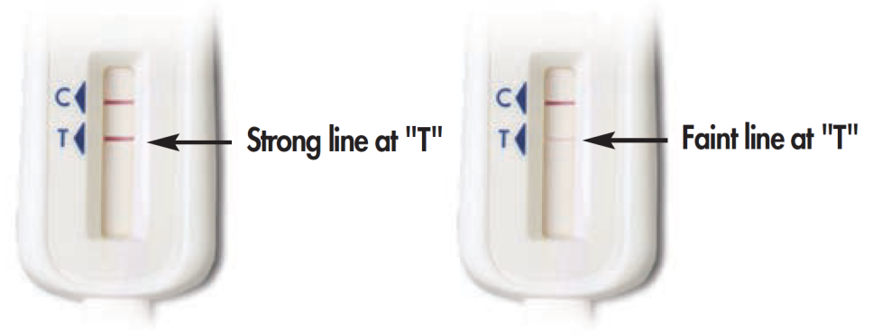
(2)
(3)
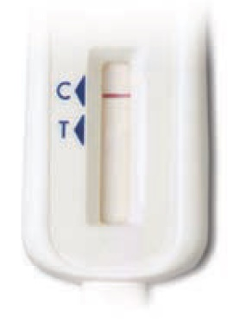

(4) No lines on the test device
(5) Some lines but my results do not look like the above examples
[OQ_PICTURE]
Source: eSTAMP (edited)

Logic: If (OQ_RESULT = 1 and OQ_PICTURE = 2 or 3) OR
(OQ_RESULT = 2 and OQ_PICTURE = 1 or 3) OR
(OQ_RESULT = 3 and OQ_PICTURE = 1 or 2)
- When you reported a test result, it was different than the image of the test device that you selected. What is your current HIV status?
- Positive / HIV Reactive
- Negative / HIV Non-reactive
- I do not know

[OQ_RECONCILIATION]
Source: Created (edited)

Logic: If (OQ_RESULT = 3 and OQ_PICTURE = 3, 4, 5, or missing) OR
(OQ_RESULT = missing and OQ_PICTURE = 3) OR
(OQ_RECONCILIATION = 3)
- You mentioned that your [FIRST/SECOND] test result was invalid or not working. What happened when you tried to run the test? Check all that apply. *

- I did not understand the instructions [OQ_INVALID_UNDERSTAND]
- I could not see the lines on the test stick clearly OQ_INVALID_NOCONTROL]
- I did not understand what the lines on the test stick meant [OQ_INVALID_LINESISSUE]
- I spilled the liquid from the test tube [OQ_INVALID_SPILL]
- The test stick fell down and got dirty before I was able to swipe my gums [OQ_INVALID_DIRTY]
- There were no lines on the test stick [OQ_INVALID_NOLINES]
- I did not follow steps in the order described in the instructions [OQ_INVALID_STEPS]
- I did not time the test correctly [OQ_INVALID_TIME]
- I did not put the test stick into the test tube [OQ_INVALID_STICK]
- I could not swipe the test stick on my gums properly [OQ_INVALID_SAMPLE]
- I think a piece of the test kit was missing [OQ_INVALID_MISSING]
- Other, please specify______ [OQ_INVALID_OTHER]
(99) I don’t know [OQ_INVALID_DK]
Source: eSTAMP (edited)

Test Kit Photo

Please upload a picture of your [FIRST/SECOND] used home test kit using the "Browse" button below. If you are using a smartphone, you have the option of taking a picture now or uploading a photo already on your phone. When you have chosen your photo, click "Upload."
An example of a successful picture is shown below. Please make sure that the results window is clearly visible.

Note: To receive your token of appreciation, you must take the test, complete the survey within 4 weeks of receiving the test, report the test results, and upload a picture of your test paddle after the test was completed.

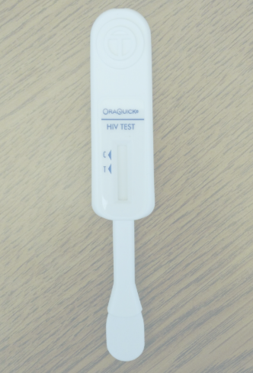

Make sure your photo has finished uploading before clicking "Next" or you will not get your Amazon gift card!
When your photo has finished uploading, it will look like this:

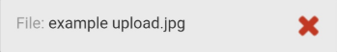

- Please upload a picture of your used home test kit here:________
* Soft-required

[OQ_PHOTO_SUBMIT]

Source: AMIS Test Kit Upload 2017
Remember... don't click "Next" until you see the grey box with your file name and a red X!

INSTI
We now will ask you some questions about the INSTI (Fingerstick) tests that you reported that you completed as part of this study. If you completed more than one INSTI test, you will be asked about each test.

Section Logic: If INSTI > 1, iterate with [FIRST/SECOND] preceding.
- We need you to verify your test kit box number. Your box number is a total of 7 numbers and/or letters that can be found on the sticker on the top or side of your box. A sample picture is below. What is your box number? Box Number: .
(Soft-require)
[INSTI_BOXNUM]
Source: Created

- Please re-enter your box number: Box Number: .

(Soft-require)
[INSTI_BOXNUM_CONFIRM]
Source: Created

- When did you test yourself for HIV using this [FIRST/SECOND] study test?

Month: INSTI_MO_FU]
Year: [INSTI_YR_FU]

Source: eSTAMP (edited)

- How much time did it take you to conduct the [FIRST/SECOND] INSTI home HIV test? __________ minutes

[INSTI_CONDUCTTIME]

Source: Created

Logic: If INSTI > 0
- What was the result from the [FIRST/SECOND] INSTI home HIV test that you used as part of this study?
- Positive / HIV Reactive
- Negative / HIV Non-Reactive
- Invalid/Test is not working (results do not look like example or there are no lines on the device

[INSTI_RESULT]
Source: eSTAMP (edited)

Logic: If INSTI > 0
- Please select the image that most looks like your [FIRST/SECOND] test device:
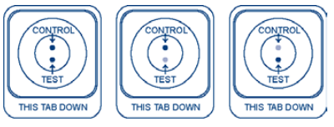
(1)

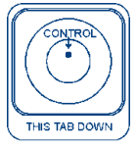
(2)

(3)
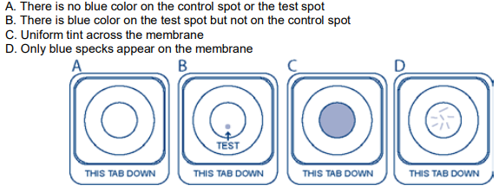
(4) Some dots but my results do not look like the above examples
[INSTI_PICTURE]
Source: eSTAMP (edited)

Logic: If (INSTI_RESULT = 1 and INSTI_PICTURE = 2 or 3) OR
(INSTI_RESULT = 2 and INSTI_PICTURE = 1 or 3) OR
(INSTI_RESULT = 3 and INSTI_PICTURE = 1 or 2)
- When you reported a test result, it was different than the image of the test device that you selected. What is your current HIV status?
- Positive / HIV Reactive
- Negative / HIV Non-reactive
- I do not know

[INSTI_ RECONCILIATION]
Source: Created (edited)

Logic: If (INSTI_RESULT = 3 and INSTI_PICTURE = 3 or 4 or missing) OR (INSTI_RESULT = missing and INSTI_PICTURE = 3) OR
(INSTI_RECONCILIATION = 3)

- You mentioned that your [FIRST/SECOND] test result was invalid or not working. What happened when you tried to run the test? Check all that apply. *

- I did not understand the instructions [INSTI_INVALID_UNDERSTAND]
- I could not see the control dots in the results window clearly INSTI_INVALID_NOCONTROL]
- I did not understand what the dots in the results window meant [INSTI_INVALID_DOTSISSUE]
- I spilled the contents of the bottles [INSTI_INVALID_SPILL]
- The bottles fell down and got dirty before I was able to collect the sample [INSTI_INVALID_DIRTY]
- There were no lines on the test stick [INSTI_INVALID_NOLINES]
- I did not follow steps in the order described in the instructions [INSTI_INVALID_STEPS]
- I did not time the test correctly [INSTI_INVALID_TIME]
- I did pour the bottles into the test device [INSTI_INVALID_POUR]
- I could not collect the blood sample properly [INSTI_INVALID_SAMPLE]
- I think a piece of the test kit was missing [INSTI_INVALID_MISSING]
- Other, please specify______ [INSTI_INVALID_OTHER]
(99) I don’t know [INSTI_INVALID_DK]

Test Kit Photo

Please upload a picture of your used [FIRST/SECOND] home test kit using the "Browse" button below. If you are using a smartphone, you have the option of taking a picture now or uploading a photo already on your phone. When you have chosen your photo, click "Upload."
An example of a successful picture is shown below. Please make sure that the results window is clearly visible.

Note: To receive your token of appreciation, you must take the test, complete the survey within 4 weeks of receiving the test, report the test results, and upload a picture of your test paddle after the test was completed.

Make sure your photo has finished uploading before clicking "Next" or you will not get your Amazon gift card!
When your photo has finished uploading, it will look like this:

- Please upload a picture of your used home test kit here:________
* Soft-required

[INSTI_PHOTO_SUBMIT]

Source: AMIS Test Kit Upload 2017
Remember... don't click "Next" until you see the grey box with your file name and a red X!

Test Result

Logic: If (OQ_RESULT = 1 and OQ_PICTURE = 1 or missing) OR
(OQ_RESULT = missing and OQ_PICTURE = 1) OR
(OQ_RECONCILIATION = 1) OR
(INSTI_RESULT = 1 and INSTI_PICTURE = 1 or missing) OR
(INSTI_RESULT = missing and INSTI_PICTURE = 1) OR
(INSTI_RECONCILIATION = 1)

- Was this the first time that you tested positive for HIV?

- No
- Yes

[FIRSTPOS]
Source: AMIS Test Kit Upload 2017 (edited)

[ACTION: Email study staff if following logic is met;
If (OQ_RESULT = 1 and OQ_PICTURE = 1 or missing) OR
(OQ_RESULT= missing and OQ_PICTURE = 1) OR
(OQ_RECONCILIATION = 1)] OR
(INSTI_RESULT = 1 and INSTI_PICTURE = 1 or missing) OR
(INSTI_RESULT= missing and INSTI_PICTURE = 1) OR
(INSTI_RECONCILIATION = 1)]

[ACTION: Email study staff if following logic is met;
If (OQ_RESULT = 1 and OQ_PICTURE = 2 or 3) OR
(OQ_RESULT = 2 and OQ_PICTURE = 1 or 3) OR
(OQ_RESULT = 3 and OQ_PICTURE = 1 or 2) OR
(INSTI_RESULT = 1 and INSTI_PICTURE = 2 or 3) OR
(INSTI_RESULT = 2 and INSTI_PICTURE = 1 or 3) OR
(INSTI_RESULT = 3 and INSTI_PICTURE = 1 or 2)]

Test Kit Photo

Please upload a picture of your used home test kit using the "Browse" button below. If you are using a smartphone, you have the option of taking a picture now or uploading a photo already on your phone. When you have chosen your photo, click "Upload."
An example of a successful picture is shown below. Please make sure that the results window is clearly visible.

Note: To receive your token of appreciation, you must take the test, complete the survey within 4 weeks of receiving the test, report the test results, and upload a picture of your test paddle after the test was completed.

Make sure your photo has finished uploading before clicking "Next" or you will not get your Amazon gift card!
When your photo has finished uploading, it will look like this:

- Please upload a picture of your used home test kit here:________
* Soft-required

[PHOTO_SUBMIT]

Source: AMIS Test Kit Upload 2017
Remember... don't click "Next" until you see the grey box with your file name and a red X!

INSTI Self-Test Usability
Section Logic: If INSTI > 0 (Do not repeat if greater than 1)
- Did you use the instructions sheet?

- No
- Yes

[INSTRUCTION_TEST]
Source: INSTI HSTAR Study 2018
Logic: If INSTRUCTION_TEST = 1
- Were the instructions easy to follow?

- No
- Yes

[INSTRUCTION_EASY_TEST]
Source: INSTI HSTAR Study 2018

- Were the pictures helpful?

- No
- Yes

[INSTRUCTION_PICTURES_HELPFUL]
Source: INSTI HSTAR Study 2018

- Which of the pictures worked well or were not good?
_______________________________
(Qualitative open entry text response)
[PICTURES_TEST]
Source: INSTI HSTAR Study 2018

- Was the device easy to use?

- No
- Yes

[DEVICE_EASY_TEST]
Source: INSTI HSTAR Study 2018

- Were you confident with performing this test on your own?

- No
- Yes
[CONFIDENT_TEST]
Source: INSTI HSTAR Study 2018

- What should you do if you have a negative test result? Check all that apply?

- Wear condoms
- Re-test
- Seek care with a doctor
- Other: ___________ [ACTION_NEGATIVE_TEST_OTHER]
[ACTION_NEGATIVE_TEST]
Source: INSTI HSTAR Study 2018

- What should you do if you have a positive test result? Check all that apply?

- Wear condoms
- Re-test
- Seek care with a doctor
- Other: ___________ [ACTION_POSITIVE_TEST_OTHER]
[ACTION_POSITIVE_TEST]
Source: INSTI HSTAR Study 2018

- What should you do if you have an invalid test result? Check all that apply?

- Re-test
- Seek care with a doctor
- Other: ____________[ACTION_INVALID_TEST_OTHER]
[ACTION_INVALID_TEST]
Source: INSTI HSTAR Study 2018

- What should you do if you are not sure of your result?
- Re-test
- Seek care with a doctor
- Other: ____________[ACTION_UNSURE_TEST_OTHER]
[ACTION_UNSURE_TEST]
Source: INSTI HSTAR Study 2018

- Would you use this test again?

- No
- Yes

[REPEAT_USE_TEST]
Source: INSTI HSTAR Study 2018

- Would you prefer to use this test at home or get tested at a clinic?

- Prefer to use at home
- Prefer to get tested at a clinic
- Both
[SETTING_TEST]
Source: INSTI HSTAR Study 2018

- Would you recommend this test to a sexual partner/friend?

- No
- Yes
[RECOMMEND_TEST]
Source: INSTI HSTAR Study 2018

- Do you have suggestions on how to make this product easier to use?
___________________________________

[SUGGESTIONS_TEST]
Source: INSTI HSTAR Study 2018

Token of Appreciation
- How would you like to receive your token of appreciation?
(1) PayPal
(2) Target Gift Card
(3) Walmart Gift Card
(4) CVS Gift Card
(5) ClinCard (prepaid debit card)
(6) Starbucks
(7) Regal Entertainment Group
(8) Amazon

[TOKEN_TEST]
Source: Created

Logic: If TOKEN_TEST equal to 1
- Please provide the email you have linked with your PayPal account: ________________
[PAYPALEMAIL_TEST]
Source: Created

Logic: If TOKEN_TEST equal to 2, 3, 4, 6, 7, or 8
- Please provide the email you would like your gift card code sent to: _________________
[GIFTCARDEMAIL_TEST]
Source: Created

Logic: If TOKEN_TEST equal to 5
- Please enter the address you would like your ClinCard mailed to:
Contact Name: _________________ [CLIN_NAME_TEST]
Address 1: ____________________ [CLIN_ADDRESS1_TEST]
Address 2: ____________________ [CLIN_ADDRESS2_TEST]
City: ____________________ [CLIN_CITY_TEST]
State: ____________________ [CLIN_STATE_TEST]
ZIP Code: ____________________ [CLIN_ZIP_TEST]

- What type of address is this?

(1) My home or residential address (house, apartment, condo)
(2) Someone else’s home or residential address (house, apartment, condo)
(3) My office or work location
(4) Someone else’s office or work location
(5) Post office or other shared mailbox (PO Box)
(6) Community based organization or health center
(7) Other, please specify______ [DBS_FU_ADDRESS_TYPE_OTHER]

[CLIN_ADDRESS_TYPE]
Source: Created

End
ACTION: Webhook pushes survey completion/results to SMART

Thank you for reporting your rapid HIV home test results! A staff member may be in contact with you soon regarding the results that you reported.

If you have any questions, problems with using the tests, or if you test positive, you can call this toll-free support number 24 hours a day, 7 days a week: 1-800-628-9240.

Study staff may be in contact with you soon regarding the results that you reported. If you think you are at risk or that you may have been exposed to HIV, it will be important for you to test again in three months. If you want to learn more about HIV, where to get more information, or where to get tested or receive care in your area, please click on the following links.

If you are currently HIV-negative, pre-exposure prophylaxis (PrEP) may be a potential option for you. PrEP is a way for people who do not have HIV to lower their risk of getting HIV by taking a pill every day. To learn more, please visit some of the links below.

If you want to learn more about HIV, where to get more information, or where to get tested in your area, please click on the following links:
  - Information about HIV
    - www.cdc.gov/hiv
  - HIV Testing Resources
    - CDC HIV Testing Locator (https://gettested.cdc.gov/)
    - CDC HIV Testing Information Page (https://www.cdc.gov/hiv/testing/)
    - HIV.gov HIV Testing Locator (https://www.hiv.gov/locator)
    - AIDSvu HIV Testing Locator (https://aidsvu.org/services)
  - PrEP Resources
    - Centers for Disease Control PrEP Resources (https://www.cdc.gov/actagainstaids/campaigns/starttalking/materials/prepresources.html)
    - Centers for Disease Control PrEP Information (https://www.cdc.gov/hiv/risk/prep/index.html)
    - The Fenway Institute: What is PrEP? (http://thefenwayinstitute.org/prepinfo/)
    - PrEP Locator (https://preplocator.org/)
    - HIV.gov PrEP Information Page (https://www.hiv.gov/hiv-basics/hiv-prevention/using-hiv-medication-to-reduce-risk/pre-exposure-prophylaxis)

If you have any questions or comments, you may contact study staff at iSTAMP@emory.edu or (404) 727-4340, or the Principal Investigator, Dr. Patrick Sullivan of Emory University, at (404) 727-2038 or pssulli@emory.edu. To get more information about HIV, please visit: www.cdc.gov/hiv.

You can use your study mobile app to set up an appointment to talk to an experienced HIV counselor. If you wish to do that, please go back to the study app now. Study staff will also be in contact with you in 3-5 business days regarding your token of appreciation.
You may now safely close your browser tab or window.

