Form Approved
OMB No. 0920-New
Expiration Date: XX/XX/XXXX

Web-based Approaches to reach black or African American and Hispanic/Latino MSM for HIV Testing and Prevention Services
Attachment 3h
Guest HIV Test Result Survey

Public reporting burden of this collection of information is estimated to average 5 minutes per response, including the time for reviewing instructions, searching existing data sources, gathering and maintaining the data needed, and completing and reviewing the collection of information. An agency may not conduct or sponsor, and a person is not required to respond to a collection of information unless it displays a currently valid OMB control number. Send comments regarding this burden estimate or any other aspect of this collection of information, including suggestions for reducing this burden to CDC/ATSDR Reports Clearance Officer; 1600 Clifton Road NE, MS D-74, Atlanta, Georgia 30333; Attn: OMB-PRA (0920-New)

Guest HIV Test Result Reporting Survey

This home HIV test kit has been distributed as part of a research study funded by the Centers for Disease Control and Prevention (CDC). On the following web pages, we will provide you with some help on how to use the HIV test kit, and ask you to provide some anonymous information as part of the study.
If participant clicks for more information, display:
The Emory University Rollins School of Public Health is doing a research study of home HIV testing. This study is to find out if men who were recruited from the Internet will test for HIV at home and if they will give test kits to people they know. What we learn will help create better HIV prevention programs for our community.
Thank you for taking the time to complete this survey! By continuing and using this website to answer questions about yourself and your previous testing experience, you are agreeing to be part of a research study.
If you have any questions, problems with using the tests, or if you test positive, you can call this toll-free study support number 24 hours a day, 7 days a week: 1-800-628-9240. If you have any questions or comments, you may contact study staff at knowathome@emory.edu or (404) 727-4340, or the Principal Investigator, Dr. Patrick Sullivan of Emory University, at (404) 727-2038 or pssulli@emory.edu.
You may choose to not answer any questions that make you feel uncomfortable. Your answers are private: the information you provide us will be kept secure and known only to study staff. This information will not be shared or used for any other research purposes.
This survey will ask questions about the recent study HIV self-tests that you have completed. Each test needs to be reported separately. If you completed more than one test, you will be asked questions about each of these tests. If you have already reported some of the test results on a previous survey, please answer questions only relating to tests you have not already reported.
If you have any questions or feel you have been harmed in this study please contact a member of the research team:
Patrick Sullivan, DVM PhD
Emory University
Rollins School of Public Health
1518 Clifton Road NE
Atlanta, GA 30322
(404) 727-2038

If you have any questions about your rights as someone receiving a study home HIV test kit from a study participant or feel you have been harmed, you can contact the institutional review board at Emory University.
For Emory University contact:
Emory IRB
1599 Clifton Road
5th Floor East
Atlanta, GA 30322 USA
Tel: 404 712 0720
Toll free: 877 503 9797
Email:irb@emory.edu

- Are you a participant in the Know@Home Study? If you have received this kit from someone else, you would not be considered a participant.

- No
- Yes
[GUEST_PARTIC]
Source: Created
[ACTION: Disqualify if GUEST_PARTIC = 1]
[Message: If you are a participant in the Know@Home Study please click the link below to do your test result reporting! Please check your email for the link to report your test results.]

Demographics
We would like to ask you a few questions to help you best use the kit. Your answers are private and anonymous.
- How old are you? _____ years old
[GUEST_AGE]
Source: eSTAMP
[ACTION: If GUEST_AGE <18, then display:
“The home test kits provided by this study are for persons aged 18 and older. To get information on where to get HIV testing at a place near you, click on this link:
www.knowathome.org

- Do you consider yourself Hispanic or Latino?

- No
- Yes
[GUEST_HISP]
Source: eSTAMP

- Which racial group or groups do you consider yourself to be in? Check all that apply.
- American Indian or Alaska Native
- Asian
- Black or African-American
- Native Hawaiian or Other Pacific Islander
- White
[GUEST_RACE]
Source: eSTAMP

- How do you describe your gender identity?
- Male
- Female
- Male-to-female transgender (MTF)
- Female-to-male transgender (FTM)
- Other gender identity (specify)_______

[GUEST_GENDER]

HIV Testing
- Where did you get the rapid HIV home test kit(s)?
- Friend
- Sex partner
- Family member/relative
- Other, please specify [GUEST_RELTYPE_OTHER]

[GUEST_RELTYPE]
Source: eSTAMP (edited)

- Before using the study home HIV test kit(s), when was your last HIV test?
____/_______ (MM/YYYY)
- I have never been tested for HIV

[GUEST_LASTTEST]
Source: eSTAMP (edited)

This survey will ask questions about the most recent study HIV self-tests that you have completed. If you have already reported some of the test results on a previous survey, please answer questions only relating to tests you have not already reported.
- How many study HIV self tests did you use?

OraQuick (oral swab): __________ tests [GUEST_OQ]
Source: Created

[Validation: Number of tests (GUEST_OQ) cannot be greater than number of mailed tests (=2)
If not, then display “The total number of self tests cannot be more than the number of study HIV self-tests you used. Please carefully re-enter your response.”, and loop back to enter the number.]

Section Logic: Repeat OraQuick sections based on the reported values in GUEST_OQ

OraQuick
We now will ask you some questions about the OraQuick (oral swab) tests that you reported that you completed as part of this study. If you completed more than one OraQuick test, you will be asked about each test.
Section Logic: If GUEST_OQ > 1, iterate with [FIRST/SECOND] preceding.
Paragraph Logic: If second time through this section:
We now will ask you questions about the second test.
Logic: If GUEST_OQ > 0
- What was the result from the [FIRST/SECOND] OraQuick home HIV test that you used as part of this study?
- Positive / HIV Reactive
- Negative / HIV Non-Reactive
- Test is not working (results do not look like example or there are no lines on the device

[GUEST_OQ_RESULT]
Source: eSTAMP (edited)

Logic: If GUEST_OQ > 0
- Please select the image that most looks like your [FIRST/SECOND] test device:
(1)
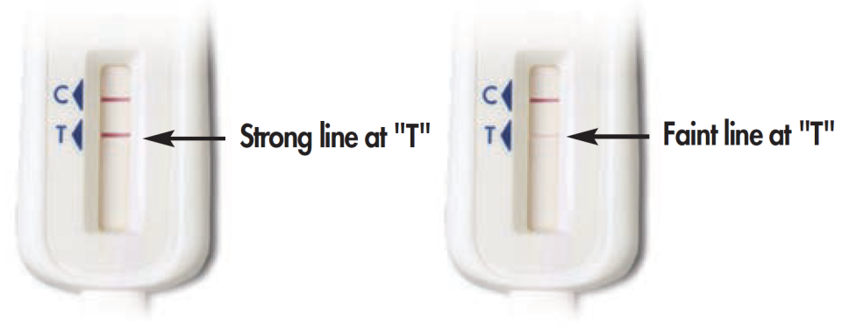
(2)
(3)
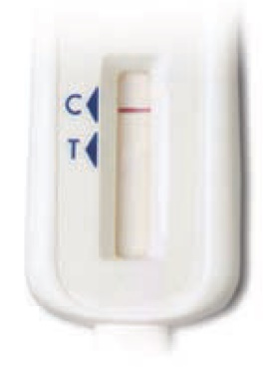

(4) No lines on the test device
(5) Some lines but my results do not look like the above examples
[GUEST_OQ_PICTURE]
Source: eSTAMP (edited)

- Logic: If (GUEST_OQ_RESULT = 1 and GUEST_OQ_PICTURE = 3 or 4 or 5) OR
- (GUEST_OQ_RESULT = 2 and GUEST_OQ_PICTURE = 1 or 2 or 4 or 5) OR
- (GUEST_OQ_RESULT = 3 and GUEST_OQ_PICTURE = 1 or 2 or 3)
- When you reported a test result, it was different than the image of the test device that you selected. What is your current HIV status?
- Positive / HIV Reactive
- Negative / HIV Non-reactive
- I do not know

[GUEST_OQ_RECONCILIATION]
Source: Created (edited)
Logic: If (GUEST_OQ_RESULT = 3 and GUEST_OQ_PICTURE = 4, 5, or missing) OR
(GUEST_OQ_RESULT = missing and GUEST_OQ_PICTURE = 4 or 5) OR
(GUEST_OQ_RECONCILIATION = 3)
- You mentioned that your [FIRST/SECOND] test result was invalid or not working. What happened when you tried to run the test? Check all that apply.

- I did not understand the instructions [GUEST_OQ_INVALID_UNDERSTAND]
- I could not see the lines on the test stick clearly GUEST_OQ_INVALID_NOCONTROL]
- I did not understand what the lines on the test stick meant [GUEST_OQ_INVALID_LINESISSUE]
- I spilled the liquid from the test tube [GUEST_OQ_INVALID_SPILL]
- The test stick fell down and got dirty before I was swipe my gums [GUEST_OQ_INVALID_DIRTY]
- There were no lines on the test stick [GUEST_OQ_INVALID_NOLINES]
- I did not follow steps in the order described in the instructions [GUEST_OQ_INVALID_STEPS]
- I did not time the test correctly [GUEST_OQ_INVALID_TIME]
- I did not put the test stick into the test tube [GUEST_OQ_INVALID_STICK]
- I could not swipe the test stick on my gums properly [GUEST_OQ_INVALID_SAMPLE]
- I think a piece of the test kit was missing [GUEST_OQ_INVALID_MISSING]
- Other, please specify______ [GUEST_OQ_INVALID_OTHER]
(99) I don’t know [GUEST_OQ_INVALID_DK]
Source: eSTAMP (edited)

Test Kit Photo
Please upload a picture of your [FIRST/SECOND] used home test kit using the "Browse" button below. If you are using a smartphone, you have the option of taking a picture now or uploading a photo already on your phone. When you have chosen your photo, click "Upload."
An example of a successful picture is shown below. Please make sure that the results window is clearly visible.
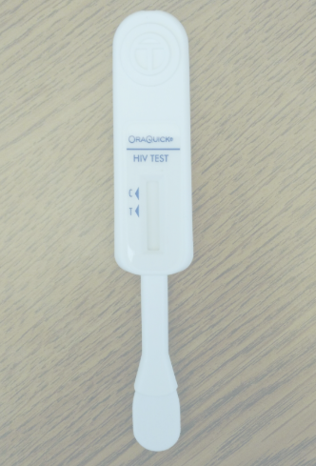

Make sure your photo has finished uploading before clicking "Next"!
When your photo has finished uploading, it will look like this:

- Please upload a picture of your used home test kit here:________
* Soft-required
[GUEST_OQ_PHOTO_SUBMIT]

Source: AMIS Test Kit Upload 2017

Test Results
Logic: If (GUEST_OQ_RESULT = 1 and GUEST_OQ_PICTURE = 1 or 2 or missing) OR
(GUEST_OQ_RESULT = missing and GUEST_OQ_PICTURE = 1 or 2) OR
(GUEST_OQ_RECONCILIATION = 1)
First iteration of the first time you tested positive for HIV [FIRSTPOS]: Logic remains same

Second iteration of 2ndFIRSTPOS will display if: [[GUEST_OQ2Result = missing and GUEST_OQ2picture = 1 OR 2] OR [GUEST_OQ2result = 1 and (GUEST_OQ2picture = 1 or 2 or missing)] OR [GUEST_OQ2reconcile = 1]] AND FIRSTPOS is not answered

- Was this the first time that you tested positive for HIV?

- No
- Yes

[GUEST_FIRSTPOS]
Source: AMIS Test Kit Upload 2017 (edited)

- Are you interested in following up with study staff about the results of your test?

- No
- Yes

[GUEST_CONTACT]
Source: Created (edited)

Logic: If GUEST_CONTACT = 1
Please contact us at knowathome@emory.edu to schedule a video counseling session. You can also visit our website www.knowathome.org for more information.

End

Thank you for reporting your rapid HIV home test results!
If you need assistance, you may contact us at knowathome@emory.edu or 404-727-4340. PLEASE DO NOT SEND YOUR TEST RESULT OR PHOTO BY EMAIL.
If you have any questions, problems with using the tests, or if you test positive, you can call this toll-free support number 24 hours a day, 7 days a week: 1-800-628-9240.
Study staff may be in contact with you soon regarding the results that you reported. If you think you are at risk or that you may have been exposed to HIV, it will be important for you to test again in three months. If you want to learn more about HIV, where to get more information, or where to get tested or receive care in your area, please click on the following links.
If you are currently HIV-negative, pre-exposure prophylaxis (PrEP) may be a potential option for you. PrEP is a way for people who do not have HIV to lower their risk of getting HIV by taking a pill every day. To learn more, please visit some of the links below.

If you want to learn more about HIV, where to get more information, or where to get tested in your area, please click on the following links:
  - Information about HIV
    - www.cdc.gov/hiv
  - HIV Testing Resources
    - CDC HIV Testing Locator (https://gettested.cdc.gov/)
    - CDC HIV Testing Information Page (https://www.cdc.gov/hiv/testing/)
    - HIV.gov HIV Testing Locator (https://www.hiv.gov/locator)
    - AIDSvu HIV Testing Locator (https://aidsvu.org/services)
  - PrEP Resources
    - Centers for Disease Control PrEP Resources (https://www.cdc.gov/actagainstaids/campaigns/starttalking/materials/prepresources.html)
    - Centers for Disease Control PrEP Information (https://www.cdc.gov/hiv/risk/prep/index.html)
    - PrEP Locator (https://preplocator.org/)
    - HIV.gov PrEP Information Page (https://www.hiv.gov/hiv-basics/hiv-prevention/using-hiv-medication-to-reduce-risk/pre-exposure-prophylaxis)

If you have any questions or comments, you may contact study staff at knowathome@emory.edu or (404) 727-4340, or the Principal Investigator, Dr. Patrick Sullivan of Emory University, at (404) 727-2038 or pssulli@emory.edu. To get more information about HIV, please visit: www.cdc.gov/hiv.

You may now safely close your browser tab or window.

