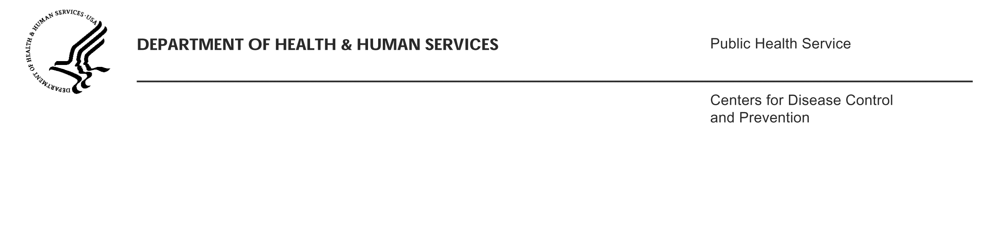
[INSERT Date]

[INSERT Airline Name]
Attn: [INSERT Name and Title of Airline Representative/POC]
[INSERT Airline Address]
[INSERT Airline POC Telephone Number]
[INSERT Airline POC Fax Number]

Dear [INSERT Name]:

Enclosed please find an order from the Centers for Disease Control and Prevention (CDC) requesting information necessary to identify and locate passengers on the following flight(s):

- On [INSERT Departure Date], a passenger with [INSERT disease] departed [INSERT Departure Airport Code, City, State, Country] on [INSERT Airline and Flight Number] arriving into [INSERT Arrival Airport Code, City, State, Country] on [INSERT Arrival Date if different from departure date].
- Repeat for each leg of same airline

We were notified by public health authorities regarding the travel history of this patient and believe this person to have been infectious during travel. Area health departments, in collaboration with CDC, are undertaking an investigation of possible contacts to this newly identified case so that exposed individuals may be evaluated for infection and offered any treatment that may be indicated.

The enclosed document is being sent for your records, as we have already received the necessary information. We greatly appreciate your rapid response and cooperation in conducting this investigation.

If you have specific questions about the ill passenger or persons we believe may have been exposed, you may direct them to [INSERT Name of lead QMO with e-mail and phone number]. If you have any questions about this order or how the requested information will be used by CDC, please contact the CDC Air Activities Project Manager by e-mail at [HQ INSERT Air Activities Project Manager’s e-mail] or by phone at [HQ INSERT Air Activities Project Manager’s telephone number].

Thank you very much for your assistance in this investigation.

Sincerely,

Clive M. Brown, MBBS, MPH, MSc, DTM&H (London)
Chief, Quarantine and Border Health Services

encl.
cc: [INSERT name of lead QMO]

