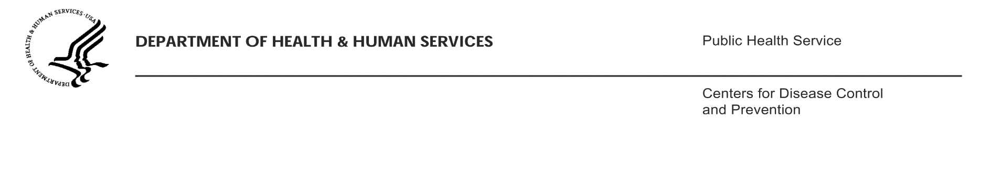

[INSERT Date]

[INSERT Airline Name]
Attn: [INSERT Name and Title of Airline Representative/POC]
[INSERT Airline Address]
[INSERT Airline POC Telephone Number]
[INSERT Airline POC Fax Number]

Dear [INSERT Name of POC]:

The enclosed document from the Centers for Disease Control and Prevention (CDC) is being sent for your records, as we have already received the necessary information. We greatly appreciate your rapid response and cooperation in conducting this investigation.

We were notified by a public health authority regarding the travel history of a ill passenger and believe this person to have been infectious during travel. Area health departments, in collaboration with CDC, are undertaking an investigation of possible contacts to this newly identified case so that exposed individuals may be evaluated for infection and offered any treatment that may be indicated.

If you have specific questions about the ill passenger or persons we believe may have been exposed, you may direct them to [INSERT Name of lead QMO with e-mail and phone number]. If you have any questions about this order or how the requested information will be used by CDC, please contact the CDC Air Activity Case Manager by e-mail at [HQ INSERT Air Activity Case Manager’s e-mail] or by phone at [HQ INSERT Air Activity Case Manager’s telephone number].

Thank you very much for your assistance in this investigation.

Sincerely,

Clive M. Brown, MBBS, MPH, MSc, DTM&H (London)
Chief, Quarantine and Border Health Services

encl.
cc: [INSERT name of lead QMO]

