Invitation Letter

May XX, 2021

John Doe, MD
Position (if provided, i.e. Director, Chief, etc.)
Practice Name (if provided)
5 Smith Street
Nowhere, NC 99999-1111

Dear Dr. Doe,

You have been randomly selected to respond to a brief mail survey on the knowledge and use of various clinical guidelines when prescribing opioids for pain management. The survey is conducted by the National Center for Health Statistics, a part of the Centers for Disease Control and Prevention (CDC). The NCHS collects data from physicians to help inform and improve health care delivery in the United States. Results from the Physician Pain Management Questionnaire (PPMQ) will be used to understand how physicians use clinical guidelines to prescribe opioids.

Participation in this 15-minute survey is voluntary, and you may stop at any time. You are not being asked to provide any patient information. All information we collect is used for statistical purposes only. There are no penalties for nonparticipation. If you choose to participate, you are giving consent for your deidentified information to be used for future survey development by NCHS or other investigators.

The NCHS Ethics Review Board has approved this survey. NCHS complies with numerous federal laws to protect your data, privacy and confidentiality. Data collection is authorized under Section 306 of the Public Health Service Act (42 U.S.C. 242k). NCHS is required to keep your survey data confidential in accordance with Section 308(d) of the Public Health Service Act (42 U.S.C. 242m(d)) and the Confidential Information Protection and Statistical Efficiency Act (CIPSEA, Title III of Public Law 115-435).

We are eager to get information from you for this study. Within 2-4 weeks, you will receive a mailed packet containing the survey, instructions on completing it and a pre-paid return envelope. Please prepare the time to complete the 15-minute survey and return it to us.

We rely on the generosity of physicians like you to provide the much-needed information to improve the health of this Nation. If you have any questions or comments regarding this study, please call the study coordinator at (301) 458-4220. If you have questions about your rights as a study participant, please call the NCHS Ethics Review Board at (800) 223-8118 and say you are calling about Protocol #2021-04.

Thank you in advance for your valuable participation in this important study.

Sincerely,

Brian C. Moyer, Ph.D.
Director, National Center for Health Statistics
Centers for Disease Control and Prevention

FREQUENTLY ASKED QUESTIONS ABOUT
THE NATIONAL HEALTH CARE SURVEYS

HOW WAS I CHOSEN FOR THE SURVEY?
You were randomly selected from all nonfederal physicians in the U.S. who are engaged in direct patient care. We picked 1,000 physicians across the entire country. All nonfederal physicians have a chance to be picked. This process ensures that the physicians selected represent all practitioners in the United States.

WHAT ARE YOU GOING TO ASK ME?
Some examples of what we collect about you include general information about the office location(s) where you practice, types of direct patient care you provide, patient characteristics and your approaches to managing pain. We do not expect physicians to have difficulty with any of the questions. We are asking about how patients on opioids are managed; some may find this question sensitive. Be assured that these questions are only used to understand how guidelines are being used. There are no penalties for answering truthfully. The information we collect is very important. We need your help to ensure that the survey results are complete and correct. You are getting a special chance to make a difference in the health of the Nation.

WHO WILL SEE MY ANSWERS?
We take your privacy very seriously. The answers you give us are used for statistical purposes only. This means that your answers will be combined with other physician’s answers in a way that protects everyone’s identity. As required by federal law, only those NCHS employees who must use your personal information for a specific reason can see your answers.

WHAT LAWS PROTECT MY PRIVACY?
Strict laws prevent us from releasing information that could identify you to anyone else without your consent. Congress authorized this data collection in Section 306 of the Public Health Service Act (Title 42, United States Code (U.S.C), 242k). Several federal laws require that all information we collect be held in strict confidence: Section 308(d) of the Public Health Service Act (42 U.S.C. 242m(d)), the Confidential Information Protection and Statistical Efficiency Act (CIPSEA, Title III of Public Law 115-435), and the Privacy Act of 1974 (5 U.S.C. § 552a). Every NCHS employee, contractor, research partner, and agent has taken an oath to keep your information private. Anyone who willfully discloses ANY identifiable information about ANYONE in the survey could get a jail term of up to five years, a fine of up to $250,000, or both.

WHO PROTECTS THE INTERESTS OF SURVEY PARTICIPANTS?
Every year, the Ethics Review Board of the National Center for Health Statistics reviews survey content and methods to protect study participants. You may call the Ethics Review Board to ask about your rights as a participant in this study. The toll-free number is (800) 223-8118. You will get an answering service. Please leave a brief message with your name and phone number. Say you are calling about Protocol #2021-04. Your call will be returned promptly.

CAN I COMPLETE THE SURVEY ONLINE?
There is no online option for the Physician Pain Management Questionnaire (PPMQ).

Introductory Letter

May XX, 2021

John Doe, MD
Position (if provided, i.e. Director, Chief, etc.)
Practice Name (if provided)
5 Smith Street
Nowhere, NC 99999-1111

Dear Dr. Doe,

About two weeks ago, we invited you to participate in a brief mail survey on the knowledge and use of various clinical guidelines when prescribing opioids for pain management. The survey is conducted by the National Center for Health Statistics (NCHS), a part of the Centers for Disease Control and Prevention (CDC). The NCHS collects data from physicians to help inform and improve health care delivery in the United States. Results from the enclosed Physician Pain Management Questionnaire (PPMQ) will be used to understand how physicians use clinical guidelines to prescribe opioids.

We are eager to get information from you! Please take 15 minutes to complete the survey and return it in the enclosed pre-paid envelope. Participation is voluntary, and you may stop at any time. If you choose not to participate, please answer Question 1 and 2 before returning the survey to us in the enclosed envelope. There are no penalties for nonparticipation. If you choose to participate, you are giving consent for your deidentified information to be used for future survey development by NCHS or other investigators.

All information we collect is used for statistical purposes only. The NCHS Ethics Review Board has approved this survey. NCHS complies with numerous federal laws to protect your data, privacy and confidentiality, as described in detail under the section: Frequently Asked Questions.

We rely on the generosity of physicians like you to provide the much-needed information to improve the health of this Nation. If you have any questions or comments regarding this study, please call the study coordinator at (301) 458-4220. If you have questions about your rights as a study participant, please call the NCHS Ethics Review Board at (800) 223-8118 and say you are calling about Protocol #2021-04.

Thank you for your valuable participation in this important study.

Sincerely,

Brian C. Moyer, Ph.D.
Director, National Center for Health Statistics
Centers for Disease Control and Prevention

FREQUENTLY ASKED QUESTIONS ABOUT
THE NATIONAL HEALTH CARE SURVEYS

HOW WAS I CHOSEN FOR THE SURVEY?
You were randomly selected from all nonfederal physicians in the U.S. who are engaged in direct patient care. We picked 1,000 physicians across the entire country. All nonfederal physicians have a chance to be picked. This process ensures that the physicians selected represent all practitioners in the United States.

WHAT ARE YOU GOING TO ASK ME?
Some examples of what we collect about you include general information about the office location(s) where you practice, types of direct patient care you provide, patient characteristics and your approaches to managing pain. We do not expect physicians to have difficulty with any of the questions. We are asking about how patients on opioids are managed; some may find this question sensitive. Be assured that these questions are only used to understand how guidelines are being used. There are no penalties for answering truthfully. The information we collect is very important. We need your help to ensure that the survey results are complete and correct. You are getting a special chance to make a difference in the health of the Nation.

WHO WILL SEE MY ANSWERS?
We take your privacy very seriously. The answers you give us are used for statistical purposes only. This means that your answers will be combined with other physician’s answers in a way that protects everyone’s identity. As required by federal law, only those NCHS employees who must use your personal information for a specific reason can see your answers.

WHAT LAWS PROTECT MY PRIVACY?
Strict laws prevent us from releasing information that could identify you to anyone else without your consent. Congress authorized this data collection in Section 306 of the Public Health Service Act (Title 42, United States Code (U.S.C), 242k). Several federal laws require that all information we collect be held in strict confidence: Section 308(d) of the Public Health Service Act (42 U.S.C. 242m(d)), the Confidential Information Protection and Statistical Efficiency Act (CIPSEA, Title III of Public Law 115-435), and the Privacy Act of 1974 (5 U.S.C. § 552a). Every NCHS employee, contractor, research partner, and agent has taken an oath to keep your information private. Anyone who willfully discloses ANY identifiable information about ANYONE in the survey could get a jail term of up to five years, a fine of up to $250,000, or both.

WHO PROTECTS THE INTERESTS OF SURVEY PARTICIPANTS?
Every year, the Ethics Review Board of the National Center for Health Statistics reviews survey content and methods to protect study participants. You may call the Ethics Review Board to ask about your rights as a participant in this study. The toll-free number is (800) 223-8118. You will get an answering service. Please leave a brief message with your name and phone number. Say you are calling about Protocol #2021-04. Your call will be returned promptly.

CAN I COMPLETE THE SURVEY ONLINE?
There is no online option for the Physician Pain Management Questionnaire (PPMQ).

Post Card Thank You/Reminder

Last week a questionnaire was mailed to you requesting your participation in an important study on the knowledge and use of various clinical guidelines when prescribing opioids for pain management.

If you returned the questionnaire, thank you for your contribution to this study. If not, please do so today. Your participation is critical and helps improve our understanding of how physicians use clinical guidelines when prescribing opioids. This information can have an impact on efforts to mitigate the opioid epidemic.

If you did not receive the questionnaire or have misplaced it, please call (301) 458-4220, and we will be happy to send you another one. If you have any questions about your rights as a study participant, please call the Ethics Review Board at the National Center for Health Statistics at (800) 223-8118 and say you are calling about protocol #2021-04.

Thank you for your participation.

Brian C. Moyer, Ph.D.
Director, National Center for Health Statistics
Centers for Disease Control and Prevention

Follow-up Letter

June XX, 2021

John Doe, MD
Position (if provided, i.e. Director, Chief, etc.)
Practice Name (if provided)
5 Smith Street
Nowhere, NC 99999-1111

Dear Dr. Doe,

About four weeks ago, we sent you the Physician Pain Management Questionnaire, which is an important survey study on the knowledge and use of various clinical guidelines when prescribing opioids for pain management. As of this mailing, we have not received your completed survey. Enclosed is a copy of the survey. I urge you to complete the survey and return it in the enclosed envelope. It should take only 15 minutes to complete. If you are no longer in practice or do not provide direct patient care, please answer Question 2 on the survey and return it in the postage-paid envelope. If you choose not to participate, please answer Questions 1 and 2 before returning the survey in the enclosed envelope.

The National Center for Health Statistics (NCHS), a part of the Centers for Disease Control and Prevention (CDC), collects data from physicians to help inform and improve health care delivery in the United States. The opioid epidemic continues to be a major health crisis in this Nation. Your participation is extremely important. We need to hear from you, as we cannot substitute your unique insight and experiences with those from another physician. You are not being asked to provide any patient information.

All information we collect is used for statistical purposes only. The NCHS Ethics Review Board has approved this survey. NCHS complies with numerous federal laws to protect your data, privacy and confidentiality, as described in detail under the section: Frequently Asked Questions. Your participation is voluntary, and you may stop at any time. There are no penalties for nonparticipation. If you choose to participate, you are giving consent for your deidentified information to be used for future survey development by NCHS or other investigators.

Thank you in advance for your time, effort, and contribution to this important study. If you have any questions or comments, please do not hesitate to contact the study coordinator at (301) 458-4220. If you have questions about your rights as a study participant, please call the NCHS Ethics Review Board at (800) 223-8118 and say you are calling about Protocol #2021-04.

Thank you for your valuable participation in this important study.

Sincerely,

Brian C. Moyer, Ph.D.
Director, National Center for Health Statistics
Centers for Disease Control and Prevention

FREQUENTLY ASKED QUESTIONS ABOUT
THE NATIONAL HEALTH CARE SURVEYS

HOW WAS I CHOSEN FOR THE SURVEY?
You were randomly selected from all nonfederal physicians in the U.S. who are engaged in direct patient care. We picked 1,000 physicians across the entire country. All nonfederal physicians have a chance to be picked. This process ensures that the physicians selected represent all practitioners in the United States.

WHAT ARE YOU GOING TO ASK ME?
Some examples of what we collect about you include general information about the office location(s) where you practice, types of direct patient care you provide, patient characteristics and your approaches to managing pain. We do not expect physicians to have difficulty with any of the questions. We are asking about how patients on opioids are managed; some may find this question sensitive. Be assured that these questions are only used to understand how guidelines are being used. There are no penalties for answering truthfully. The information we collect is very important. We need your help to ensure that the survey results are complete and correct. You are getting a special chance to make a difference in the health of the Nation.

WHO WILL SEE MY ANSWERS?
We take your privacy very seriously. The answers you give us are used for statistical purposes only. This means that your answers will be combined with other physician’s answers in a way that protects everyone’s identity. As required by federal law, only those NCHS employees who must use your personal information for a specific reason can see your answers.

WHAT LAWS PROTECT MY PRIVACY?
Strict laws prevent us from releasing information that could identify you to anyone else without your consent. Congress authorized this data collection in Section 306 of the Public Health Service Act (Title 42, United States Code (U.S.C), 242k). Several federal laws require that all information we collect be held in strict confidence: Section 308(d) of the Public Health Service Act (42 U.S.C. 242m(d)), the Confidential Information Protection and Statistical Efficiency Act (CIPSEA, Title III of Public Law 115-435), and the Privacy Act of 1974 (5 U.S.C. § 552a). Every NCHS employee, contractor, research partner, and agent has taken an oath to keep your information private. Anyone who willfully discloses ANY identifiable information about ANYONE in the survey could get a jail term of up to five years, a fine of up to $250,000, or both.

WHO PROTECTS THE INTERESTS OF SURVEY PARTICIPANTS?
Every year, the Ethics Review Board of the National Center for Health Statistics reviews survey content and methods to protect study participants. You may call the Ethics Review Board to ask about your rights as a participant in this study. The toll-free number is (800) 223-8118. You will get an answering service. Please leave a brief message with your name and phone number. Say you are calling about Protocol #2021-04. Your call will be returned promptly.

CAN I COMPLETE THE SURVEY ONLINE?
There is no online option for the Physician Pain Management Questionnaire (PPMQ).

Modified Follow-up Letter

June XX, 2021

John Doe, MD
Position (if provided, i.e. Director, Chief, etc.)
Practice Name (if provided)
5 Smith Street
Nowhere, NC 99999-1111

Dear Dr. Doe,

We have been trying to reach you about an important survey study on the knowledge and use of various clinical guidelines when prescribing opioids for pain management. We have not received your completed survey. Results from the enclosed Physician Pain Management Questionnaire will be used to inform health services researchers about how physicians use clinical guidelines to prescribe opioids and to develop broader studies to investigate this topic.

The study period is coming to an end, and a concern is that physicians who have not responded to the survey may have different experiences from those who responded. We need to hear from all types of physicians, and we cannot substitute your responses with another physician’s responses. The survey should take only 15 minutes to complete. If you are no longer in practice or do not provide direct patient care, please answer Question 2 on the survey and return it in the pre-paid envelope. If you choose not to participate, please answer Question 1 and 2 before returning the survey to us in the enclosed pre-paid envelope.

You are not being asked to provide any patient information, and participation is voluntary. You may stop participation at any time. There are no penalties for nonparticipation, however, the information we collect is very important. We rely on information from physicians like to improve the health of this Nation. If you choose to participate, you are giving consent for your deidentified information to be used for future survey development by the National Center for Health Statistics (NCHS) or other investigators.

All information we collect is used for statistical purposes only. The NCHS Ethics Review Board has approved this survey. NCHS complies with numerous federal laws to protect your data, privacy and confidentiality, as described in detail under the section: Frequently Asked Questions.

Thank you in advance for your time, effort, and contribution to this important study. If you have any questions or comments regarding this study, please do not hesitate to contact the study coordinator at (301) 458-4220. If you have questions about your rights as a study participant, please call the NCHS Ethics Review Board at (800) 223-8118 and say you are calling about Protocol #2021-04.

Sincerely,

Brian C. Moyer, Ph.D.
Director, National Center for Health Statistics
Centers for Disease Control and Prevention
FREQUENTLY ASKED QUESTIONS ABOUT
THE NATIONAL HEALTH CARE SURVEYS

HOW WAS I CHOSEN FOR THE SURVEY?
You were randomly selected from all nonfederal physicians in the U.S. who are engaged in direct patient care. We picked 1,000 physicians across the entire country. All nonfederal physicians have a chance to be picked. This process ensures that the physicians selected represent all practitioners in the United States.

WHAT ARE YOU GOING TO ASK ME?
Some examples of what we collect about you include general information about the office location(s) where you practice, types of direct patient care you provide, patient characteristics and your approaches to managing pain. We do not expect physicians to have difficulty with any of the questions. We are asking about how patients on opioids are managed; some may find this question sensitive. Be assured that these questions are only used to understand how guidelines are being used. There are no penalties for answering truthfully. The information we collect is very important. We need your help to ensure that the survey results are complete and correct. You are getting a special chance to make a difference in the health of the Nation.

WHO WILL SEE MY ANSWERS?
We take your privacy very seriously. The answers you give us are used for statistical purposes only. This means that your answers will be combined with other physician’s answers in a way that protects everyone’s identity. As required by federal law, only those NCHS employees who must use your personal information for a specific reason can see your answers.

WHAT LAWS PROTECT MY PRIVACY?
Strict laws prevent us from releasing information that could identify you to anyone else without your consent. Congress authorized this data collection in Section 306 of the Public Health Service Act (Title 42, United States Code (U.S.C), 242k). Several federal laws require that all information we collect be held in strict confidence: Section 308(d) of the Public Health Service Act (42 U.S.C. 242m(d)), the Confidential Information Protection and Statistical Efficiency Act (CIPSEA, Title III of Public Law 115-435), and the Privacy Act of 1974 (5 U.S.C. § 552a). Every NCHS employee, contractor, research partner, and agent has taken an oath to keep your information private. Anyone who willfully discloses ANY identifiable information about ANYONE in the survey could get a jail term of up to five years, a fine of up to $250,000, or both.

WHO PROTECTS THE INTERESTS OF SURVEY PARTICIPANTS?
Every year, the Ethics Review Board of the National Center for Health Statistics reviews survey content and methods to protect study participants. You may call the Ethics Review Board to ask about your rights as a participant in this study. The toll-free number is 1–800–223–8118. You will get an answering service. Please leave a brief message with your name and phone number. Say you are calling about Protocol #2021-04. Your call will be returned promptly.

CAN I COMPLETE THE SURVEY ONLINE?
There is no online option for the Physician Pain Management Questionnaire (PPMQ).

Final Post Card Thank You/Reminder

Several weeks ago, you were invited to participate in an important mail survey study on the knowledge and use of various clinical guidelines when prescribing opioids for pain management. The end of the study is approaching, and we want to thank you for your contribution to this study!

If you have not returned the questionnaire, it is not too late! Please do so today. Your participation is critical to understanding how physicians use clinical guidelines when prescribing opioids. This information can have a positive impact on the opioid epidemic.

If you did not receive the questionnaire or have misplaced it, please call (301) 458-4220, and we will be happy to send you another one. If you have any questions about your rights as a study participant, please call the Ethics Review Board at the National Center for Health Statistics at (800)-223-8118 and say you are calling about protocol #2021-04.

Thank you for your participation.

Brian C. Moyer, Ph.D.
Director, National Center for Health Statistics
Centers for Disease Control and Prevention

Postcard Design:

Front of postcard (applies to both postcards):
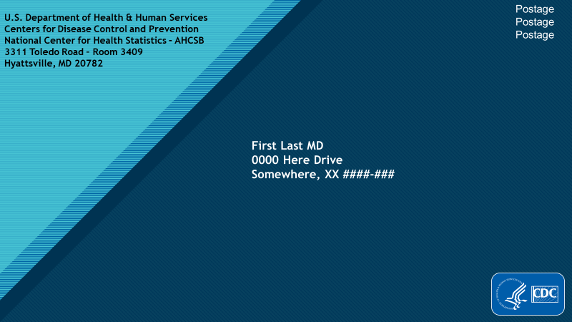

Internal top half empty (applies to both postcards)

Internal bottom half (postcard1)
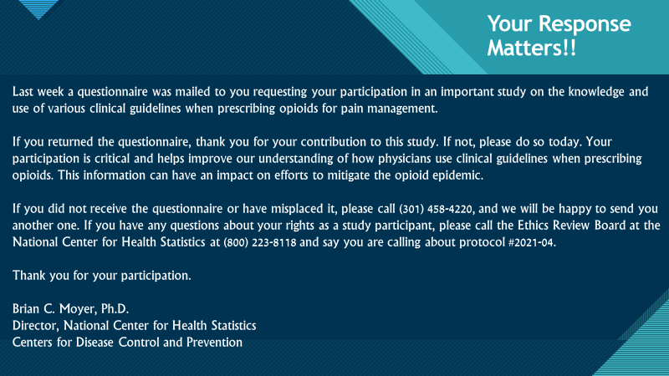

Internal bottom half (final postcard)
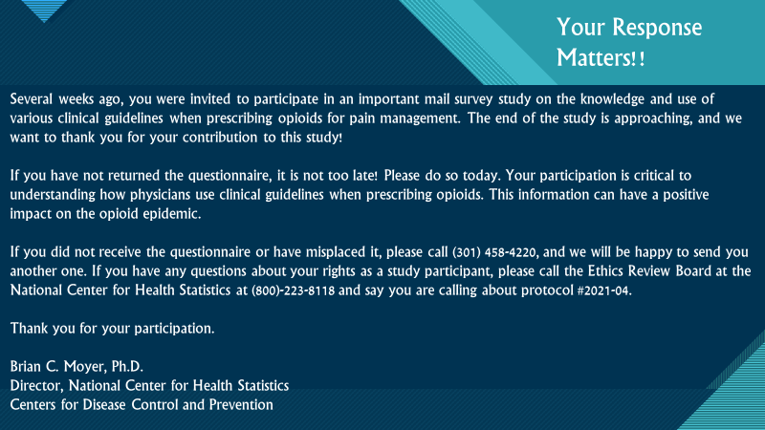

External back (postcard1)
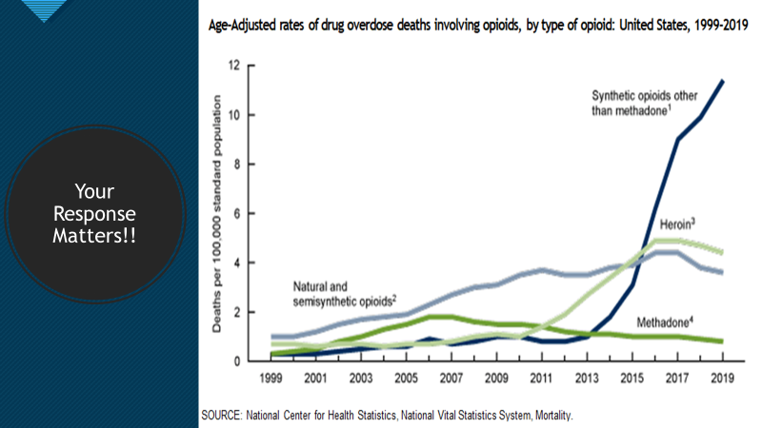

External back (final postcard)
