WebPro Screens

Login Screen
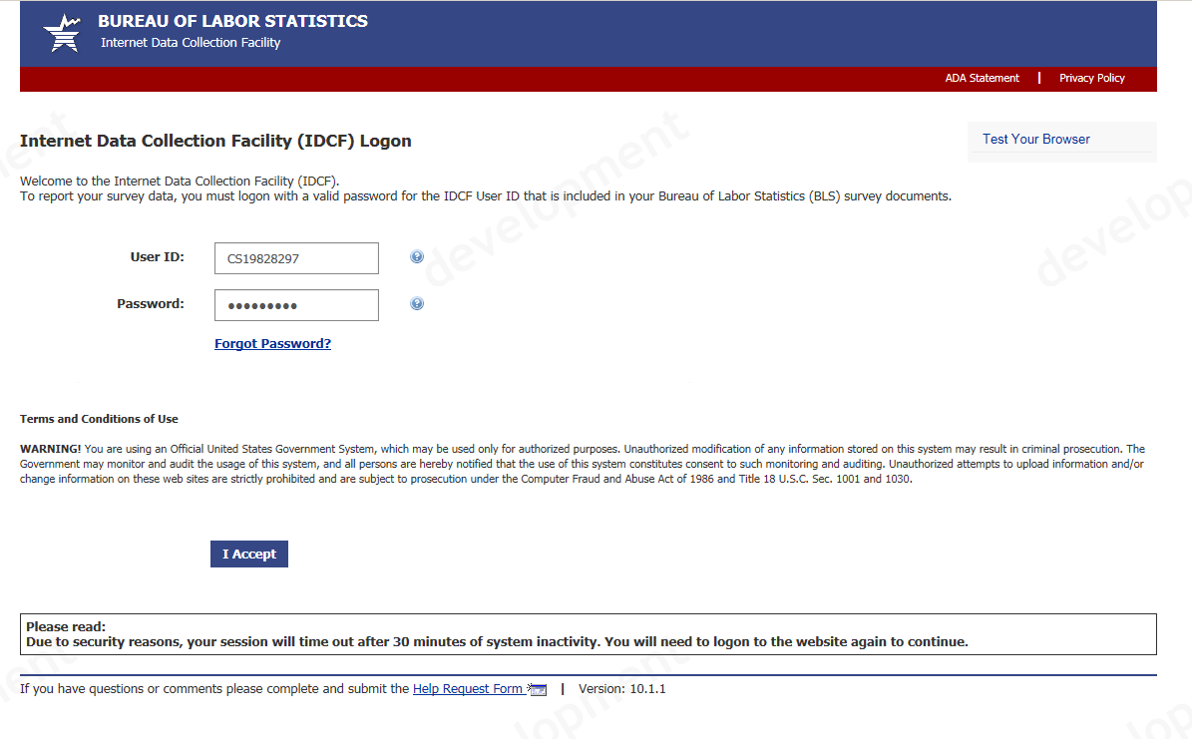
Survey Screen

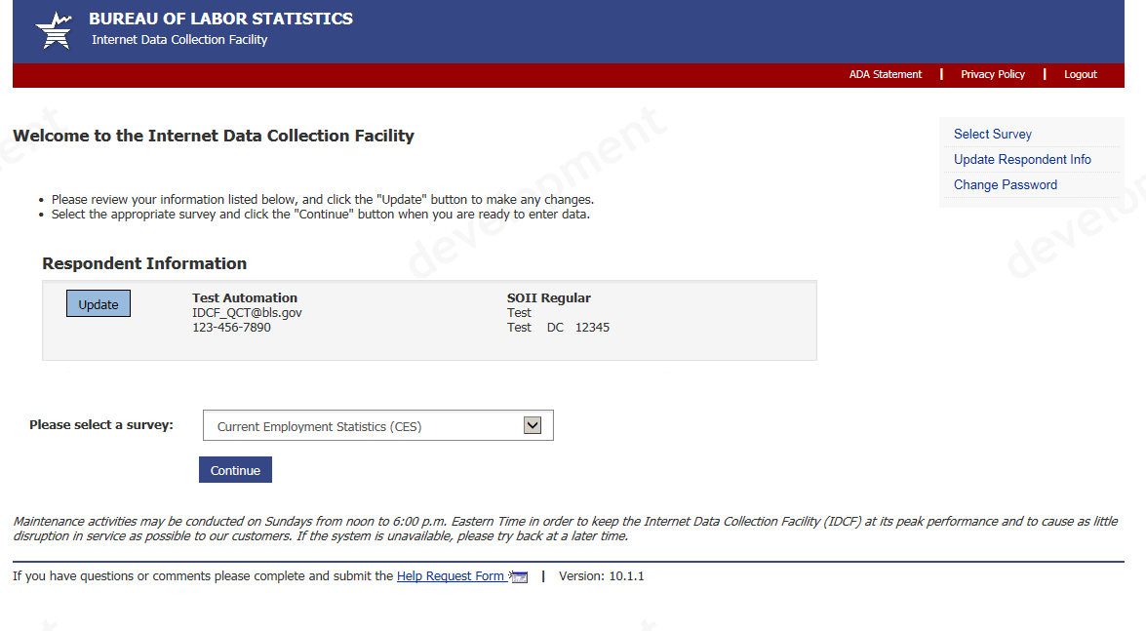
Dear Employer Screen

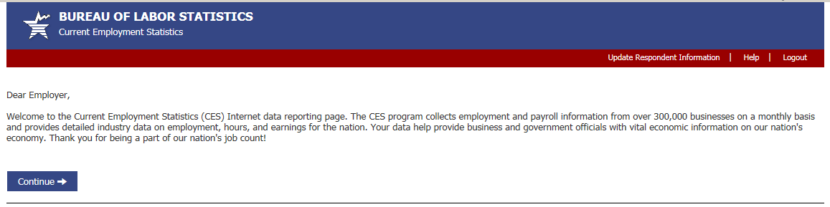
This report is authorized by law 29 U.S.C.2. We request your cooperation to make the results of this survey comprehensive, accurate, and timely. The Bureau of Labor Statistics, its employees, agents, and partner statistical agencies, will use the information you provide for statistical purposes only and will hold the information in confidence to the full extent permitted by law. In accordance with the Confidential Information Protection and Statistical Efficiency Act of 2002 (Title 5 of Public Law 107-347) and other applicable Federal laws, your responses will not be disclosed in identifiable form without your informed consent. Per the Federal Cybersecurity Enhancement Act of 2015, Federal information systems are protected from malicious activities through cybersecurity screening of transmitted data.

Please note this report is mandatory in Oregon, under the Oregon Revised Statute 657.660; in South Carolina, under Section 41-29-120 of the Code of Laws of South Carolina (for firms employing more than twenty individuals); and in Puerto Rico, under State Law 15, Sections 5, 6 and 15, amended and approved on April 14, 1931.

We estimate that it will take an average of 10 minutes to complete this form each month including time to review instructions, search existing data sources, gather and maintain the necessary data, and complete and review this information. If you have any comments regarding these estimates or any other aspects of this survey, send them to the Bureau of Labor Statistics, Division of Current Employment Statistics (1220-0011), 2 Massachusetts Avenue, NE, Washington, DC 20212. You are not required to respond to the collection of information unless it displays a currently valid OMB control number. Form Approved OMB No. 1220-0011.

Data Entry Screen
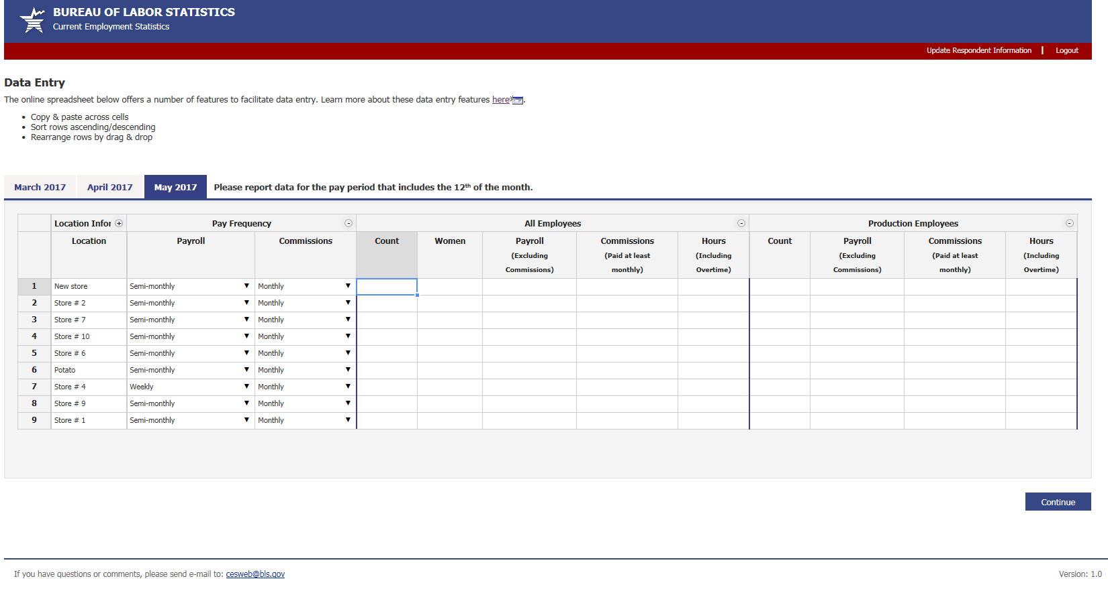

Editing Screen
