# International Exchange Alumni website (alumni.state.gov)

# Registration Forms for Account Setup

All who wish to have full access to the International Exchange Alumni website (https://alumni.state.gov) must have an account. All accounts requested by individuals are subject to verification and approval by administrators. Users can activate accounts on the website through two different mechanisms: manual registration or an automated process.

The following five steps detail the process (the automated process starts at step 3).

Step 1: Account Inquiry Form

Step 2: Account Inquiry Automated Response

Step 3: Activation Email

Step 4: Account Activation Form

Step 5: Profile Form (voluntary)

Addendum 1: Terms of Service

Addendum 2: Privacy Act Statement

Screenshots for each step follow:

**Step 1: Account Inquiry Form**

Applicants can request an account visa the Account Inquiry on the website. The information on this form is transmitted to a federal government administrative staff via email. The employee uses this information to verify alumni status and then upload to the system via spreadsheet.

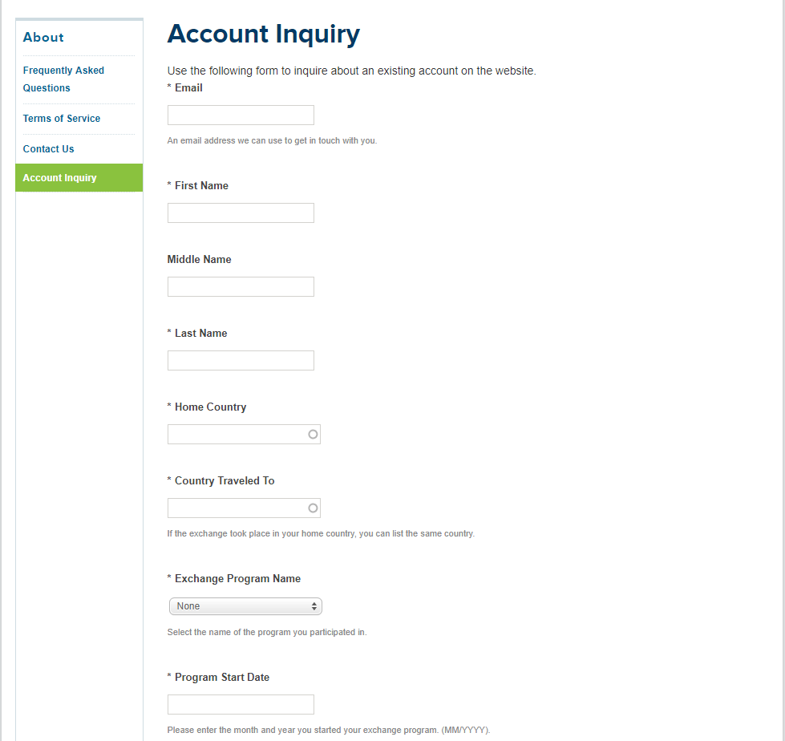

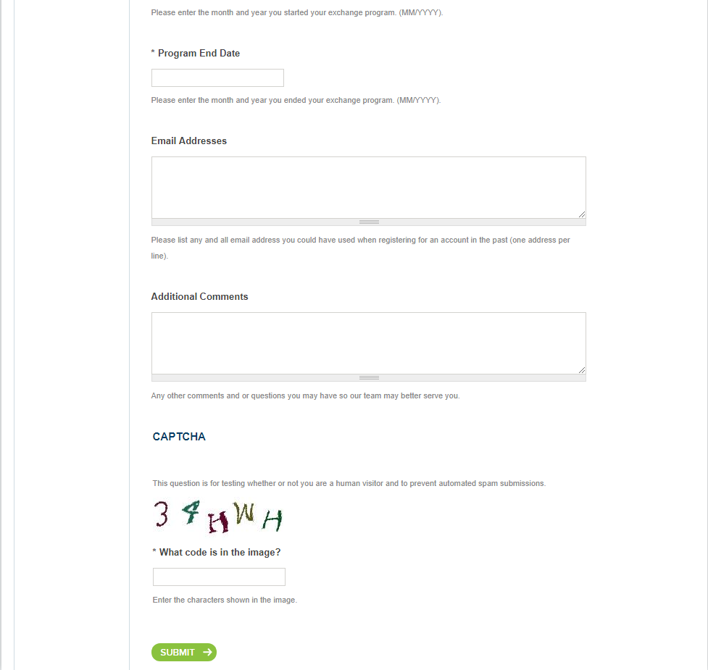

## Step 2: Account Inquiry Automated Response

Once the account inquiry is submitted, this window displays next steps.

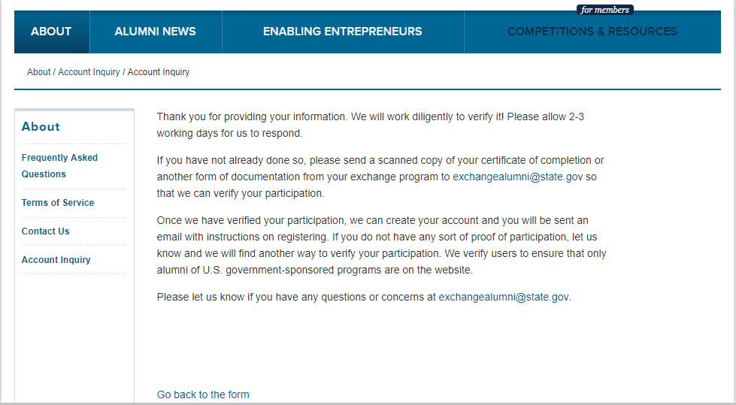

## Step 3: Activation Email

Once federal government administrative staff verifies a participant’s status as a current or past participant of a U.S. government-funded and U.S. government-facilitated exchange program, the account will be created on the website and a user will be prompted by email to click on a link to activate their account and agree to the terms and conditions of the site.

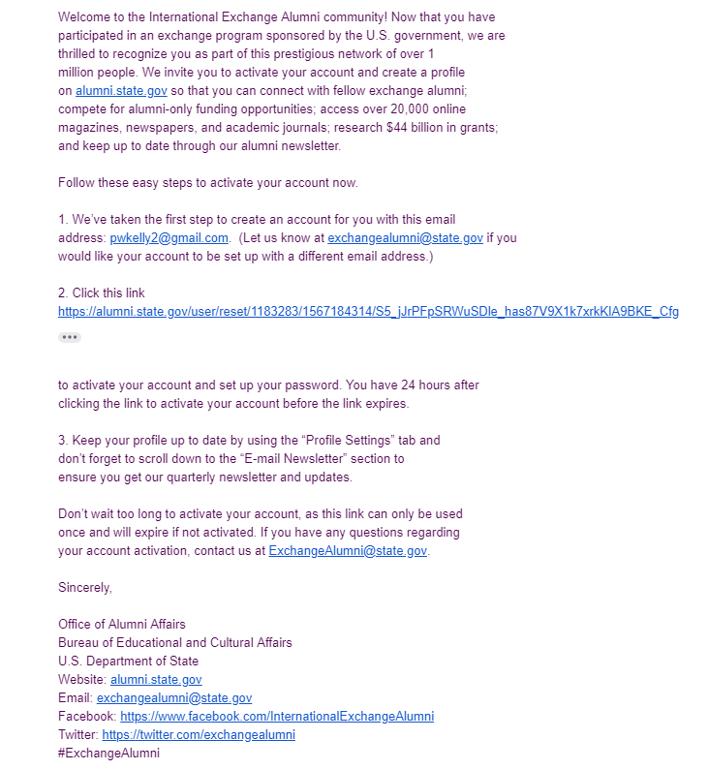

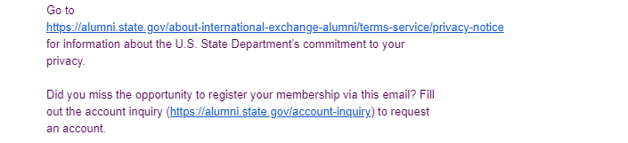

**Step 4: Account Activation Form**

Upon clicking on the link in the email, the alumni are taken to this page to activate their account.

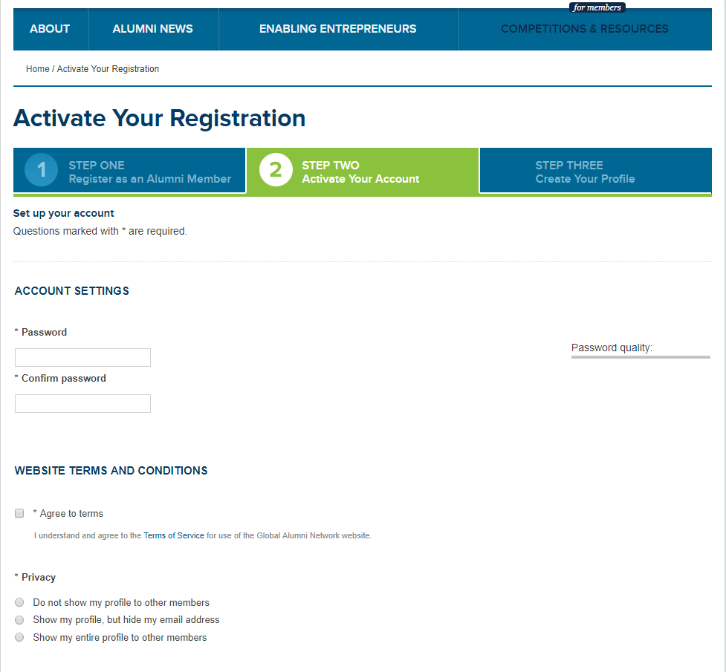

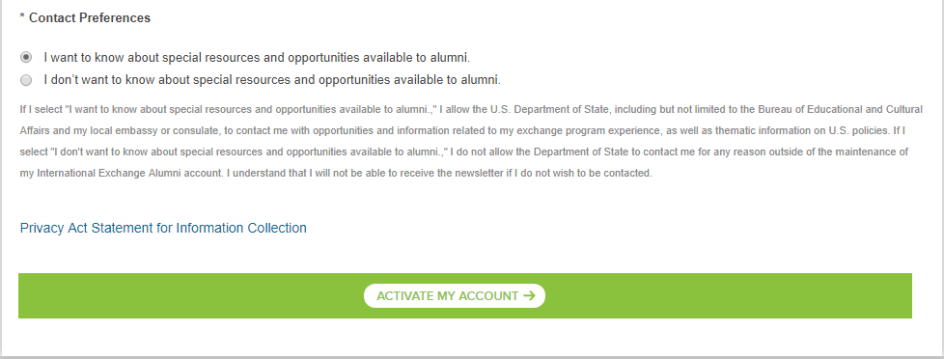

**Step 5 (voluntary): Profile Form**

The alumni are then prompted to fill out their profile. Other than contact and exchange program information, which is required for website registration, all other information is provided on a voluntary basis. Participants also have the option of restricting access to their information.

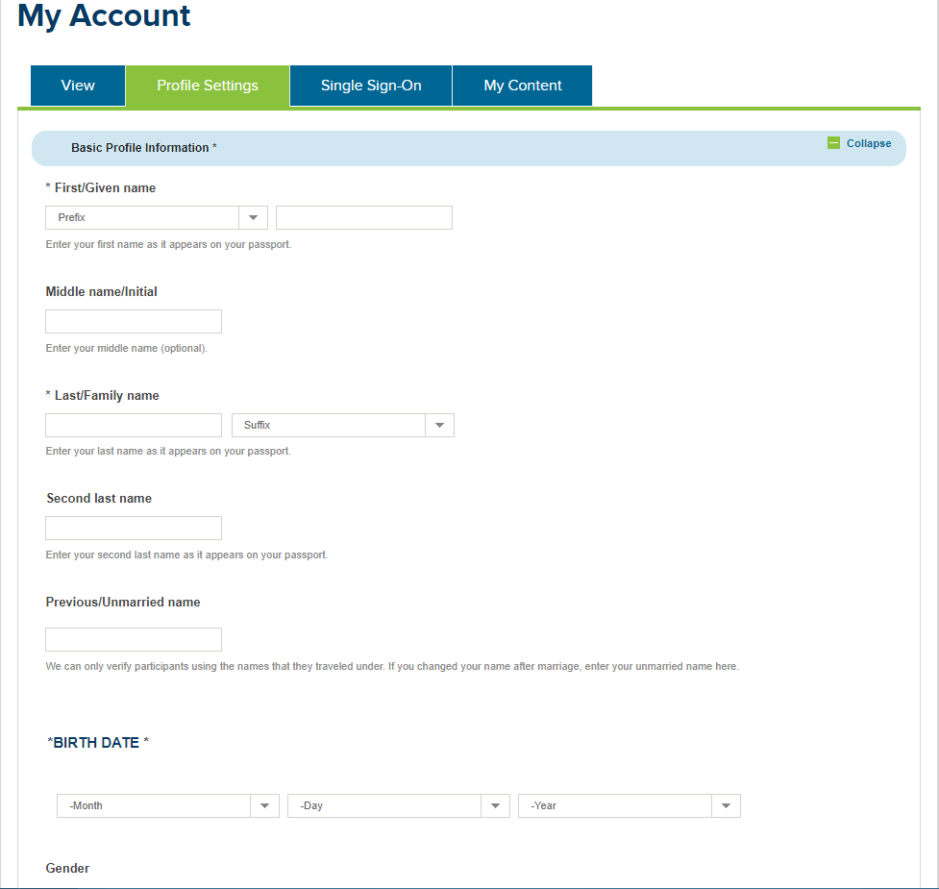

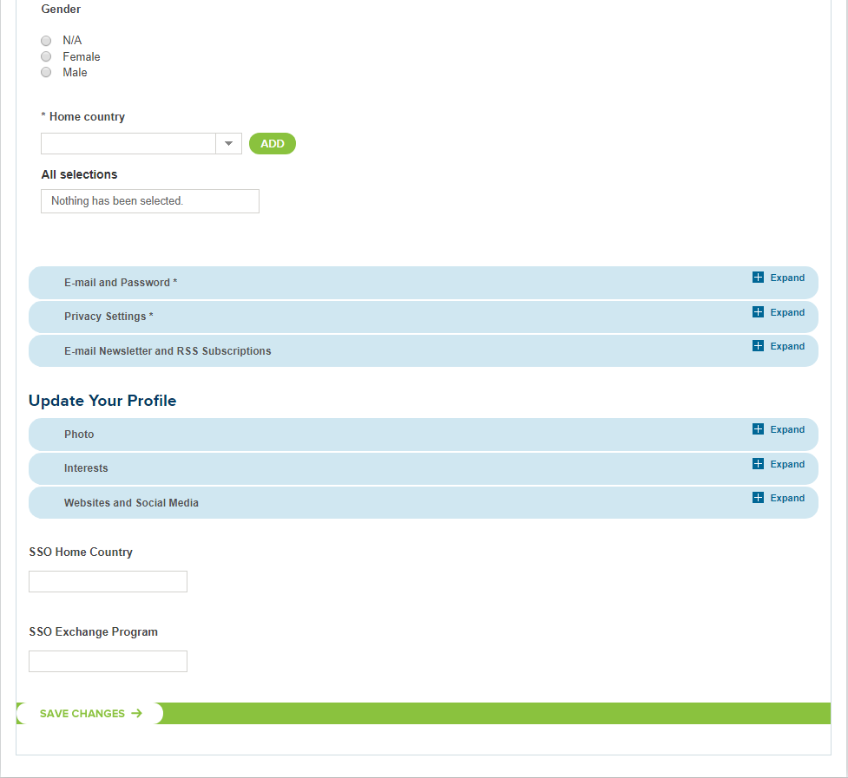

**Addendum 1: Full text of the terms of service**

1. **Acceptance of terms**  
   Welcome to the International Exchange Alumni website! The U.S. Department of State provides this service to you, subject to the following Terms of Service ("TOS"), which may be updated by us from time to time without notice to you. You can review the most current version of the TOS at any time.
2. **Description of service**  
   The International Exchange Alumni website currently provides its participants with a variety of services including (but not limited to): grant proposals, the ability to post jobs or grants, networking capabilities (events, alumni updates, and the ability to find and contact other alumni directly), events listings and career information.
3. **Your registration obligations**  
   In consideration of your use of this service, you agree to: (a) provide true, accurate, current and complete information about yourself as prompted by the registration form and (b) maintain and promptly update your information to keep it true, accurate, current and complete. If you provide any information that is untrue, inaccurate, not current or incomplete, or International Exchange Alumni has reasonable grounds to suspect that such information is untrue, inaccurate, not current or incomplete, International Exchange Alumni reserves the right to suspend or terminate your account and refuse any and all current or future use of the International Exchange Alumni site (or any portion thereof).
4. **International Exchange Alumni Privacy Policy**  
   Registration data and certain other information about you is subject to our Privacy Policy. For more information, see our full [privacy policy](https://alumni.state.gov/about-international-exchange-alumni/benefits-joining/terms-service/privacy-notice).
5. **Member account, password and security**  
   You choose a username and password upon signing up for participation in the International Exchange Alumni website. You are responsible for maintaining the confidentiality of your username and password, and are fully responsible for all activities that occur under your password. You agree to (a) immediately notify International Exchange Alumni of any unauthorized use of your password or account or any other breach of security, and (b) ensure that you exit from your account at the end of each session. The U.S. Department of State cannot and will not be liable for any loss or damage arising from your failure to comply with this Section 5.
6. **Member conduct**  
   You understand that all information, data, messages or other materials ("Content"), whether publicly posted or privately transmitted, are the sole responsibility of the person from which such Content originated. This means that you, and not the U.S. Department of State, are entirely responsible for all Content that you post, email, transmit or otherwise make available via the site. The U.S. Department of State does not control the Content posted and, as such, does not guarantee the accuracy, integrity or quality of such Content. You understand that by using the Service, you may be exposed to Content that is offensive, indecent or objectionable. Under no circumstances will the U.S. Department of State be liable in any way for any Content, including, but not limited to, for any errors or omissions in any Content, or for any loss or damage of any kind incurred as a result of the use of any Content posted, emailed, transmitted or otherwise made available via the site.   
     
   You agree to not use the site to:
   * post, email, transmit or otherwise make available any Content that is unlawful, harmful, threatening, abusive, harassing, tortious, defamatory, vulgar, obscene, libelous, invasive of another's privacy, hateful, or racially, ethnically or otherwise objectionable;
   * harm minors in any way;
   * impersonate any person or entity, including, but not limited to, another participant of the U.S. Department of State's international exchange programs;
   * forge headers or otherwise manipulate identifiers in order to disguise the origin of any Content transmitted through the site;
   * post, email, transmit or otherwise make available any Content that you do not have a right to make available under any law or under contractual or fiduciary relationships (such as inside information, proprietary and confidential information learned or disclosed as part of employment relationships or under nondisclosure agreements);
   * post, email, transmit or otherwise make available any Content that infringes any patent, trademark, trade secret, copyright or other proprietary rights ("Rights") of any party;
   * post, email, transmit or otherwise make available any unsolicited or unauthorized advertising, promotional materials, "junk mail," "spam," "chain letters," "pyramid schemes," or any other form of solicitation;
   * post, email, transmit or otherwise make available any material that contains software viruses or any other computer code, files or programs designed to interrupt, destroy or limit the functionality of any computer software or hardware or telecommunications equipment;
   * disrupt the normal flow of dialogue or otherwise act in a manner that negatively affects other users' ability to engage in exchanges;
   * interfere with or disrupt the site or servers or networks connected to the site, or disobey any requirements, procedures, policies or regulations of networks connected to the site;
   * intentionally or unintentionally violate any applicable local, state, national or international law, including, but not limited to, regulations promulgated by the U.S. Securities and Exchange Commission, any rules of any national or other securities exchange, including, without limitation, the New York Stock Exchange, the American Stock Exchange or the NASDAQ, and any regulations having the force of law;
   * stalk or otherwise harass another; or
   * collect or store personal data about other users.

You acknowledge that the U.S. Department of State does not pre-screen all Content, but that the U.S. Department of State and its designees shall have the right (but not the obligation) in their sole discretion to refuse or move any Content that is available via the site. Without limiting the foregoing, the U.S. Department of State and its designees shall have the right to remove any Content that violates the TOS or is otherwise objectionable. You agree that you must evaluate, and bear all risks associated with, the use of any Content, including any reliance on the accuracy, completeness, or usefulness of such Content.  
  
You acknowledge and agree that the U.S. Department of State may preserve Content and may also disclose Content if required to do so by law or in the good faith belief that such preservation or disclosure is reasonably necessary to: (a) comply with legal process; (b) enforce the TOS; (c) respond to claims that any Content violates the rights of third-parties; or (d) protect the rights, property, or personal safety of the U.S. Department of State, its users and the public.  
  
You understand that the technical processing and transmission of the site, including your Content, may involve (a) transmissions over various networks; and (b) changes to conform and adapt to technical requirements of connecting networks or devices.

1. **Special admonitions for international use**  
   Recognizing the global nature of the Internet, you agree to comply with all local rules regarding online conduct and acceptable Content. Specifically, you agree to comply with all applicable laws regarding the transmission of technical data exported from the United States or the country in which you reside.
2. **Content submitted or made available for inclusion on the site**  
   The U.S. Department of State does not claim ownership of Content you submit or make available for inclusion on the site.
3. **Indemnity**  
   You agree to indemnify and hold the U.S. Department of State, and its subsidiaries, affiliates, officers, agents, co-branders or other partners, and employees, harmless from any claim or demand, including reasonable attorneys' fees, made by any third party due to or arising out of Content you submit, post, transmit or make available through the site, your use of the site, your connection to the site, your violation of the TOS, or your violation of any rights of another.
4. **No resale of service**  
   You agree not to reproduce, duplicate, copy, sell, resell or exploit for any commercial purposes, any portion of the site, use of the site, or access to the site.
5. **General practices regarding use and storage**  
   You acknowledge that the U.S. Department of State may establish general practices and limits concerning use of the site, including without limitation the maximum number of days that message board postings or other uploaded Content will be retained by the site, and the maximum number of times (and the maximum duration for which) you may access the site in a given period of time. You agree that the U.S. Department of State has no responsibility or liability for the deletion or failure to store any messages and other communications or other Content maintained or transmitted by the site. You acknowledge that the U.S. Department of State reserves the right to log off accounts that are inactive for an extended period of time. You further acknowledge that the U.S. Department of State reserves the right to change these general practices and limits at any time, in its sole discretion, with or without notice.
6. **Modifications to service**  
   The U.S. Department of State reserves the right at any time and from time to time to modify or discontinue, temporarily or permanently, the site (or any part thereof) with or without notice. You agree that the U.S. Department of State shall not be liable to you or to any third party for any modification, suspension or discontinuance of the site.
7. **Termination**  
   You agree that the U.S. Department of State, in its sole discretion, may terminate your password, account (or any part thereof) or use of the site, and remove and discard any Content within the site, for any reason, including, without limitation, for lack of use or if the U.S. Department of State believes that you have violated or acted inconsistently with the letter or spirit of the TOS. The U.S. Department of State may also in its sole discretion and at any time discontinue providing the site, or any part thereof, with or without notice. You agree that any termination of your access to the site under any provision of this TOS may be effected without prior notice, and acknowledge and agree that the U.S. Department of State may immediately deactivate or delete your account and all related information and files in your account and/or bar any further access to such files or the site. Further, you agree that the U.S. Department of State shall not be liable to you or any third-party for any termination of your access to the site.
8. **Links**  
   The site may provide, or third parties may provide, links to other World Wide Web sites or resources. You acknowledge and agree that the U.S. Department of State is not responsible for the availability of such external sites or resources, and does not endorse and is not responsible or liable for any Content, advertising, products, or other materials on or available from such sites or resources. You further acknowledge and agree that the U.S. Department of State shall not be responsible or liable, directly or indirectly, for any damage or loss caused or alleged to be caused by or in connection with use of or reliance on any such Content, goods or services available on or through any such site or resource.
9. **The U.S. Department of State's proprietary rights**  
   You acknowledge and agree that the site and any necessary software used in connection with the site ("Software") contain proprietary and confidential information that is protected by applicable intellectual property and other laws. You further acknowledge and agree that Content is protected by copyrights, trademarks, service marks, patents or other proprietary rights and laws. Except as expressly authorized by the U.S. Department of State or the appropriate participant, you agree not to modify, rent, lease, loan, sell, distribute or create derivative works based on the site or the Software, in whole or in part.   
     
   The U.S. Department of State grants you a personal, non-transferable and non-exclusive right and license to use the object code of its Software on a single computer; provided that you do not (and do not allow any third party to) copy, modify, create a derivative work of, reverse engineer, reverse assemble or otherwise attempt to discover any source code, sell, assign, sublicense, grant a security interest in or otherwise transfer any right in the Software. You agree not to modify the Software in any manner or form, or to use modified versions of the Software, including (without limitation) for the purpose of obtaining unauthorized access to the Service. You agree not to access the site by any means other than through the interface that is provided by the U.S. Department of State for use in accessing the site.

**Addendum 2: Privacy Act Statement Screenshot**

