Department of Memorandum
Veterans Affairs

Date: June 2, 2021

From: Office of National Veterans Sports Programs & Special Events

Subj: Submission of Stipends4Vets App for Office of Management and Budget (OMB) Authorization

To: Whom It May Concern

PURPOSE: This memorandum provides the Stipends4Vets App information for OMB review and authorization for Department of Veterans Affairs (VA) electronic data collection in support of the VA Monthly Training Allowance.

REASON FOR TIMING: Currently, the VA Forms (VAF) 0918a and 0918b are undergoing OMB review for updating their authorization under the Paperwork Reduction Act (PRA). The Stipends4Vets app is designed to accomplish similar data collection to the VAFs 0918a and 0918b and will be submitted as a supplemental data collection means under the same application as the VAFs 0918a and 0918b.

ISSUE: Since 2011, VA has used the VAFs 0918a and 0918b for collection of application and payment data for the VA Monthly Training Allowance. For both ease of use and protection of sensitive personal data, VA arranged for creation of the Stipends4Vets app to collect this data for the allowance program. Since the VAFs 0918a and 0918b are undergoing OMB review for updating the forms and their compliance with PRA, this memo provides data for OMB to simultaneously review the Stipends4Vets app for authorization for data collection and PRA compliance.

Although the Veteran also submits the VAF 10091 through the Stipends4Vets app, OMB authorization for data collection and PRA compliance is covered under the authorization for the VAF 10091. Also, although there are other users of the Stipends4Vets app, these users are VA employees and their data inputs are not required for OMB review.

The NVSPSE point of contact for this submission is Michael Welch, (202) 725-6423, Michael.Welch5@va.gov.

v/r

Michael F. Welch
Paralympic Program Specialist

2 Attachments:
- Veteran Data Collection Requirements under the Stipends4Vets App for the VA Monthly Training Allowance
- Olympic and Paralympic Certifying Official Data Collection Requirements under the Stipends4Vets App for the VA Monthly Training Allowance
- VA Forms 0918a and 0918b

Attachment 1

Veteran Data Collection Requirements under the Stipends4Vets App for the VA Monthly Training Allowance

Other than the Olympic or Paralympic sport certifying official’s signature, the Veteran enters all data on each of the VA Forms (VAF) 0918a and 0918b. The Stipends4Vets app data collection equivalents for these forms follow. The Stipends4Vets app also is designed to interact with other VA databases and therefore, VAF 0918a, Block 1 and VAF 0918b, Blocks 1, 2, 3, 16 & 17 will be auto-populated under the electronic data collection option and screenshots are not required. The overall effect is reducing the burden on Veterans.

To create an allowance application through the app similar to the VAF 0918b, the Veteran first must select the applicable sport from a pre-established dropdown menu; this equates to VAF 0918a, Block 4 and VAF 0918, Block 4A. The screenshot follows:

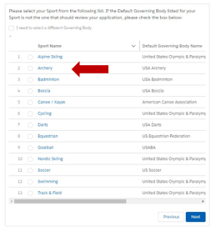

Next, the Veteran updates if they’re classified Olympic or Paralympic and if the Veteran has a VA rating for a service-connected disability (VAF 0918a, Block 3), as follows:

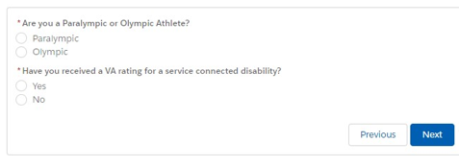

Next, the Veteran enters details on their training location (VAF 0918b, Block 6), as follows:

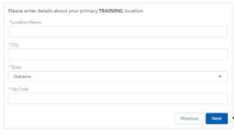

Next, the Veteran enters details on dependents until all dependents are updated (VAF 0918b, Section C), as follows:

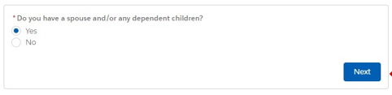
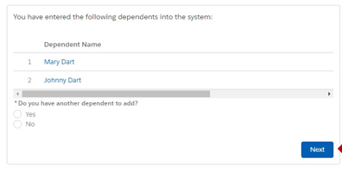
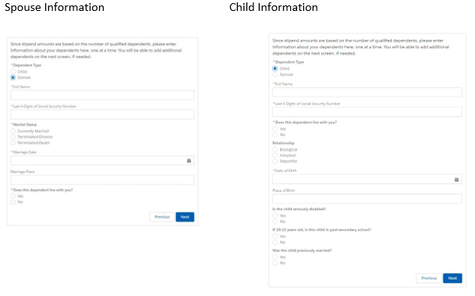

Once the above information is updated, the Veteran has completed data input for the application and presses next to submit to the applicable Olympic or Paralympic sport certifier for review. No additional input is required from the Veteran.

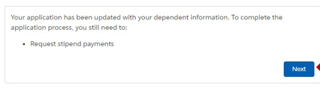

To create an allowance payment request through the app similar to the VAF 0918a, the Veteran first inputs sport-related data that verifies the Veteran met performance standards for the allowance (VAF 0918a, Blocks 2, 4B, 5A-C & 6C&D). Several items must be provided by typing the data in the provided space. The sport-related data input screenshot follows:
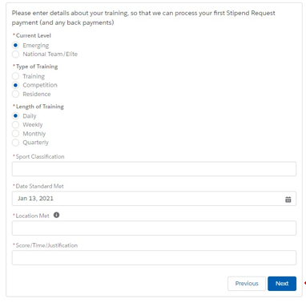

Next, the Stipends4Vets app is designed to aid the Veteran by pre-populating payment requests for current payments. However, Veterans may be qualified for payments for previous months. If the Veteran is qualified for a retroactive payment for a previous month, the Veteran enters the backpay eligibility in the app and fills out the data for that applicable month. Although the first screenshot shows a specific date regarding backpay, that date will update each month in the Stipends4Vets app to reflect the current payment month. Covering VAF 0918a, Blocks 6A-B, the current and backpay eligibility screenshot follows:

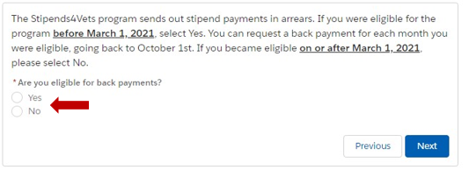
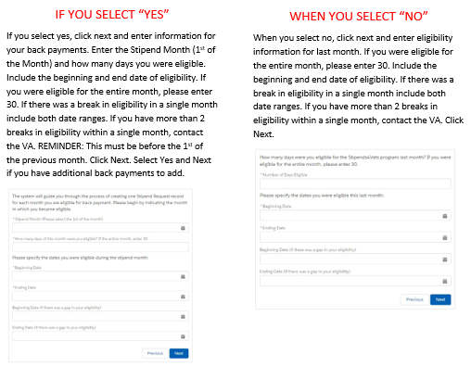

When the Veteran has determined all data has been updated for submission, the Veteran clicks “Next” and the payment is submitted to the applicable Olympic or Paralympic sport certifying official for review. No further action is required by the Veteran. The screenshot follows:

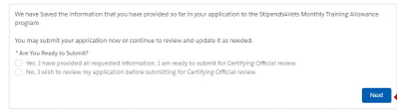

Attachment 2

Olympic and Paralympic Certifying Official Data Collection Requirements under the Stipends4Vets App for the VA Monthly Training Allowance

The Olympic and Paralympic sport certifying officials have only one entry on each of the VA Forms (VAF) 0918a and 0918b; they sign to certify the Veteran meets all of the requirements on the respective form and thus qualify for the VA Monthly Training Allowance. The Stipends4Vets app data collection equivalents for these forms follow.

Registration: Olympic and Paralympic sport officials must first register for an account on the Stipends4Vets app; this is a one-time occurrence. The screenshot for opening an account follows:

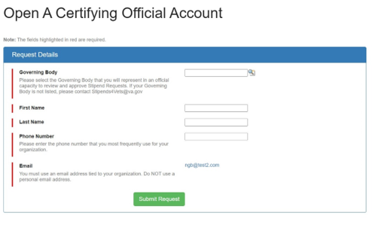
When a Veteran applies for the allowance, the appropriate Olympic or Paralympic sport certifying official will review the application to ensure the Veteran meets standards for eligibility. This is equivalent to the VAF 0918b. The certifier does not add any data at this point. The application data screenshot follows:

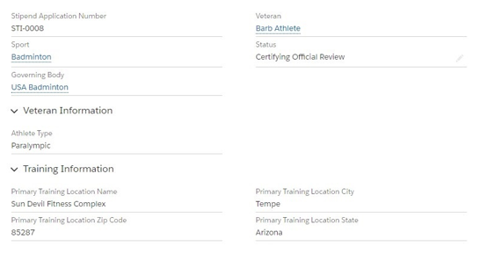
Similar to VAF 0918b, Block 7, the certifier either approves the application or updates it as ineligible. If approved, no further action is required, and the application is forwarded to VA. If ineligible, the certifier updates the “Ineligible” block with the reason for ineligibility and the application is returned to the Veteran. The certifier action screenshot follows:
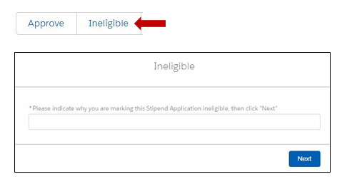

When a Veteran submits an allowance payment request, the appropriate Olympic or Paralympic sport certifying official will review the payment request to ensure the Veteran meets standards for payment. This is equivalent to the VAF 0918a. The certifier does not add any data at this point. The payment request data screenshot follows:
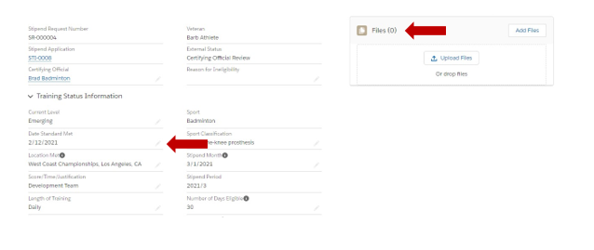
Next the certifier either approves the application request or updates it as ineligible. If approved, it matches VAF 0918a, Blocks 10A&B and no further action is required; the payment request is forwarded to VA. If ineligible, the certifier updates the “Ineligible” block with the reason for ineligibility like the screenshot above for the application request and the payment request is returned to the Veteran. The certifier action screenshot follows:

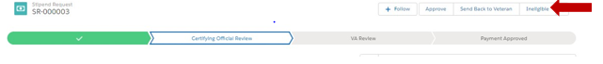
Attachment 3

VA Forms 0918a and 0918b

The revised VA Forms 0918a and 0918b are currently under review for OMB authorization for use for the VA Monthly Training Allowance. Copies of these forms follow for cross-referencing to their Stipend4Vets app electronic input counterparts.

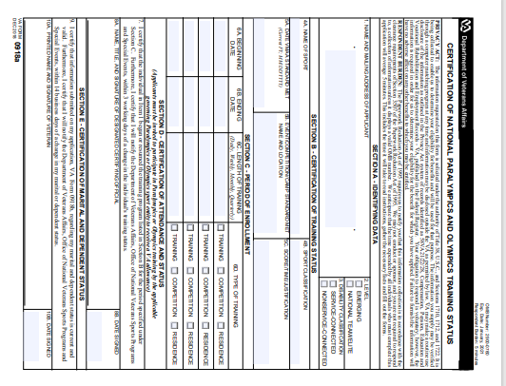
VA Form 0918a, primarily for certifying allowance payments

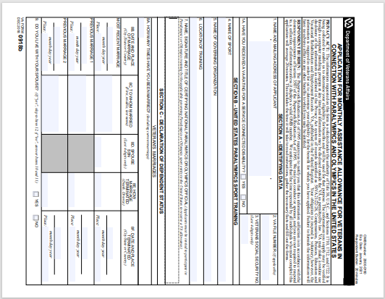

VA Form 0918b (page 1), primarily for certifying a Veteran’s eligibility for the allowance
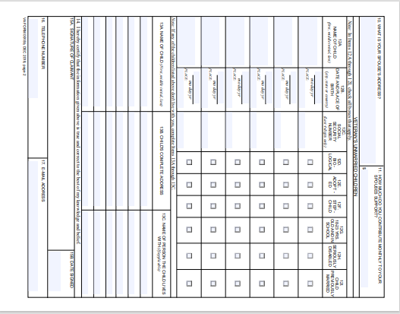
VA Form 0918b (page 2)

