Month/Year

Dear Farmer or Rancher,

The United States Department of Agriculture is conducting the 2017 Census of Agriculture to provide a complete picture of all U.S. farms and ranches and the people who operate them. Collected once every five years, this information is used to help make decisions that benefit you and your community – from decisions guiding succession planning and new and beginning farmer programs to decisions impacting agriculture practices, land stewardship, and sustainability.

Everyone who receives a census form is required by law to respond. If you are not farming, please reply promptly so we can update our records. You may respond in either of the following ways:

- Online – Respond online. It’s fast, secure, and cost effective. Go to www.agcounts.usda.gov and enter your unique 17-digit survey code from the census mailing label, then click “Continue.”
- By mail – Fill out the census form and return it in the envelope provided.

If you need assistance completing your census form, call toll free 1-888-424-7828. You will need the survey code found on your census mailing label. For more information visit www.agcensus.usda.gov.

The results of the 2017 Census of Agriculture will be available in aggregate form only, ensuring that no individual operation or producer can be identified as required by federal law. Results will be available in February 2019 at www.agcensus.usda.gov.

Thank you for responding and making the 2017 Census of Agriculture Your Voice. Your Future. Your Opportunity.

Sincerely,
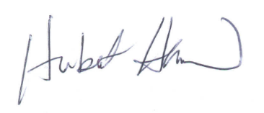
Hubert Hamer
Administrator, National Agricultural Statistics Service
United States Department of Agriculture

Enclosures

17-A01(L1)

It’s Convenient. It’s Secure.
Online Survey Response
Responding online is both convenient and secure. The online form:
- allows you to skip questions that don’t apply to you
- calculates totals automatically

To complete your survey online, follow these steps:
- Go to www.agcounts.usda.gov.
- Enter your unique 17-digit Survey Code from the label on the report form, then click “Continue.”
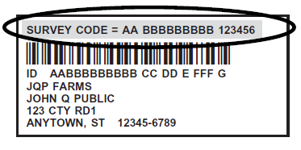
Survey Code

- Find the survey you are completing and click on it.
- Verify and complete your contact information, then continue to the survey.
- Complete the survey questions.

If you need to stop, press the “Save & Return Later” tab at the top of the page. When you return, go back to Step 1 above. After the opening page, you will be taken to the last page you completed.

- When you finish the survey, click “Submit.” If you do not see the Submit button, reduce the zoom setting on your screen.

You will receive a confirmation code and can choose to view your completed survey form. Using the options provided by your browser (Internet Explorer, Chrome, Mozilla, etc.), you can print, copy, or save the completed form.

