Corn (10 States)

Cotton (6 States)

Soybeans (11 States)

Winter Wheat (10 States)

Potatoes (7 States)
Objective Yield Survey

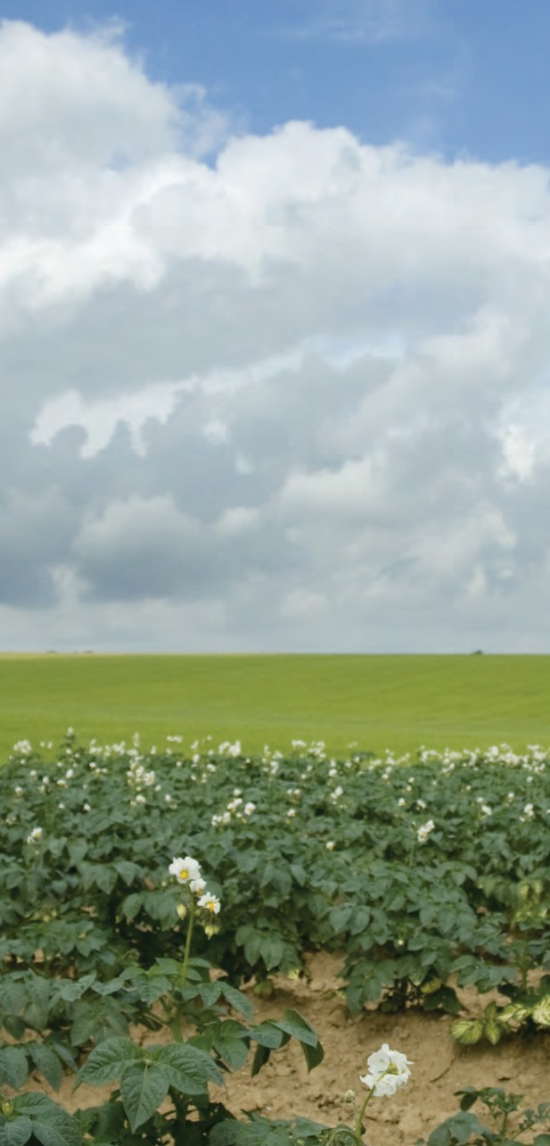
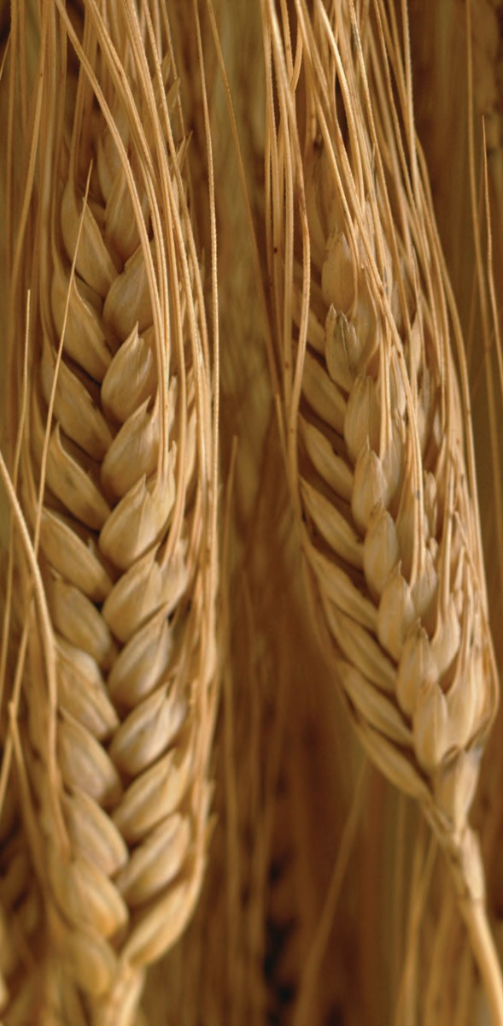
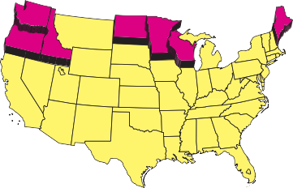
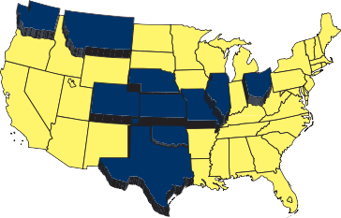
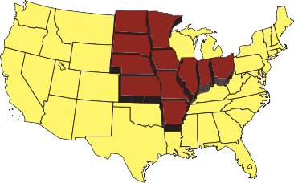
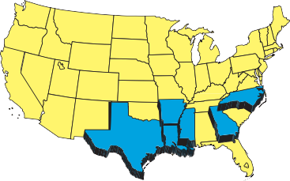
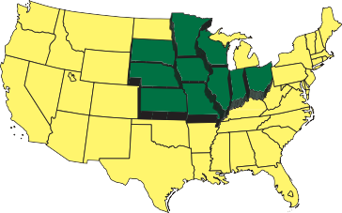
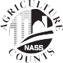
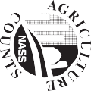
UNITED STATES
DEPARTMENT OF AGRICULTURE
NATIONAL AGRICULTURAL STATISTICS SERVICE
Rm 5030 South Building
1400 Independence Ave., S.W. Washington, DC 20250-9540

United States Department of Agriculture National Agricultural Statistics Service

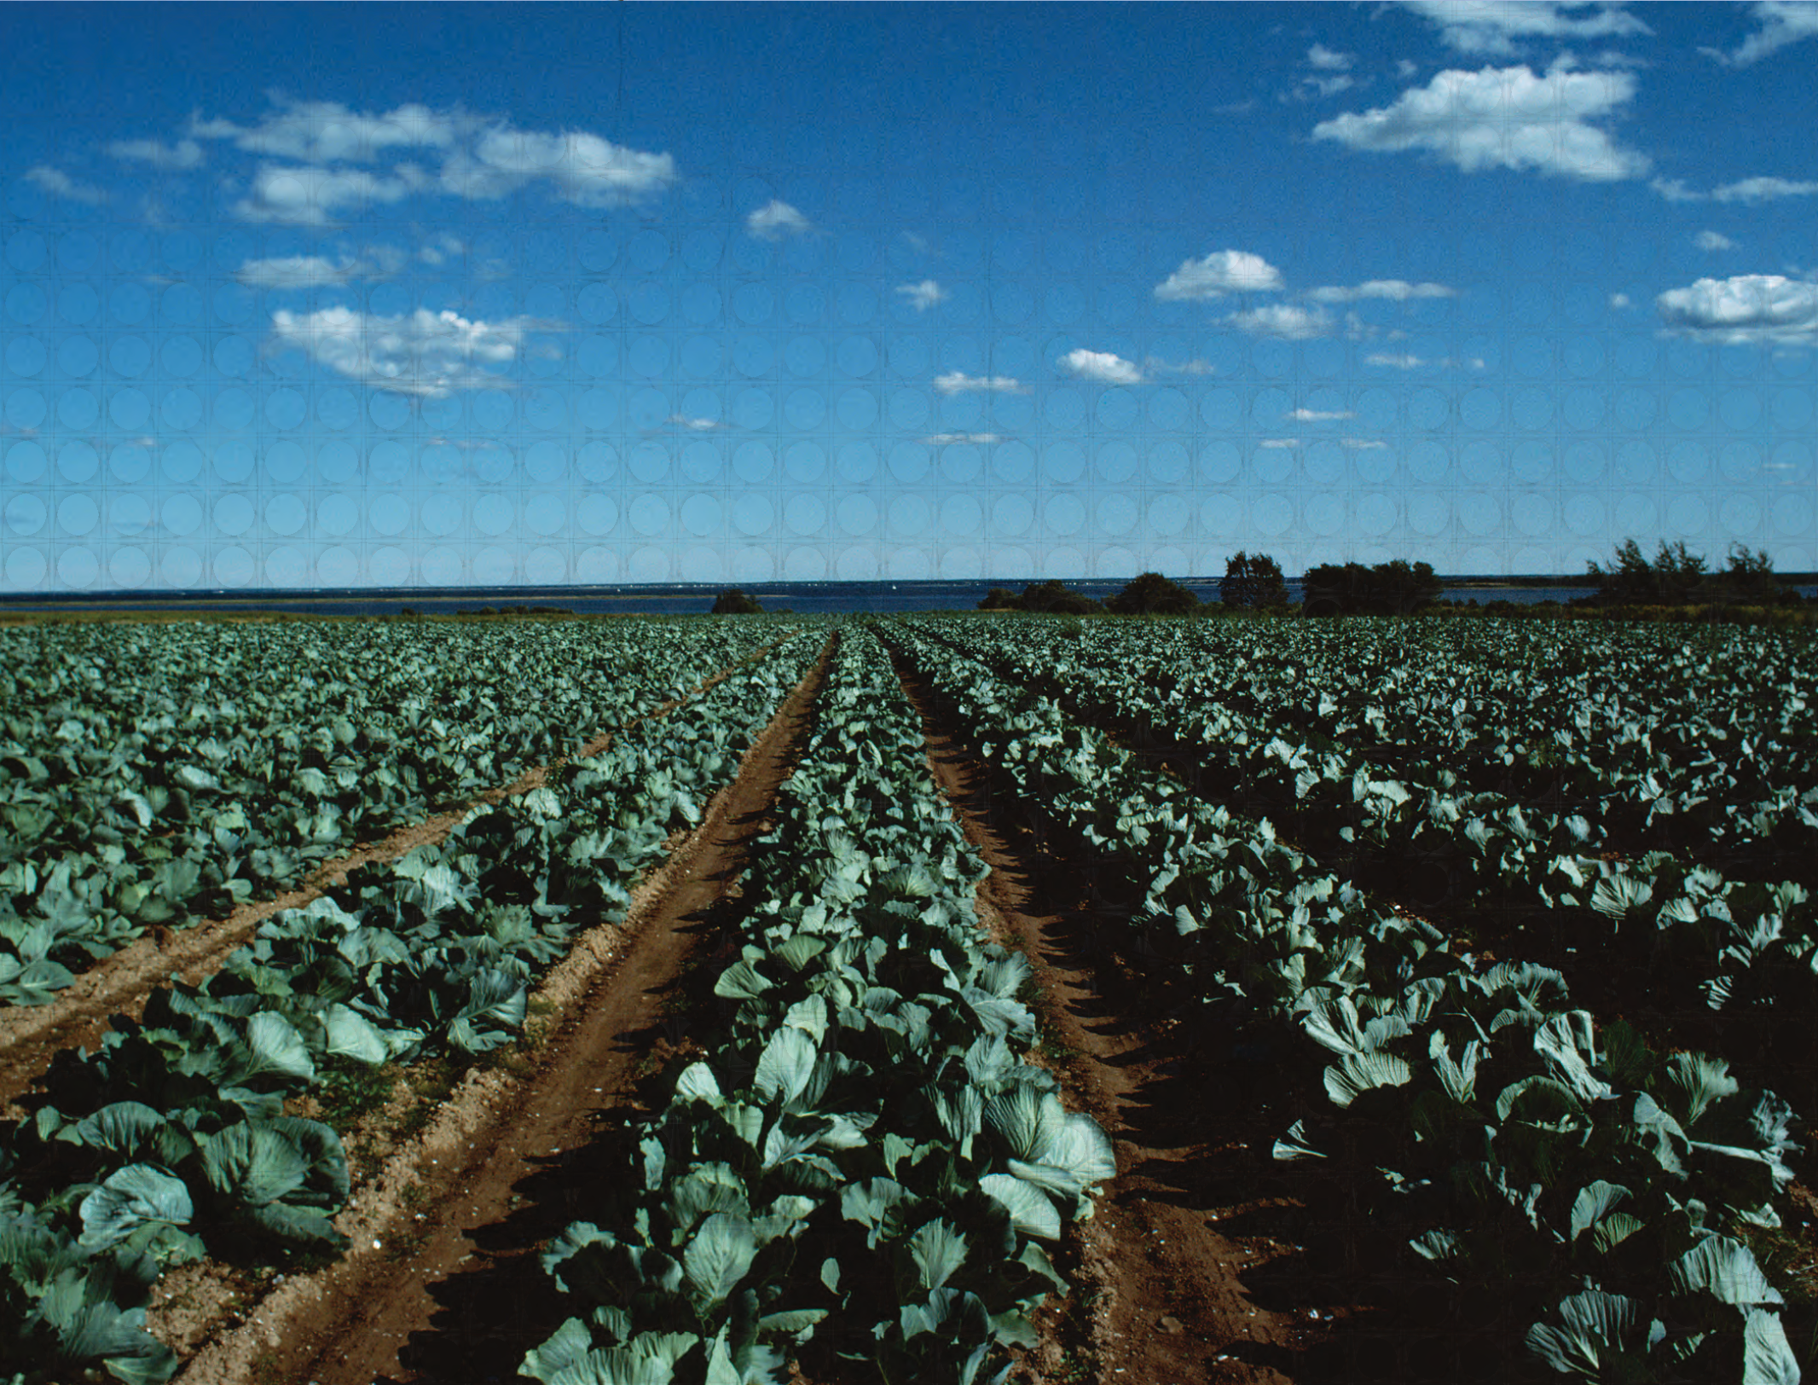
The Objective Yield Survey is the only USDA survey that provides actual
measurements of the current condition and progress of principal crops throughout the growing season.

For more than 50 years, the Objective Yield Survey has played an integral part in U.S. crop forecasts. Conducted by USDA’s National Agricultural Statistics Service (NASS), this survey gathers vital information needed to estimate production and provide early season forecasts.

NASS combines these field measurements with farmer-reported survey data to publish monthly crop production estimates. The information is used by farmers across
the country to make informed decisions about their operations. It is also used by federal, state and local governments, agribusinesses, financial institutions and many others who serve the agricultural community.

The crops included in the Objective Yield Survey are:

- Corn
- Soybeans
- Winter Wheat
- Cotton
- Potatoes

How is the survey conducted?
FREQUENTLY ASKED QUESTIONS
A NASS representative will visit selected fields to count and measure crop progress throughout the growing season. NASS will use this information to determine the per- acre yield, which is later used to calculate the total yield.

When is the survey conducted?
The Objective Yield Survey will begin in late April for wheat and late July for corn, soybeans, cotton and potatoes. Selected fields are revisited at the end of each month during the growing season to measure the crop progress.

What should I expect during
the first visit?
During the initial visit, a NASS representative will ask you to verify the acreage reported on previous NASS surveys. With your permission, the surveyor will then enter your field(s)
to collect plant and fruit counts and measurements.

How much of my involvement
is needed?
A NASS representative will need to speak with you during the first visit and the last visit after harvest. During the growing season, follow-up field visits conducted by NASS will not require your time.

Can I get my field’s yield from this survey?
No. The samples collected do not provide
an accurate assessment of the field itself. Reports are combined to calculate state- and national-level yield.

Will my information be kept
confidential?
Absolutely. Respondents are guaranteed by law (Title 7, U.S. Code) that their individual information will be kept confidential. NASS uses the information for statistical purposes and publishes data only in aggregate form only.

Where can I find results?
Monthly production forecasts are published in the Crop Production report, beginning in May. End-of-season estimates are issued in the annual Small Grains Summary in September and in the annual Crop Production Summary in January.

Where can I get more
information?
For more information about the Objective Yield Survey, call (800) 727-9540 or visit www.nass.usda.gov.

The U.S. Department of Agriculture (USDA) prohibits discrimination in all its programs and activities on the basis of race, color, national origin, age, disability, and, where applicable, sex, marital status, familial status, parental status, religion, sexual orientation, genetic information, political beliefs, reprisal, or because all or part of an individual’s income is derived from any public
assistance program. (Not all prohibited bases apply to all programs.) Persons with disabilities who require alternative means for communication of program information (Braille, large print, audiotape, etc.) should contact USDA’s TARGET Center at
(202) 720-2600 (voice and TDD). To file a complaint of discrimination, write USDA, Director, Office of Civil Rights, 1400 Independence Avenue, S.W., Washington, D.C. 20250-9410, or call (800) 795- 3272 (voice) or (202) 720-6382 (TDD). USDA is an equal opportunity provider and employer.

