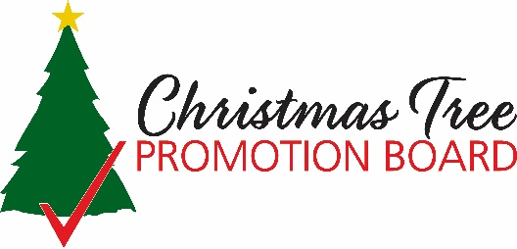

**CHRISTMAS TREE PROMOTION, RESEARCH AND INFORMATION ORDER**

**Donation Form**

***Thank you for your generous support!***

**Company Name:** _________________________________________________

**Address:** ________________________________________________________

**Phone:** _________________________________________________________

**Email:** __________________________________________________________

**Contact Person:** __________________________________________________

**Donation:** $__________________

**CHRISTMAS TREE PROMOTION, RESEARCH, AND INFORMATION ORDER**

**7 CFR § 1214.50** (f) The Board may accept voluntary contributions, but these shall only be used to pay expenses incurred in the conduct of programs, plans, and projects approved by the Secretary. Such contributions shall be free from any encumbrance by the donor and the Board shall retain complete control of their use.

*The Christmas Tree Promotion Board is authorized by the Commodity Promotion, Research, and Information Act of 1996 (7 U.S.C. 7411-7425) and its activities are subject to administrative oversight by the United States Department of Agriculture (USDA) as outlined under the Christmas Tree Promotion, Research and Information Order (7 CFR part 1214).  This form is your receipt for tax purposes, please retain a copy for your records.  It is not our intent to provide tax or legal information, so you will want to seek the assistance of a professional tax advisor regarding charitable deductions on your tax returns.  The Christmas Tree Promotion Board Tax ID number is IRS EIN# 47-3749864*

**Christmas Tree Promotion Board**

**Street Address**

**City, State, Zip**

**Phone: xxx-xxx-xxxx**

**Email:**

According to the Paperwork Reduction Act of 1995, an agency may not conduct or sponsor and a person is not required to respond to a collection of information unless it displays a valid OMB control number. The valid OMB control number for this information collection is 0581-0268. The time required to complete this information collection is estimated to average 15 minutes per response, including the time for reviewing instructions, searching existing data sources, gathering and maintaining the data needed, completing and reviewing the collection of information.

In accordance with Federal civil rights law and U.S. Department of Agriculture (USDA) civil rights regulations and policies, the USDA, its Agencies, offices, and employees, and institutions participating in or administering USDA programs are prohibited from discriminating based on race, color, national origin, religion, sex, gender identity (including gender expression), sexual orientation, disability, age, marital status, family/parental status, income derived from a public assistance program, political beliefs, or reprisal or retaliation for prior civil rights activity, in any program or activity conducted or funded by USDA (not all bases apply to all programs). Remedies and complaint filing deadlines vary by program or incident.

Persons with disabilities who require alternative means of communication for program information (e.g., Braille, large print, audiotape, American Sign Language, etc.) should contact the responsible Agency or USDA’s TARGET Center at (202) 720-2600 (voice and TTY) or contact USDA through the Federal Relay Service at (800) 877-8339. Additionally, program information may be made available in languages other than English.

To file a program discrimination complaint, complete the USDA Program Discrimination Complaint Form, AD-3027, found online at http://www.ascr.usda.gov/complaint_filing_cust.html and at any USDA office or write a letter addressed to USDA and provide in the letter all of the information requested in the form. To request a copy of the complaint form, call (866) 632-9992. Submit your completed form or letter to USDA by: 1) mail: U.S. Department of Agriculture Office of the Assistant Secretary for Civil Rights 1400 Independence Avenue, SW Washington, D.C. 20250-9410; 2) fax: (202) 690-7442; or 3) email: program.intake@usda.gov.

USDA is an equal opportunity provider, employer, and lender.