B: Small Business Pulse Survey Data Visualization Mockup

In the short-term, data will be represented in a user-friendly graphical format and available at https://www.census.gov/businesspulsedata as a featured experimental data product.

Home
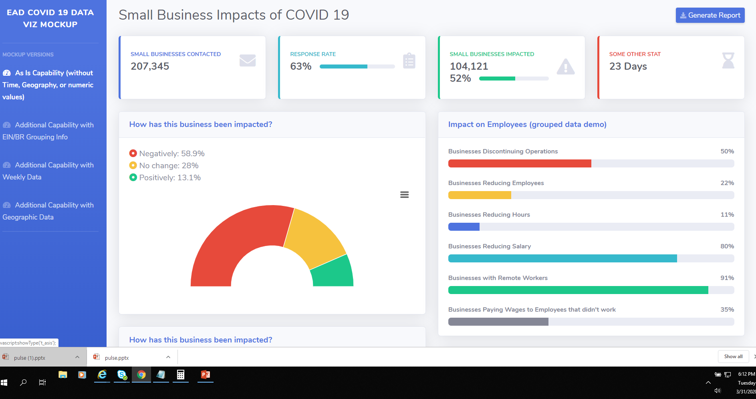

Yes No Questions
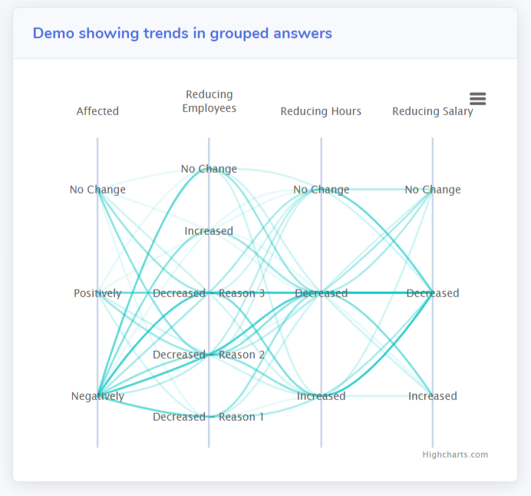

Using EINs
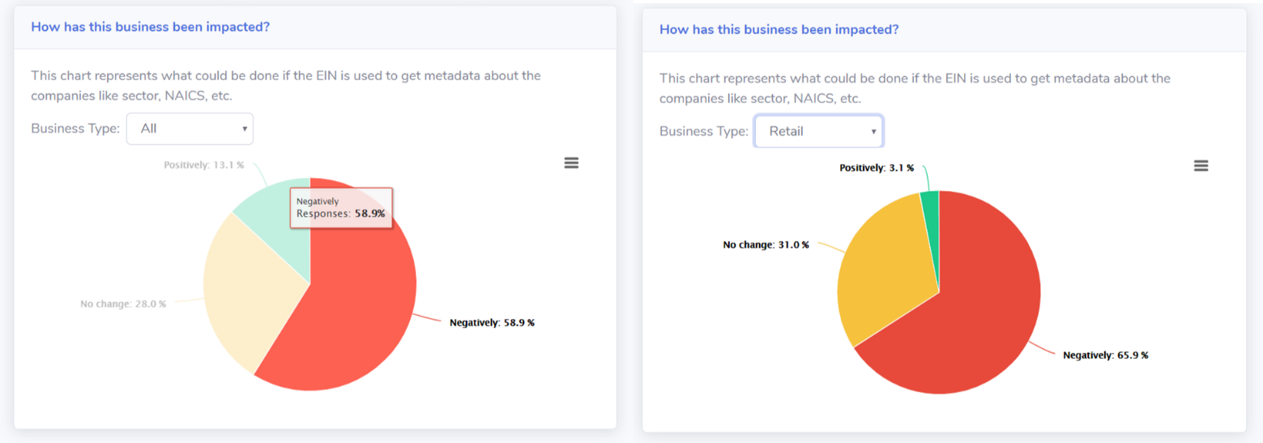

Trends
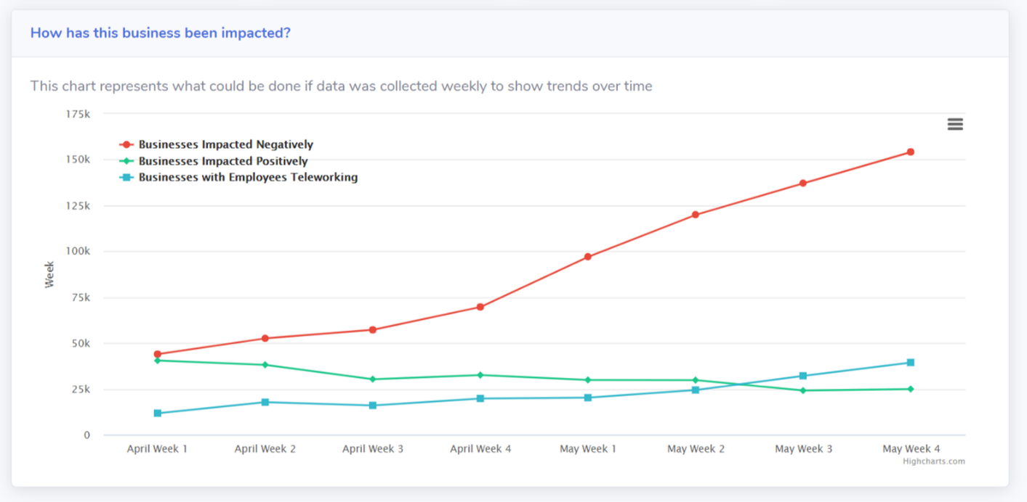

Geographical
