OMB No. 0915-0337
Exp. Date XX/XX/XXXX

The National Health Service Corps (NHSC) and Nurse Corps Interest Capture Form, which will be used when HRSA staff presents information regarding HRSA funding opportunities for health profession students and providers at national and regional conferences and at campus recruiting events, is an optional form that a health profession student, licensed clinician, faculty member, or clinical site administrator can fill out and submit to BHW representatives at the event. The purpose of the form is to enable individuals and clinical sites to ask BHW for periodic program updates and other general information regarding opportunities with the NHSC and/or the Nurse Corps via e-mail. An agency may not conduct or sponsor, and a person is not required to respond to, a collection of information unless it displays a currently valid OMB control number. The OMB control number for this information collection is 0915-0337 and it is valid until XX/XX/202X. This information collection is voluntary. Public reporting burden for this collection of information is estimated to average xx hours per response, including the time for reviewing instructions, searching existing data sources, and completing and reviewing the collection of information. Send comments regarding this burden estimate or any other aspect of this collection of information, including suggestions for reducing this burden, to HRSA Reports Clearance Officer, 5600 Fishers Lane, Room 14N136B, Rockville, Maryland, 20857 or paperwork@hrsa.gov.

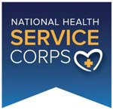
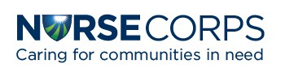
Interest Capture Form

Name: Email Address(es): Clinical Discipline: Title: Organization: City and State:

For Students
Univ/College:

Graduation Year:
1. Which NHSC and/or NURSE Corps Programs would you like to receive emails about?
- NHSC Loan Repayment Program
- NHSC Scholarship Program
- Ambassador Program
- Becoming an NHSC‐Approved Clinical Site
- NURSE Corps Loan Repayment Program
- NURSE Corps Scholarship Program
- Other (please specify)
2. What questions do you have about the NHSC and/or NURSE Corps?
3. When and how did you first hear about the NHSC and/or NURSE Corps?

