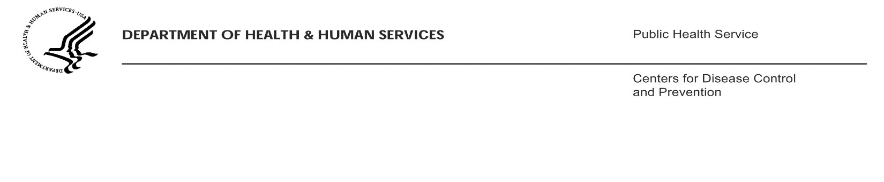

[INSERT Date]

[INSERT Airline Name]
Attn: [INSERT Name and Title of Airline Representative/POC]
[INSERT Airline Address]
[INSERT Airline POC Telephone Number]
[INSERT Airline POC Fax Number]

Dear [INSERT Name of POC]:

A public health authority notified the Centers for Disease Control and Prevention (CDC) of the travel history of an ill passenger. We believe this person was infectious during travel. In collaboration with CDC, area health departments are undertaking an investigation of possible contacts to this newly identified case for clinical evaluation of infection and treatment where indicated. Based on expert opinions as data are lacking, CDC considers the risk of infection for passengers on board the same flights as the ill passenger to vary depending on the aircraft size.

We are requesting information necessary to identify and locate passengers. This information may be provided directly to the requesting CDC Quarantine officer, or may be sent to the CDC Air Activity Case Manager via encrypted email to [HQ INSERT Air Activity Case Manager’s name] at [HQ INSERT Air Activity Case Manager’s e-mail] or by fax to (404) 498-0820.

If you have specific questions about the ill passenger or other potentially exposed passengers, you may direct them to [INSERT Name of lead QMO with e-mail and phone number]. If you have any questions about this order or how the requested information will be used by CDC, please contact the CDC Air Activity Case Manager by e-mail at [HQ INSERT Air Activity Case Manager’s e-mail] or by phone at [HQ INSERT Air Activity Case Manager’s telephone number].

Thank you very much for your assistance in this investigation.

Sincerely,

____________________________________________________
Clive M. Brown, MBBS, MPH, MSc, DTM&H (London)
Chief, Quarantine and Border Health Services

encl.
cc: [INSERT Name of lead QMO]

