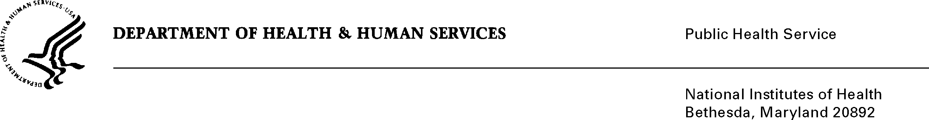

DATE: April 27, 2020

TO: Quinn Hirsch
Office of Management and Budget (OMB)
Reports Clearance Officer, DHHS

FROM: Mikia P. Currie
Chief, Project Clearance Branch

SUBJECT: Change Request to a Currently Approved Form
(OMB# 0925-0002, Expiration Date 2/28/2023)

This is a request for OMB to approve a non-substantial modification to Form PHS 6031-1 Annual Payback Activities Certification (APAC).

The changes to PHS 6031-1 Annual Payback Activities Certification (APAC) per red line strikethrough attached:
- updated language under Payback Requirements section to provide clarifying guidance on how individuals may satisfy the obligation
- updated the mailing address for the NRSA Payback Service Center

Your full consideration is appreciated.

Attachment A: PHS 6031-1 Annual Payback Activities Certification (APAC)

