**COVID ENHANCED OUTREACH (CEO) DESK GUIDE**

**Conducting Assigned CEOs – Represented Claimants**

1. Decision writers (DW) will conduct a CEO on cases in **Ready-to-Schedule (RTS)** or **Scheduled (SCHD)** status for represented claimants**. We are prioritizing cases in SCHD status.**
2. A Group Supervisor (GS) will add a case characteristic (CVEO) and assign a case to Unassigned ALJ Review – Pre Hearing (UNAP) status for the DW to complete a CEO. For cases in SCHD status, the GS will first put the case on SCHD HOLD before assigning the case to UNAP. For cases in RTS, the GS can assign the case to UNAP after the case characteristic has been added.

* DW will find assigned cases by running a *Workload Listing* for cases in UNAP status in CPMS and check for a valid 1696 or other appointment of representation. For reference, the publicly available 1696 form is accessible on the Social Security website, at [Claimant's Appointment of Representative](https://www.ssa.gov/forms/ssa-1696.pdf). Other publicly available forms related to the disability process are available at <https://www.ssa.gov/forms/>.
* In all cases assigned to a DW in UNAP, DW will first review the file for a potential on-the-record (OTR) decision. Refer to the detailed step-by-step instructions for completing an OTR review in Section 7 of this Guide.
* If the DW recommends a potential OTR fully favorable decision after a review of the evidence in the file, alert management for assignment to a Senior Attorney for further review, and do not proceed with the CEO.

1. DW will follow the steps in the CEO Encrypted Email Guide and attempt to email the representative the electronic file in advance of the CEO contact if the representative does not have access to Electronic Records Express (ERE)
2. DW will create a ***Report of Contact (ROC)*** for each SSN via DGS by selecting Co*rrespondence*, then *Other,* then *Report of Contact.* The DW can then associate the ROC with the claimant’s SSN, select *Done,* andsave the ROC to his or her folder on the shared drive. The following is an example of a ROC generated using DGS:

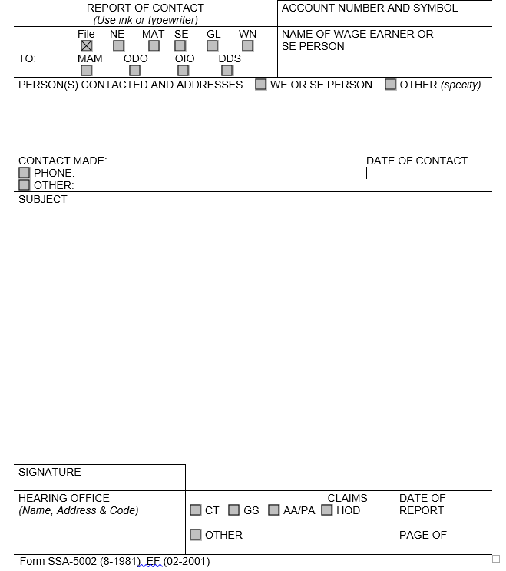

* Use the ROC to document whether contact was made, and, if successful, what transpired at the CEO. The DW can use the templates found in section 7 of this Guide to assist with completing the ROC following a CEO.

1. DW will then check the *Parties of Interest* screen to see if an interpreter may be needed. If the representative needs an interpreter, the DW should:

* Contact the interpreter line at (1-800-200-7236) or (1-818-504-1296)
* Tell the interpreter to hold, and then press the *Conference* soft key.
* Then dial the representative’s number, and after the representative picks up, press the *Conference* soft key a second time.
* Ask the interpreter to relay that you are calling the representative from the Social Security Administration to gather some information about their claim for disability benefits.
* DW should update the *Parties of Interest* languages section and the *Scheduling & Hearing Held* page of CPMS as applicable.

1. Call the representative from his or her agency issued Softphone at the number on file and proceed as directed below.

* If the DW is unable to reach the representative, the DW should leave a voicemail identifying himself or herself as set forth in the Introduction and Confirmation section below, and requesting that the representative call back to discuss the claim as soon as possible.
* DW should diary the case for seven (7) days, or sooner as workloads demand, and call the representative again at the end of the diary period.
* If the DW is unable to reach the representative on the second attempt, the DW should deem the CEO unsuccessful and proceed as instructed in Section 7, below.

If contact is successful, proceed with the CEO as follows:

1. **Introduction and confirmation of representation**

[If no prior contact through email]

“Good morning/afternoon. My name is _________________ and I am [position title] with the [hearing office location] in the Social Security Administration.

May I speak with ___________________? Can you verify your name and address?”

[Ensure the information the representative provides matches the information that appears on the SSA-1696.]

[If no, politely end the call. If yes, proceed as follows:]

“Are you the representative for the claimant [Claimant Name]?”

[If the representative indicates that they do not represent the claimant, politely end the call. If the representative confirms that they represent the claimant, state the following:]

“As you may know, the coronavirus, or COVID-19, pandemic has required us to change our business process. I am calling you today to discuss those changes. Do you have a few minutes to talk?”

[If prior contact through email]

“Good morning/afternoon. This is _________________ calling again from the Social Security Administration.

Is this ___________________? Can you verify your name and address again for me?

[Ensure the information the representative provides matches the information that appears on the SSA-1696.]

As I previously stated in my email, I am following up with you today to discuss changes in our business process. Do you have a few minutes to talk?”

[If the representative is unavailable to speak at that time, set up a more convenient time to call back.]

[If the representative does not wish to proceed, inform the representative that the CEO cannot continue and must now end.]

1. **Inform the representative that hearings will be conducted by telephone**

[For cases in RTS prior to UNAP status]

“Due to the current COVID-19 public health emergency, we are only conducting hearings by telephone at this time. The Administrative Law Judge assigned to hear the case will conduct the hearing from his or her personal residence. The Administrative Law Judge will take every reasonable precaution to protect your client’s personal information and to ensure the hearing remains private. In order for us to schedule the hearing, you will need to agree to a hearing by telephone. Do you agree to proceed with a telephone hearing?”

[If yes,] “We will send you and your client a notice containing the date and time of the hearing. On the day of the hearing, we will call you at the number you have previously provided.” [Confirm with the representative the phone number for the claimant and representative that we have on file and make any changes that the representative provides.]

[If your supervisor informs you that the cases you are calling about will be scheduled less than 75 days out, state the following] “We generally must provide at least 75 days’ notice in advance of a hearing. Because we must schedule the hearing in less than 75 days, we cannot provide this advance notice. Do you agree to waive advanced notice of the scheduled hearing?”

[If representative does not agree to a telephone hearing or 75 days’ notice]

“Since you have not agreed to a telephone hearing [or to waive 75 days’ notice], we cannot schedule the case for a hearing at this time. We will schedule the hearing once our offices reopen.” [DW should add the refusal in the ROC, proceed to the file review and evidence development section, and follow the steps at the end of this document, including adding the appropriate case characteristic (CVNC, CVTA, CVTD).]

[If representative requests blanket denial of telephone hearing in all cases, document in ROC and alert management]

[For cases in SCHD status prior to UNAP]

“We scheduled your client to appear at the hearing [choose in person or by video teleconferencing, as applicable]. Due to the current COVID-19 public health emergency, we are only conducting hearings by telephone at this time. The Administrative Law Judge assigned to hear the case will be conducting the hearing from his or her personal residence. The ALJ will take every reasonable precaution to protect the claimant’s personal information and to ensure hearings remain private. In order to proceed with the hearing on the scheduled date and time, you will need to agree to appear by telephone.

If the claimant does not wish to appear by telephone, we will postpone the hearing for a future date. Due to COVID-19, however, we cannot predict when the hearing will be rescheduled. Do you wish to conduct the hearing over telephone, or would you like us to postpone the hearing?” [Postponement is effective if the representative verbally states that he or she wishes to postpone the hearing.]

[If representative does not agree to a telephone hearing]

“Since you have not agreed to a telephone hearing, we must postpone the scheduled hearing at this time. We will reschedule the hearing once our offices reopen. When the agency reschedules the hearing, we will mail an amended notice of hearing that includes the new date and time, at least 20 days before the date of the rescheduled hearing.” [DW should add the refusal in the ROC, proceed to the file review and evidence development section, and follow the steps at the end of this document, including adding the appropriate case characteristic (CVNC, CVTA, CVTD).]

1. **When applicable, ask the representative if the claimant will waive the right to an amended notice of hearing mailed at least 20 days before the hearing**

[For SCHD cases prior to UNAP, if representative wants to proceed with the telephone hearing, and if waiver applicable]

“Because we are changing the claimant’s manner of appearance, we are required to mail an amended notice of hearing at least 20 days before the date of the hearing. However, less than 20 days remain before the date of the hearing, so we cannot proceed with the hearing as scheduled unless the claimant waives his or her right to an amended notice of hearing. If the claimant does not waive the right to an amended notice of hearing, we must reschedule the hearing for a later date. Does the claimant agree to waive the right to an amended notice of hearing?”

[If the representative does agree] “On the day of the hearing, we will call you and the claimant at the numbers you have previously provided.” [Confirm with the representative the phone numbers we have on file for the claimant and the representative. Make any changes that the representative provides.]

[If the representative does not agree, DW should add the refusal in the ROC, proceed to the file review and evidence development section, and follow the steps at the end of this document, including adding the appropriate case characteristic (CVNC, CVTA, CVTD).]

1. **Discuss the electronic file with the representative**

Mr./Ms. Representative, do you have access to the claimant’s electronic file?

[If yes, ask if the representative has any questions about the evidence in the file. **DO NOT** conduct file review if representative has access to ERE. Move to Section E.]

[If no, and representative received an email containing the efile]

“On [Date/time], I sent you an email containing the evidence we have in your client’s case [Verify that the representative received the email and reviewed the evidence.

If so, ask the representative if he or she has any questions about the evidence in the file.

After completing this step, move to Section E]

[If records reflect representative did not receive an efile but received a CD]

“Our records show that you received a CD containing the evidence in the file on xx/xx/xxx.”  [Verify that the representative has received a CD.  If so, ask the representative if he or she has any questions about the evidence in the file, and identify any new exhibits that have been added to the file. Move to Section E.]

[If the representative does not have ERE access and has not received a CD or email with the efile, proceed with the below information and walk them through the evidence in the file.]

“Due to the COVID-19 public health emergency, we are unable to provide you with a CD containing the evidence in the claims file. Our offices are currently closed, so you cannot visit one of our offices to review the evidence in person, as would normally be the case. For these reasons, I will now walk you through the evidence in your claims file.

Our claims file divides the evidence in the case file into five sections, comprised of sections A, B, D, E, and F. I’ll begin with Section A. If you have any questions as I proceed through the evidence, please let me know and I will answer any questions if possible.

Section A contains documents explaining any past decisions the claimant received from the Social Security Administration regarding his or her claim. [List the total number of exhibits in section A, then walk through each exhibit in Section A, stating the title and providing a brief description of each exhibit].

Section B contains the jurisdictional and procedural history of the case, including certain notices we have sent the claimant about the status of his or her case. [List the total number of exhibits in section B, then walk through each exhibit in Section B, stating the title and providing a brief description of each exhibit].

Section D contains our records of the claimant’s wage and earnings reports. [List the total number of exhibits in section D. Do **not** walk through each exhibit, state the title, or provide a brief description of each exhibit].

Section E contains the documents we send the claimant requesting additional information, as well as any forms that we asked him or her to complete. [List the total number of exhibits in section E, then walk through each exhibit in Section E, stating the title and providing a brief description of each exhibit].

Finally, section F contains all of the medical records in the claims file. [List the total number of exhibits in section F, then walk through each exhibit in Section F, stating the title and providing a brief description of the exhibit].

[After you have completed a walkthrough of the evidence] The evidence in the claims file is what the Administrative Law Judge will consider when issuing a decision in your client’s claim for disability benefits.”

1. **Advise the representative of the importance of updating the record**

“Please make sure that we have all records prior to the scheduled hearing.” [For representatives who use ERE, please encourage them to submit evidence through this route]. “Having a complete file before the hearing prevents delays. With that in mind, you must generally inform us about, or submit your records no later than five business days before the hearing. If you need to inform us about or submit written evidence but miss the five-day deadline, please let us know that and tell us why you missed the deadline. We are mindful and acknowledge that the COVID-19 pandemic may give rise to unusual, unexpected, or unavoidable circumstances beyond your control that prevent you from meeting such a deadline, however.

Are you aware of any outstanding evidence that has not been obtained?”

1. **Reminders and Best Practices [Not to be read to the representative, for internal use only]**

* Do not communicate with the representative in an adversarial manner.
* If a representative becomes abusive or discourteous, end the call and contact your supervisor.
* Keep your discussion focused on issues of the telephone hearing, representation, current work activity, and medical evidence.
* If your Softphone has technical issues, do not use your personal phone. Use the guidance provided by OESSI and contact your supervisor.

1. **After the CEO contact has concluded, take the following steps as appropriate**
2. If applicable, DW should create a Development in CPMS assigned to the supervisor, to communicate necessary development as indicated in the ROC. To create a Development item:

* In CPMS *Development* screen, select *Add New Development*

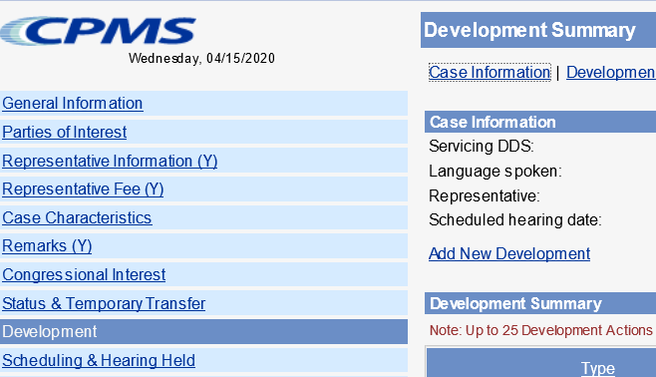

* Development group: *Other*
* Type: *Unsolicited Development*
* Place development in the supervisor’s name.

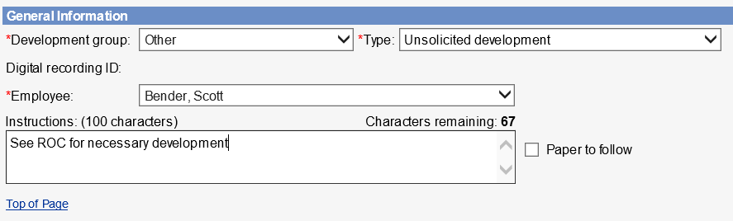

* Select the radial button that states *Request has not been sent*, click *Save*.

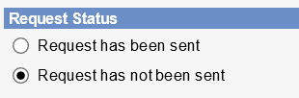

1. DW should add the appropriate case characteristic (CVNA, CVTA, CVNC).
2. DW should copy/paste the completed ROC Template into the ROC in the SUBJECT section, then send to eView by selecting the ADD-INS button, then Send to eFolder, then SEND.

If contact was unsuccessful, use the following ROC format:

**I *did not* reach the representative for a COVID Enhanced Outreach.**

**Provide reason(s) for unsuccessful attempt:**

**Confirm if voicemail(s) left:**

**Call(s) attempted on (Date(s)):**

If contact was successful, use the following ROC format:

**I reached the representative for a COVID Enhanced Outreach Conference on the date of this ROC.**

**During the CEO, I:**

* Verified the representative’s identification and case information
* Informed the representative that the hearing will be conducted by telephone and obtained agreement to the manner of appearance
* [If applicable] Informed the representative that the hearing will be postponed
* [If applicable] Obtained waiver of 75-day advance notice for RTS cases
* [If applicable] Obtained waiver of 20-day advance notice for SCHD cases
* Confirmed the representative [received a CD/has access to the electronic file/has no access to the evidence]
* [If applicable] Discussed the evidence in the claimant’s file
* Informed the representative of the responsibility to obtain information, including updated medical evidence, and provide it to the hearing office as soon as possible, but at least 5 business days prior to the scheduled hearing date
* **I also asked the representative about any updated medical sources. They reported the following:**

**(Include (1) Clinic or Doctor's name; (2) Address; (3) When to request records from)**

1. If the CEO contact was successful and the representative agreed to a telephone hearing, DW will create a brief outline and associate with the case.
2. **Follow the below steps for the Brief Outline and On-the-Record Review**
3. Run a Case Processing and Management System (CPMS) Workload Listing of cases in UNAP status.

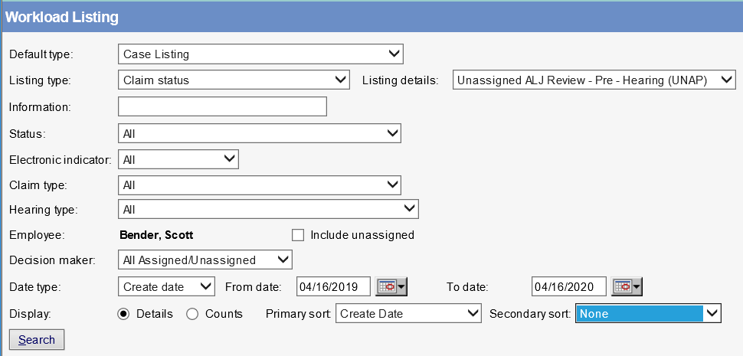

1. Select the appropriate case by clicking the claimant’s name.
2. In the case entry, click the “HACPS Case Analysis” link at the top right of the screen to launch the *HACPS Case Analysis* application.



1. Select “Case Notes” within the Open Case Analysis box.



1. If the CEO contact was successful and the representative agreed to a telephone hearing, use the “General Notes” feature in Case Analysis to add a “General Note” that contains a brief outline of observations and any relevant issues that came up during the CEO.

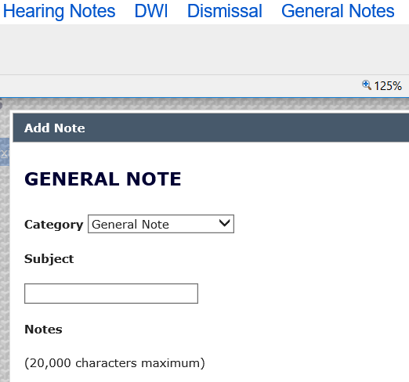

1. In the General Note, include the following information:

* The representative was informed that the hearing would take place by telephone and the hearing would be postponed if he or she did not agree to waive the 20-day notice requirement.
* Document whether verbal waiver was obtained.
* Any recent medical treatment identified by the representative that may need to be obtained.
* Any observations that might be helpful for a future reviewer or adjudicator.

1. In any case assigned for a CEO, use the “General Notes” feature in Case Analysis to add an “OTR Review Note” that contains the analysis of the claimant’s file and recommendation as to whether or not a fully favorable decision is recommended. **NOTE**: This is a separate entry from the “Brief Outline” discussed above.

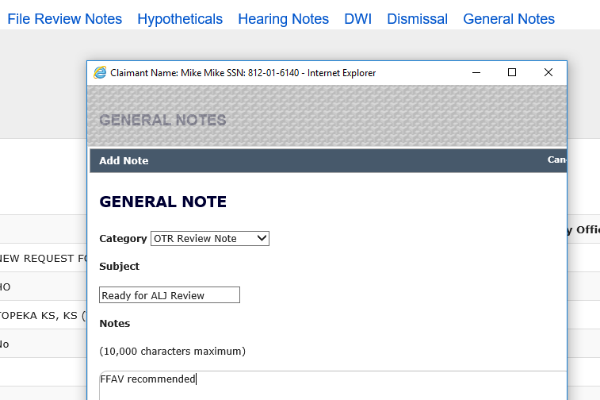

1. In eView, add queries to Section D of the Certified Electronic Folder (CEF), if necessary (A guide for adding queries to the CEF is available here):

* Information/Certified Earnings Record System (ICERS)
* Detailed Earnings Query (DEQY)
* Summary Earnings Query (SEQY)
* National Directory of New Hires, Wage, and Unemployment Query (NDNH)
* To add queries in eView, click on the "Queries" hyperlink in the Case Documents tab, which will open a "Query Selection Screen." Select "View & Save to EF" in the Query Selection Screen and the query will appear under the queries section of the electronic file in eView.

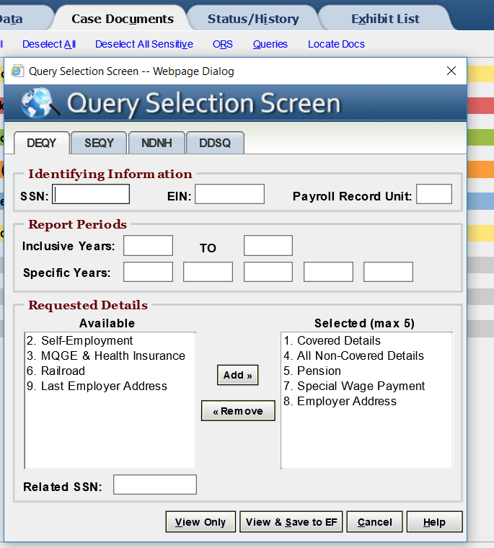

NOTE: The DEQY on the “Query Selection Screen” in eView will automatically select Covered Details, Non-Covered Details, Pension, Special Wage Payment, and Employer Address.  Additionally, run the DEQY covering the period beginning 15 years prior to the date of adjudication of the issue of initial entitlement or continuing disability, unless it is a title II only claim with a date last insured in the past.  In those claims, run the DEQY covering the period beginning 15 years prior to the expiration of the claimant’s insured status.

* Lock the case, then select the queries and move them to the D Section.

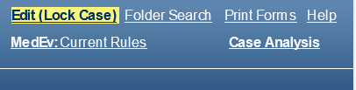

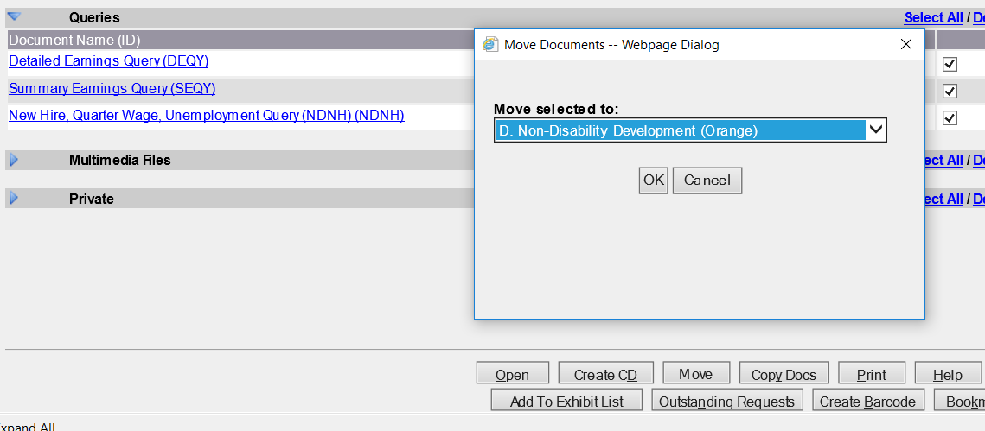

* For instructions on how to upload the ICERS query to eView, refer to [“Push to eView” Template User Guide](http://oho.ba.ssa.gov/resources/workload/hearing-level/dgs/push-to-eview-template/push-to-eview-user-guide2/).

1. Review the medical evidence and other evidence of record to evaluate whether a preponderance of the evidence supports a fully favorable decision.

* Ensure the claimant’s wage and earnings records do not reflect disqualifying substantial gainful activity.
* In Title II cases, note the claimant’s date last insured (DLI) or other date relevant to eligibility.
* Review the claimant’s medical records in Section F (and Section E, as needed) for evidence that may support further review by a Senior Attorney related to whether the claimant has a severe impairment that meets a listing at Step 3 of the sequential evaluation process.
  + If the evidence does not support a potential OTR fully favorable decision at Step 3, perform a cursory review of the evidence related to past relevant work and other work.
  + Considering the claimant’s age, education and work experience, without proposing a residual functional capacity, note if the evidence may support a finding that:
    - Applying the special medical-vocational profiles results in an inability to make an adjustment to other work;
    - Directly applying a grid rule in the medical-vocational guidelines results in a finding of disability at Step 5; or
    - Using the medical-vocational guidelines as a framework results in a finding of disability at Step 5.

1. **Once the CEO and OTR have been completed, assign the case in the appropriate status based on the outcome of the case.**

* For cases previously in RTS prior to UNAP, move from UNAP to RTS and assign to the supervisor.
* For cases previously in SCHD prior to UNAP:
  + Where the representative has agreed to a telephone hearing, go into the Scheduling & Hearing Held Summary and click the “Remove from Hold” link. It will automatically update the case back to SCHD status.
  + Where the representative has NOT agreed to a telephone hearing, assign to the supervisor in UNAP, with an alert that the hearing needs to be postponed.

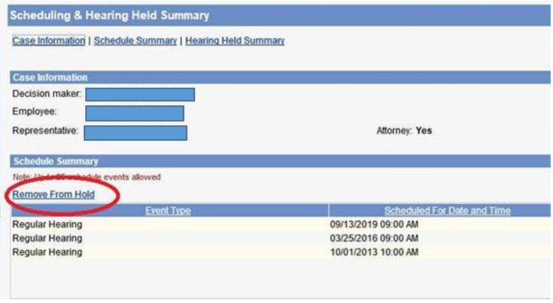

* Add the appropriate case characteristic based on the outcome of the CEO:
  + CVTA – Telephone hearing accepted
  + CVTD – Telephone hearing declined
  + CVNC – Unable to make contact with the claimant

