TPP PM Data Submission Pages
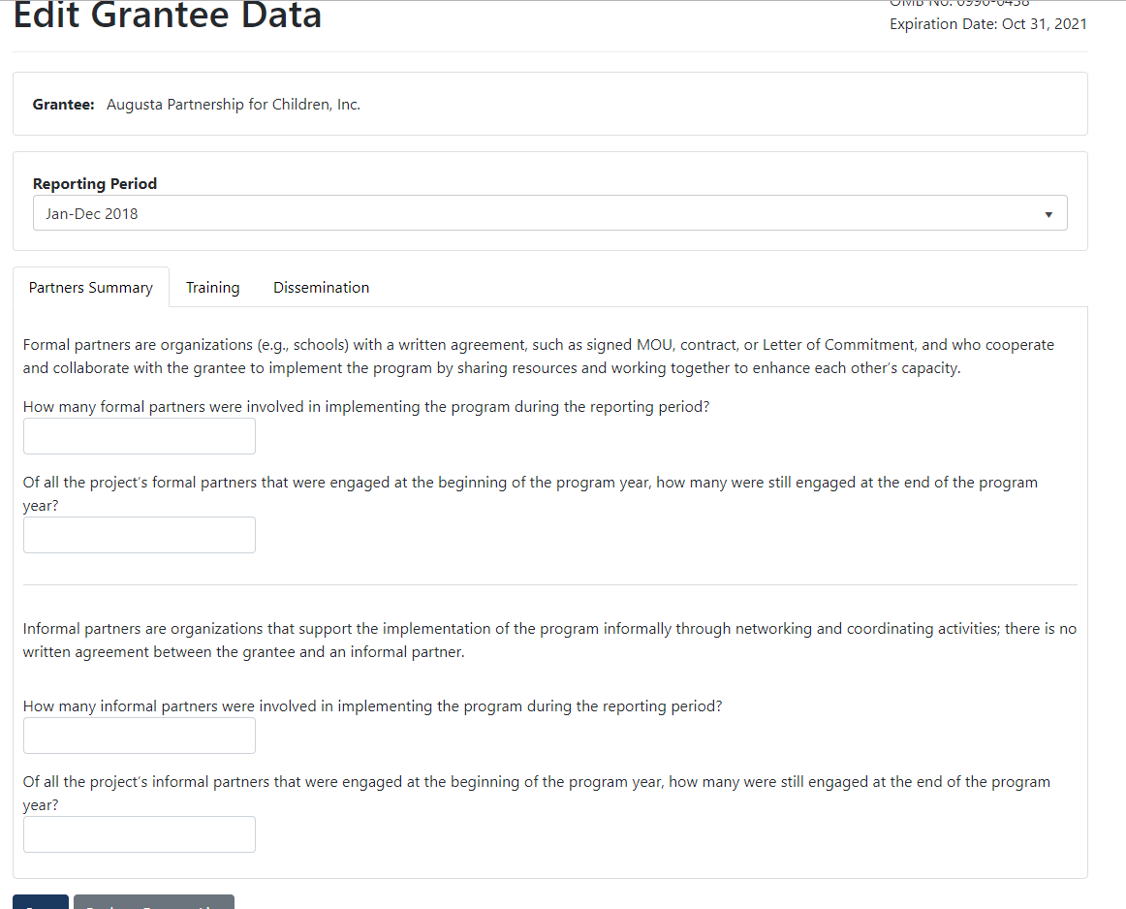
The screenshots shown below are the screens that the grantees will use to submit data. The data dictionary from the existing system and the list of performance measures were used to identify the data elements.

Partners Summary

Training
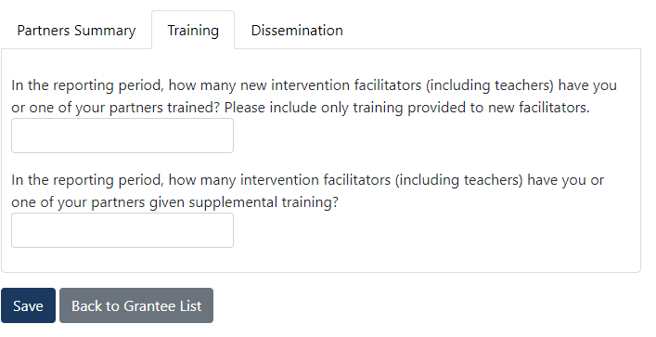

Dissemination
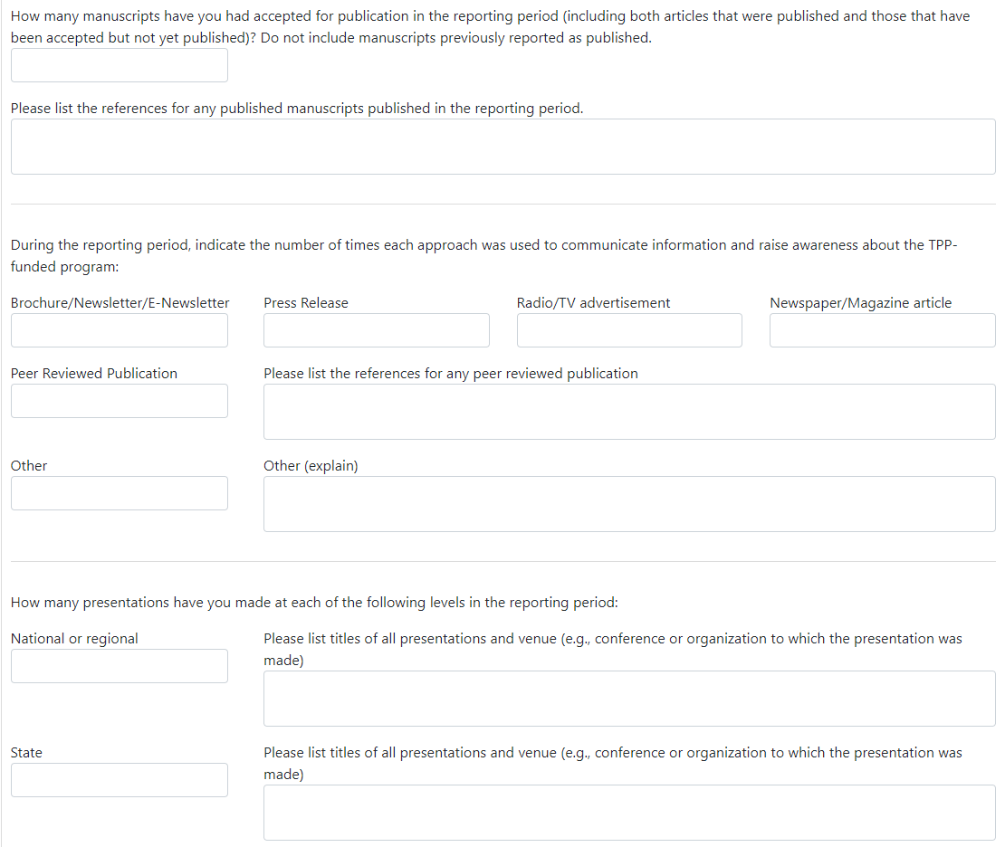

Grantee Level Costs - Personnel Costs
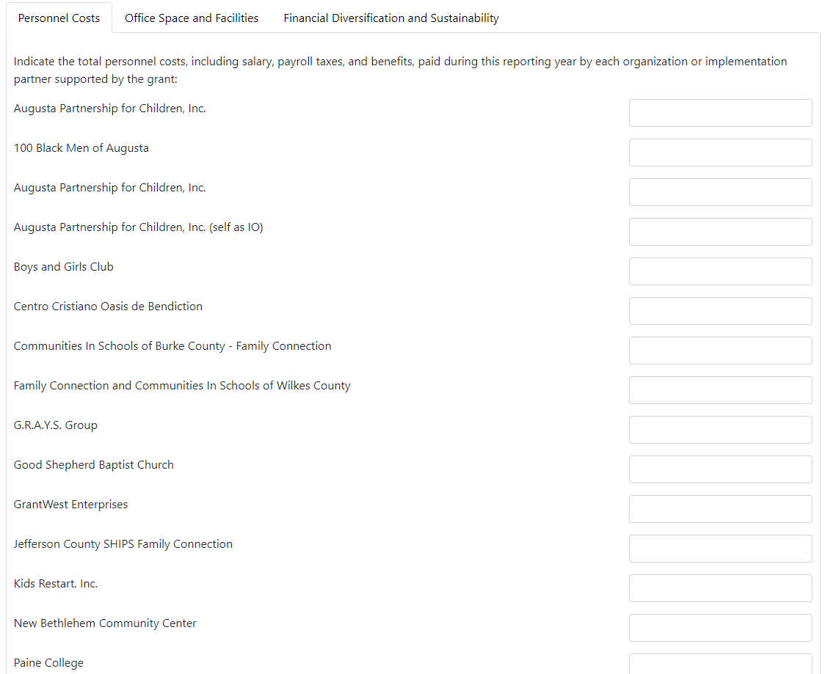
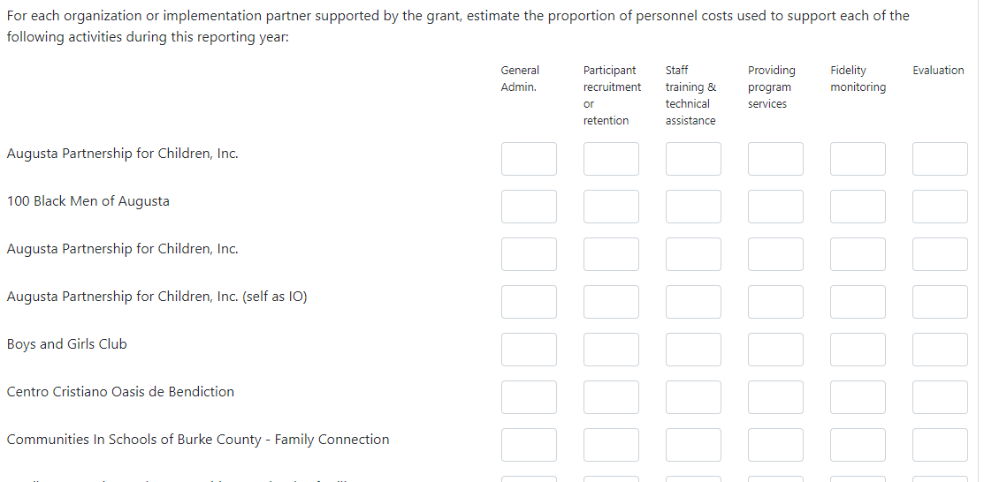

Grantee Level Costs - Office Space and Facilities

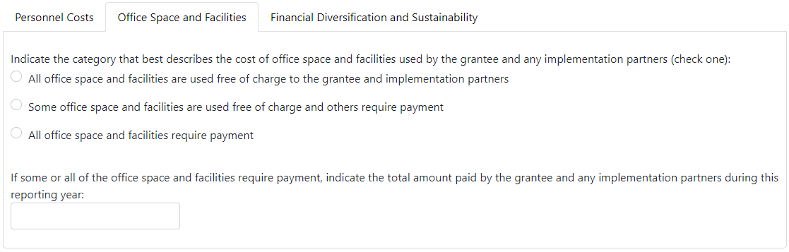

Grantee Level Costs - Financial Diversification and Sustainability

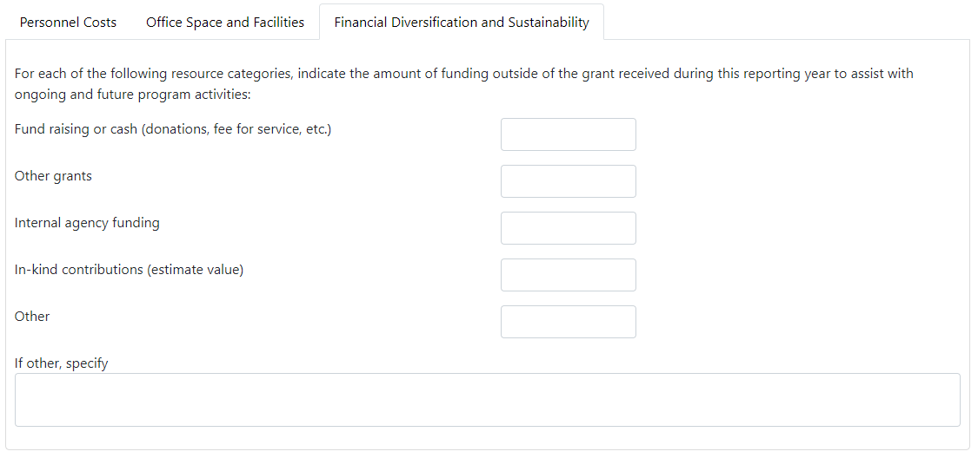

IO Level Data - Section Data

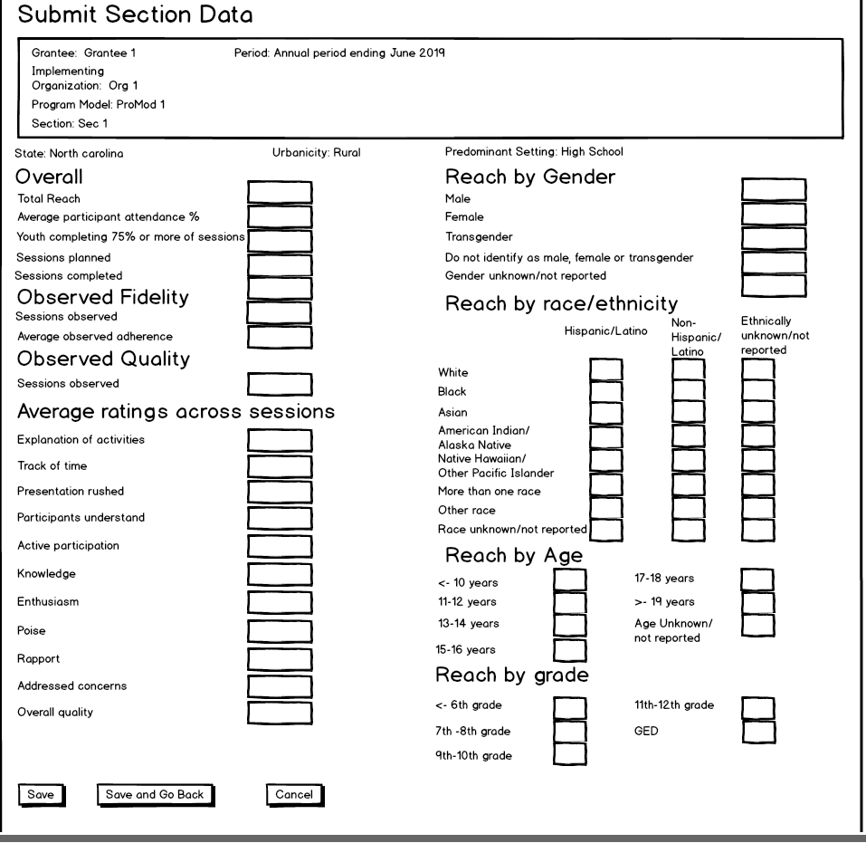

IO Level Data – Healthcare Linkages

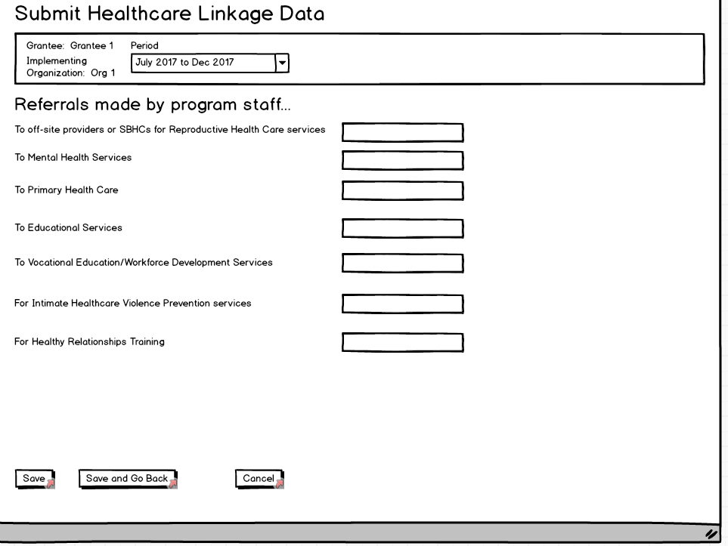

IO Level Data - Costs

