B. Collection of Information Employing Statistical Methods

1. Universe and Sample Selection
Local jails are publicly or privately operated facilities that generally have the ability to hold inmates beyond 72 hours and beyond arraignment. Facilities include jails, detention centers, city or county correctional centers, special jail facilities (such as medical or treatment centers and pre-release centers), and temporary holding or lockup facilities that are part of the jail’s combined function. The universe for the Annual Survey of Jails (ASJ) includes all local jails (city, county, regional, and private) in the United States, except—(1) jails in Indian country, which are covered by the Survey of Jails in Indian Counties (OMB Control No. 1121-0329); and (2) detention facilities in six states with combined prison-jail systems (i.e., Alaska, Connecticut, Delaware, Hawaii, Rhode Island, and Vermont), which are surveyed in BJS’s Census of State and Federal Adult Correctional Facilities (OMB Control No. 1121-0147) and National Prisoner Statistics (OMB Control No. 1121-0102). However, Alaska has 15 jails that are locally operated and these facilities are included in the ASJ universe.
The 2020 ASJ universe is identified through the 2019 Census of Jails (COJ, OMB Control No. 1121-0100), which was fielded from August 2019 through February 2020. In conducting the 2019 COJ, BJS not only verified facility information for all jails in BJS’s existing jail frame, but also conducted a series of activities to enhance its existing jail frame (e.g., searching for jails in counties unrepresented in the existing jail frame; searching state department of corrections websites for locally operated detention facilities; and updating the operational status of facilities that were temporarily out of scope). Through the frame enhancement work, 14 jails were added to the frame, 9 jails were deemed ineligible and removed from the frame, and 2 jails were split into two.
The 2020 ASJ will use a probability sample that includes about 950 jails selected out of the approximately 3,000 local jails from the 2019 COJ. The selected jails will be surveyed annually until the next iteration of COJ is conducted in 2025. The ASJ sample is drawn at the jurisdiction level. A jail jurisdiction is a county (parish in Louisiana) or municipal government that administers one or more local jails and represents the entity responsible for managing jail facilities under its authority. Most jail jurisdictions consist of a single facility, but some have multiple facilities, or multiple facility operators (e.g., county jail, sheriff’s office, and police department), called reporting units. For example, three reporting units in Allegheny County, Pennsylvania, represent a single jail jurisdiction. When a jail jurisdiction with multiple reporting units is sampled, data are collected from all reporting units within that jail jurisdiction.
Statistical precision is a priority of the ASJ sampling design. Survey costs and respondent burden also play significant roles in determining the sample size and selection criteria. In selecting the 2020 ASJ sample, all jail jurisdictions will be grouped into 10 strata based on their inmate population and the presence of juveniles on June 28, 2019, as measured by the 2019 COJ (table 4). In 8 of the 10 strata, a random sample of jail jurisdictions will be selected. The remaining two strata are designated as certainty strata, where all jurisdictions will be selected with a probability of one. One certainty stratum (stratum 10) will consist of all jails that are operated jointly by two or more jurisdictions (referred to as regional jails). The other certainty stratum (stratum 1) will consist of all jail jurisdictions that—
- held juvenile inmates and 500 or more inmates, or
- held only adult inmates and 750 or more inmates.
Table 4: 2020 Annual Survey of Jails Sampling Design
Stratum |  |  | Number of jurisdictions in census | Number of sampled jurisdictions | Number of sampled RU | Weight
1 | Large jails (certainty stratum) |  | 258 | 258 | 293 | 1.000
2 | Holding at least one juvenile | 264-499 inmates | 73 | 29 | 29 | 2.517
3 |  | 141-263 inmates | 69 | 17 | 17 | 4.059
4 |  | 69-140 inmates | 60 | 10 | 10 | 6.000
5 |  | 0-68 inmates | 48 | 4 | 4 | 12.000
6 | Holding adults only | 227-749 inmates | 359 | 275 | 288 | 1.305
7 |  | 103-226 inmates | 452 | 100 | 100 | 4.520
8 |  | 40-102 inmates | 579 | 64 | 64 | 9.047
9 |  | 0-39 inmates | 883 | 73 | 73 | 12.096
10 | Regional jails (certainty stratum) |  | 69 | 69 | 69 | 1.000
Total |  |  | 2850 | 899 | 947
Note: Jails are placed into strata based on their inmate population and presence of juveniles on June 28, 2019, as measured by the 2019 Census of Jails.
About one-third of the ASJ sample includes certainty jail jurisdictions (large jails and regional jails), which account for two-thirds of the total U.S. jail population. The sample sizes of the non-certainty strata are determined by Neyman allocation method to minimize the variance of population estimate for a fixed total sample size. The formula for Neyman allocation is 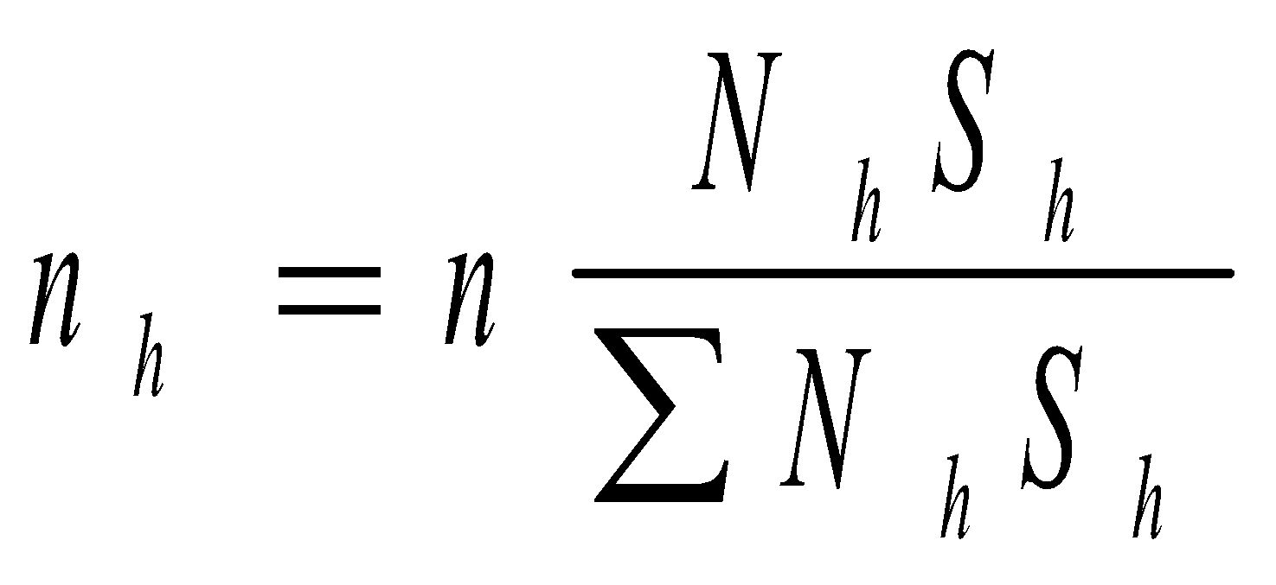, where n_{h} is the sample size of stratum h, n is the total sample size, N_{h} is the total number of units (or the population) in stratum h, and S_{h} is the square root of the variance in stratum h. Sampling large jails with certainty and precise sample size calculations play a significant role in maintaining small standard errors. Year-to-year comparison of standard errors are available in the appendix tables of the Jail Inmates annual bulletin series (https://www.bjs.gov/index.cfm?ty=pbse&sid=38).
The 2020 ASJ sample design is similar to the 2015 design shown in table 4 except for a difference in stratum 1 (non-regional certainty jails). As mentioned above, the 2020 ASJ sample will include large jails as certainty jails in stratum 1. The 2015 ASJ, however, included not only large jails but also all jails located in California as certainty jails in stratum 1. BJS started to sample all Californian jails in 2013 in response to California’s enactment of AB 109 and AB 117, aimed to reduce the number of inmates housed in state prisons starting in October 2011. As a result of these two laws, the jail population in California experienced an unusual increase, which was atypical of the rest of the United States. In order to properly capture the unique population growth in Californian jails, the ASJ sampling design was modified in 2013 to include all California jail jurisdictions in a certainty (self-representing) stratum (see Methodology in Jail Inmates at Midyear 2014 (NCJ 248629, BJS web, June 2015)). The inclusion of all California jail jurisdictions resulted in an additional 21 jurisdictions. As the jail population in California has stabilized in recent years, BJS will no longer include all jails located in California in the certainty stratum in the 2020 ASJ.

2. Procedures for Information Collection
BJS will administer the 2020-22 ASJ as a web survey. The website is currently being developed and will look similar to the 2018 ASJ website (see Attachment A: Website screenshots). The website will be hosted by BJS’s data collection agent, RTI International, and is located on a secure server. Each jail has an individual username and a password to enter the website. To improve data quality and lower cost, respondents will be encouraged to submit data online, while options to submit data by email, fax, and mail will also be provided. In particular, a postage-paid envelope and a paper form will be mailed to jail administers who have not responded after about 2-3 months.
The reference date for most questions in the ASJ is the last weekday in June. Each cycle of the 2020-22 ASJ collection runs from early June through October 1 of the reference year. The general collection schedule is shown in table 5:
Table 5: Data Collection Schedule
Date | Contact | Description | Est. # of Respondents Contacted
June 8 | Pre-notification Mailing | Letter with link to survey preview | 950
July 1 | Invitation Email | Announces forms can be submitted online | 950
July 27 | Reminder Email 1 | Friendly reminder of upcoming deadline (end of July) | 650
August 6 | Reminder Email 2 | Friendly reminder | 500
August 10 – August 30 | Nonresponse Call Prompt | Single prompt call; request to submit by the end of August | 400
August 27 | Paper Form Mailing | Contains copy of ASJ form; extended deadline to October 1 | 300
September 1 – October 1 | Customized Nonresponse Contact | 4 phone calls / 4 emails | 200
September 7 | BJS Director Letter | Send signature required mail; request forms returned by October 1 | 100
July 15 – October 1 | Data quality follow-up | Resolve data quality issues through phone calls and emails | 665
October 1 – close out data collection

Data collection activities begin in early June with each jail receiving a notification letter announcing the impending data collection (see Attachment D: Pre-notification). PDF survey form (see Attachment B: Form CJ-5) will be made available on the ASJ website for preview at that time. In early July, an email (see Attachment E: Invitation email) will be sent to each jail, announcing the start of ASJ data collection and directing them to the ASJ website with login information. Data-quality follow-up (calling and emailing respondents to verify questionable data points and obtain missing data) will start about two weeks after data collection opens in early July and continues through the end of collection period.

BJS will request that jails submit their data by July 31. Reminder email (see Attachment F: Reminder email 1 and Attachment G: Reminder email 2) will be sent on July 27 and August 6 to solicit late responses. Next, a hard-copy survey form will be sent on August 27 with a postage-paid envelope. Around September 7, a registered letter, signed by BJS Director (see Attachment H: Reminder director) will be sent to the remaining non-respondents to encourage survey participation. Personalized nonresponse follow-up, where data collection staff contact individual nonrespondents via phone and email will start in September 1 and continue through October 1.
The data collection will close on October 1. About one month after that, the data collection agent will deliver a cleaned and edited data file to BJS.

3. Methods to Maximize Response
Although participation in the ASJ is voluntary, BJS has maintained high survey response rates and item response rates for this collection. For example, 92% of the sampled jails participated in the 2018 ASJ, and the lowest item response rate was over 90%. To maximize response rates, BJS and the data collection agent will work with the American Jail Association (AJA) to advertise the upcoming ASJ to encourage participation. About one month before data collection starts, BJS will send a prenotification letter to sampled jails, explaining what the ASJ is about and why it is important to participate in the study. The letter will also provide a survey preview and a list of frequently asked questions. While BJS encourages online data submission for best data quality, it also provides other modes of data submission (fax, e-mail, or telephone) to accommodate jails that have limited access to the internet or simply prefer to work with hardcopy survey forms.
Throughout the data collection period, the data collection agent will monitor data submission and track survey paradata, e.g., respondent log-in timestamps, contacts made with each agency, and comments respondents left on the survey form. The paradata will be used for tailored non-response follow-up and data quality follow-up. For these outreach activities, each jail will be assigned to, and managed by, a specific member of the data collection team, who serves as a consistent “agency liaison” throughout data collection.
The above proposed data collection schedule and respondent contact materials (Attachments D-H) have been used in past ASJ collections and proven to be successful in achieving a high response rate. During each iteration of the ASJ, the schedule and materials are reviewed to determine if further improvement can be made to increase response rates, reduce respondent burden, save cost, and enhance data quality.
Starting with the 2011 ASJ, BJS implemented nonresponse weight adjustment procedures to account for unit nonresponse. For responding jails that were unable to provide some requested items, missing values were imputed using a cold-deck carry forward method. When past data for the same jail were not available, missing data were imputed using the weighted sequential hot-deck method. Detailed information on nonresponse adjustment and missing data imputation is available in the methodology section of Jail Inmates, 2018. The 2020 ASJ will continue to use the same procedures to minimize bias arising from unit and item nonresponse.

4. Test of Procedures or Methods
As discussed in Part A, the 2020 ASJ will introduce three new questions: inmate counts by age group, counts of parole and probation violators and number of non-U.S. citizens by conviction status. In 2018, BJS conducted a cognitive test (under BJS generic clearance OMB Control No. 1121-0339) to obtain feedback from jails on newly proposed questions and some existing questions. BJS tested these questions with 33 jails that varied in size, past survey response pattern, and county overdose death rate (for testing questions on jail opioid programs to be used in the COJ). Respondents filled out a test survey online and participated in a follow-up semi-structured phone interview to discuss their understanding of the items and difficulties encountered in reporting. The test was completed in two rounds, with 16 jail respondents in round 1 and 17 jail respondents in round 2. Based on feedback received from the cognitive test, BJS improved wording of the question and instructions and incorporated some new questions into the 2019 COJ forms. Despite that some jails reported difficulty in providing data on the new items during the 2018 cognitive test, the new items actually received high item response rates in the 2019 COJ. Ninety-six percent of the jail respondents provided data on parole and probation question and 99% of the jails holding non-U.S. citizens provided a breakdown by conviction status. These item response rates were comparable to other COJ items.
In April 2020, BJS decided to add a special addendum on the COVID-19 pandemic to the 2020 and 2021 ASJ to capture the impact of this public health emergency on local jails. In designing the questions, BJS received helpful comments and suggestions from nine outside experts and jail respondents regarding data availability, question wording and flow, and estimated burden.

5. Contact Information
The Corrections Statistics Unit of BJS takes responsibility for the overall design and management of the activities described in this submission, including data collection procedures, development of the questionnaire, and analysis of the data.
BJS contacts for the Annual Survey of Jails are:

Zhen Zeng, Ph.D.
Statistician
Corrections Statistics Unit
Bureau of Justice Statistics
810 Seventh Street, N.W.
Washington, DC 20531
(202) 305-2711
Zhen.Zeng@usdoj.gov

Todd D. Minton
Statistician
Corrections Statistics Unit
Bureau of Justice Statistics
810 Seventh Street, N.W.
Washington, DC 20531
(202) 305-9630
Todd.Minton@usdoj.gov

Zeng, Z. (2020). Jail Inmates in 2018. Bureau of Justice Statistics, Washington, D.C. NCJ 253044.

