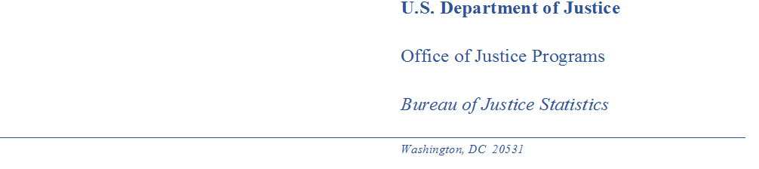

MEMORANDUM

TO: Robert Sivinski
Office of Statistical Science and Policy
Office of Management and Budget

THROUGH: Melody Braswell
Clearance Officer
Justice Management Division

Jeffrey H. Anderson
Director, Bureau of Justice Statistics

Devon Adams
Acting Deputy Director, Bureau of Justice Statistics

FROM: Kevin Scott
Law Enforcement Statistics Unit Chief, Bureau of Justice Statistics

SUBJECT: Non-substantive Change to OMB# 1121-0367 Survey of Law Enforcement Personnel in Schools (SLEPS) – Burden Increase

DATE: April 21, 2020

PURPOSE:

The purpose of this memorandum is to advise OMB of and request approval for a small burden increase to the approved Survey of Law Enforcement Personnel in Schools (SLEPS) program.

SLEPS collects data on the roles, functions, and supporting infrastructure of police officers in public K-12 schools. SLEPS employs a two-phase approach, first selecting a sample of law enforcement agencies (LEAs) to receive an agency-level survey and a request to provide a roster of school resource officers (SROs). The rosters are compiled to develop a frame from which a sample of SROs are selected to receive an officer-level survey. RTI International was competitively awarded a cooperative agreement in FY 2014 to, under BJS’s direction, develop this data collection.

Proposed burden increase

The SLEPS data collection received OMB approval in July 2019 with a burden estimate of 3,743 hours. Data collection with a sample of approximately 2,000 LEAs began in late August 2019 and concluded in February 2020. To minimize the chance for SRO turnover between the time an agency completed its roster and the time the SROs received the survey, the data collection protocol planned for two waves of the SRO survey. The first wave began in December 2019 and the final reminder was sent in mid-February 2020. The second wave of the SRO survey was scheduled to be mailed out in late March 2020. Due to the COVID-19 pandemic and its impact on schools and LEAs, BJS and RTI decided to postpone the second wave of the SRO survey until the fall of 2020.

There are 432 LEAs in wave 2 and these LEAs provided their SRO rosters between November 2019 and February 2020. Come the fall mailout for these LEAs, some of these rosters will be nearly one year old. The fall will also be the beginning of a new school year and reassignments may occur over the summer. To address the issue of outdated rosters, BJS would like to complete a verification effort through which RTI will provide these LEAs with the roster they provided during the LEA data collection phase and request that the LEAs update the roster. This will allow RTI to develop an up-to-date frame and select an up-to-date sample in order to mitigate nonresponse and eligibility issues that would occur if the original rosters were used.

Verification of the roster is expected to require about 10 minutes of an LEA’s time. With 432 LEAs in wave 2, this would be an additional 72 hours in addition to the previously approved 3,743 hours for a new total burden of 3,815.

Implementation plan

Pending OMB approval of the proposed burden increase, RTI will develop a roster verification tool through which LEAs will be able to update their SRO roster. The roster verification effort is tentatively planned to take place from late August 2020 to late September 2020.

Summary

BJS seeks OMB approval of the above noted burden increase for SLEPS. We will work to expeditiously respond to any OMB inquiries and/or requests for additional information.

Thank you in advance for your time and consideration.

