U.S. Department Labor

Employment and Training Administration

Allotment Request Data Entry Screen – ETA 658

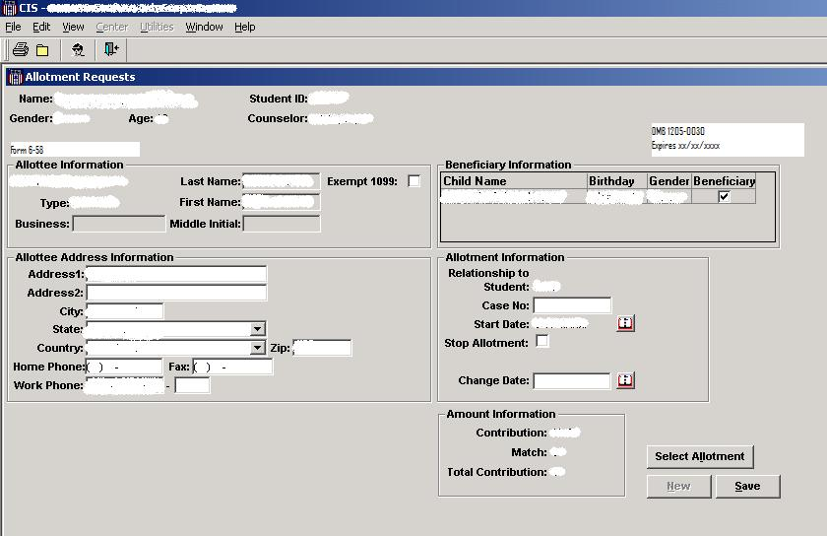

Paperwork Reduction Act Public Burden Statement: Persons are not required to respond to this collection of information unless it displays a currently valid OMB control number and expiration date.  Public reporting burden for this collection of information, which is required to obtain or retain benefits (29 USC 3196), is estimated to average 3 minutes per response, including the time for reviewing instructions, searching existing data sources, gathering and maintaining the data needed, and the completing and reviewing the collection of information.  This information collection is for program management and Congressional reporting purposes.  Send comments regarding this burden estimate or any other aspect of this collection of information, including suggestions for reducing this burden, to the U.S. Department of Labor, Office of Job Corps Room N-4507, Washington, D.C. 20210 (Paperwork Reduction Project 1205-0030).