American Time Use Survey

Well-being Module Questionnaire

July 2020

The ATUS is sponsored by the Bureau of Labor Statistics and conducted by the U.S. Census Bureau.

The Well-being Module begins with an introductory screen explaining the purpose of the module questions, and then proceeds to the screen asking how the respondent felt during the selected activities.

QUESTIONS 1 THROUGH 7

Now I want to go back and ask you some questions about how you felt yesterday. We’re asking these questions to better understand people’s health and well-being during their daily lives. As before, whatever you tell us will be kept confidential. The computer has selected 3 time intervals that I will ask about.

Between [STARTTIME OF EPISODE] and [STOPTIME OF EPISODE] yesterday, you said you were doing [ACTIVITY]. The next set of questions asks how you felt during this particular time.

Please use a scale from 0 to 6, where a 0 means you did not experience this feeling at all and a 6 means the feeling was very strong. You may choose any number 0,1,2,3,4,5 or 6 to reflect how strongly you experienced this feeling during this time.

1. | Happy | First, from 0 – 6, where a 0 means you were not happy at all and a 6 means you were very happy, how happy did you feel during this time?
2. | Tired | From 0 – 6, where a 0 means you were not tired at all and a 6 means you were very tired, how tired did you feel during this time?
3. | Stressed | From 0 – 6, where a 0 means you were not stressed at all and a 6 means you were very stressed, how stressed did you feel during this time?
4. | Sad | From 0 – 6, where a 0 means you were not sad at all and a 6 means you were very sad, how sad did you feel during this time?
5. | Pain | From 0 – 6, where a 0 means you did not feel any pain at all and a 6 means you were in severe pain, how much pain did you feel during this time if any?
6. | Meaningful | From 0 to 6, how meaningful did you consider what you were doing? 0 means it was not meaningful at all to you and a 6 means it was very meaningful to you.

[THE ORDER OF THE AFFECTIVE DIMENSIONS (ITEMS 1-5) WAS RANDOMIZED BY RESPONDENT].

7. Were you interacting with anyone during this time, including over the phone? (Yes/No)

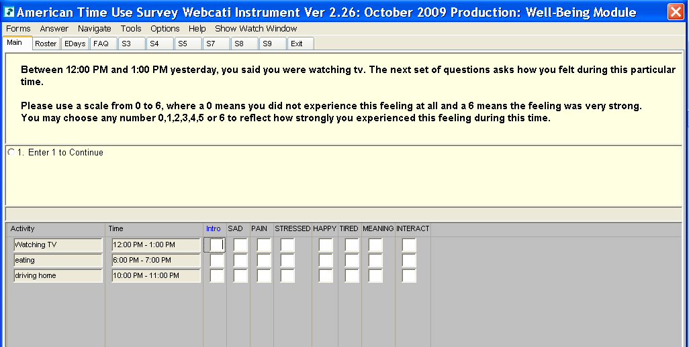

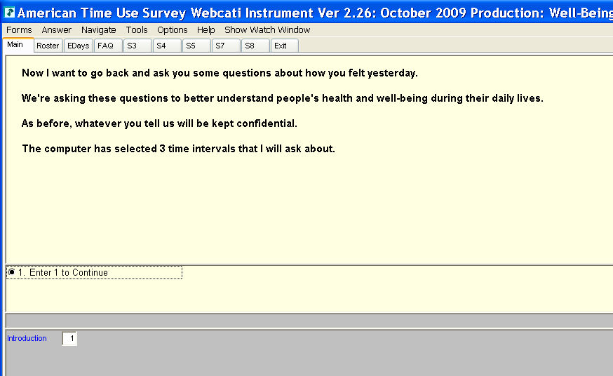
These screens demonstrate the introduction to the module and the questions about the respondent’s feelings:

The 2012 and 2013 Well-being Module had two questions that did not appear in the 2010 Well-being Module. They are described in the box below:

New Transition added to the 2012 and 2013 Well-being modules:
[CANTRIL_INT] Thank you. We’re going to switch focus now. The next two questions ask you to think about your life in general, not just in terms of the specific activities we just talked about. And, rather than using a 6-point scale to represent how you feel, we’ll be using a 10-point scale. To begin,
New Questions added to the 2012 and 2013 Well-being modules:

8. [CANTRIL] Please imagine a ladder with steps numbered from zero at the bottom to ten at the top. The top of the ladder represents the best possible life for you and the bottom of the ladder represents the worst possible life for you.

If the top step is 10 and the bottom step is 0, on which step of the ladder do you feel you personally stand at the present time?

9. [TYPICAL] Thinking about yesterday as a whole, how would you say that your feelings, both good and bad, compared to a typical [fill day of the week]? Were they better than a typical [fill day of the week], the same as a typical [fill day of the week], or worse than a typical [fill day of the week]?

[The new introduction (CANTRIL_INT) appeared directly after the affect questions, and CANTRIL and TYPICAL became the new questions #8 and #9. The old question #8 and all subsequent questions in the module were bumped back. For example, the old question #8, PAIN ITEM #1, became question #10 in the 2012 and 2013 modules.]

The next set of questions asks about the respondent’s health in general.

PAIN ITEM # 1

10. Did you take any pain medication yesterday, such as Aspirin, Ibuprofen or prescription pain medication?
[INTERVIEWER NOTE: IF MENTIONS A DRUG, CODE AS A YES. FOR EXAMPLE, TYLENOL AND ALEVE ARE BOTH PAIN MEDS.]
❑ Yes
❑ No

HEALTH STATUS # 1

11. Finally, I have a couple of questions about your health. Would you say your health in general is excellent, very good, good, fair, or poor?
1. EXCELLENT
2. VERY GOOD
3. GOOD
4. FAIR
5. POOR
9. DON'T KNOW/REFUSED

HEALTH STATUS # 2

12. In the last five years, were you ever told by a doctor or other health professional that you have hypertension, also called high blood pressure, or borderline hypertension?
❑ Yes
❑ No

HEALTH STATUS # 3

13. When you woke up yesterday, how well-rested did you feel? Did you feel very rested, somewhat rested, a little rested, or not at all rested?
❑ Very
❑ Somewhat
❑ A little
❑ Not at all

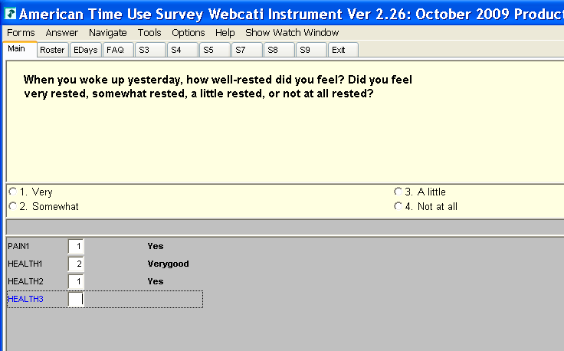
This screen shows the last HEALTH STATUS question.

The following question is proposed for the 2021 Well-being module:

Proposed New Question in 2021:

Thank you, we have one more question about how the coronavirus pandemic has affected you.
In the past seven days, has the coronavirus pandemic caused you stress about:
- Your finances?
❑ Yes
❑ No
b. Your health or the health of a family member?
❑ Yes
❑ No
- Caring for a child or adult family member?
❑ Yes
❑ No

