INFORMATION COLLECTION REQUEST
SUPPORTING STATEMENT

for

REVISIONS TO APPENDIX P
TO 40 CFR PART 51

EPA ICR Number 2590.01

Prepared by:

State and Local Programs Group
Air Quality Policy Division
Office of Air Quality Planning and Standards
Office of Air and Radiation
United States Environmental Protection Agency
Research Triangle Park, North Carolina 27711

February 2019

                - EXECUTIVE SUMMARY
This document, titled “Information Collection Request Supporting Statement for Revisions to Appendix P to 40 CFR Part 51,” is part of an initial, rule-related information collection request (ICR) package (“Proposed Rule ICR”) that is assigned EPA Tracking No. 2590.01. No OMB Control Number has been assigned for the proposed new collection under this Proposed Rule ICR. The ICR requests approval of a proposed new collection of information, to be conducted by the U.S. Environmental Protection Agency (EPA), that would potentially affect 56 respondents (56 state air agencies). To comply with the subject rule’s requirements as proposed, states may choose to (but would not be required to) prepare and submit state implementation plan (SIP) revisions to the EPA. The regulatory burden under the proposed new collection is attributed to states’ preparation and submission of SIP revisions, a type of reporting burden. The estimated regulatory burden on states is 9,240 hours at a labor cost of $547,200 totaled over a 3-year collection period.

1. IDENTIFICATION OF THE INFORMATION COLLECTION

1(a) Title of the Information Collection
This document is part of an initial, rule-related information collection request (ICR) package (“Proposed Rule ICR”) that is assigned EPA Tracking No. 2590.01. The Proposed Rule ICR requests approval of a proposed new collection of information titled: Revisions to Appendix P to 40 CFR Part 51.

1(b) Short Characterization/Abstract
Under the Clean Air Act (CAA), the states and the U.S. Environmental Protection Agency (EPA) each have certain authorities and responsibilities. Each state must have a state implementation plan (SIP) that provides for the implementation, maintenance, and enforcement of the national ambient air quality standards (NAAQS), and the EPA must assure that SIPs satisfy the CAA requirements. These authorities and responsibilities are further described in this document’s section 2(a), Need/Authority for the Collection.
The EPA promulgated regulations at Part 51, “Requirements for Preparation, Adoption, and Submittal of Implementation Plans,” that specify the minimum requirements that each state must include in its SIP. State and local air pollution control agencies are the main users of the Part 51 regulations, which are referred to in brief as the EPA’s SIP preparation regulations.
Appendix P to Part 51 (cited from 40 CFR 51.214) sets forth minimum continuous emission monitoring and reporting requirements that each SIP must include for sources among four source categories. These four “Appendix P” source categories are:
- Fossil fuel-fired steam generators;
- Fluid bed catalytic cracking unit catalyst regenerators (at petroleum refineries);
- Sulfuric acid plants; and
- Nitric acid plants.

The information collection being addressed in this document corresponds to a proposed rule revising Appendix P and titled, “Revisions to Appendix P to 40 CFR Part 51.” The EPA notes that the subject rule, by generally relaxing a “minimum reporting frequency” specification for SIPs from quarterly to semiannually, would be a revision only of the minimum requirement, and so the rule would not require that any state change the actual reporting frequency requirement in its SIP that applies to Appendix P sources. Therefore, to comply with the subject rule’s requirements, each state may choose to prepare and submit a SIP revision but would not be required to do so. For purposes of the Proposed Rule ICR (as described in section 3 of this document), the EPA conservatively assumes that every state would make a single SIP submission within 3 years after the rule becomes effective, to update their SIP consistent with the regulatory changes.
Each state would make its SIP submission to its designated EPA Regional Office. For a more detailed description of the submission process, see this document’s section 5(b), Collection Methodology and Management.
The proposed collection of information being addressed in this document would impose a burden of the reporting type. The Proposed Rule ICR corresponds to the proposal of a rule that would solicit voluntary SIP revisions from states. The collection resulting from the rule would impose a burden on such states to prepare SIP revisions that are consistent with the subject rule and to submit them to the EPA for approval. The collection would be used both by the states and by the EPA toward fulfilling SIP requirements pursuant to the CAA (as described in section 2 of this document). As summarized in section 6 of this document, the estimated regulatory burden on states is 9,240 hours at a labor cost of $547,200 totaled over the 3-year collection period for which OMB’s clearance is requested.

2. NEED FOR AND USE OF THE COLLECTION

2(a) Need/Authority for the Collection
In general, any reporting requirement imposed on non-Federal respondents by the EPA will require an ICR. When an ICR is approved, the Office of Management and Budget (OMB) assigns a control number to indicate that the information collection has been cleared for a specified period of time (not to exceed 3 years). The Code of Federal Regulations is updated periodically (see 40 CFR 9.1) to identify current ICRs and their OMB control numbers.
The Clean Air Act (CAA) establishes a framework for state-federal partnership based on the concept of “cooperative federalism,” and the states and the EPA are each granted certain authorities and given certain responsibilities with respect to implementing the CAA’s requirements. States develop, implement, and enforce their own regulatory programs. The EPA oversees state compliance with federal standards and may enforce directly if necessary. Through this design, pollution control is achieved with equity among the states.
About the states’ authorities and responsibilities:
- Pursuant to CAA section 107(a), the states have primary responsibility for assuring attainment of the NAAQS within their borders. Under CAA section 110(a)(1), each state has a duty to develop and submit a SIP that provides for the attainment, maintenance, and enforcement of the NAAQS, as well as for meeting many other CAA requirements and objectives. The specific procedural and substantive requirements that states must meet for SIPs are set forth in section 110(a)(1) and section 110(a)(2) and in other more specific requirements throughout the CAA (e.g., the attainment plan requirements for each of the NAAQS as specified in part D).
About the EPA’s authorities and responsibilities:
- The EPA has the statutory authority and responsibility to assure the states, through their SIPs, meet the requirements of the CAA, such as by interpreting the basic requirements of CAA sections 110(a)(2)(F)(ii) and (iii) and by reviewing SIPs for compliance with those requirements. The EPA does not require states to adopt any particular emission limitation or other specific control measure in their SIPs. Rather, in an overseer role, the EPA directs the states to address the statutory requirements that all SIPs must meet. In that role, the EPA has promulgated regulations at Part 51, “Requirements for Preparation, Adoption, and Submittal of Implementation Plans,” which specify the minimum requirements that each SIP must meet. State and local air pollution control agencies are main users of the Part 51 regulations, referred to in brief as the EPA’s SIP preparation regulations.
- CAA section 110(a)(2)(F) mandates that each SIP require, as may be prescribed by the Administrator, (i) the installation, maintenance, and replacement of equipment, and the implementation of other necessary steps, by owners or operators of stationary sources to monitor emissions from such sources, (ii) periodic reports on the nature and amounts of emissions and emissions-related data from such sources, and (iii) correlation of such reports by the State agency with any emission limitations or standards established under the CAA, which reports shall be available at reasonable times for public inspection. The EPA promulgated the original emission monitoring requirements under 40 CFR Part 51 to “more fully implement[]” CAA sections 110(a)(2)(F)(ii) and (iii).
- The SIP review process is by nature an ongoing one, for the states and for the EPA. Pursuant to CAA section 110, states are required to reexamine and potentially to revise their SIP provisions, for instance whenever the EPA promulgates a new or revised NAAQS. Regulations applicable to states toward implementing their CAA requirements are periodically amended, and states need to revise their SIPs accordingly. It is not uncommon for a state to make a SIP submission that includes provisions needed to address more than one regulatory amendment. From time to time, as a state determines a need to update its SIP in order to continue to meet CAA requirements, the state will submit for the EPA’s approval a SIP revision that also satisfies the EPA’s Part 51 requirements for SIPs. The EPA is required to evaluate and take action on all such SIP submissions.
Related to the Proposed Rule ICR, the EPA has proposed a rule that amends the EPA’s SIP preparation regulations under 40 CFR Part 51. As proposed, the subject rule neither requires that any state make a SIP revision nor specifies a due date for submission of SIP revisions associated with the rule. The subject rule would change regulatory requirements with which all SIPs must comply only to the extent it is relaxing a minimum requirement. Thus, a state’s SIP revision to comply with the subject rule would be voluntary, not mandatory. Each state may choose whether to revise its SIP (and relax an actual requirement among SIP provisions) or instead leave its SIP unchanged (and continue to apply the existing requirement). To provide a conservatively high burden estimate, the EPA assumes that within 3 years after the rule becomes effective, all states would choose to prepare and submit SIP revisions to reflect the relaxation in the minimum requirement. Whether a given state makes explicit that its submission is made in response to the subject rule may depend on how many other, unrelated SIP changes the state has chosen to include in the same submission.
A state may have multiple motivations and purposes when undertaking a given SIP revision. Thus, a question EPA considered in deciding to prepare the Proposed Rule ICR was whether states’ SIP revision activities, when Appendix P-related, would constitute a collection of information conducted by the EPA. If so, the collection of information would require an ICR to address the reporting burden that it would impose on states (to prepare the Appendix P-related SIP revisions and submit them to the EPA for approval).
In determining that the reporting burden on states may be attributed to the subject rule—and therefore that a new collection would require OMB clearance (approval for a collection period not to exceed 3 years) through an ICR—the EPA considered motivation and compliance as factors, as explained below.
- First, consider compliance: If it were unlikely that the state could comply with its CAA requirements unless the SIP were revised, it would be reasonable to conclude that the SIP revision was necessary to the state’s compliance with CAA requirements. However, the subject Appendix P rule does not point to any change in CAA requirements, and so it is likely that, even in light of the subject rule, all states would continue to comply with their CAA requirements whether or not they revised their SIPs. At least for this particular information collection, it is also likely that all states would continue to comply with the SIP regulations promulgated by the EPA whether or not they revised their SIPs.
- Next, consider motivation: In this case, there is no particular triggering event that creates a new obligation for states to make SIP revisions in order to comply with either CAA requirements or the subject rule (revisions to Appendix P). Nevertheless, recognizing that a state is less likely to prepare and submit a SIP revision relaxing the actual requirement in the absence of a relaxation of the minimum requirement in the SIP preparation regulations, it would not be unreasonable to conclude that the subject rule was the state’s motivation for revising its SIP.
Accordingly, the EPA determined that the proposed new collection of information, comprising voluntary SIP submissions that reflect and comply with the subject rule, would impose a burden on states. While the EPA should not be viewed as necessarily imposing reporting requirements on states, it would not be unreasonable to take the view that the EPA nevertheless would do so, through the subject rule. Neither is it unreasonable to take a conservative view that the EPA would be imposing the reporting requirements on all states, given that it would be nearly impossible to correctly predict how many states might choose to submit a SIP revision as a result of the subject rule.
The EPA prepared this document, titled “Information Collection Request Supporting Statement for Revisions to Appendix P to 40 CFR Part 51,” to fulfill federal agency requirements under the Paperwork Reduction Act of 1995 (PRA). As a federal agency, the EPA must determine, report, and periodically update the estimated regulatory burden associated with the subject rule, once it is promulgated, because the subject rule involves collection of information from the public. The EPA is unaware of any existing ICRs, either current or expired, that cover recordkeeping and reporting requirements associated with the subject rule under Part 51. See section 3(a) of this document for description of existing ICRs that cover other SIP-related requirements. The proposed information collection that is the subject of this document concerns the minimum requirements that each state must include in its SIP. Because this is an initial ICR rather than a renewal ICR, the 3-year collection period for which OMB’s clearance is requested would start on the date specified by OMB in its notice of action on the request.
Referencing the need and authority for this collection:
- In Appendix A to this document, see selected excerpt of the Clean Air Act, namely: section 110(a).
- In Appendix B to this document, see selected excerpts of the EPA’s SIP regulations under 40 CFR Part 51, namely: section 51.214; and Appendix P to Part 51 as most recently amended August 30, 2016.

2(b) Practical Utility/Users of the Data
The EPA’s role in implementation of the NAAQS through SIPs, pursuant to 40 CFR Parts 51 and 52, is centered around the concept of “cooperative federalism,” sharing responsibility with state and local air agencies. Pursuant to CAA section 110, states are responsible for ensuring on an ongoing basis that their SIPs are consistent with requirements of the CAA and for ensuring sources’ compliance with the SIP requirements.
This information collection concerns the subject rule and the one-time SIP revisions that state respondents would prepare and submit to the EPA for approval. The collection would be used both by state respondents and by the EPA, over the 3-year period for which OMB’s clearance is requested, as described below:
- State respondents. Each state air agency will review the reporting frequency requirements in its existing SIP to: (i) ensure that the SIP meets the minimum requirements for reporting frequency applicable to Appendix P source categories; and (ii) determine the extent to which the state will revise its SIP in a manner consistent with the change in Appendix P minimum requirements. For purposes of this document, the EPA conservatively assumes that every state will elect to prepare and submit (to its designated EPA Regional Office) a single SIP revision that includes an Appendix P-related provision.
- The EPA. Regional Office program personnel of the EPA will review one SIP submission that includes an Appendix P-related provision from each state. The EPA’s role in the SIP review process involves evaluation of each submitted provision to ensure that the provision serves the state in implementing and enforcing the CAA. Among criteria against which the EPA evaluates SIP submissions are the minimum requirements specified under Part 51. Provisions that meet CAA requirements will be approved by the EPA into the SIP. The approval of each state’s SIP and SIP revisions is recorded under 40 CFR Part 52.

3. NONDUPLICATION, CONSULTATIONS, AND OTHER COLLECTION CRITERIA

3(a) Nonduplication
Among the EPA’s SIP preparation regulations, Appendix P to Part 51 was promulgated in 1975, with a requirement that each state adopt minimum specifications for Appendix P sources by October 6, 1976. For purposes of this document, the EPA assumes that all states already have SIPs that address Part 51 requirements for Appendix P sources. The subject rule as proposed, by changing one minimum specification for SIPs, does solicit SIP revisions from states that choose to reflect that change (a relaxation in reporting frequency) in their SIPs. However, the subject rule would not require any duplication of effort, such as to require a SIP revision for reapproval of unchanged Appendix P-related requirements that already satisfy the minimum specifications.
As described in greater detail under section 2(a) of this document, states’ SIP revision activities are typically numerous and ongoing. The EPA examined numerous existing information collections but identified none that appear to address burden associated with SIP revisions to address the subject rule’s Appendix P change. Examined information collections that specifically involve SIP submissions include those listed below (in reverse chronological order according to the upload date reported on the OMB website for ICRs, https://www.reginfo.gov/public/do/PRAMain).
- “Prevention of Significant Deterioration and Nonattainment New Source Review,” renewal ICR, OMB Control No. 2060­0003, EPA Tracking No. 1230.32. Per Supporting Statement uploaded 2/24/17, the estimated burden is primarily associated with activities such as submittal and processing of NSR permit applications and issuance of preconstruction permits. For activities associated with SIP submissions, the identified ICR attributes 40 hours for each of 58 SIP revisions to burden on states (Table 6­2) and 5 hours for each of 58 SIP reviews to burden on the EPA (Table 6­3).
- “PM_{2.5} National Ambient Air Quality Standards State Implementation Plan Requirements Rule,” renewal ICR, OMB Control No. 2060­0611, EPA Tracking No. 2258.04. Per Supporting Statement uploaded 8/24/16, the estimated burden is primarily associated with developing and submitting SIPs to attain the PM_{2.5} NAAQS. The identified ICR, in Table 7, specific to the 2012 NAAQS, attributes 126,000 hours to total incremental burden on states and 13,860 hours to total incremental burden on the EPA. The identified ICR, in Table 8, specific to the 1997 and 2006 NAAQS, attributes 145,800 hours to total incremental burden on states and 16,038 hours to total incremental burden on the EPA.
- “Implementation of the 2008 National Ambient Air Quality Standards for Ozone: State Implementation Plan Requirements,” renewal ICR, OMB Control No. 2060­0695, EPA Tracking No. 2347.02. Per Supporting Statement uploaded 8/16/16, the estimated burden is primarily associated with meeting attainment demonstration requirements and with “reasonable further progress” (RFP) and “reasonably available control technology” (RACT) SIP submissions, to attain and maintain the 2008 8-hour ozone NAAQS. For those activities (including but not limited to the SIP submissions), the identified ICR in Table 7 attributes 120,000 hours to total incremental burden on states and 24,200 hours to total incremental burden on the EPA.
- “Regional Haze Regulations,” renewal ICR, OMB Control No. 2060­0421, EPA Tracking No. 1813.09. Per Supporting Statement uploaded 2/26/16, the estimated burden is primarily associated with developing interim progress reports and with developing and submitting periodic comprehensive SIP revisions as required by the regional haze rule. For activities associated with the periodic comprehensive SIP submissions, the identified ICR attributes 500 hours to per-plan burden on states (Table 6.5) and 400 hours to per-plan burden on the implementing federal agencies (including the EPA; Table 6.4).
- “8-hour Ozone National Ambient Air Quality Standard Implementation Rule,” renewal ICR, OMB Control No. 2060­0594, EPA Tracking No. 2236.04. Per Supporting Statement uploaded 11/12/13, the estimated burden is primarily associated with meeting attainment demonstration requirements and with “reasonable further progress” (RFP) and “reasonably available control technology” (RACT) SIP submissions, to attain and maintain the 8-hour ozone NAAQS, accounting for the transition from implementing the 1997 standard to implementing the 2008 standard. For those activities (including but not limited to the SIP submissions), the identified ICR in Table 7 attributes 35,000 hours to total incremental burden on states and 3,850 hours to total incremental burden on the EPA.
Based on its examination, the EPA concludes that the SIP revisions that would be solicited by the subject rule are not available from other sources and thus that the information requested under this ICR is unique and does not duplicate other SIP requirements.

3(b) Public Notice Required Prior to ICR Submission to OMB
Because the Proposed Rule ICR is a request for clearance for a proposed initial collection rather than for renewal of clearance for an existing collection, the EPA is soliciting public comment on the ICR as part of the same notice in which the EPA proposes to revise the subject rule. EPA will address any comments received in the ICR for the subsequent final rule.

3(c) Consultations
As specified in the OMB’s regulation at 5 CFR 1320.8(d)(1), an agency should consult with potential respondents and other members of the public prior to submitting an ICR to OMB for approval.

3(d) Effects of Less Frequent Collection
In general, the proposed new information collection involves a single SIP revision by each state over the requested 3-year collection period, so this document does not address potential effects of less frequent collection.
Although the ICR burden estimate is based on an assumption that every state would elect to revise its SIP to address reporting frequency for Appendix P sources, the EPA notes that the actual collection may involve a lesser number of Appendix P-related SIP revisions. The reason for the potential difference is that even in light of the subject rule’s change in minimum requirements for SIPs, any given state may (as is allowed) elect to retain its existing SIP requirements, such as to require that sources located in the state report continuous monitoring system-related information on a more frequent basis than the minimum specified for SIPs under Part 51.

3(e) General Guidelines
The EPA is adhering to OMB’s general guidelines for information collections. The proposed new collection would not require any characteristic of the collection of information that warrants the EPA’s justification (such as listed under 5 CFR Part 1320, “Controlling Paperwork Burdens on the Public,” at 5 CFR 1320.5). For instance, this information collection would not require that any respondent:
- Report information to the Agency more often than quarterly;
- Prepare a written response to a collection of information in fewer than 30 days after receipt of a request;
- Submit more than an original and two copies of any document; or
- Retain records for more than 3 years.

3(f) Confidentiality
The EPA proposed to determine that the requested information collection (SIP submissions) would not include any confidential information. In accordance with 40 CFR 51.116, “Data availability,” each state must retain and make available for public inspection all detailed data and calculations used in the preparation of its SIP and SIP revisions.

3(g) Sensitive Questions
The consideration of sensitive questions (i.e., sexual, religious, personal or other private matters) is not applicable to the Part 51 SIP preparation regulations. The information gathered for purposes of states’ SIP submissions and the EPA’s review of SIP submissions does not include personal information about any owner or operator.

4. THE RESPONDENTS AND THE INFORMATION REQUESTED

4(a) Respondents/NAICS Codes
Under CAA section 110(a)(1), each state has a duty to develop and submit a SIP. As of the date of this document, no Indian tribes have chosen to be treated as states with respect to compliance with Appendix P to Part 51. Thus, the universe of respondents for the Proposed Rule ICR comprises 56 states (and no tribes).
According to the North American Industry Classification System (NAICS), the respondents are classified under 2017 NAICS code 924110, which represents the “Administration of Air and Water Resource and Solid Waste Management Programs” industry. As used throughout this document, the term “state” refers to any of the following entities (listed alphabetically):

- Alabama
- Alaska
- American Samoa
- Arizona
- Arkansas
- California
- Colorado
- Connecticut
- Delaware
- District of Columbia
- Florida
- Georgia
- Guam
- Hawaii
- Idaho
- Illinois
- Indiana
- Iowa
- Kansas
- Kentucky
- Louisiana
- Maine
- Maryland
- Massachusetts
- Michigan
- Minnesota
- Mississippi
- Missouri
- Montana
- Nebraska
- Nevada
- New Hampshire
- New Jersey
- New Mexico
- New York
- North Carolina
- North Dakota
- Northern Mariana Islands
- Ohio
- Oklahoma
- Oregon
- Pennsylvania
- Puerto Rico
- Rhode Island
- South Carolina
- South Dakota
- Tennessee
- Texas
- Utah
- Vermont
- Virgin Islands
- Virginia
- Washington
- West Virginia
- Wisconsin
- Wyoming

4(b) Information Requested
As specified in the EPA’s SIP preparation regulations at 40 CFR 51.214, each state must have a SIP that applies, at a minimum, the requirements specified in Appendix P. For purposes of this document, the EPA assumes that all states already have SIPs that address Part 51 requirements for Appendix P sources. However, the subject rule as proposed, by changing one minimum specification for SIPs, does solicit SIP revisions from states that choose to reflect that change (a relaxation in reporting frequency) in their SIPs. Accordingly, the EPA assumes that this information collection would include submissions of SIP revisions for the EPA’s approval from each of 56 states.
Identified below are data items, including any recordkeeping requirements, and respondent activities that the EPA anticipates in connection with this proposed information collection.

4(b)(i) Data items, including recordkeeping requirements
In this Proposed Rule ICR, 56 SIP revisions represent the data items proposed to be collected. As described in greater detail under section 2(a) of this document, states’ SIP revision activities are typically numerous and ongoing. For each state, many recordkeeping activities associated with SIP revisions are undertaken collectively and considered to be undertaken independent of the subject rule. This Proposed Rule ICR specifically addresses a recordkeeping burden of the reporting type, for states’ preparation and submission of SIP revisions related to the Appendix P rulemaking. Being part of each state’s “customary and usual business practice,” the recordkeeping burden associated with SIP revisions more generally is therefore not being further addressed in this ICR.

4(b)(ii) Respondent activities
Under the requested information collection, states as the respondents would prepare and submit SIP revisions that are consistent with the subject rule. Each state’s reporting activity, being preparation and submission of a single SIP revision, is likely to involve the following subtasks:
- Upon deciding to undertake the SIP revision, propose to amend the relevant provision(s) in the state regulations and rules, and adopt the amendment at the state level (as required by CAA section 110(l), “Plan Revisions”);
- develop a draft submission of the SIP revision, and solicit public comment on the proposed SIP revision through notice and hearing procedures (as set out under 40 CFR 51.102, “Public hearings”);
- receive preliminary review by the EPA (if the state requests review, through the appropriate EPA Regional Office staff) prior to making an official submission (as set out under 40 CFR 51.103, “Submission of plans, preliminary review of plans”); and
- officially submit the SIP revision to the EPA Administrator for approval, through the EPA Regional Office designated for that state.
For each such SIP revision, to complete the respondent’s reporting activity, the EPA estimates an annual reporting burden of 55 hours per year, for a total reporting burden of 165 hours over the requested 3-year collection period. As explained in section 2(a) of this document, states revise their SIPs from time to time, to address various requirements, and they are already familiar with the EPA’s procedural requirements (see Subpart F of 40 CFR Part 51) that address these activities.
For this information collection in particular, there is no specified date by which such SIP revisions must be submitted to the EPA. To comply with the subject rule, “Revisions to Appendix P to 40 CFR Part 51,” each state would have the option to retain its existing Appendix P-related SIP provisions rather than revise its SIP. Nevertheless, for purposes of the Proposed Rule ICR, the EPA assumes that every state would make a SIP submission within the requested 3-year collection period.

5. THE INFORMATION COLLECTED—AGENCY ACTIVITIES, COLLECTION METHODOLOGY, AND INFORMATION MANAGEMENT

5(a) Agency Activities
Under the requested information collection, each state would prepare a SIP revision and submit it to the EPA, as the sponsoring federal agency, for approval by the EPA Administrator. The corresponding activity by the EPA would be that of taking final action on the submitted SIP revision. In completing that activity, the EPA would likely perform the following subtasks:
- Provide preliminary review of the state’s presubmission materials prior to receipt of the official submission (if requested by the state, as set out under 40 CFR 51.103, “Submission of plans, preliminary review of plans”);
- receive the officially submitted SIP revision, and determine that the submission is complete (as required by CAA section 110(k)(1), and according to Appendix V to 40 CFR Part 51, “Criteria for determining the completeness of plan submissions”);
- provide timely review of the submitted SIP revision, as required by CAA section 110(k)(2), to ensure that it satisfies CAA requirements for SIPs;
- issue a public notice in the Federal Register, within 6 months of the completeness determination, of the EPA’s proposed approval of the SIP revision, soliciting public comment and providing opportunity for a public hearing;
- develop responses to public comments received on the proposal, as appropriate; and
- issue a public notice in the Federal Register of the EPA Administrator’s final approval of the SIP revision, including response to significant public comments.
For each such SIP revision, to complete the EPA’s activity, the EPA estimates an annual burden of 11 hours per year, for a total burden of 33 hours (which equates to 20 percent of its hour estimate for respondent activities) over the requested 3-year collection period. The EPA’s subtasks leading to final rulemaking action on each SIP revision would be undertaken in accordance with SIP requirements of CAA section 110 and the EPA’s SIP preparation regulations under 40 CFR Part 51. As set out under 40 CFR 51.105, “Approval of plan,” the submitted SIP revision would not be considered part of the applicable SIP until such revision has been approved by the EPA Administrator in accordance with Part 51.

5(b) Collection Methodology and Management
Each state would make its SIP submission, whether in hard copy or electronically, to its designated EPA Regional Office. The EPA’s SIP preparation regulations include requirements concerning format (hard copies, electronic versions) at 40 CFR 51.103. The means of submission is generally according to arrangement between each of the ten EPA Regional Offices and the states it serves.
Prior to 2015, states typically made their SIP submissions in printed form, by mail (USPS) to the appropriate EPA Regional Office. However, on February 3, 2015, the U.S. Environmental Protection Agency notified states of the option to instead make their SIP submissions electronically, using a web-based system accessible through the EPA’s Central Data Exchange website. The State Planning Electric Collaboration System (SPeCS) for SIPs, publicly accessible, enables submission, review, and tracking of SIPs. The EPA’s preferred way to receive a SIP submission and associated information is, in fact, through the state’s use of SPeCS for SIPs.
Each of the ten EPA Regional Offices would receive, review, and take rulemaking action on the SIP submissions comprising this proposed collection. There is no need for the EPA to maintain complete files of data or calculations used in the preparation of the SIP revisions, because the states retain such information in accordance with 40 CFR 51.116, “Data availability.”

5(c) Small Entity Flexibility
An agency must certify that its proposed collection of information reduces, to the extent practicable and appropriate, the burden on persons who shall provide information to or for the agency. Particularly in reducing burden for “small entities” as defined in the Regulatory Flexibility Act (5 U.S.C. 601(6)), the agency must use techniques such as those listed under 5 CFR 1320, “Controlling Paperwork Burdens on the Public,” in 5 CFR 1320.9(c).
With respect to this ICR, the EPA proposes to certify that the subject rule would not have a significant economic impact on a substantial number of small entities. In fact, the subject rule as proposed would not impose any requirements on small entities.

5(d) Collection Schedule
For this information collection, there is no specified date by which such SIP revisions must be submitted to the EPA. As explained in this document under section 4(b)(ii), the EPA assumes that one-third of the respondents would make their SIP submissions in each year of the requested 3-year collection period.

6. ESTIMATING THE BURDEN AND COST OF THE COLLECTION
When developing an ICR, the sponsoring federal agency must consider the burden of all activities not incurred by persons in their normal course of activities. Typical ICR burden activities include reviewing instructions, maintaining records, completing paperwork, gathering information, and reporting information. The agency must also consider nonlabor costs associated with the information collection activities, such as capital costs and “operating and maintenance” (O&M) costs.
As used in this document, the term “burden” means the total time, effort, or financial resources expended by persons to generate, maintain, retain, or disclose or provide information to or for a Federal agency. Burden is described more fully in this document under section 6(g) “Burden Statement,” and it is also defined in OMB’s regulations at 5 CFR 1320.3(b)(1).
Under section 6 of this document, the EPA presents its estimates of burden and cost associated with the proposed information collection’s activities over the requested 3-year period of the collection. The starting-point estimate is the burden (in hours) for each respondent (a state) to develop and submit a single SIP revision that is consistent with the subject rule, “Revisions to Appendix P to 40 CFR Part 51.” See this document’s section 6(a). From that starting point, respondent burden hours, the EPA has also estimated the respondent labor cost. See this document’s section 6(b).
Although the focus of the PRA is on the respondent burden, the agency must also account for its own burden hours and labor cost as the sponsoring federal agency for the collection. Accordingly, this document also includes estimates of the EPA’s burden hours and labor cost. See this document’s section 6(c).
The EPA estimated no capital costs or “operating and maintenance” costs associated with the proposed information collection, for either the respondents or the agency. See this document’s section 6(d).
For the proposed information collection, the EPA’s “bottom line” estimates of total annual burden hours and cost, tabulated separately for the respondents and the agency itself, are presented in this document’s section 6(e).

6(a) Estimating Respondent Burden
Under the requested information collection, states as the respondents would prepare and submit SIP revisions that are consistent with the subject rule, “Revisions to Appendix P to 40 CFR Part 51.” This would be a reporting task, with a burden in hours and labor cost. The EPA’s estimate of respondent burden starts with an estimated reporting burden of 165 hours for each respondent over the requested 3-year collection period, or 55 hours per year, to prepare and submit a single SIP revision that is consistent with the subject rule.
The typical subtasks comprising the respondents’ single activity of preparing and submitting SIP revisions are listed in this document under section 4(b)(ii), “Respondent activities.” As is explained in section 4, the EPA assumes for purposes of this ICR that all 56 respondents identified in section 4(a) would make their SIP submissions within the 3-year collection period for which OMB’s clearance is requested. To estimate respondent burden on an annual basis, therefore, the EPA attributes only 55 hours (representing one-third of 165 hours) of activity to each respondent for each year of the requested 3-year collection period.

6(b) Estimating Respondent Costs

6(b)(i) Estimating Labor Costs
With an ICR’s burden hour estimates in place, the sponsoring federal agency must apply an appropriate labor rate in order to estimate the labor cost of those burden hours. Therefore, the agency must assume a mix of labor categories (e.g., legal, managerial, technical, clerical) for each respondent activity.
To estimate the labor cost of respondent burden hours for the proposed information collection, the EPA is assuming that the respondents’ single activity (preparing and submitting a SIP revision) would be completed entirely by state agency personnel employed in a professional capacity and categorized as technical labor. Accordingly, to estimate the respondent labor cost, the EPA applied a labor rate of $59.22 per hour to the respondent burden hour estimate. This labor rate is drawn from employer costs reported by the Bureau of Labor Statistics (BLS) for December 2017. It represents the cost per hour worked for a “State and local government worker” in the “Management, professional, and related” occupational group. Of the $59.22 cost per hour (total compensation), wages and salaries account for $38.30; the other $20.92 is the total of benefit costs (paid leave, supplemental pay, insurance, retirement and savings, and legally required benefits).

6(b)(ii) Estimating Capital Costs and “Operating and Maintenance” Costs
When developing an ICR, an agency will estimate the capital costs and “operating and maintenance” (O&M) costs associated with an information collection only if they were incurred for the purpose of collecting information as required by EPA. Nonlabor-related costs (either capital costs or O&M costs) should not be included in the ICR if they are attributed to respondent activities of a “usual and customary” nature.
Under the requested information collection, the EPA assumes that the burden on each state as a respondent would be exclusively labor-related, associated with the reporting task of preparing and submitting a SIP revision. Costs to acquire goods such as computers, machinery, and equipment are examples of capital costs. Costs for file storage, photocopying, and postage are examples of O&M costs. However, the EPA assumes that such capital and O&M costs, even when associated with SIP revisions, are part of each state’s “customary and usual business practice.” For purposes of this ICR, therefore, the EPA attributes no capital costs or O&M costs to the respondents.

6(b)(iii) Capital/Start-up vs. Operating and Maintenance (O&M) Costs
When developing an ICR, an agency must consider both capital/start-up costs and O&M costs in estimating nonlabor-related costs. One-time capital/start-up costs typically include any produced physical goods needed to provide the necessary information. In addition to the actual acquisition of start-up capital, one-time activities associated with the production of capital also should be included. O&M costs are defined by the PRA as “the recurring dollar amount of cost associated with O&M or purchasing services.” Costs for the general upkeep of start-up capital equipment and costs to purchase contractor or auditing services are examples of O&M costs.
For purposes of this ICR, however, the EPA assumes that the burden on each state as a respondent would be exclusively labor-related. Therefore, the EPA attributes no capital/start-up or O&M costs to the respondents.

6(b)(iii) Annualizing Capital Costs
Typically, annualized capital cost would be derived from a discounted net present value of the stream of capital costs that would occur over either the length of the collection period or the life of the equipment, whichever is shorter.
For purposes of this ICR, however, the EPA assumes that the burden on each state as a respondent would be exclusively labor-related. Therefore this document includes no estimate for annualized capital costs.

6(c) Estimating Agency Burden and Cost
As the sponsoring federal agency for an information collection, an agency must account for its own burden hours and labor cost.
Under the requested information collection, each state would prepare a SIP revision and submit it to the designated EPA Regional Office for that state for approval by the EPA Administrator. The EPA’s corresponding activity would be to take final action on the submission, with the SIP revision’s approval being the goal. The EPA’s estimate of agency burden is 33 hours for each respondent SIP revision over the requested 3-year collection period, or 11 hours per year, to take final action on a single submitted SIP revision.
The typical subtasks undertaken by the EPA to complete this single activity are listed in this document under section 5(a), “Agency Activities.” As is explained in section 4, the EPA assumes for purposes of this ICR that all 56 respondents identified in section 4(a) would make their SIP submissions within the 3 years over which the ICR requests clearance. Accordingly, for purposes of this ICR, the EPA assumes that it would take final action on one-third of the expected 56 submissions in each of those 3 years. To estimate agency burden on an annual basis, therefore, the EPA attributes only 11 hours (representing one-third of 33 hours) of activity to the agency for each year of the requested 3-year collection period.
The EPA’s estimate of agency burden starts with an assumption that the EPA Regional Office staff would perform 1 hour of activity for every 5 hours of activity performed by the respondent on an Appendix P-affected SIP revision. Calculated from the estimate of 160 burden hours for each respondent’s SIP revision, the EPA estimates 32 burden hours for each EPA action on the SIP revision.
To estimate the labor cost of agency burden hours for the proposed information collection, the EPA is assuming that the activity of taking final action on the submission would be completed entirely by EPA Regional Office personnel classified as technical labor at Grade 12, Step 5, under the federal government’s General Schedule classification and pay system. The EPA is applying a labor rate of $55.26 per hour to the estimated agency burden hours for this ICR. This rate is calculated from the hourly base rate of $34.54 in the General Schedule Salary Tables for 2018, multiplied by the standard “benefits multiplication factor” of 1.6.

6(d) Estimating the Respondent Universe and Total Burden and Costs
For the purpose of estimating burden in this Proposed Rule ICR, the EPA has identified the respondent universe as follows.
States. The EPA expects that 56 states would prepare and submit a SIP revision that includes an Appendix P-related provision.
Tribes. As of the date of this document, no Indian tribes have chosen to be treated as states with respect to compliance with Appendix P to Part 51.
Industrial sources. As proposed, the subject rule, in revising Appendix P to 40 CFR Part 51, would solicit only SIP submissions from states; there is no anticipated information collection burden on industrial sources.

6(e) Bottom Line Burden Hours and Cost Tables

6(e)(i) Respondent Tally
According to the EPA’s estimate, the total respondent burden associated with the EPA’s revisions to Appendix P to 40 CFR Part 51 can be attributed to a single reporting activity, in which each of 56 states prepares and submits a SIP revision that includes Appendix P-related provisions. As shown in Table 6­1 below, the total respondent burden is estimated to be 3,080 hours per year and $182,400 per year of the requested 3-year clearance period.

Table 6­1. Bottom Line Annual Respondent Burden Hours and Cost
Information Collection Activity | Respondent Hours and Costs,  Per Respondent |  |  |  |  | Total Respondent  Hours and Costs
 | Tech. Labor Rate/Hour | Respon-dent Hours/Year | Labor Cost/Year | Capital/ Startup Cost | O&M Cost | No. Respon-dents | Total Hours/Year | Total Cost/Year
Prepare and submit SIP revision | $59.22 | 55 | $3,257 | $0 | $0 | 56 | 3,080 | $182,400
Total | $59.22 | 55 | $3,257 | $0 | $0 | 56 | 3,080 | $182,400

6(e)(ii) The Agency Tally
According to the EPA’s estimate, the total agency burden associated with the EPA’s revisions to Appendix P to 40 CFR Part 51 can be attributed to a single activity, in which EPA Regional Offices take final action on 56 states’ submitted SIP revisions that include Appendix P-related provisions. As shown in Table 6­2, the total agency burden is estimated to be 616 hours per year and $34,040 per year of the requested 3-year clearance period.

Table 6­2. Bottom Line Annual Agency Burden Hours and Cost
Information Collection Activity | Agency Hours and Costs,  Per Respondent |  |  |  |  | Total Agency  Hours and Costs
 | Tech. Labor Rate/Hr | Agency Hr/Yr | Labor Cost/Yr | Capital/ Startup Cost | O&M Cost | No. Respon-dents | Total Hr/Yr | Total Cost/Yr
Take final action on submitted SIP revision | $55.26 | 11 | $608 | $0 | $0 | 56 | 616 | $34,040
Total | $55.26 | 11 | $608 | $0 | $0 | 56 | 616 | $34,040

6(e)(iii) Variations in the Annual Bottom Line
The annual burden on state respondents collectively is not expected to change significantly from year to year over the 3 years covered by the initial ICR. The subject rule’s minimum requirements apply to every state independent of the number of sources to which the state’s Appendix P-related SIP may apply. As this document’s section 4(b)(ii) describes, for this information collection in particular, there is no specified date by which the solicited SIP revisions must be submitted to the EPA. For purposes of this ICR, the EPA assumes that all respondents would make their SIP submissions within the requested 3-year collection period.

6(f) Reasons for Change in Burden

The new burden included in this ICR results from a proposed rule that revises Appendix P to 40 CFR Part 51, which relaxes the “minimum reporting frequency” specification for SIPs from quarterly to semiannually. For those states that chose to do so, this ICR addresses the burden to prepare and submit a SIP revision that is consistent with the provisions of the proposed rule.

6(g) Burden Statement
For states preparing and submitting SIP revisions that are consistent with Appendix P to 40 CFR Part 51 as revised in the subject rule, the public reporting burden is estimated on a per-respondent basis as a one-time activity at 165 hours to be completed within the requested 3-year collection period. The burden estimate expressed as a per-respondent annual average is 55 hours (representing one-third of 165 hours). This estimate includes time for adopting amendments to relevant provisions in the state regulations and rules, soliciting public comment on a proposed SIP revision through notice and hearing procedures, receiving preliminary review by the EPA, and officially submitting the SIP revision to the EPA for approval.
Burden means the total time, effort, or financial resources expended by persons to generate, maintain, retain, or disclose or provide information to or for a federal agency. This includes the time needed to review instructions; develop, acquire, install, and utilize technology and systems for the purposes of collecting, validating, and verifying information, processing and maintaining information, and disclosing and providing information; adjust the existing ways to comply with any previously applicable instructions and requirements; train personnel to be able to respond to a collection of information; search data sources; complete and review the collection of information; and transmit or otherwise disclose the information. An agency may not conduct or sponsor, and a person is not required to respond to, a collection of information unless it displays a currently valid OMB control number. The OMB control numbers for the EPA's regulations are listed in 40 CFR part 9 and 48 CFR chapter 15.
To comment on the Agency's need for this information, the accuracy of the provided burden estimates, and any suggested methods for minimizing respondent burden, including the use of automated collection techniques, the EPA has established a public docket for this ICR under Docket ID Number EPA­HQ­OAR­2018­0633, which is available for online viewing at www.regulations.gov, or in-person viewing at the Air and Radiation Docket and Information Center in the EPA Docket Center (EPA/DC), EPA West, Room 3334, 1301 Constitution Avenue, NW, Washington, D.C. The EPA Docket Center Public Reading Room is open from 8:30 a.m. to 4:30 p.m., Monday through Friday, excluding legal holidays. The telephone number for the Reading Room is (202) 566­1744, and the telephone number for the Air and Radiation Docket and Information Center is (202) 566­1742. An electronic version of the public docket is available at www.regulations.gov. This site can be used to submit or view public comments, access the index listing of the contents of the public docket, and to access those documents in the public docket that are available electronically. When in the system, select “search,” then key in the Docket ID Number identified above. Also, you can send comments to the Office of Information and Regulatory Affairs, Office of Management and Budget, 725 17th Street, NW, Washington, D.C. 20503, Attention: Desk Officer for EPA. Please include the EPA Docket ID Number EPA­HQ­OAR­2018­0633 in any correspondence.

APPENDIX A
Section 110(a) of the Clean Air Act

Accessed 2/13/2018 from the US Government Printing Office link to the United States Code on FDSys: https://www.gpo.gov/fdsys/pkg/USCODE-2016-title42/pdf/USCODE-2016-title42-chap85.pdf

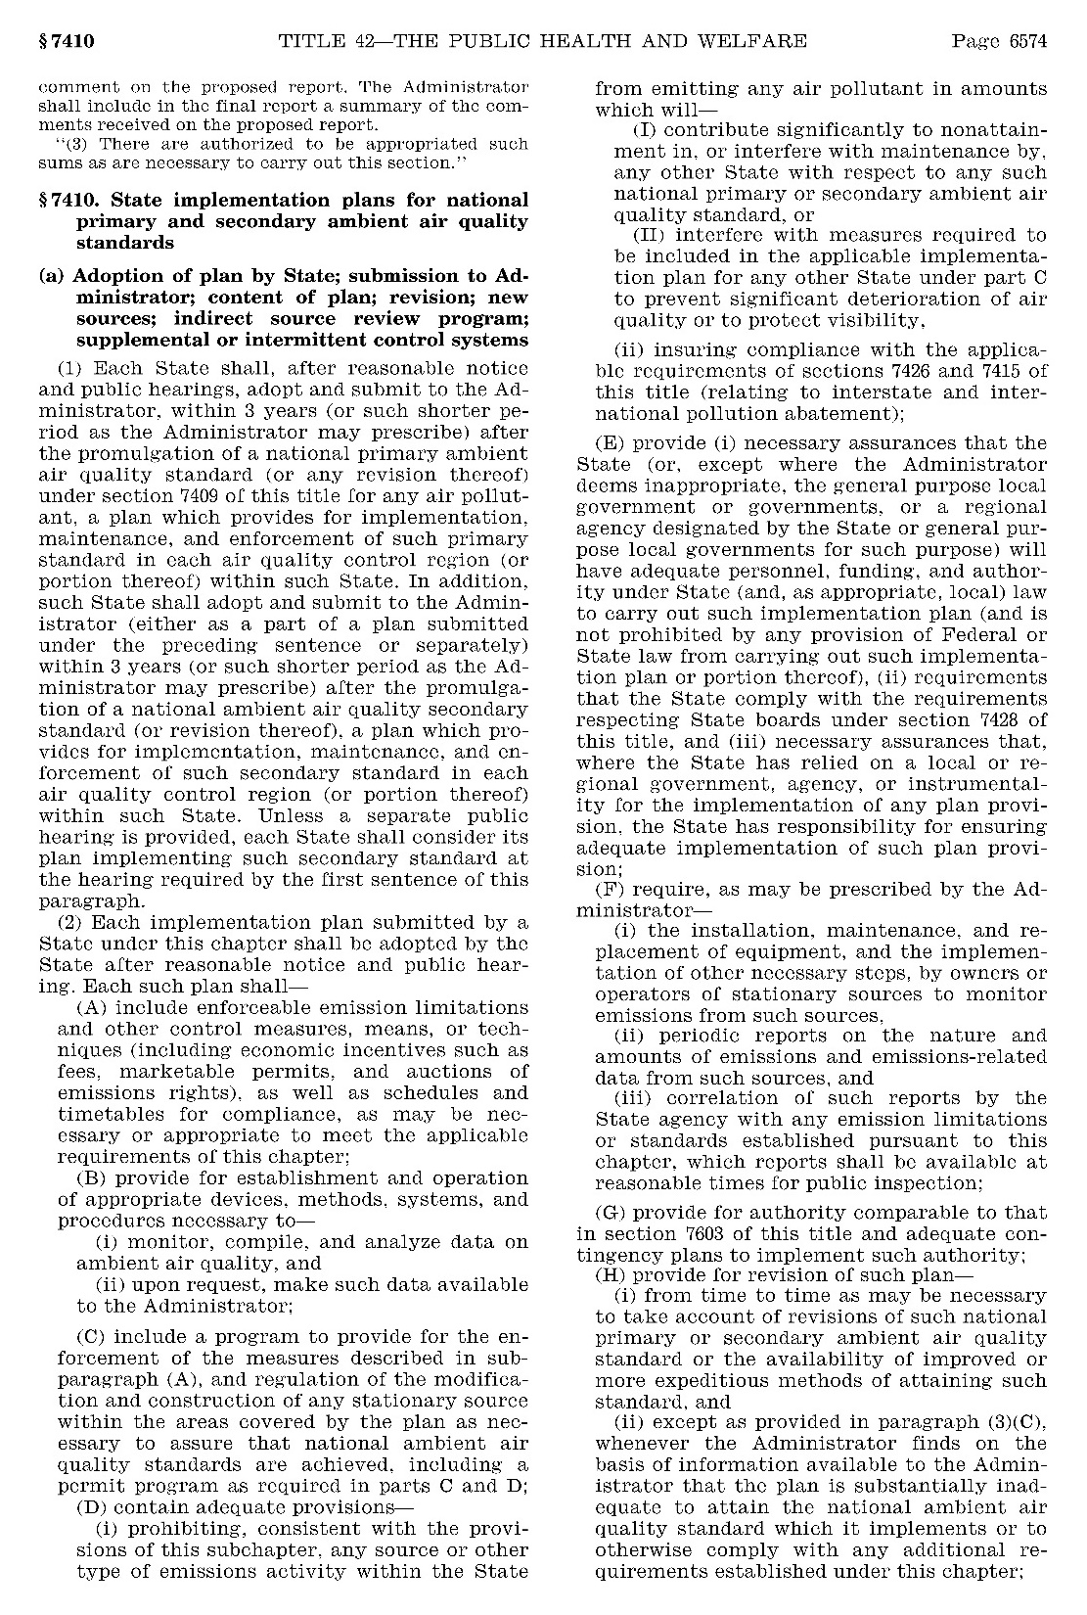
Clean Air Act Section 110(a) excerpted as 42 U.S.C. 7410(a):
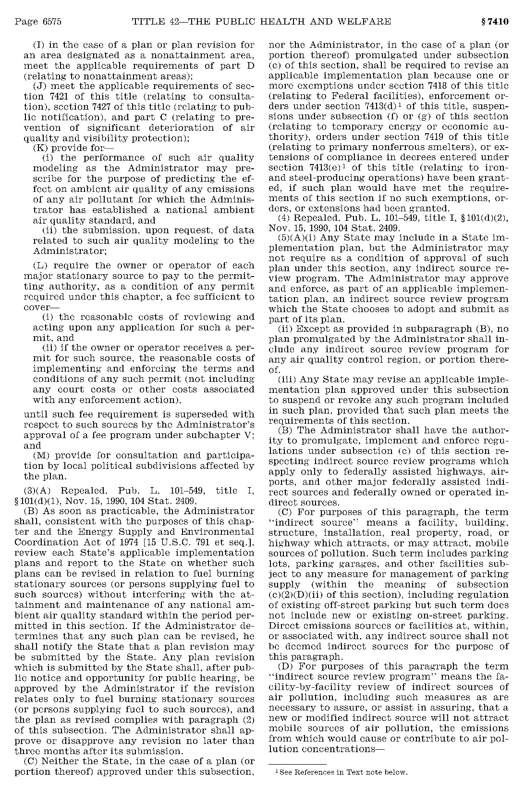
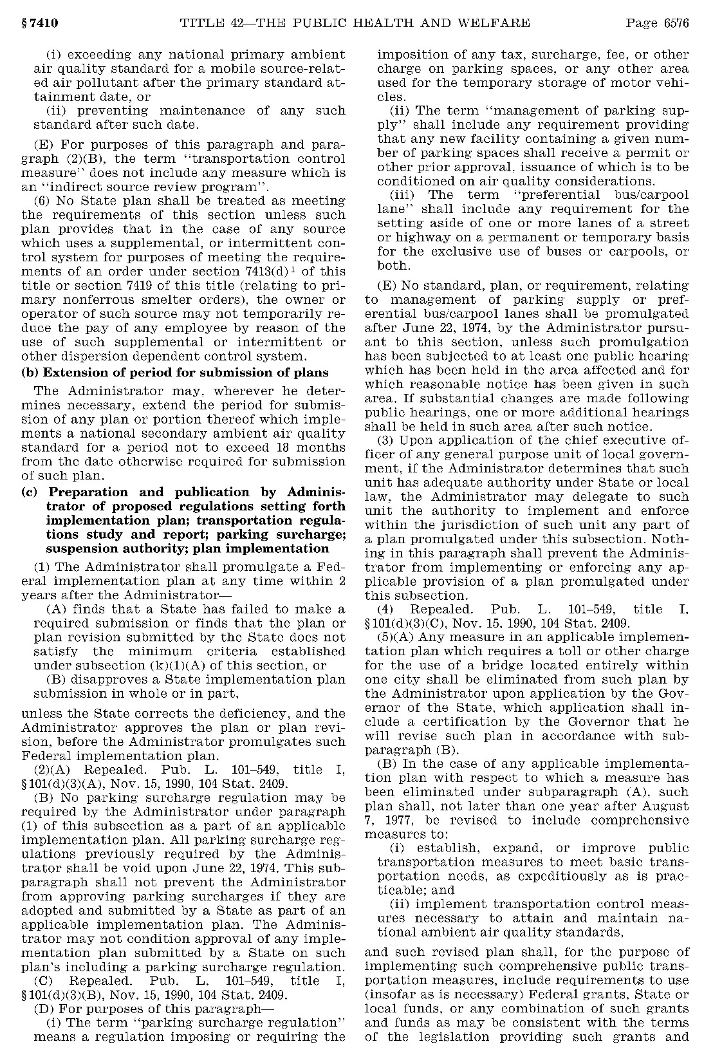

APPENDIX B:
Selected Excerpts of the EPA’s SIP Preparation Regulations Under 40 CFR Part 51

Accessed 2/13/2018 from the US Government Printing Office link to the Electronic Code of Federal Regulations (e-CFR): https://www.ecfr.gov/cgi-bin/text-idx?SID=7f44b0197de9297a39eddfe932218bc9&mc=true&node=se40.2.51_1214&rgn=div8

40 CFR §51.214 excerpted, unchanged:
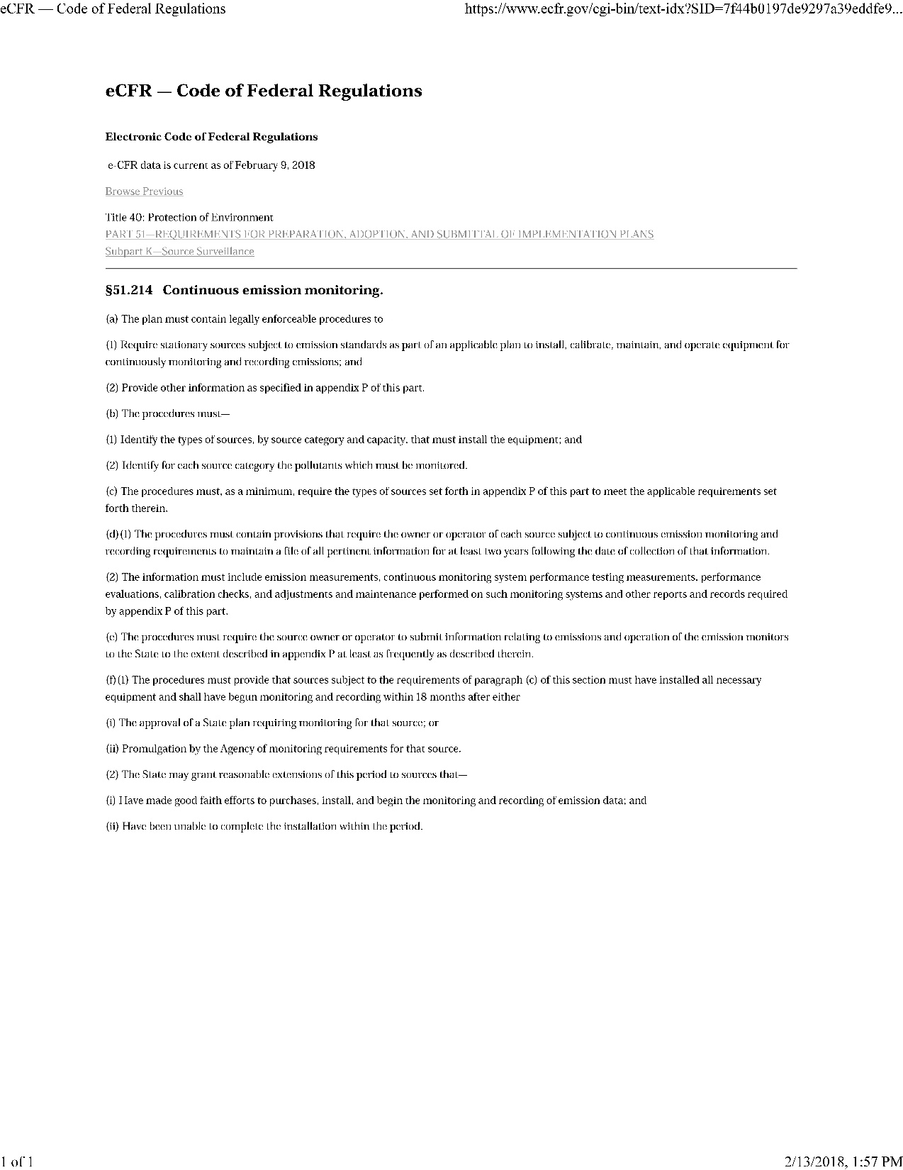

Accessed 2/13/2018 from the US Government Printing Office link to the Electronic Code of Federal Regulations (e-CFR): https://www.ecfr.gov/cgi-bin/text-idx?SID=677713a8c600bb17ec212b087b6b6da2&mc=true&node=ap40.2.51_11205.p&rgn=div9

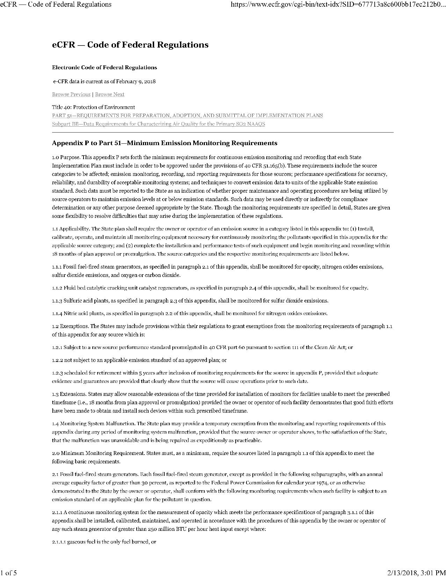
Appendix P to 40 CFR Part 51 excerpted, as most recently amended August 30, 2016:
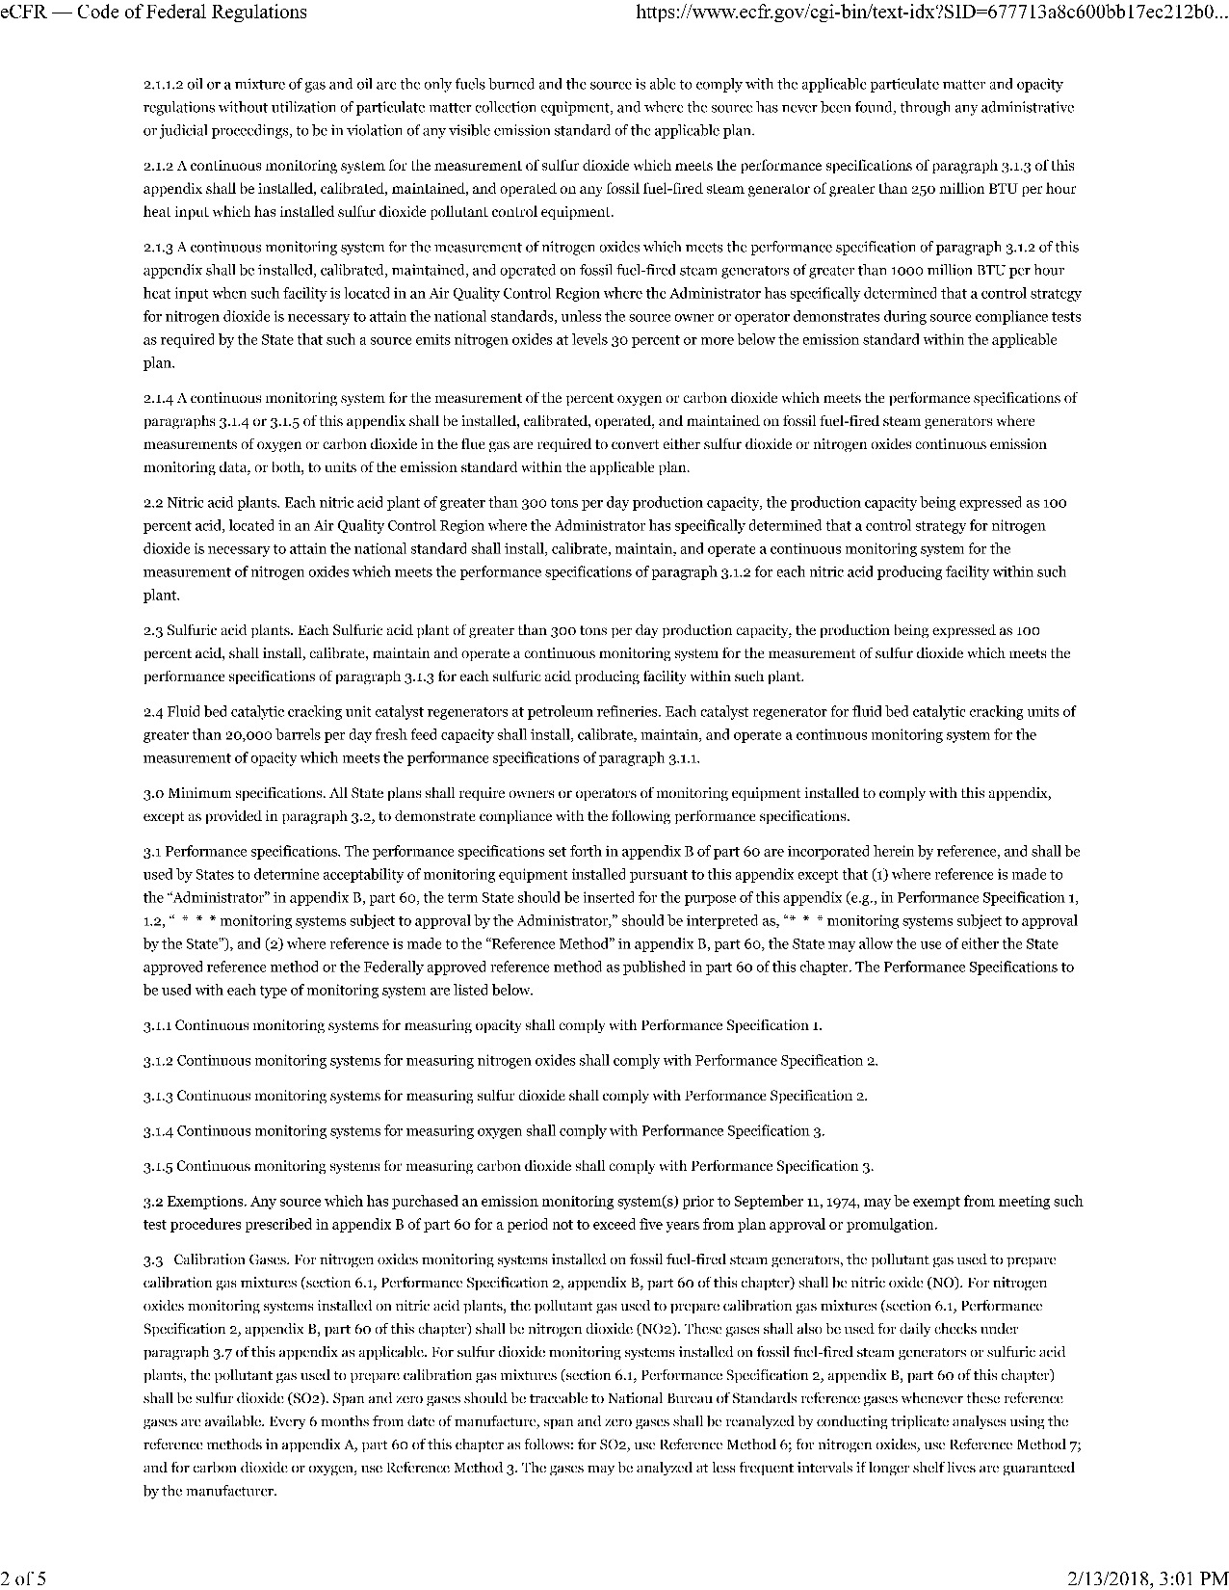
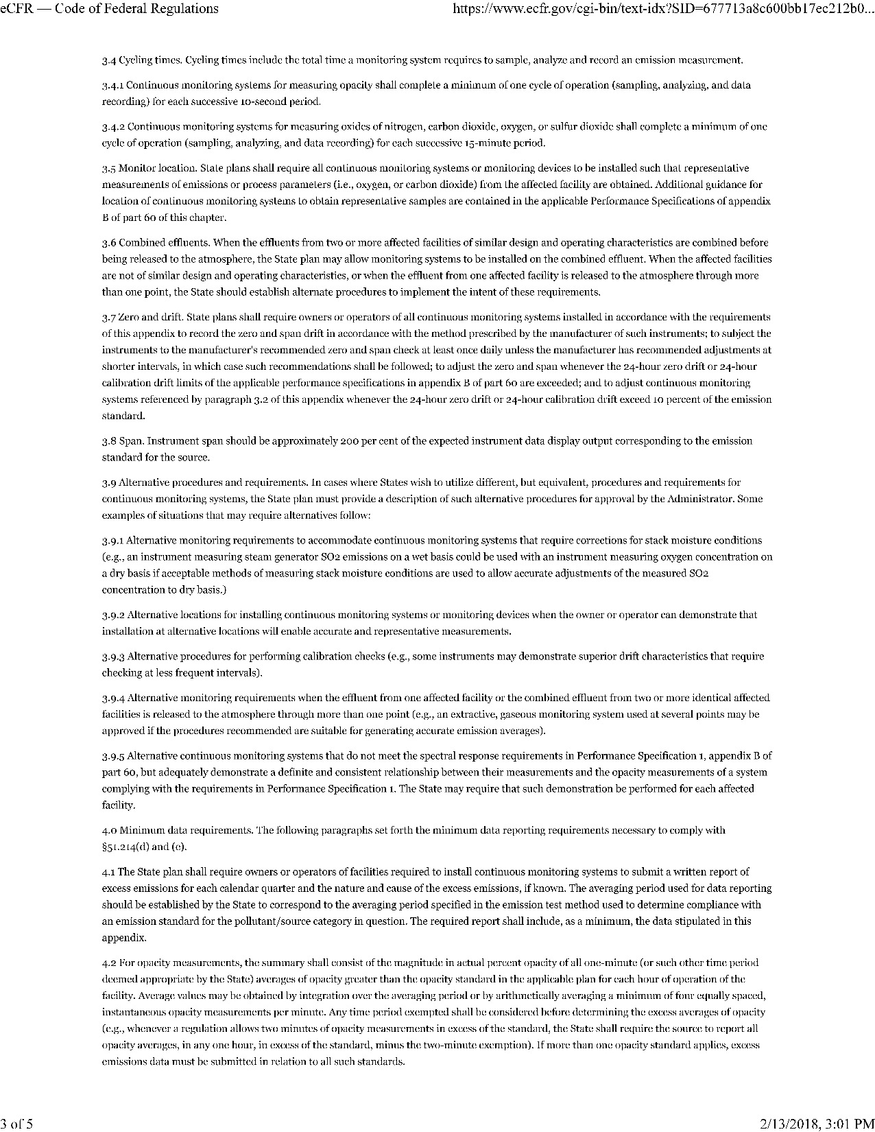
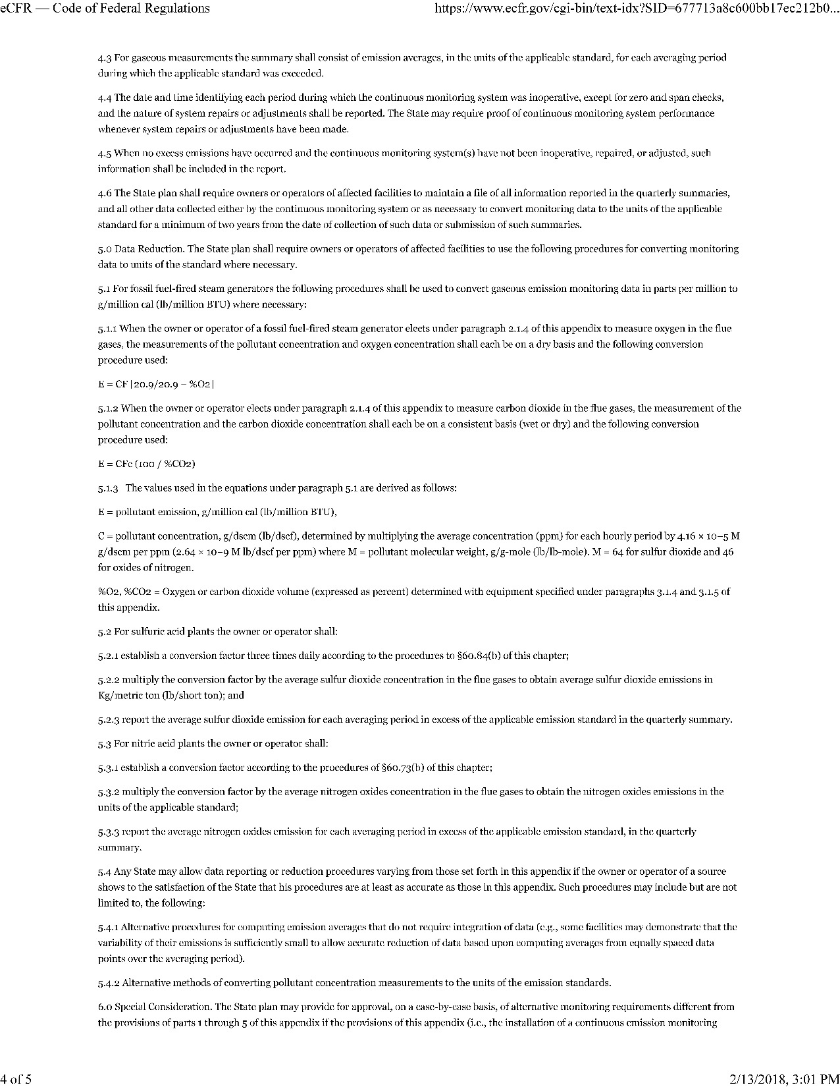
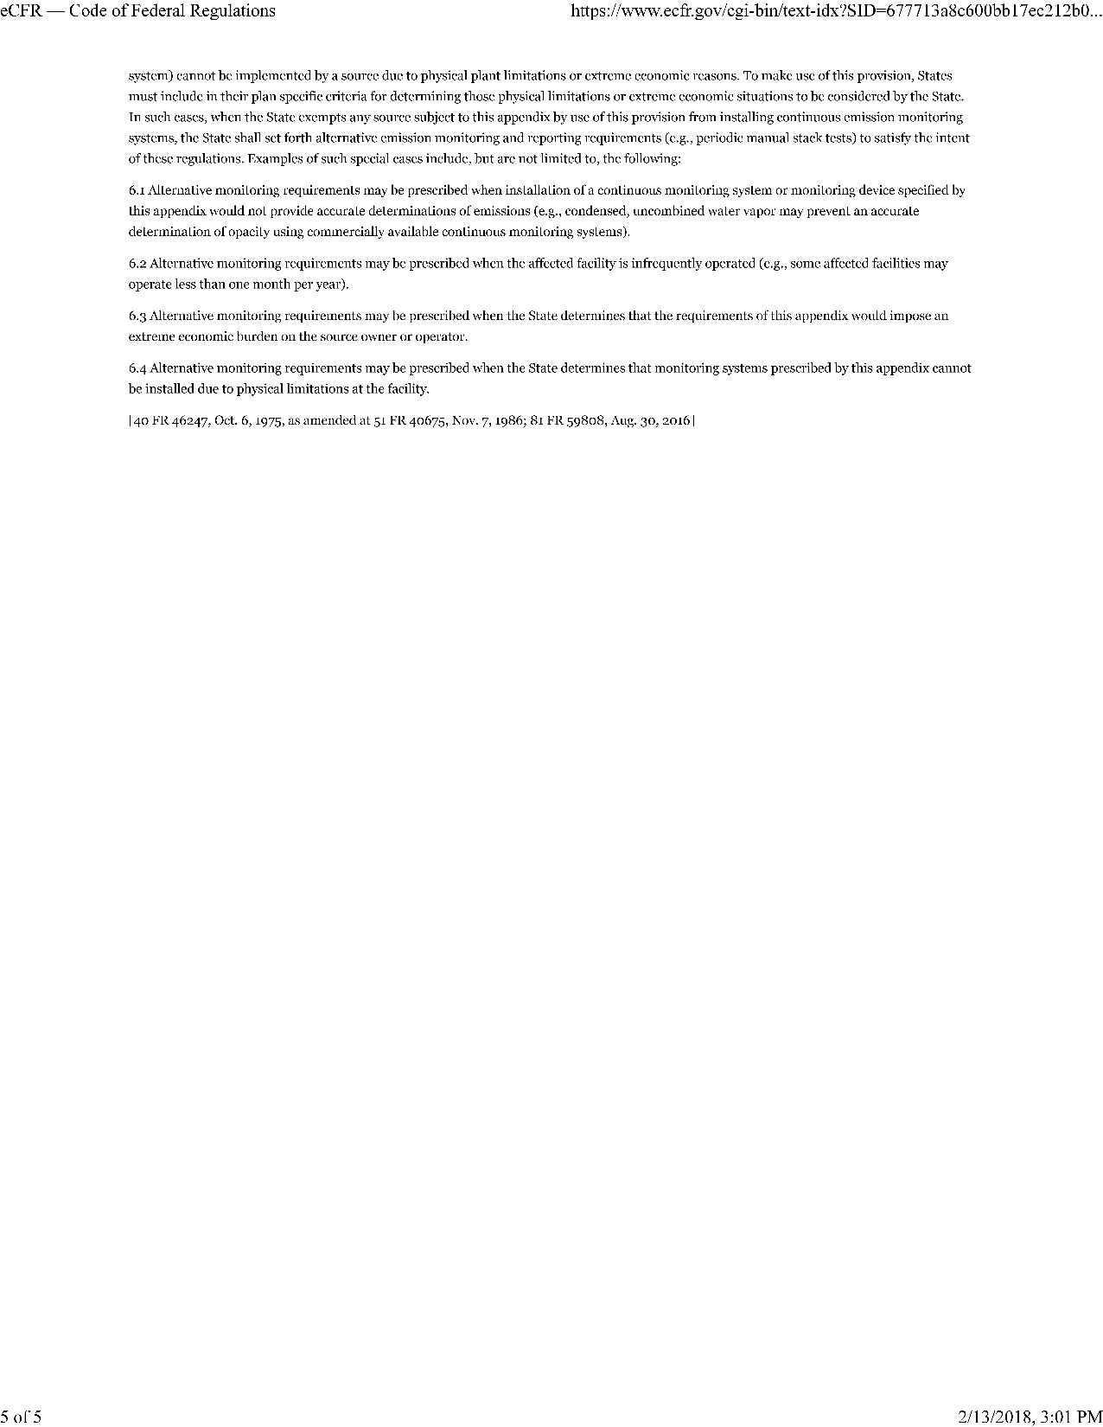

As CAA section 110(a)(2)(E) allows, a state may authorize and rely on a local or regional government, agency, or instrumentality to carry out the SIP or a portion of the SIP within the its jurisdiction. As a result, some SIP provisions apply to specific portions of a state. Thus, in certain states, submission of a SIP revision may involve rulemaking in more than one jurisdiction.
“Requirements for the Preparation, Adoption and Submittal of Implementation Plans: Emission Monitoring of Stationary Sources,” 40 FR 46240 (October 6, 1975).
While a state may not revise its SIP requirements to a level of stringency below that of Appendix P’s minimum requirement, the state may choose to revise it down to the level of stringency of the minimum requirement.
40 FR 46240 at 46246/3.
Where a state has delegated implementation of any plan provision to a local or regional government, agency, or instrumentality, the state itself has responsibility for ensuring adequate implementation of such plan provision, as specified under CAA section 110(a)(2)(E).
Requirements under CAA section 110 may also apply, as provided in CAA section 110(o) and as appropriate under the Tribal Authority Rule at 40 CFR Part 49, to an Indian tribe that receives a determination of eligibility for treatment as a state for purposes of administering a tribal air quality management program. See “Indian Tribes: Air Quality Planning and Management,” final rule published February 12, 1998 (63 FR 7254).
NAICS is the standard used by federal statistical agencies in classifying business establishments for the purpose of collecting, analyzing, and publishing statistical data related to the U.S. business economy. NAICS, developed under the auspices of the OMB, was adopted in 1997 to replace the Standard Industrial Classification (SIC) system. See http://www.census.gov/naics.
The “eSIP” electronic SIP submission system announced in 2015 was subsequently integrated with the more comprehensive and still-developing “SPeCS for SIPs.” For more detailed information about how to use SPeCS for SIPs, see the EPA webpage at https://www.epa.gov/air-quality-implementation-plans/submit-sips-online.
Total compensation, as a cost per hour worked, is reported by the U.S. Department of Labor, Bureau of Labor Statistics. According to the “Employer Costs for Employee Compensation–December 2017” news release, the rate for state and local government workers in the “Management, professional, and related” occupational group is $59.22, as accessed on March 29, 2018, through the BLS website at https://www.bls.gov/news.release/ecec.t04.htm. Refer to “Table 4. Employer costs per hour worked for employee compensation and costs as a percent of total compensation: State and local government workers, by occupational and industry group, December 2017.”
Administered by the U.S. Office of Personnel Management, the General Schedule (GS) classification and pay system covers the majority of civilian white-collar Federal employees in professional, technical, administrative, and clerical positions. The hourly basic rate for each grade and step is found in the “Salary Table 2018­GS” accessible online from https://www.opm.gov/policy-data-oversight/pay-leave/pay-systems/general-schedule/.

