**ETRS FORMS - Screenshots**

**Figure 1.**

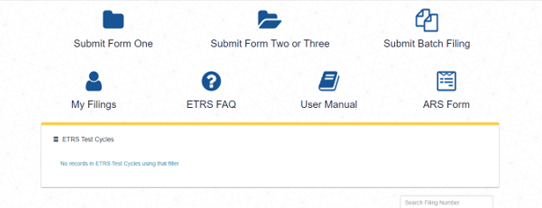

**Figure 2.**

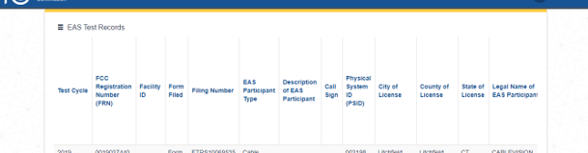

**Figure 3.**

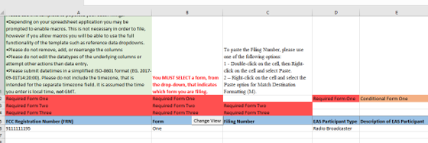

**Figure 4.**

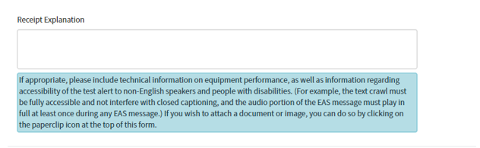

**Figure 5.**

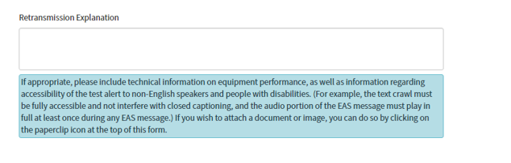

**Figure 5.**

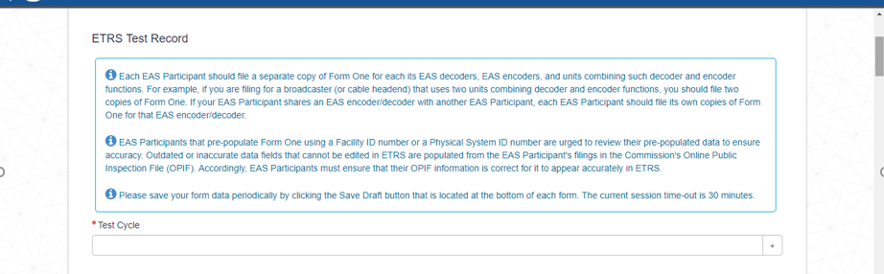

**Figure 6.**

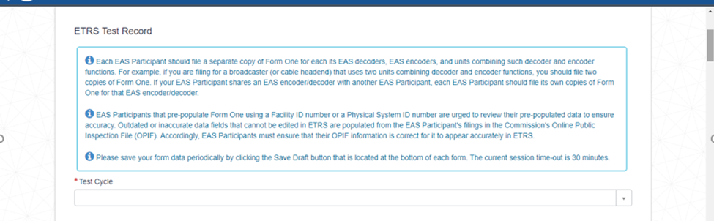

**Figure 7.**

