Proposed New Form
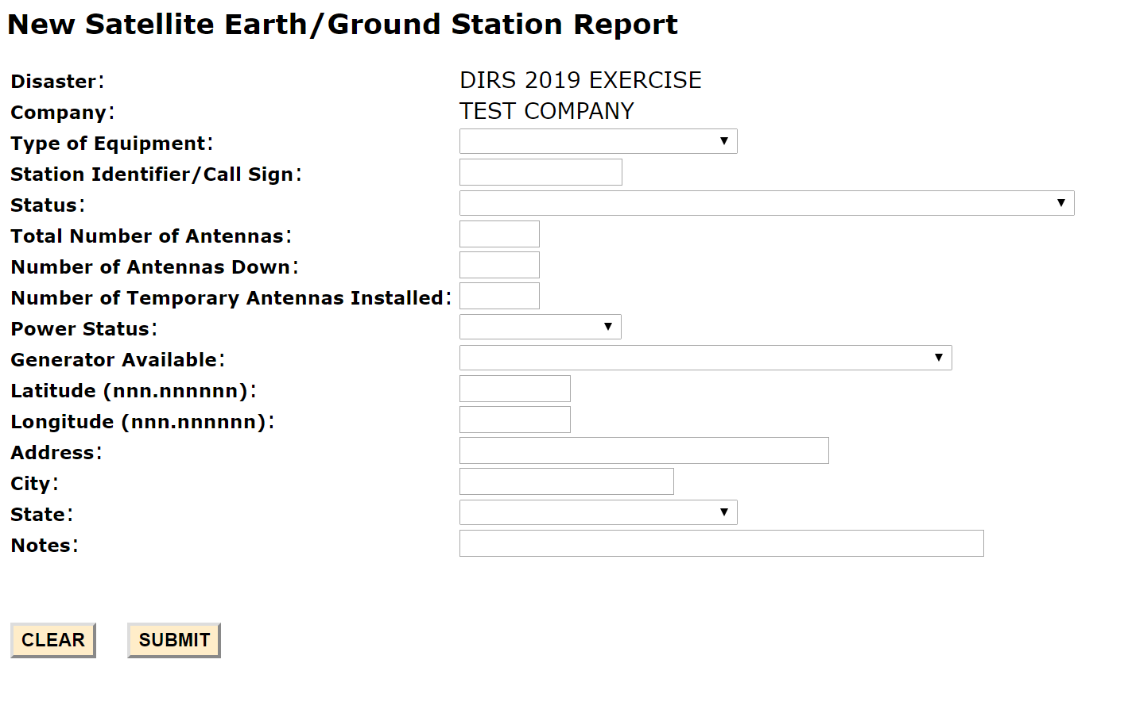

Proposed New Form – illustrating the “Type of Equipment” pull-down menu in more detail
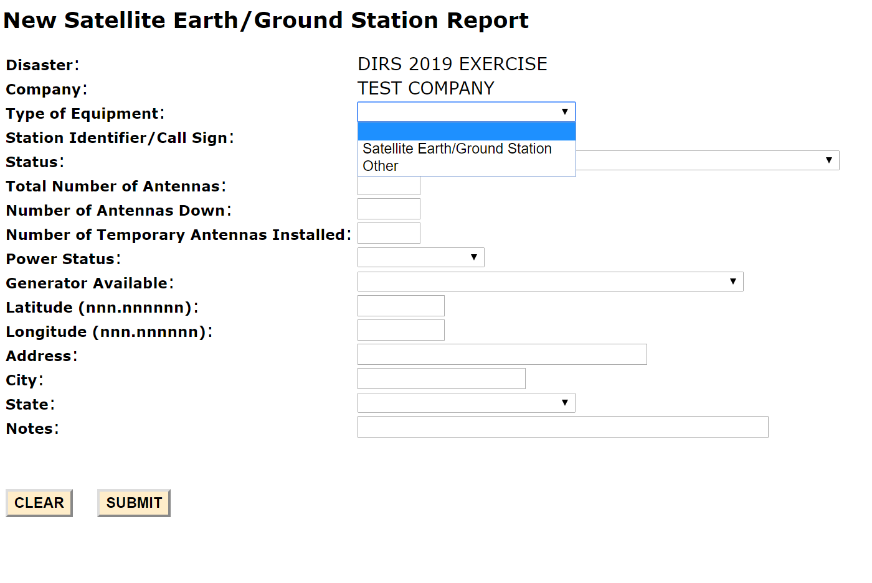
Proposed New Form – illustrating the “Status” pull-down menu in more detail
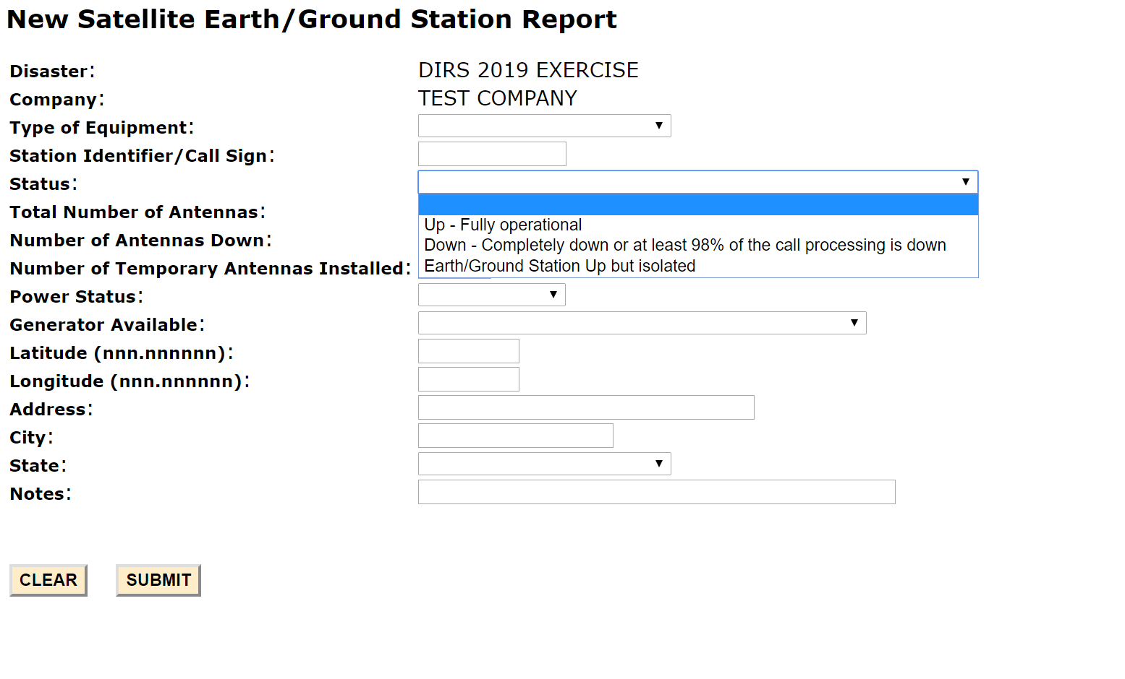

Proposed New Form – illustrating the “Power Status” pull-down menu in more detail
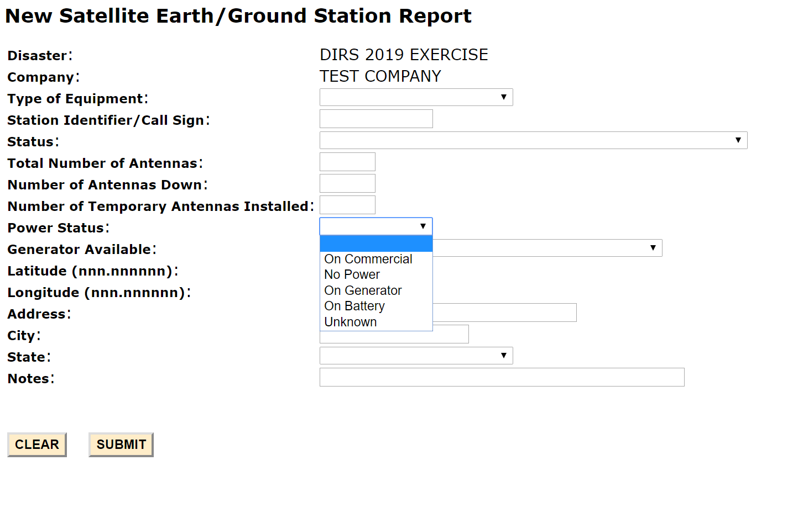

Proposed New Form – illustrating the “Generator Available” pull-down menu in more detail
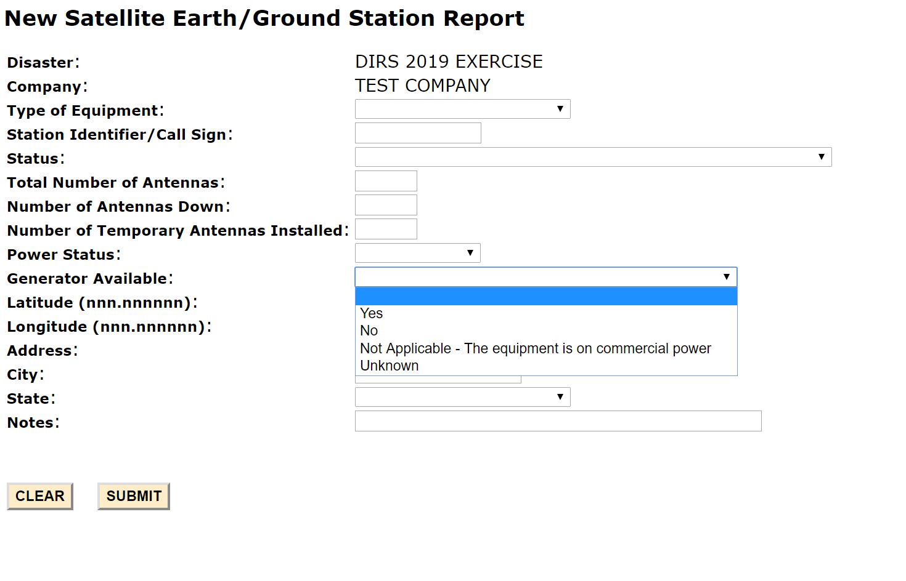

Proposed New Form – illustrating the “State” pull-down menu in more detail
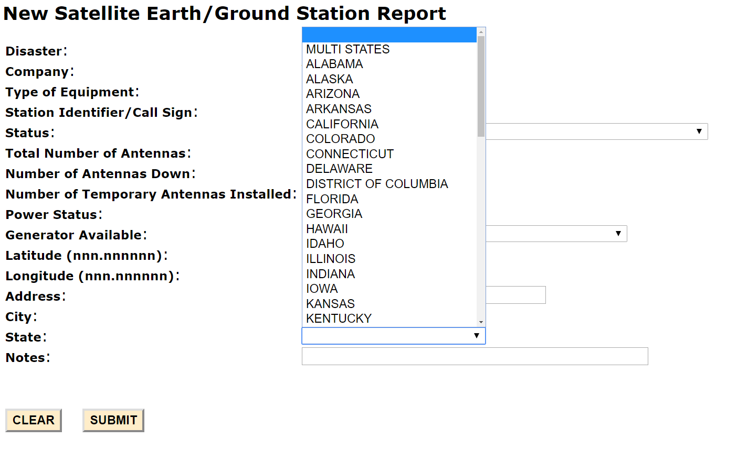

We have estimated that your response to this collection of information will take an average of 6 to 30 minutes (or 0.1 to 0.5 hours). Our estimate includes the time to read the instructions, look through existing records, gather and maintain required data, and actually complete and review the form or response. If you have any comments on this estimate, or on how we can improve the collection and reduce the burden it causes you, please write the Federal Communications Commission, Office of Managing Director, AMDPERM, Washington, DC 20554, Paperwork Reduction Act Project (3060-1003). We will also accept your PRA comments via the Internet if you send an e-mail to PRA@fcc.gov.
Please DO NOT SEND COMPLETED RESPONSES TO THIS ADDRESS. You are not required to respond to a collection of information sponsored by the Federal government, and the government may not conduct or sponsor this collection, unless it displays a currently valid OMB control number and/or we fail to provide you with this notice. This collection has been assigned an OMB control number of 3060-1003.
THIS NOTICE IS REQUIRED BY THE PAPERWORK REDUCTION ACT OF 1995, PUBLIC LAW 104-13, OCTOBER 1, 1995, 44 U.S.C. SECTION 3507.

