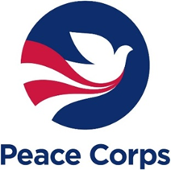

May 22, 2020

By Electronic Submission

The Office of Management and Budget
725 17th Street, NW
Washington, DC 20503

Dear OIRA Desk Officer:

Pursuant to 5 C.F.R. § 1320.13, the Peace Corps requests emergency approval by May 26, 2020, of the use of the LearningSpace Portal. This is an essential vehicle which the Peace Corps will use to allow Peace Corps Volunteers who was recently evacuated due to the coronavirus disease 19 (COVID19) access the LearningSpace Portal from their personal devices. We are seeking an emergency clearance to allow Returned Peace Corps Volunteers to gain access so that they can train and develop their volunteer skills related to Volunteer service, as outlined in 22 USC 2504 (k). Further description of the need for particular skills and foreign language aptitude is referenced in 22 CFR Part 305.
The Peace Corps has determined that this request meets the criteria of 5 CFR 1320.13, in that the collection of information is needed prior to the expiration of time periods established under 5 CFR 1320; it is essential to the mission of Peace Corps to collect this information. The use of normal clearance procedures, which will take at least 90 days, will hinder the mission of the Peace Corps by not allowing us to screen applicants who have a prior service. The emergency notice that Peace Corps will publish in the Federal Register is enclosed.
If you have any questions and/or would like to confirm a publication date, please contact Virginia Burke, Freedom of Information Act Officer at vburke@peacecorps.gov.

Sincerely,

Virginia Burke
Privacy Act Officer

