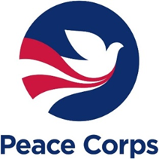

May 22, 2020

By Electronic Submission

The Office of Management and Budget
725 17th Street, NW
Washington, DC 20503

Dear OIRA Desk Officer:

Pursuant to 5 C.F.R. § 1320.13, the Peace Corps requests emergency approval by May 26, 2020, of the use of the Peace Corps Response Reinstatement Application 2020. This is an essential vehicle which the Peace Corps will use for reenrollment of the Peace Corps Volunteers. We are seeking to continue our eligibility and selection process as outlined in 22 CFR 305. It is critical that the agency rebuild its volunteer program as soon as possible. Currently there are not any active Peace Corps Volunteers due to their earlier evacuation, in response to the coronavirus disease 2019 pandemic. The traditional application form is still in use (PC-1502, OMB Control Number 0420-0005).
The Peace Corps has determined that this request meets the criteria of 5 CFR 1320.13, in that the collection of information is needed prior to the expiration of time periods established under 5 CFR 1320; it is essential to the mission of Peace Corps to collect this information. The use of normal clearance procedures, which will take at least 90 days, will hinder the mission of the Peace Corps by not allowing us to screen applicants who have a prior service. The emergency notice that Peace Corps will publish in the Federal Register is enclosed.
If you have any questions and/or would like to confirm a publication date, please contact Virginia Burke, Freedom of Information Act Officer at vburke@peacecorps.gov.

Sincerely,

Virginia Burke
Privacy Act Officer

Enclosure

