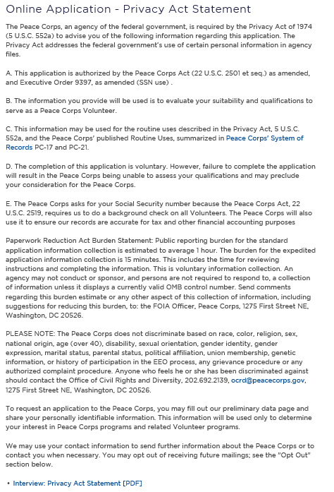

https://www.peacecorps.gov/about/open-government/website-policy/privacy-statement/

