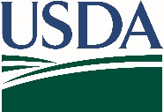
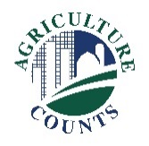
United States Department of Agriculture
National Agricultural Statistics Service

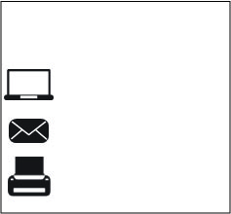
May 11, 2018
What should I do next?
Complete your survey in one of the following ways:
Online at www.agcounts.usda.gov beginning on Tuesday, May 11, 2018. Online reporting is fast, cost-effective, and secure. All you need is the 17-digit survey code on the enclosed form to begin.

By mail or fax. Complete the survey questionnaire and mail it back in the return envelope provided or fax it to (855) 415-3687.

Why am I getting this letter?

Enclosed is your 2018 Agricultural Resource Management Survey (ARMS). Your response is important to ensure farms in your state are accurately represented in the survey results. Completing the ARMS survey is important to help understand production practices and the financial health of U.S. farms and ranches.

Please complete the questionnaire at your earliest convenience. If we do not hear from you by Monday, May 21, 2018, we will contact you to arrange a telephone interview.

How will the data be used?

The results of this survey will be available in aggregate form only as shown in the graph below, ensuring that no individual operation or producer can be identified, as required by federal law. Your information is important and will help state departments of agriculture, local banks, and input suppliers with decisions that affect farmers and ranchers nationwide.
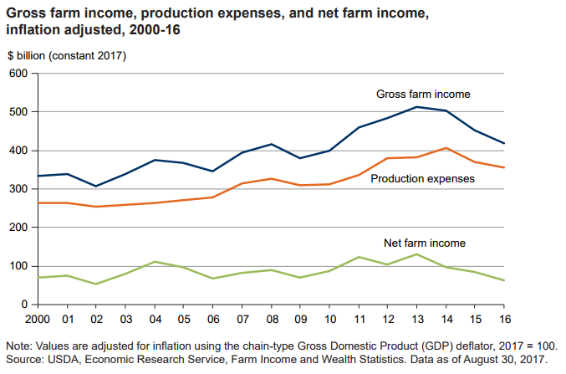
Thank you for participating and for your support of our programs and U.S. agriculture. If you have any questions, please feel free to contact us at 1-888-424-7828.
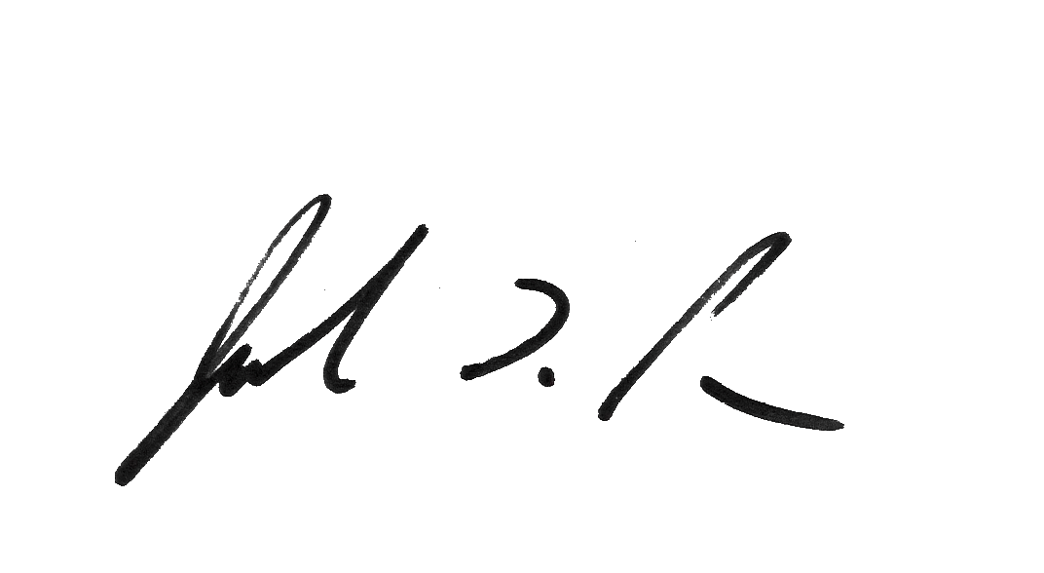
Sincerely,

Joseph L. Parsons
Chair, Agricultural Statistics Board

Enclosure
