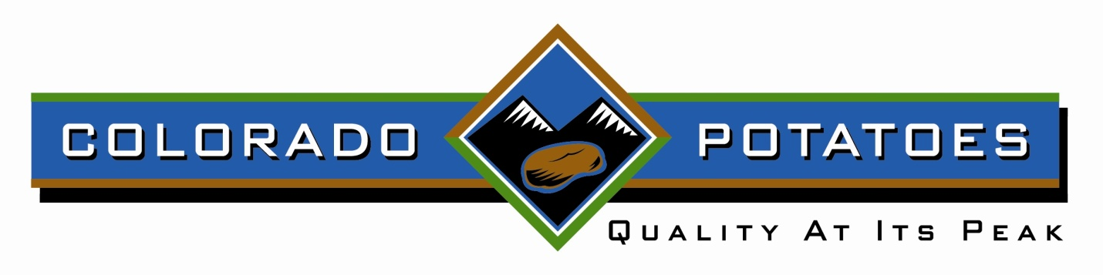
Colorado Potato Administrative Committee Phone: 970-352-5231
Area III - Northern Colorado Fax: 970-304-0861
P.O. Box 1774
Greeley, CO 80632

AREA III POTATO ADMINISTRATIVE COMMITTEE APPLICATION FORM FOR
CONSIDERATION OF APPROVAL AS A CANNER, FREEZER, OR OTHER PROCESSOR
OR PREPEELER OF POTATO PRODUCTS FOR SPECIAL PURPOSE SHIPMENT REPORTS

TO: Colorado Potato Administrative Committee
Northern Colorado Office Area III
P. O. Box 1774
Greeley, CO 80632
FROM: __________________________________________________________________________________________
(Applicant's Name)
I/We, __________________________________________________________________________________________
(The Above Named Applicant)
hereby apply to the Colorado Potato Administrative Committee (Committee) for approval as a "RECEIVER" of potatoes under the Committee's Special Purpose Permit for the purpose of

_________________________________________________________________________________________________
(Canning, Freezing, Other Processing, or Prepeeling---List One**)

I/We hereby certify to the Committee, the Colorado Department of Agriculture (CDA), and the U.S. Department of Agriculture (USDA) that potatoes received from the Area III production area, for processing, will be used for the purpose stated above, and will not be placed in fresh market channels.

I/We agree to report on shipments received as the Committee may require and the CDA and USDA approve.

The undersigned certifies to the Committee, the Commissioner, and the Secretary that potatoes received will be used in accordance with current Marketing Order Regulations for use only for the purpose stated. False certification, knowing it to be false, is a violation of title 18, section 1001, of the United States Code, among other statures, which provide for a fine, imprisonment, or both.

NAME OF COMPANY ______________________________________________

ADDRESS _______________________________________________________

AUTHORIZED SIGNATURE__________________________________________
**If you list "other processing" also show the specific use, as "other processing" is defined.

According to the Paperwork Reduction Act of 1995, an agency may not conduct or sponsor, and a person is not required to respond to a collection of information unless it displays a valid OMB control number. The valid OMB control number for this information collection is 0581-0178. The time required to complete this information collection is estimated to average 9 minutes per response, including the time for reviewing instructions, searching existing data sources, gathering and maintaining the data needed, and completing and reviewing the collection of information.

In accordance with Federal civil rights law and U.S. Department of Agriculture (USDA) civil rights regulations and policies, the USDA, its Agencies, offices, and employees, and institutions participating in or administering USDA programs are prohibited from discriminating based on race, color, national origin, religion, sex, gender identity (including gender expression), sexual orientation, disability, age, marital status, family/parental status, income derived from a public assistance program, political beliefs, or reprisal or retaliation for prior civil rights activity, in any program or activity conducted or funded by USDA (not all bases apply to all programs). Remedies and complaint filing deadlines vary by program or incident.

Persons with disabilities who require alternative means of communication for program information (e.g., Braille, large print, audiotape, American Sign Language, etc.) should contact the responsible Agency or USDA’s TARGET Center at (202) 720-2600 (voice and TTY) or contact USDA through the Federal Relay Service at (800) 877-8339. Additionally, program information may be made available in languages other than English. To file a program discrimination complaint, complete the USDA Program Discrimination Complaint Form, AD-3027, found online at http://www.ascr.usda.gov/complaint_filing_cust.html and at any USDA office or write a letter addressed to USDA and provide in the letter all of the information requested in the form. To request a copy of the complaint form, call (866) 632-9992. Submit your completed form or letter to USDA by: (1) mail: U.S. Department of Agriculture Office of the Assistant Secretary for Civil Rights 1400 Independence Avenue, SW Washington, D.C. 20250-9410; (2) fax: (202) 690-7442; or (3) email: program.intake@usda.gov. USDA is an equal opportunity provider, employer, and lender.

