Attachment H:
Initial Site Visit Followback Survey

Form Approved OMB No.: 0920-0260
Expiration Date: xx/xx/20xx
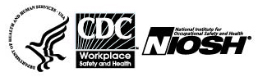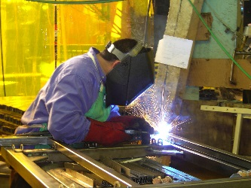

Followback Survey – After the Health Hazard Evaluation Site Visit

The National Institute for Occupational Safety and Health (NIOSH) surveys people involved with its health hazard evaluations. We want to learn your thoughts about the evaluation thus far. Your responses will be kept securely according to federal laws. Our reports include only summary information and will not identify you. We will send you other surveys after the evaluation is completed and one year later.

Thank you for completing this survey!

Please fill in circles completely like this:
- Did NIOSH keep you well informed about the health hazard evaluation plans? | O Yes  O No, I wanted to know more  O No, but I didn’t need to know
- Did NIOSH visit the workplace in a reasonable time after the health hazard evaluation request was made? | - Yes  - No  - I don’t know
- At the end of the site visit, did NIOSH give a good summary of what they did? | - Yes  - No  - I don’t know
- At the end of the site visit, did NIOSH describe well  the future plans for the health hazard evaluation? | - Yes  - No  - I don’t know
- Was the letter NIOSH sent you after the site visit helpful? | - Yes, very  - Yes, somewhat  - Mostly not  - Not at all
- Do you think that NIOSH has been objective? | - Yes  - No
- Did NIOSH make recommendations that address the workplace concerns well? | - Yes  - No  - No recommendations were made
- Overall, are the recommendations NIOSH has made practical? | - Yes  - No  - No recommendations were made

Public reporting burden of this collection of information is estimated to average 10 minutes per response, including the time for reviewing instructions, searching existing data sources, gathering and maintaining the data needed, and completing the collection of information. An agency may not conduct or sponsor, and a person is not required to respond to a collection of information unless it displays a currently valid OMB control number. Send comments regarding this burden estimate or any other aspect of this collection of information, including suggestions for reducing this burden to CDC/ATSDR Information Collection Review Office, 1600 Clifton Road NE, MS D-74, Atlanta, Georgia 30333; ATTN: PRA (0920-0260).

Followback Survey Form 1A - 39869

- What do you think about the NIOSH health hazard evaluation? |  | - It is Excellent  - It is Good  - It is Fair  - It is Poor
10. Please tell us more of your thoughts about the health hazard evaluation thus far.

11. Are you still associated with the workplace that NIOSH is evaluating? | - Yes  O No
Please make any corrections to this label

8/31/2017

Please mail the completed survey to NIOSH in the enclosed postage paid envelope.
Call Pita Gomez at 513-458-7143 if you have any questions about this survey.

