NATIONAL CENTER FOR EDUCATION STATISTICS NATIONAL ASSESSMENT OF EDUCATIONAL PROGRESS

National Assessment of Educational Progress (NAEP)
2019 and 2020
Long-Term Trend (LTT) 2020 Update 3

Appendix J5
Long Term Trend 2020 Content of the MyNAEP System

OMB# 1850-0928 v.17
Carried over to v.20



July 2019
revised August 2019

This appendix is carried over from v. 17 of this package, which described NAEP 2019-2020. Due to COVID-19 school closures in Spring 2020, although LTT 9 and LTT 13 were successfully administered, LTT 17 was not administered on schedule. We now plan to administer LTT 17 in Spring 2021. The materials here represent our best plans for the administration of LTT 17 at this time and will be revised in Materials Update #2 in late 2020.
Table of Contents
MyNAEP Login Screen 4
Home page 6
Provide School Information 7
Prepare for Assessment 8
Review and Verify List of Students Selected for NAEP 9
Review and Verify Student Information 10
Print Reports 13
Complete SD/ELL Student Information 15
Review NAEP Inclusion Policy 17
Give Access to SD and/or ELL Specialists 18
Provide Information for Students Who Are Both SD and ELL 19
Provide Information for SD (IEP or 504 Plan) Only 25
Print Reports 35
Create Accommodation Sessions (Field Staff Only) 43
Notify Parents 44
Download Parent/Guardian Notification Template 45
Upload Letter 46
Verify Parent/Guardian Notification 47
Plan for Assessment Day 49
Record Assessment Details 50
Provide NAEP Team Instructions 52
Encourage Participation 57
Review Resources 58
Select Strategies to Encourage Participation 61
Update Student List 63
Give Access for Student Data Specialist 64
Submit Current List 65
Support Assessment Activities 72
Wrap Up 73
Additional Resources 74
Prepare for Assessment 74
Instructions for the School Coordinator brochure 74
Review and Verify List of Students Selected for NAEP 78
Information Needed to Review and Verify List of Students Selected for NAEP 78
Dept. of Agriculture Memo Authorizing Release of NSLP to NAEP 80
Complete SD/ELL Student Information 81
Inclusion on NAEP Fact Sheet 81
Letter from Department of Education Encouraging Inclusion 85
Information Needed to Include SD/ELL Students 86
Notify Parents 88
Parent’s page on Nation’s Report Card website 88
What Every Parent Should Know About NAEP: PDF version 88
What Every Parent Should Know About NAEP: Video version 88
Sample Questions Booklets 88
Plan for Assessment Day 89
Suggested Testing Room Layouts 89
Encourage Participation 92
Measure Up: NAEP News for the School Community 92
Update Student List 93
Student List Requirements and Instructions 93
Support Assessment Activities 95
Teacher Notification Letter 95
Appointment Cards 96

Description of MyNAEP: The school coordinators are responsible for preparing for the Long-term trend (LTT) assessment in their school using the MyNAEP system, which is an online secure site that provides participating schools with a convenient way to prepare for the upcoming assessment. MyNAEP serves as the primary resource and action center throughout the assessment process. The site also offers school coordinators an electronic way to prepare for the assessment at their own pace. The NAEP field representative will schedule an initial call to pre-review the major areas of the MyNAEP system with the school coordinator. A description of the tasks completed in the MyNAEP system can be found in Part B. The content of the MyNAEP system is included in this appendix.
Notes on the organization of Appendix J5
- Red text indicates descriptive notes and references to Appendices other than J5
- Green text indicates text from hyperlinks or references within this document.
- The Additional Resources section of this document (beginning on page 74) contains the text of hyperlinks

MyNAEP Login Screen
Welcome
MyNAEP is a restricted-use website that contains information on the National Assessment of Educational Progress (NAEP), widely known as The Nation's Report Card.
Login
Email or Username:
Password:
Forgot Username or Password
Having trouble logging in?
First time visiting the 2019 MyNAEP site?
Please register
According to the Paperwork Reduction Act of 1995, no persons are required to respond to a collection of information unless it displays a valid OMB control number. The valid OMB control number for this voluntary information collection is 1850-0928. The time required to complete this information collection is estimated to average 270 minutes for schools that do not submit student sample information or 390 minutes for schools that submit student sample information manually, plus an additional 10 minutes for each student identified as SD or ELL, including the time to review instructions, search existing data resources, gather the data needed, and complete and review the information collection. If you have any comments concerning the accuracy of the time estimate, suggestions for improving this collection, or any comments or concerns regarding the status of your individual submission, please write to: National Assessment of Educational Progress (NAEP), National Center for Education Statistics (NCES), Potomac Center Plaza, 550 12th St., SW, 4th floor, Washington, DC 20202.
OMB No. 1850-0928 APPROVAL EXPIRES 9/30/2021
National Center for Education Statistics (NCES) is authorized to conduct NAEP by the National Assessment of Educational Progress Authorization Act (20 U.S.C. §9622) and to collect students’ education records from education agencies or institutions for the purposes of evaluating federally supported education programs under the Family Educational Rights and Privacy Act (FERPA, 34 CFR §§ 99.31(a)(3)(iii) and 99.35).
All of the information provided by participants may be used only for statistical purposes and may not be disclosed, or used, in identifiable form for any other purpose except as required by law (20 U.S.C. §9573 and 6 U.S.C. §151). By law, every NCES employee as well as every NCES agent, such as contractors and NAEP coordinators, has taken an oath and is subject to a jail term of up to 5 years, a fine of $250,000, or both if he or she willfully discloses ANY identifiable information about students. Electronic submission of each student’s information will be monitored for viruses, malware, and other threats by Federal employees and contractors in accordance with the Cybersecurity Enhancement Act of 2015. The collected information will be combined across respondents to produce statistical reports.
Notice: You are accessing a U.S. Government information system. This warning banner provides privacy and security notices consistent with applicable federal laws, directives, and other federal guidance for accessing this Government system, which includes all devices/storage media attached to this system. This system is provided for Government-authorized use only. Unauthorized or improper use of this system is prohibited and may result in disciplinary action and/or civil and criminal penalties. If you have questions or need help accessing the website, please contact the NAEP help desk at 1-800-283-6237 or naephelp@westat.com Monday through Friday between 8 a.m. and 5:30 p.m. ET.

Screenshot
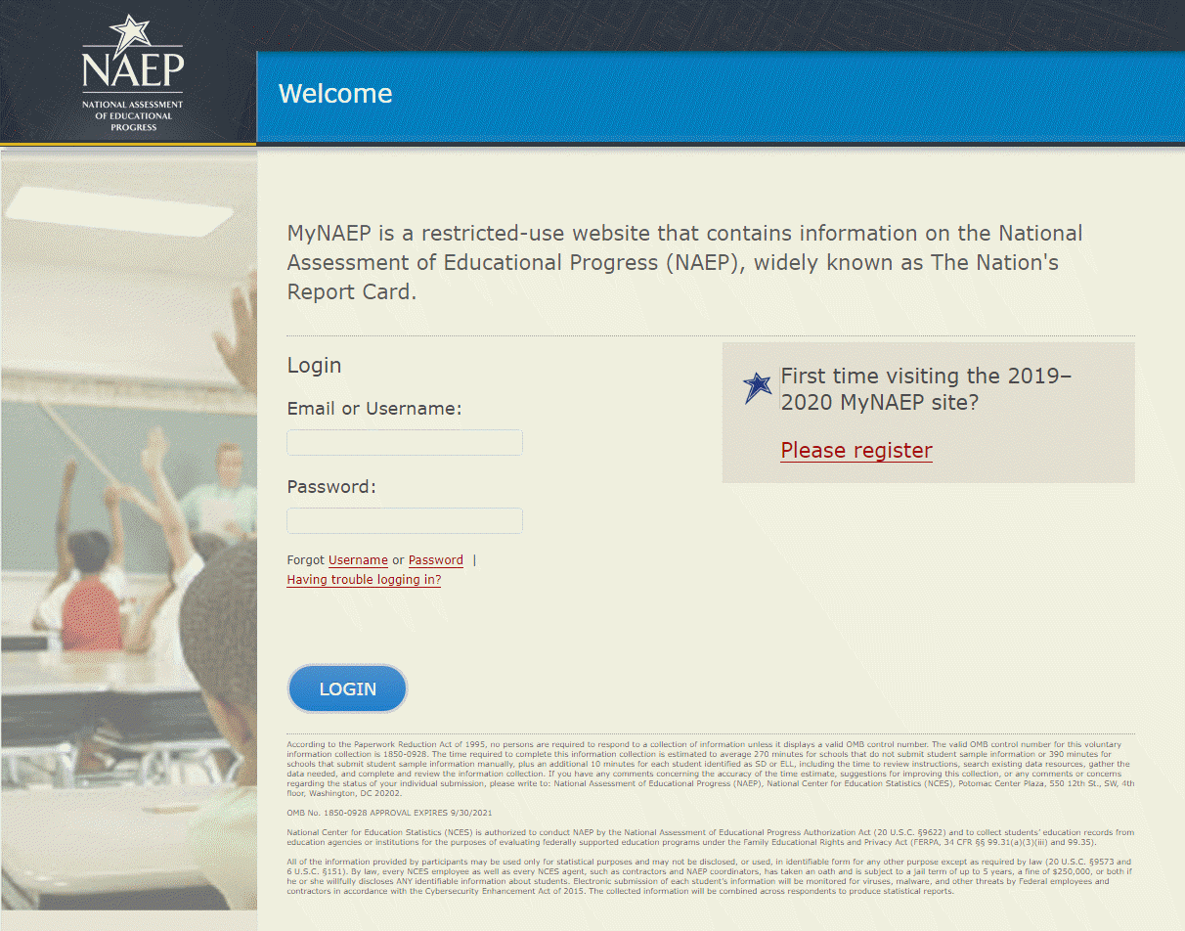

Home page
Welcome to the National Assessment of Educational Progress!
The MyNAEP website will help you prepare for the assessment.
Assessment Details
Age:
Subject(s):
Assessment Date:
Preassessment Review Call Date:
NAEP Representative:
MyNAEP Registration ID:
NAEP School Coordinator:
*If a school coordinator name does not appear above, then no one is currently assigned as school coordinator. Notify your NAEP State Coordinator, _________, at ________ if this information is missing. School coordinators must register their own MyNAEP account.
Prepare for Assessment
It's time to prepare for your school's upcoming assessment date.
- The first step is to watch this quick tutorial video (https://bcove.video/2rHlh6v), which will give you an overview of the Prepare for Assessment menu.
- Complete the activities in the menu before your scheduled preassessment review call.
What's Next?
Download teacher notification letters and student appointment cards in the Support Assessment Activities section.
Screenshot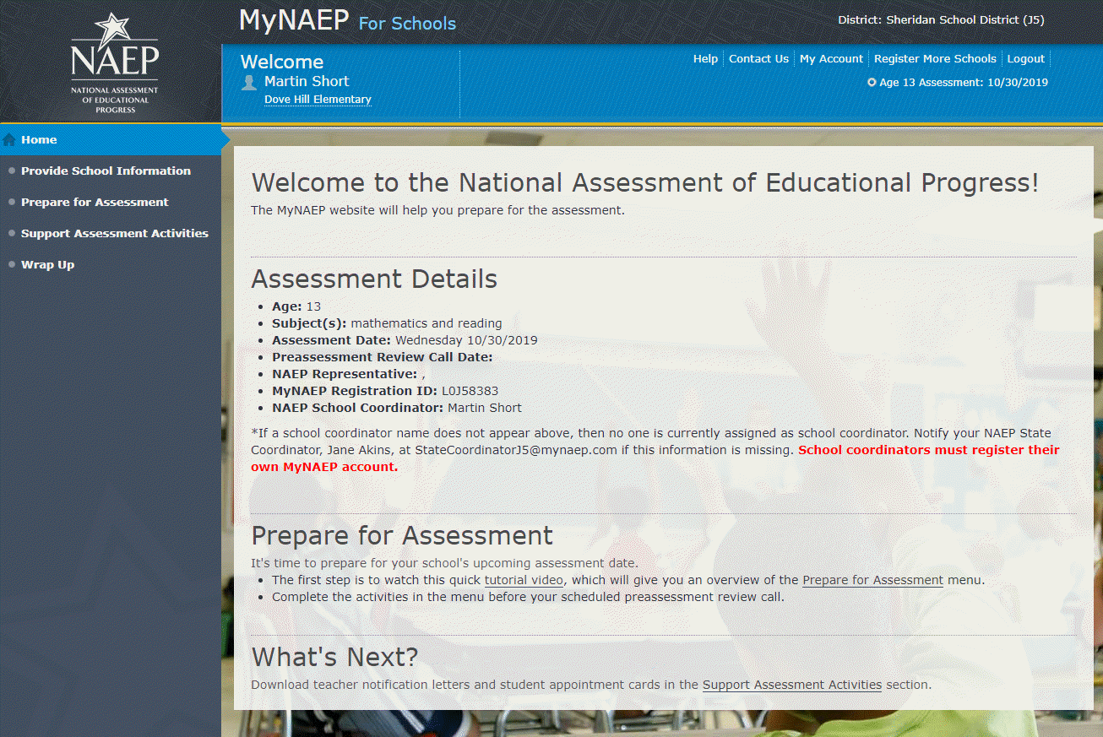

Provide School Information
Provide School Information
Please use the links below to ensure that NAEP has the most up-to-date information about your school.
Complete the following:
School Contact Information
- School name and address
- Shipping address
- Principal contact information
- School coordinator contact information
School Characteristics Information
- Student enrollment
- Charter school status
- Date school adjourns for break
- Date school returns from break
- School calendar type (traditional or year round)
- School start and end times
Screenshot
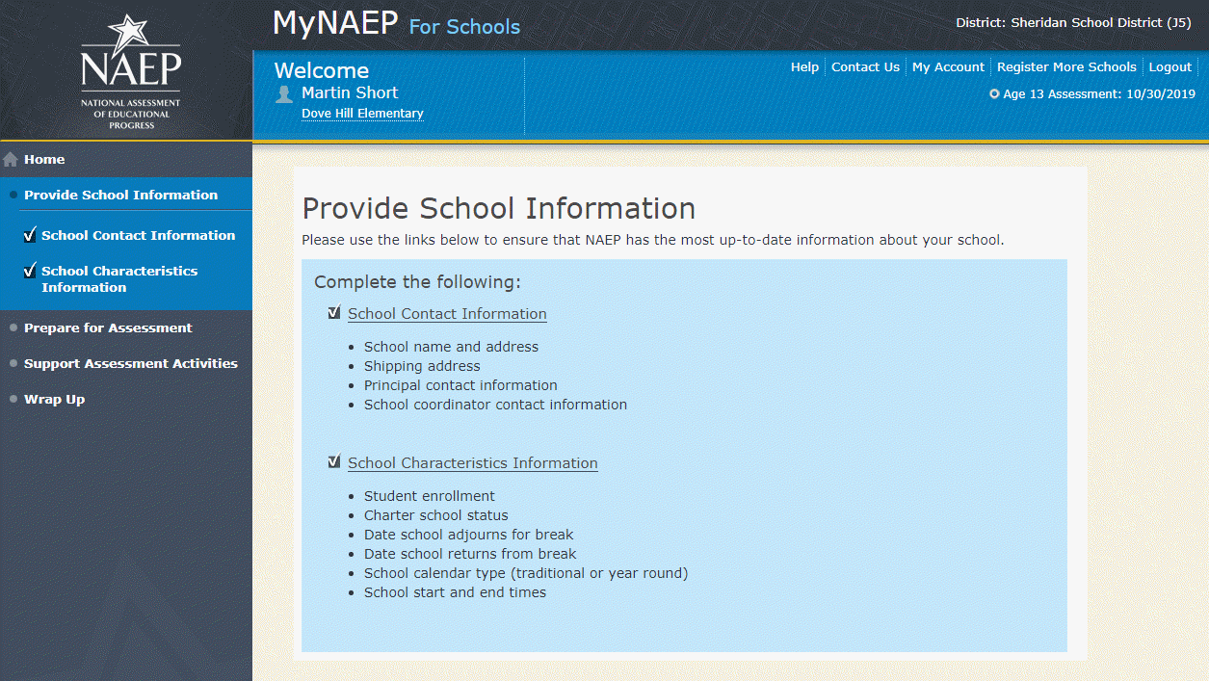

Prepare for Assessment
Prepare for Assessment
The list of students selected for NAEP will become available in early December (Note: for age 13, this will read: “September”). The school coordinator will need to complete some activities after the list is available. Completion of these activities will ensure a successful administration of NAEP. Use the links in the checklist on the left-hand menu under Prepare for Assessment to:
- Review and verify the list of students selected for NAEP
- Complete information about how students with disabilities and English language learners will participate in NAEP
- Notify parents/guardians of sampled students
- Plan assessment day logistics
- Encourage participation and motivate students to do their best
Complete the following activity upon return from winter break…(Note: this text and the bullet point below will not be shown for age 13 since it is assessed in the fall and an updated list is not needed.)
- Update the student list to include any new age [9/17] students at your school
Your NAEP representative will contact the school coordinator in early December (Note: for age 13, this will read: “September”) to explain how to complete these activities and to schedule a preassessment review call. Please complete all activities before the preassessment review call date.
A storage envelope and the Instructions for School Coordinator brochure will be mailed in early December (Note: for age 13, this will read: “September”). Store any printed reports that include student names and information in the NAEP Storage Envelope.
Additional Resources
- Instructions for the School Coordinator (see Additional Resources section of this document)

Screenshot
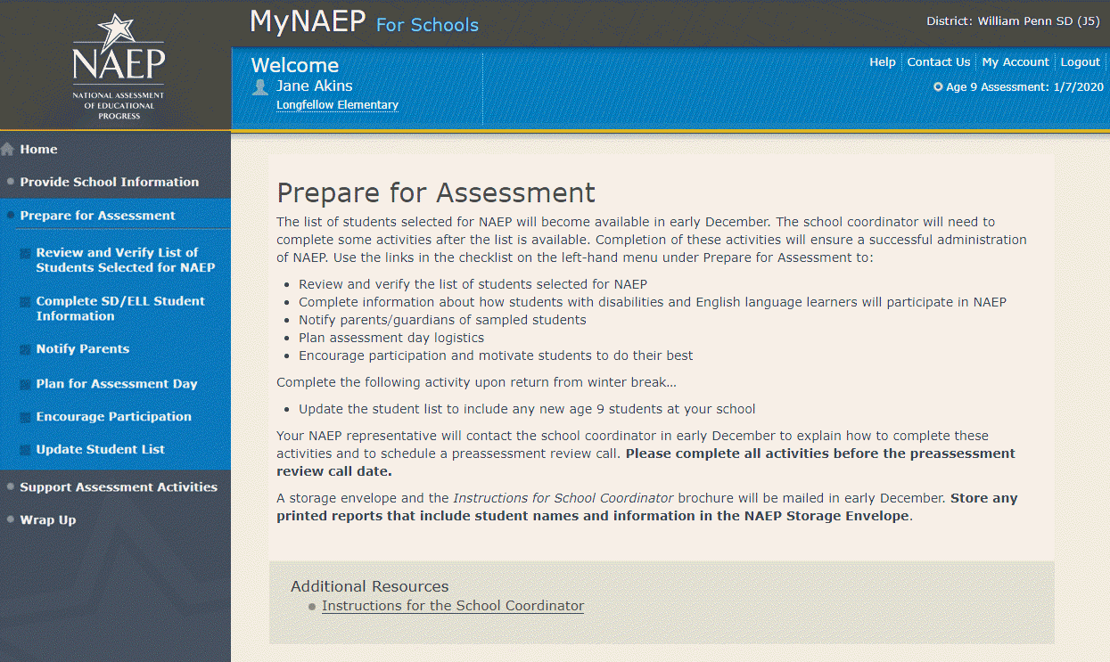

Review and Verify List of Students Selected for NAEP
Note: The student list is initially submitted outside of the MyNAEP system and the information is loaded into MyNAEP for the school coordinator to review and verify for accuracy.
Prepare for Assessment
Review and Verify List of Students Selected for NAEP
NAEP reports results for student demographic groups, so it is important to collect accurate data. Review the list of students to be tested at your school and update their enrollment status and demographic information as needed.
Complete the following:
- Watch the Review and Verify List of Students Selected for NAEP Tutorial (5:36) (https://bcove.video/2fEo6iA)
- Review and Verify Student Information
- Print Reports
Additional Resources
- Information Needed to Review and Verify List of Students Selected for NAEP
(see Additional Resources section of this document)
- Dept. of Agriculture Memo Authorizing Release of NSLP to NAEP
(see Additional Resources section of this document)
Screenshot
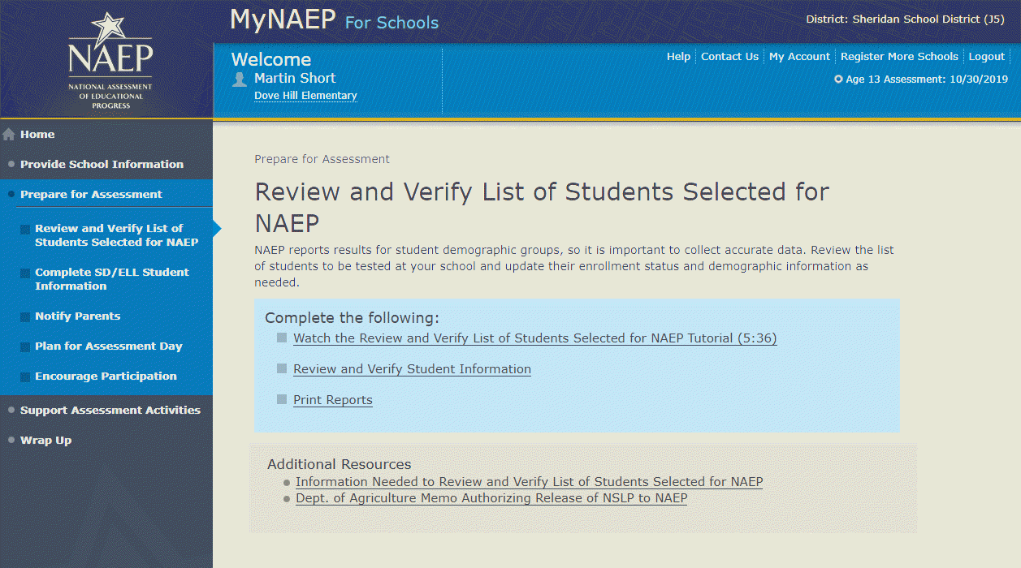

Review and Verify Student Information
Review and Verify Student Information
Print Worksheet – REV-INFO-1
Select Print Worksheet to review and note changes to student enrollment status and demographics on a hardcopy worksheet. Select Continue when you are ready to enter information into MyNAEP.
Some students may not be eligible to participate in NAEP. A list of possible reasons is available here.
(Note: the content of the list is provided below for convenience of reviewing this appendix)
Reasons Student Cannot Take NAEP:
- Withdrawn
- Graduated
- Expelled
- Does not attend any academic classes on campus
- Home schooled and receives limited services on campus
- Student listed more than once
- Not in tested age group
- Foreign exchange student
- Student deceased
- Long-term illness/homebound
- Parent notified about NAEP and refused NAEP testing
- Student notified about NAEP and refused NAEP testing
- Enrolled in U.S. schools less than one full academic year before the NAEP assessment and cannot access NAEP (applies only to English language learners)
- Meets (or met) participation criteria for one or more state alternative assessments (applies only to students with disabilities)
Screenshot
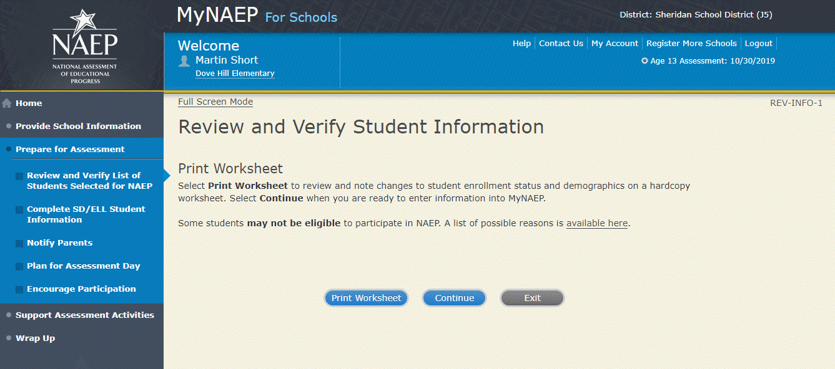
Review and Verify Student Information
Demographic Data-REV-INFO-2
Note: School coordinators will be asked to review and verify student demographic information (as shown in the screenshot below), and also to indicate whether students were displaced from a natural disaster (screen REV-INFO-6).
Review all demographic data for the students listed below.
Select the Edit pencil next to the student name to enter a student's correct or missing information, or indicate a reason the student cannot take NAEP.
- If a student has a Section 504 Plan and requires an accommodation to be tested, change his or her Student with a Disability status to Yes, 504.
- If there are missing data for a student, there will be an icon in the column. Hover over the icon to see how many students have missing data.
- All columns can be sorted by clicking on the column header. Missing data will filter to the top.
Screenshot
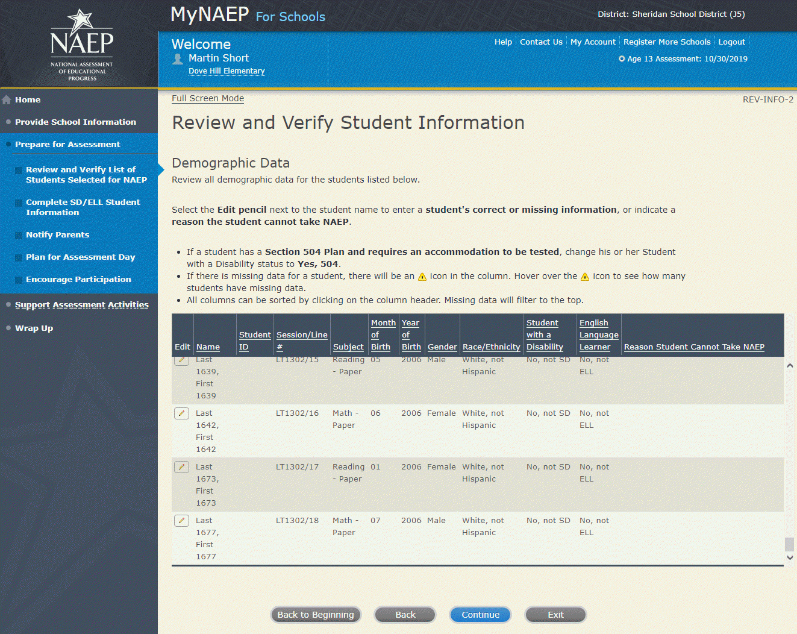

Review and Verify Student Information-REV-INFO-6
Identify Displaced Students
Due to natural disasters, families may be forced from their homes, displacing students who have enrolled outside their home district or state. For reporting purposes, NAEP is collecting information about displaced students.
Are any of the students listed below enrolled in your school because they were displaced from another district or state by a disaster, such as a hurricane?
Screenshot
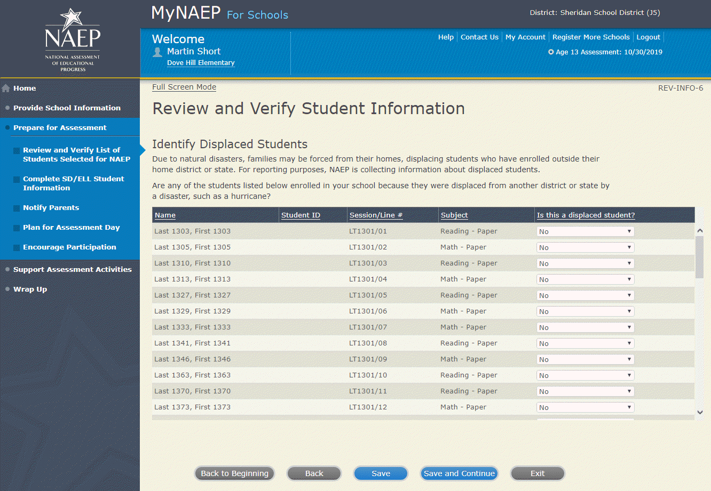

Review and Verify Student Information
Print Summary Report-REV-INFO-7
Select Print Summary to print a record of the student information entered into MyNAEP. Keep this report in the NAEP Storage Envelope and refer to it during the preasessment review call.
Select Submit when you are finished with this section.

Screenshot
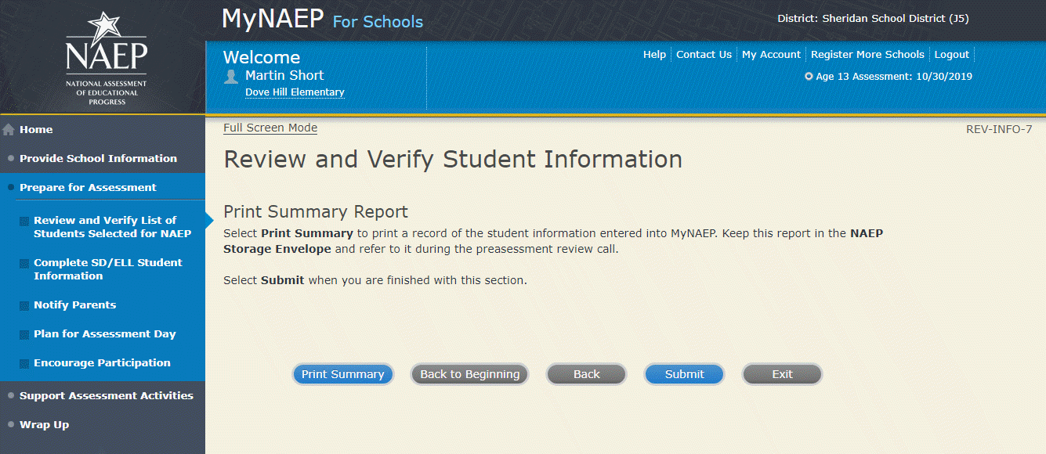

Print Reports
Print Reports – REV-REP-1
Before entering student data in the system
Print this worksheet and use it to review and verify student enrollment status and demographics before entering the data into the system.
After entering student data in the system
Select Print Summary Report to print a record of the student information entered in the system. Keep this report in the NAEP Storage Envelope and refer to it during the preassessment review call.
Select Submit to indicate you are finished with this section.
Screenshot
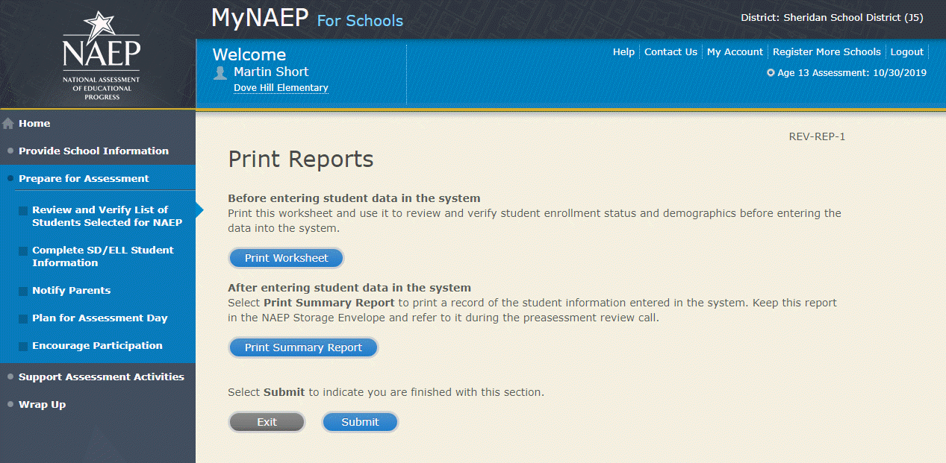

Sample of information included in the worksheet and summary report (note the worksheet is a resource to assist school coordinator in collecting the information that will be contained in the summary report)
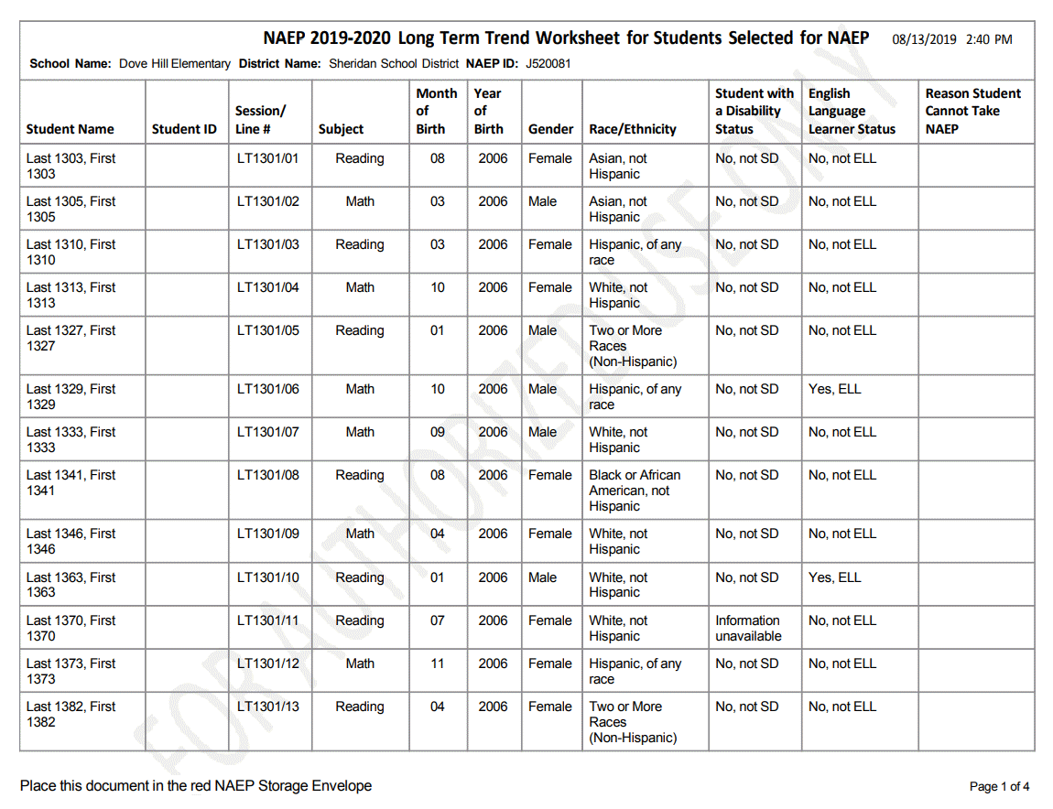

Complete SD/ELL Student Information
Note: In this section the school coordinator will provide information to determine how students participate in NAEP (i.e., without accommodations, with accommodations, or do not test). The school coordinator will provide the Individuals with Disabilities Education Act (IDEA) disability status, English proficiency, primary language, grade-level performance, and accommodations, using the state-specific NAEP inclusion policies (see Appendices D3-16 and D3-17 for templates of the SD and ELL inclusion policies, which are customized by the NAEP State Coordinators). The purpose of providing this information is to make sure students have appropriate supports to access the NAEP assessment.
Prepare for Assessment
Complete SD/ELL Student Information
To ensure that NAEP reflects the educational progress of all students, students with disabilities (SD) and English language learners (ELL) must be included to the fullest extent possible.
NAEP provides accommodations only for SD and ELL. Therefore, this section only includes students whose SD status is "Yes, IEP" or "Yes, 504" or ELL status is "Yes, ELL." Changes to these status codes can only be made in the Review and Verify List of Students Selected for NAEP section.
The information that you provide in this section indicates how students will participate in NAEP and the accommodations they will receive.
Complete the following:
- Watch Complete SD/ELL Student Information Tutorial (5:59) (https://bcove.video/2fECUxM)
- Review NAEP Inclusion Policy
- Give Access to SD and/or ELL Specialist(s) (optional)
- Provide Information for Students Who Are Both SD and ELL
- Provide Information for SD (IEP or 504 Plan) Only
- Provide Information for ELL Only
- Print Reports
- Create Accommodation Sessions (Field Staff Only)
Additional Resources
- Inclusion on NAEP Fact Sheet
- Letter from Department of Education Encouraging Inclusion
- Information Needed to Include SD/ELL Students

Screenshot
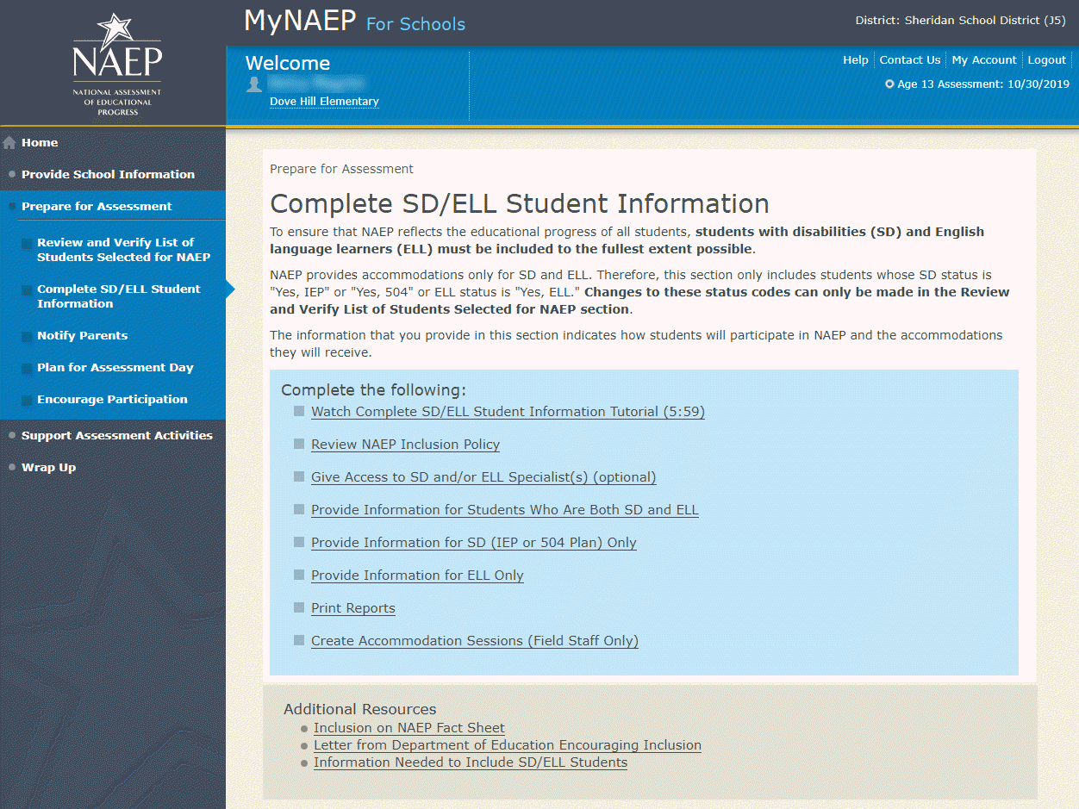

Review NAEP Inclusion Policy
Review NAEP Inclusion Policy-COMP-INCL 1-1
NAEP Inclusion Policy for Students with Disabilities and English Language Learners
The policy provides inclusion expectations, lists the NAEP accommodations, and describes how the accommodations are administered.
SD Inclusion Policy (See Appendix D3-16)
ELL Inclusion Policy (See Appendix D3-17)
We expect most students with disabilities and English language learners to participate. The only students eligible for exclusion are:
Students who meet (or met) participation criteria for the State Alternate Assessment
English language learners who have been enrolled in U.S. schools less than 1 full academic year before the NAEP assessment and cannot access NAEP
All other SD and ELL students should participate with or without NAEP accommodations.
Monitoring Exclusions
Your NAEP State Coordinator will monitor exclusions and may contact you regarding excluded students. If you have any questions about how to include a student, contact your NAEP State Coordinator, NAME, at EMAIL ADDRESS.
I downloaded and reviewed the NAEP Inclusion Policy for Students with Disabilities and English Language Learners.
Yes No
Screenshot
  - Please note: Due to an artifact of the development process, the placeholder phrase “Training J5” is being used in the screenshot. The applicable state name will show on the actual site in place of each instance of the “Training J5” text.
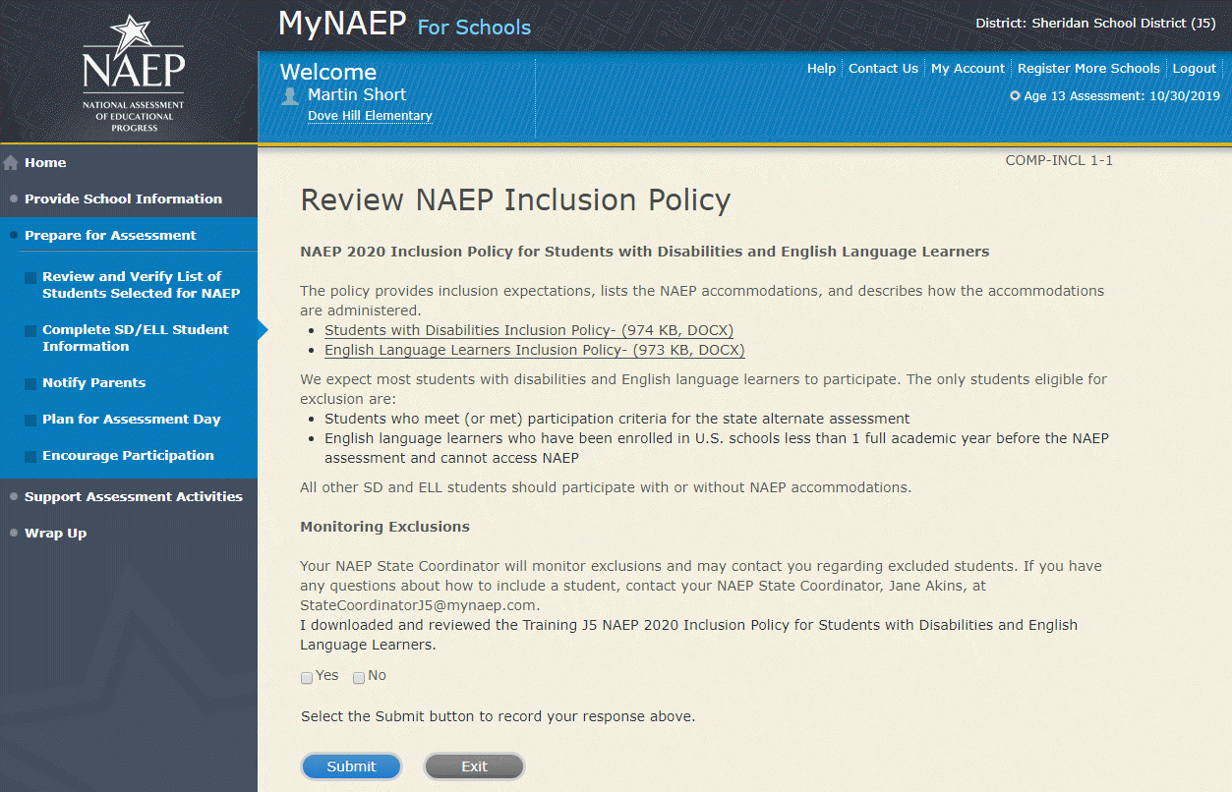

Give Access to SD and/or ELL Specialists
Please complete the Review and Verify List of Students Selected for NAEP section before giving access to SD and/or ELL Specialists
Give Access to SD and/or ELL Specialists-COMP-SPEC 1-1
The person most familiar with how students with disabilities (SD) and English language learners (ELL) are tested should provide the information for these students. Complete and submit the information below to give access to the Complete SD/ELL Student Information section for one or more SD/ELL specialists.
For confidentiality reasons, access is limited to you and five additional school staff.
- Enter all names and email addresses then select Save.
- Select the Send Email button for each record.
- Select Submit.
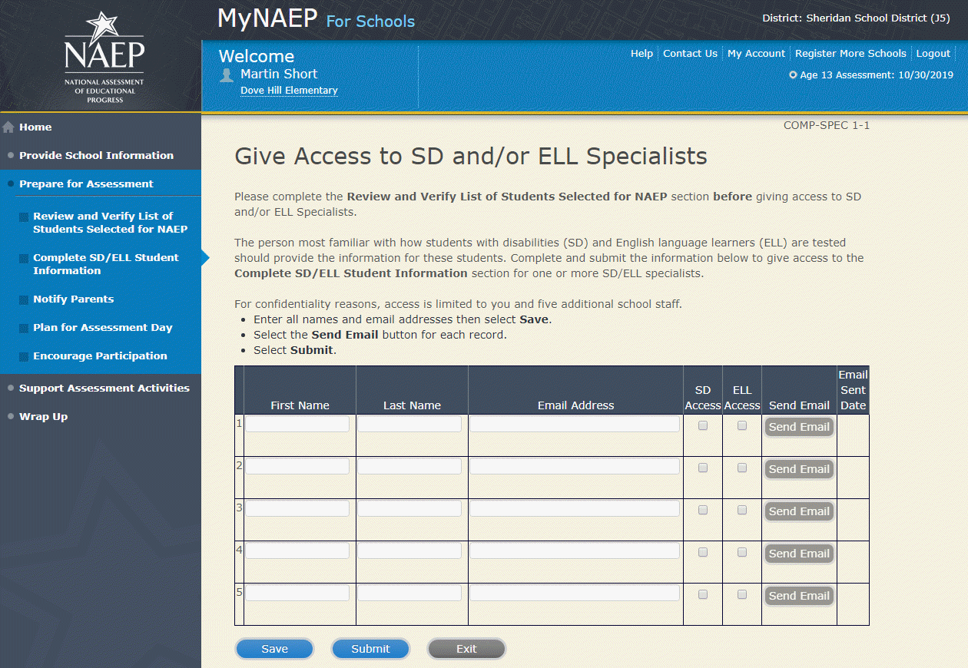
Screenshot

Provide Information for Students Who Are Both SD and ELL
Print Worksheet-COMP-BOTH-2
Select Print Worksheet to record the information for each student on a hardcopy worksheet. Select Continue when you're ready to enter information into MyNAEP.
Review the NAEP inclusion policy (see Appendices D3-16 and D3-17) to see the universal design elements and accommodations for NAEP, and to determine how students should participate.
Screenshot
  - Please note: Due to an artifact of the development process, the placeholder phrase “Training J5” is being used in the screenshot. The applicable state name will show on the actual site in place of each instance of the “Training J5” text.

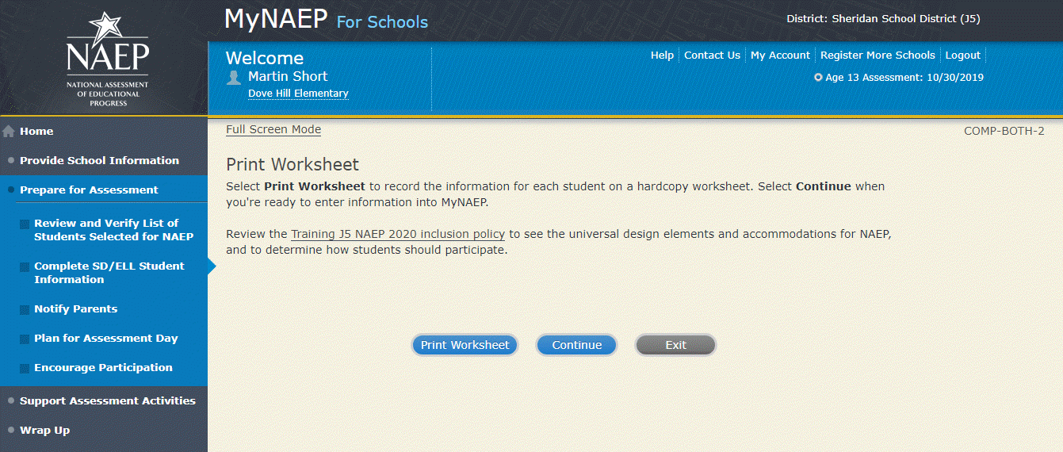

ELL Details-COMP-BOTH-3
For each student listed below, record the following information by selecting the Edit pencil next to the student name. Review the NAEP inclusion policy (see Appendices D3-16 and D3-17) prior to completing.
- What is the student's primary language?
- Including this year, how long has this student been receiving academic instruction primarily in English? (note a hover note displays in the system that reads: Instructor presents academic content in English and the student receives only occasional translation of words or explanation of ideas/concepts in his/her native language.)
- At what grade level (note a hover note displays in the system that reads: For example, a grade 4 student is selected to take the NAEP math assessment who performs at a second-grade level should be marked as two or more years below grade level.) does this student perform in the NAEP subject?
- How would you characterize this student’s English proficiency (note a hover note displays in the system that reads: How this student's English language proficiency compares to other ELLS in the same grade.) in listening comprehension, reading, speaking, and writing?
All columns can be sorted by selecting the column header.
Screenshot
  - Please note: Due to an artifact of the development process, the placeholder phrase “Training J5” is being used in the screenshot. The applicable state name will show on the actual site in place of each instance of the “Training J5” text.

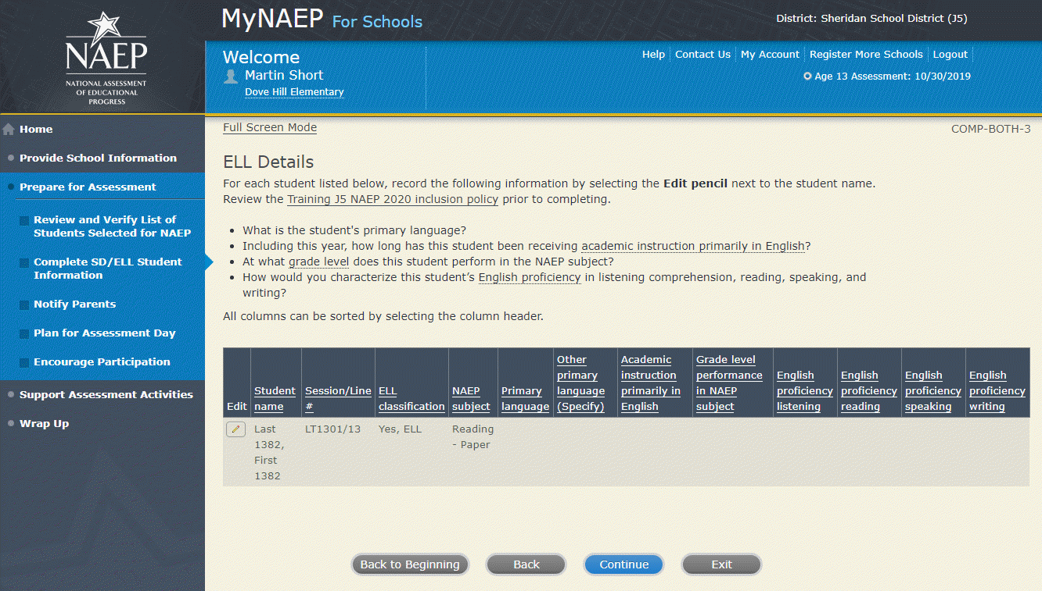

SD Details-COMP-BOTH-4
For each student listed below, record the following information by selecting the Edit pencil next to the student name. Review the NAEP inclusion policy prior to completing.
- Which of the following IDEA categories (see list below) best describes each student’s identified disability(ies)?
  - Autism
  - Deaf-blindness
  - Developmental delay
  - Emotional disturbance
  - Hearing impairment, including deafness
  - Intellectual disability
  - Multiple disabilities
  - Orthopedic impairment
  - Other health impairment
  - Specific learning disability
  - Speech or language impairment
  - Traumatic brain injury
  - Visual impairment, including blindness
- What is the degree (note that in the system a hover note appears that reads: The response should be based on the knowledge of the person most familiar with this student's disability(ies) and based on the professional judgment how it/they might compare to other students with similar) of each student's disability(ies)?
All columns can be sorted by selecting the column header.
Screenshot
  - Please note: Due to an artifact of the development process, the placeholder phrase “Training J5” is being used in the screenshot. The applicable state name will show on the actual site in place of each instance of the “Training J5” text.
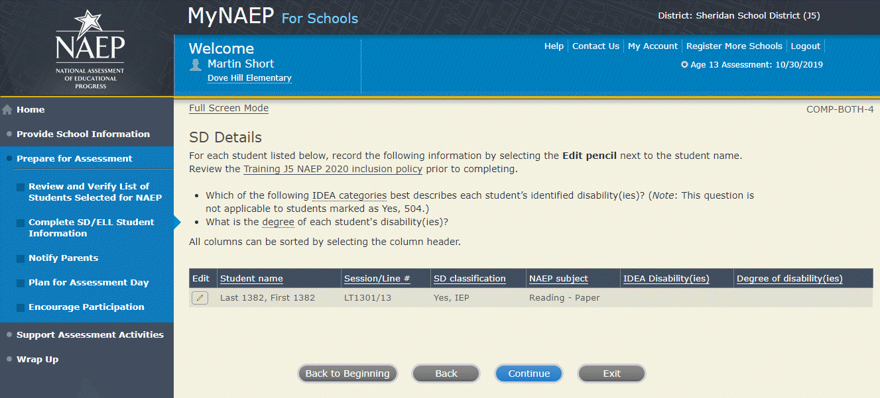How Students Should Participate-COMP-BOTH-5
For each student listed below, record the following information by selecting the Edit pencil next to the student name. Review the {State} NAEP inclusion policy (see Appendices D3-16 and D3-17) prior to completing. If you have any questions on how to include students, contact your NAEP State Coordinator, First and Last Name, at Email address.
- How long has each student been enrolled in U.S. schools?
- How is each student assessed on the state or classroom assessments in the NAEP subject?
- How should each student be assessed on NAEP?
- (If appropriate) What accommodations does the student need to access NAEP?
- (If appropriate) Reason student cannot take NAEP?
- (If appropriate) Is the decision to exclude each student a school decision or a parent/student decision?
All columns can be sorted by selecting the column header.
Screenshot
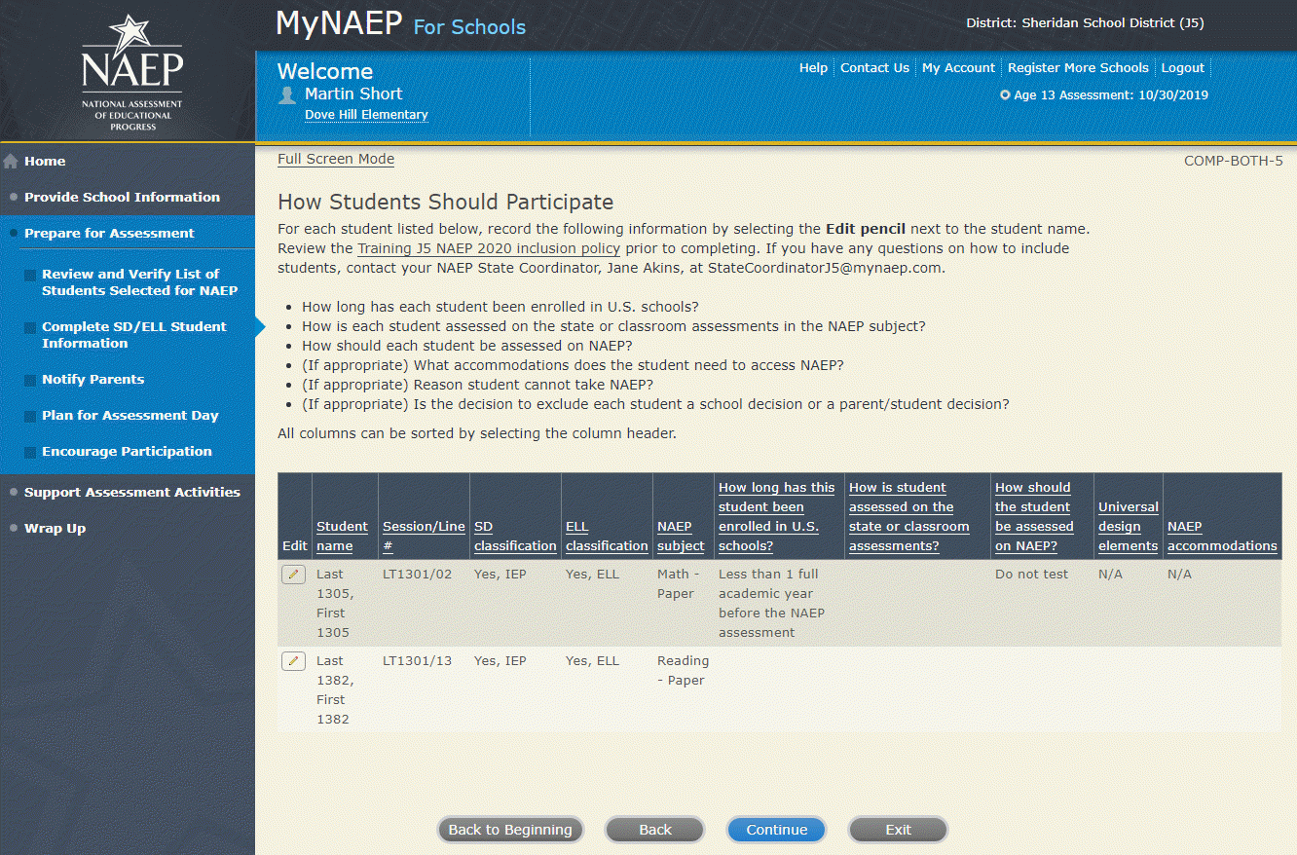

Exclusions Summary-COMP-BOTH-7

The student(s) listed below are marked as “Do not test” and will be excluded from the NAEP assessment.

Your NAEP State Coordinator will monitor exclusions and may contact you regarding excluded students. If you have any further questions on how to include students, contact your NAEP State Coordinator, First and Last Name, at Email address and/or review the {State} NAEP inclusion policy (see Appendices D3-16 and D3-17).

Select Back to make any changes for the students on the previous screen.

All columns can be sorted by selecting the column header.

Screenshot
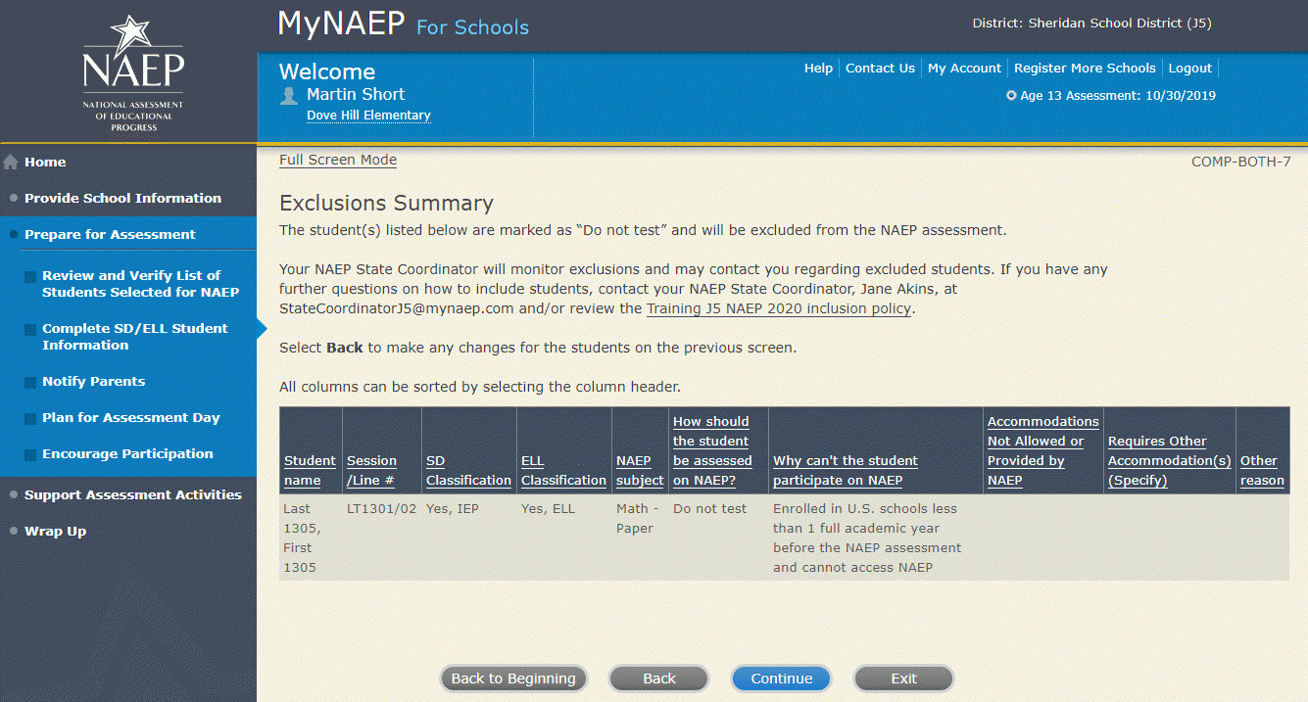

Print Summary Report-COMP-BOTH-8
Thank you for providing student data. If you have any further questions, contact your NAEP State Coordinator, First and Last Name, at Email address.
Your NAEP State Coordinator will monitor exclusions and may contact you regarding excluded students.
Select Print Summary to print a record of the student information entered into MyNAEP. Keep this report in the NAEP Storage Envelope and refer to it during the preassessment review call.
Select Submit when you are finished with this section.
Screenshot
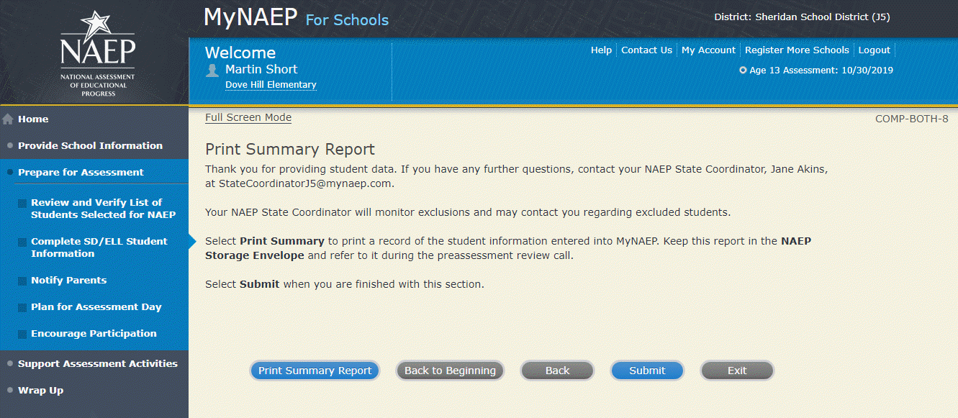

Provide Information for SD (IEP or 504 Plan) Only
Print Worksheet-COMP-SD-2
Select Print Worksheet to record the information for each student on a hardcopy worksheet. Select Continue when you're ready to enter information into MyNAEP.
Review the NAEP inclusion policy (see appendix D3-16) to see the universal design elements and accommodations for NAEP, and to determine how students should participate.
Screenshot
  - Please note: Due to an artifact of the development process, the placeholder phrase “Training J5” is being used in the screenshot. The applicable state name will show on the actual site in place of each instance of the “Training J5” text.

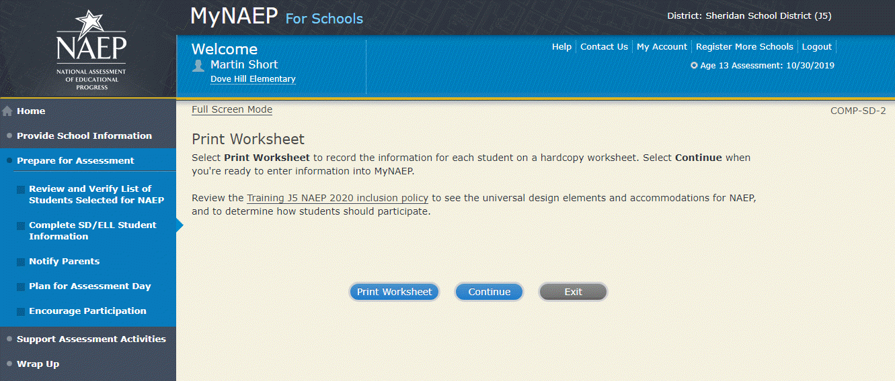
SD Details-COMP-SD-3
For each student listed below, record the following information by selecting the Edit pencil next to the student name:
- Which of the following IDEA categories (see list below) best describes each student’s identified disability(ies)? (Note: This question is not applicable to students marked as Yes, 504.)
  - Autism
  - Deaf-blindness
  - Developmental delay
  - Emotional disturbance
  - Hearing impairment, including deafness
  - Intellectual disability
  - Multiple disabilities
  - Orthopedic impairment
  - Other health impairment
  - Specific learning disability
  - Speech or language impairment
  - Traumatic brain injury
  - Visual impairment, including blindness
- What is the degree (note that in the system a hover note appears that reads: The response should be based on the knowledge of the person most familiar with this student's disability(ies) and based on the professional judgment how it/they might compare to other students with similar) of each student's disability(ies)?
- At what grade level (note that in the system a hover note appears that reads: For example, a grade 4 student is selected to take the NAEP math assessment who performs at a second-grade level should be marked as two or more years below grade level) does this student perform in the NAEP subject?
All columns can be sorted by selecting the column header.
Screenshot
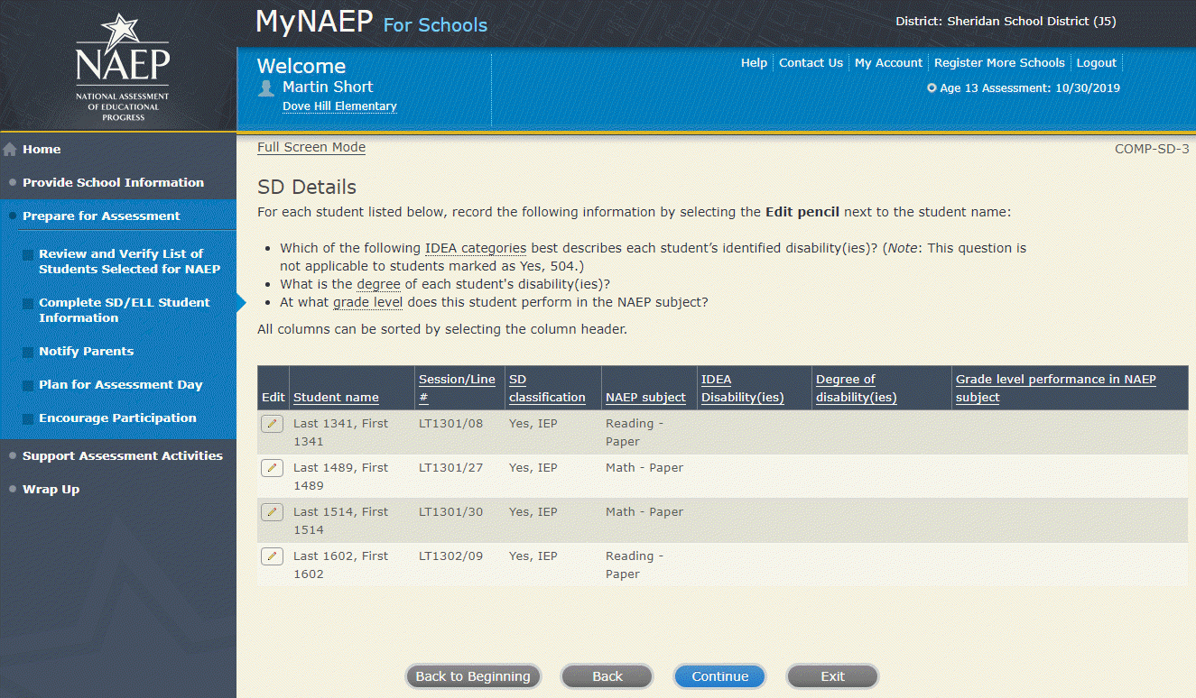

How Students Should Participate-COMP-SD-4
For each student listed below, record the following information by selecting the Edit pencil next to the student name. Review the {State} NAEP inclusion policy (see appendix D3-16) prior to completing. If you have any questions on how to include students, contact your NAEP State Coordinator, First and Last Name, at Email address.
- How is each student assessed on the state or classroom assessments in the NAEP subject?
- How should each student be assessed on NAEP?
- (If appropriate) What accommodations does the student need to access NAEP?
- (If appropriate) Reason student cannot take NAEP?
- (If appropriate) Is the decision to exclude each student a school decision or a parent/student decision?
All columns can be sorted by selecting the column header.
Screenshot
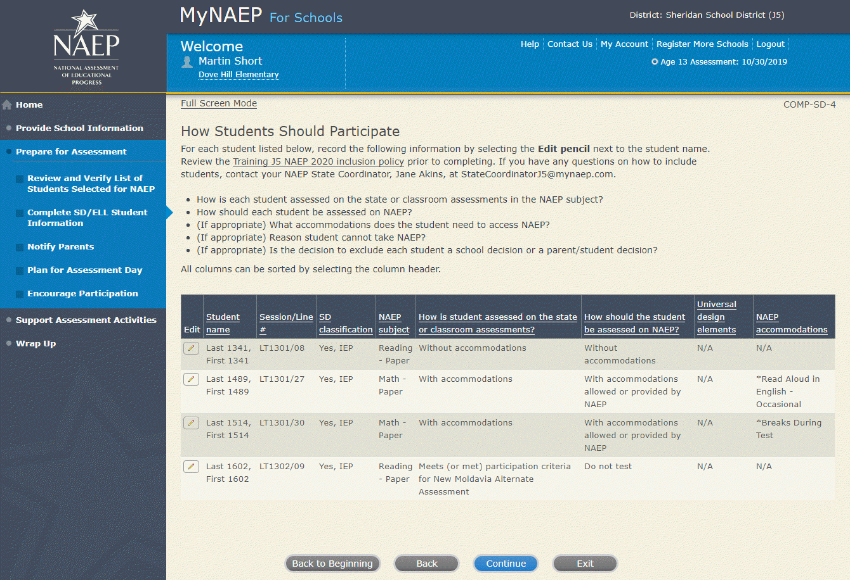

Exclusions Summary-COMP-SD-6

The student(s) listed below are marked as “Do not test” and will be excluded from the NAEP assessment.

Your NAEP State Coordinator will monitor exclusions and may contact you regarding excluded students. If you have any further questions on how to include students, contact your NAEP State Coordinator, First and Last Name, at Email address and/or review the {State} NAEP inclusion policy (see appendix D3-16).

Select Back to make any changes for the students on the previous screen.

All columns can be sorted by selecting the column header.

Screenshot

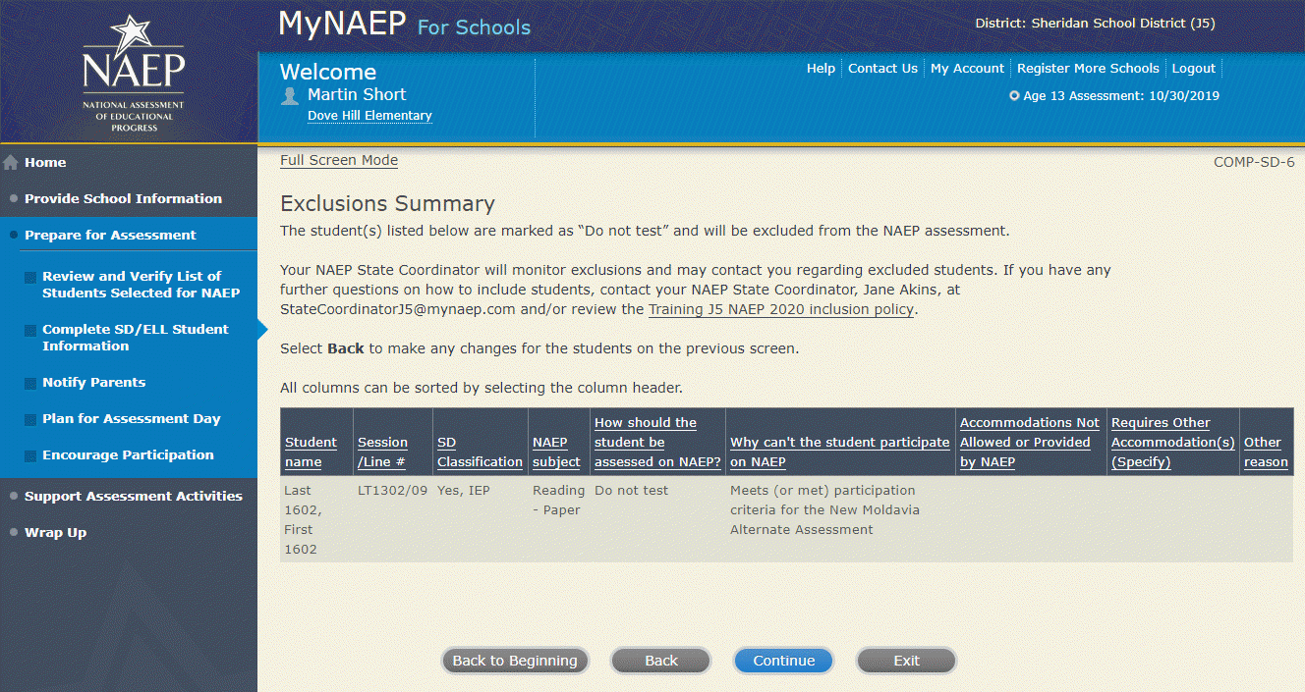

Print Summary Report-COMP-SD-7

Thank you for providing student data. If you have any further questions, contact your NAEP State Coordinator, First and Last Name, at Email address.

Your NAEP State Coordinator will monitor exclusions and may contact you regarding excluded students.

Select Print Summary to print a record of the student information entered into MyNAEP. Keep this report in the NAEP Storage Envelope and refer to it during the preassessment review call.

Select Submit when you are finished with this section.

Screenshot
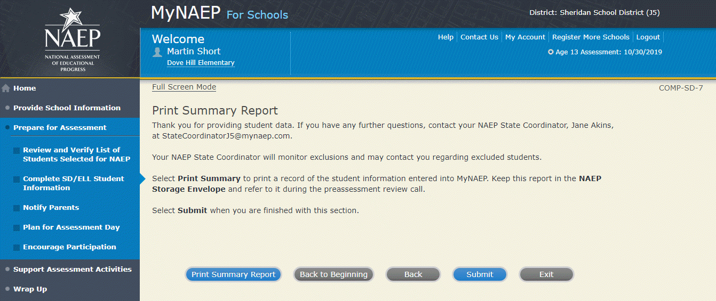

Provide Information for ELL Only
Print Worksheet-COMP-ELL-2
Select Print Worksheet to record the information for each student on a hardcopy worksheet. Select Continue when you're ready to enter information into MyNAEP.
Review the NAEP inclusion policy (see appendix D3-17) to see the universal design elements and accommodations for NAEP, and to determine how students should participate.
Screenshot
  - Please note: Due to an artifact of the development process, the placeholder phrase “Training J5” is being used in the screenshot. The applicable state name will show on the actual site in place of each instance of the “Training J5” text.

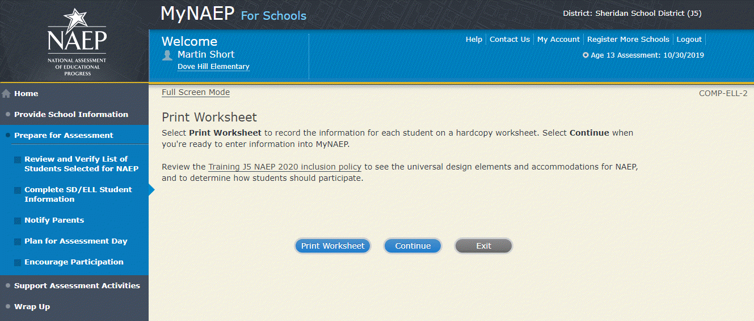

ELL Details-COMP-ELL-3
For each student listed below, record the following information by selecting the Edit pencil next to the student name. Review the NAEP inclusion policy (see appendix D3-17) prior to completing.
- What is the student's primary language?
- Including this year, how long has this student been receiving academic instruction primarily in English? (note a hover note displays in the system that reads: Instructor presents academic content in English and the student receives only occasional translation of words or explanation of ideas/concepts in his/her native language.)
- At what grade level (note a hover note displays in the system that reads: For example, a grade 4 student is selected to take the NAEP math assessment who performs at a second-grade level should be marked as two or more years below grade level) does this student perform in the NAEP subject?
- How would you characterize this student’s English proficiency (note a hover note displays in the system that reads: How this student's English language proficiency compares to other ELLS in the same grade.) in listening comprehension, reading, speaking, and writing?
All columns can be sorted by selecting the column header.
Screenshot
  - Please note: Due to an artifact of the development process, the placeholder phrase “Training J5” is being used in the screenshot. The applicable state name will show on the actual site in place of each instance of the “Training J5” text.

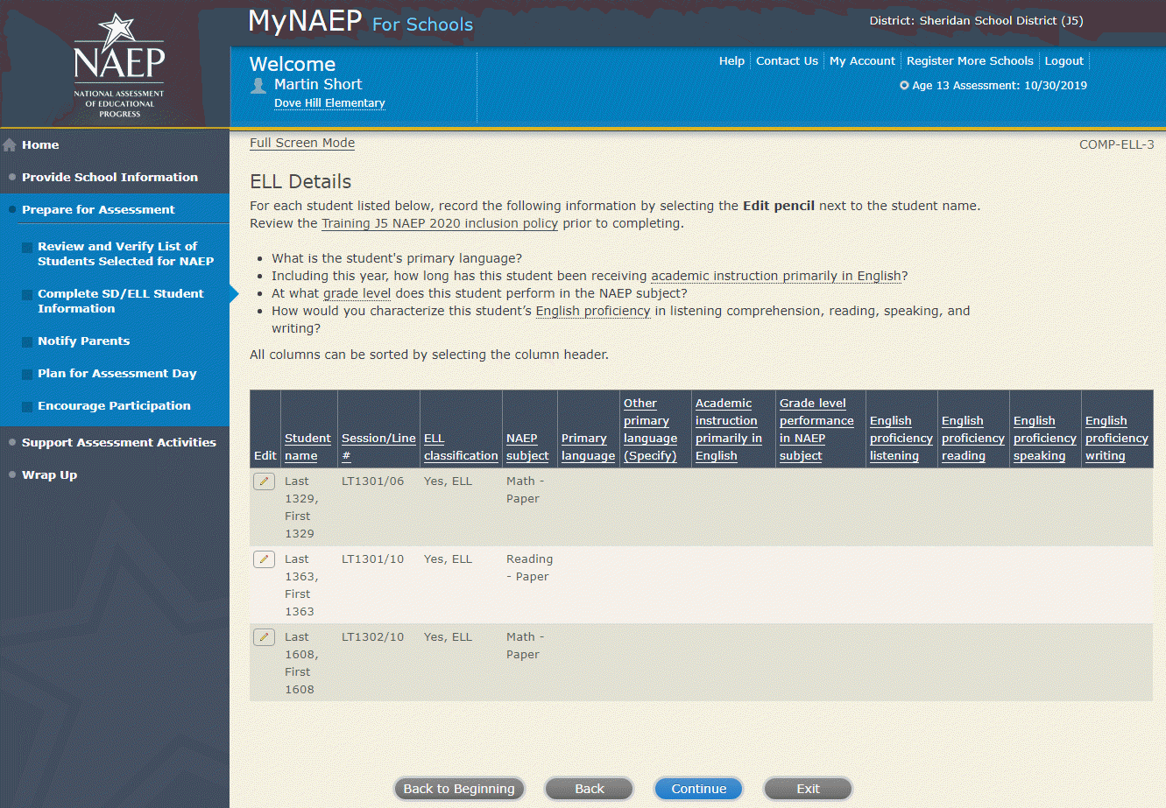
How Students Should Participate-COMP-ELL-4
For each student listed below, record the following information by selecting the Edit pencil next to the student name. Review the {State} NAEP inclusion policy (see appendix D3-17) prior to completing. If you have any questions on how to include students, contact your NAEP State Coordinator, First and Last Name, at Email address.
- How long has each student been enrolled in U.S. schools? (One full academic year is defined as one full school year before the assessment)
- How should the student be assessed on NAEP?
- (If appropriate) What universal design elements and accommodations does the student need to access NAEP?
- (If appropriate) Reason student cannot take NAEP?
- (If appropriate) Is the decision to exclude each student a school decision or a parent/student decision?
All columns can be sorted by selecting the column header.

Screenshot
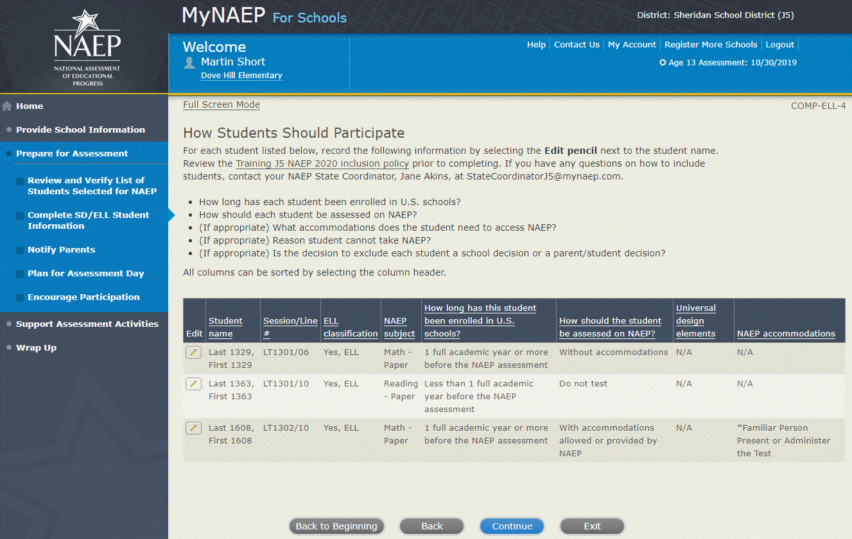

Exclusions Summary-COMP-ELL-5
The student(s) listed below are marked as “Do not test” and will be excluded from the NAEP assessment.
Your NAEP State Coordinator will monitor exclusions and may contact you regarding excluded students. If you have any further questions on how to include students, contact your NAEP State Coordinator, First and Last Name, at Email address and/or review the {State} NAEP 2020 inclusion policy (see appendix D3-17).
Select Back to make any changes for the students on the previous screen.
All columns can be sorted by selecting the column header.

Screenshot
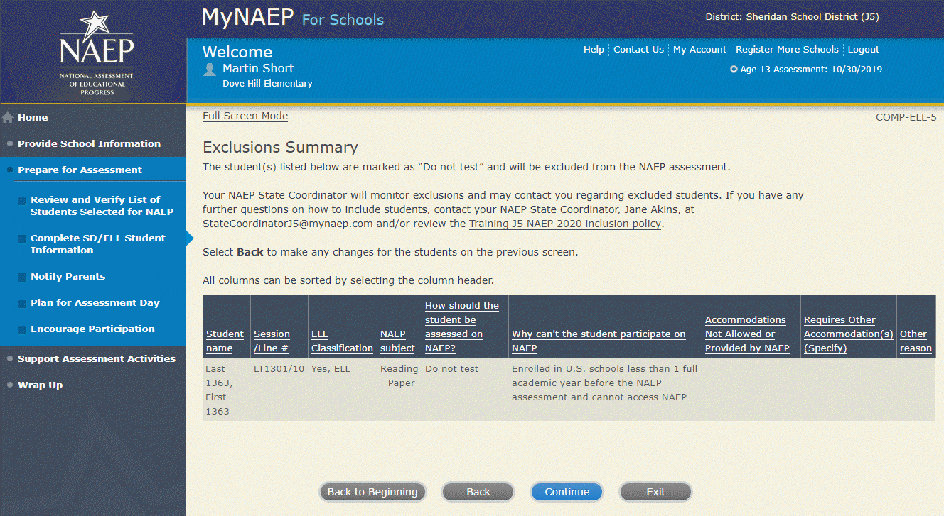

Print Summary Report-COMP-ELL-6
Thank you for providing student data. If you have any further questions, contact your NAEP State Coordinator, First and Last Name, at Email address.

Your NAEP State Coordinator will monitor exclusions and may contact you regarding excluded students.

Select Print Summary to print a record of the student information entered into MyNAEP. Keep this report in the NAEP Storage Envelope and refer to it during the preassessment review call.

Select Submit when you are finished with this section.

Screenshot
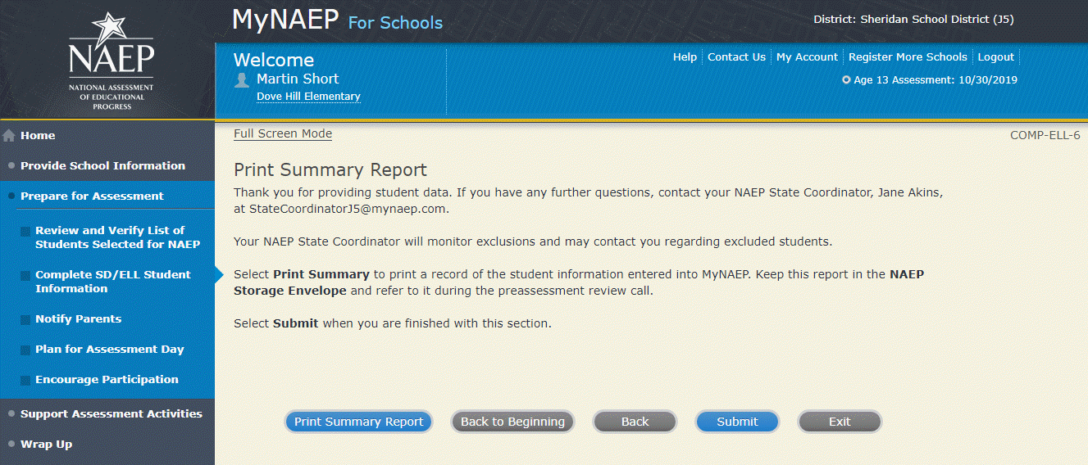

Print Reports
Print Reports-COMP-REP-1
Before entering student data in the system
Print the worksheets to record student information.
After entering student data in the system
Select Print Summary Report to print a record of the student information entered in the system. Keep this report in the NAEP Storage Envelope and refer to it during the preassessment review call. Print the Exclusion Report to discuss with the NAEP State Coordinator.
Screenshot
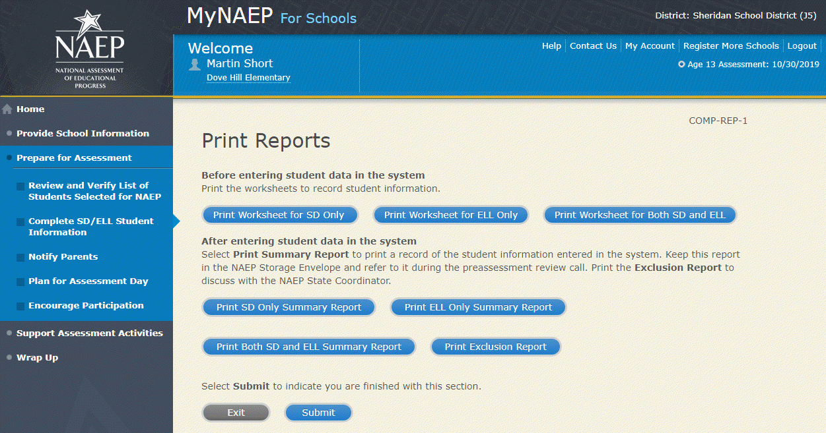
Sample of information contained in worksheets and reports:
(Note: the worksheets are resources to assist teachers in collecting the information that will be contained in the summary reports)
Both SD and ELL
Worksheet Page 1

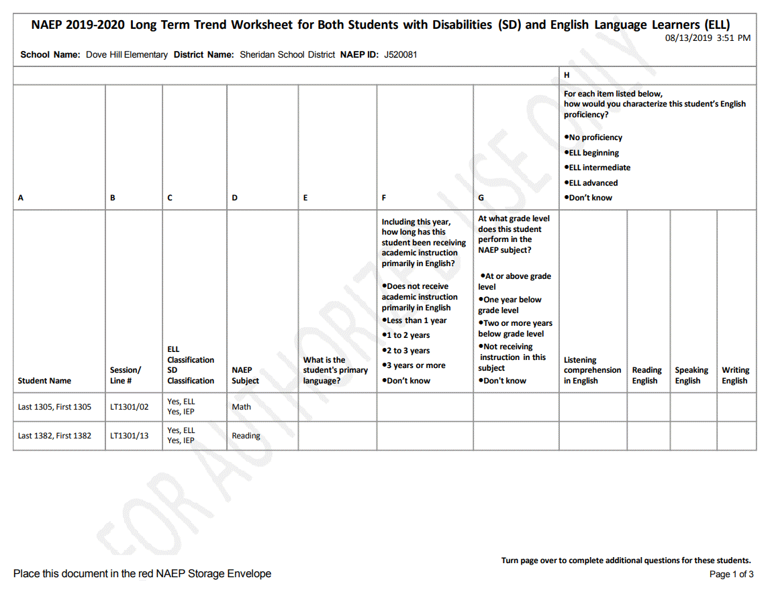

Worksheet Page 2
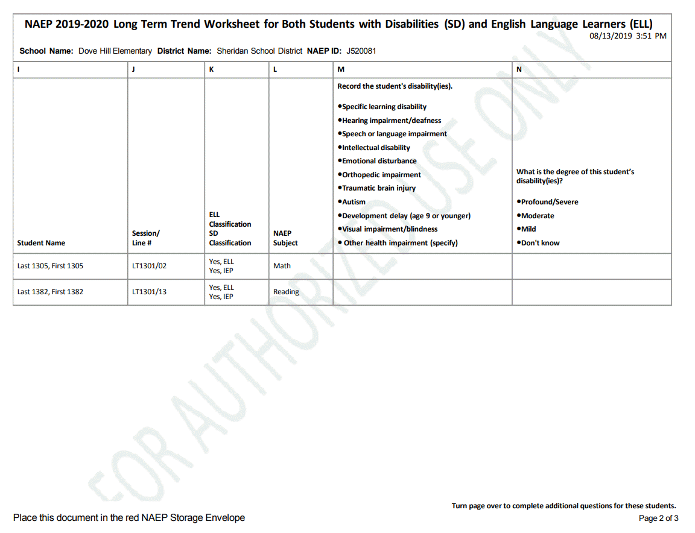

Worksheet Page 3
(Note: “New Moldavia” will be replaced with the respective name of the state)

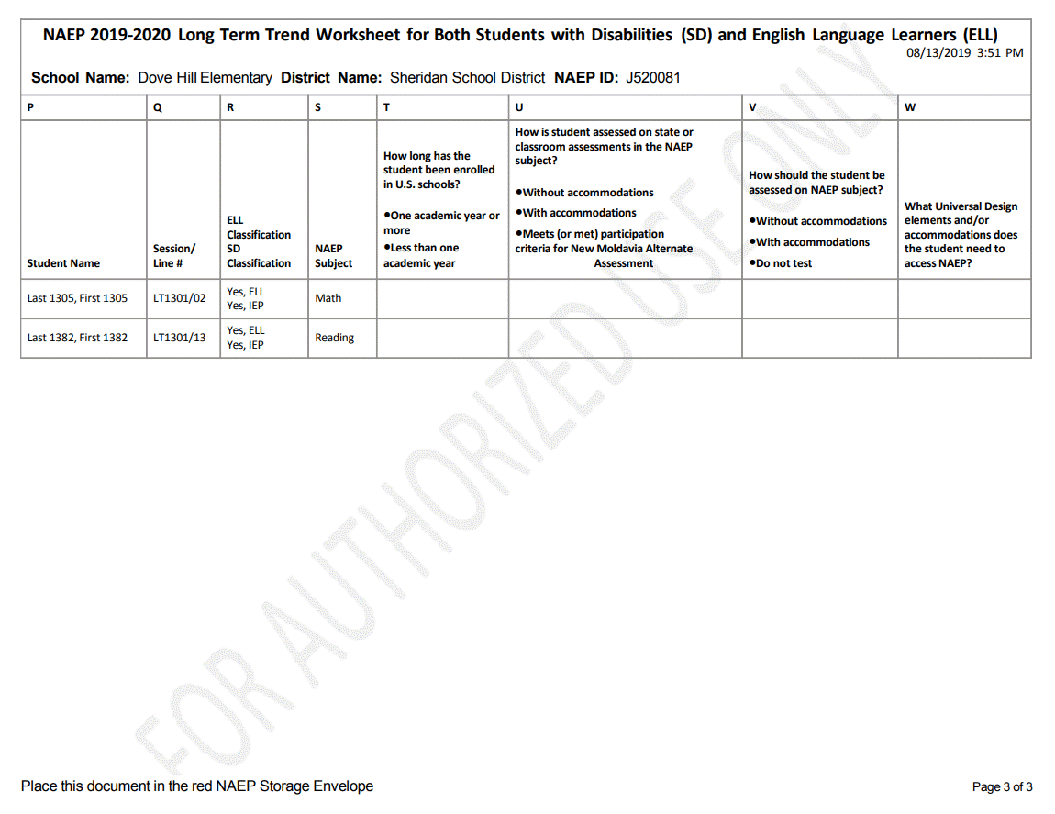

For SD Only
Worksheet Page 1
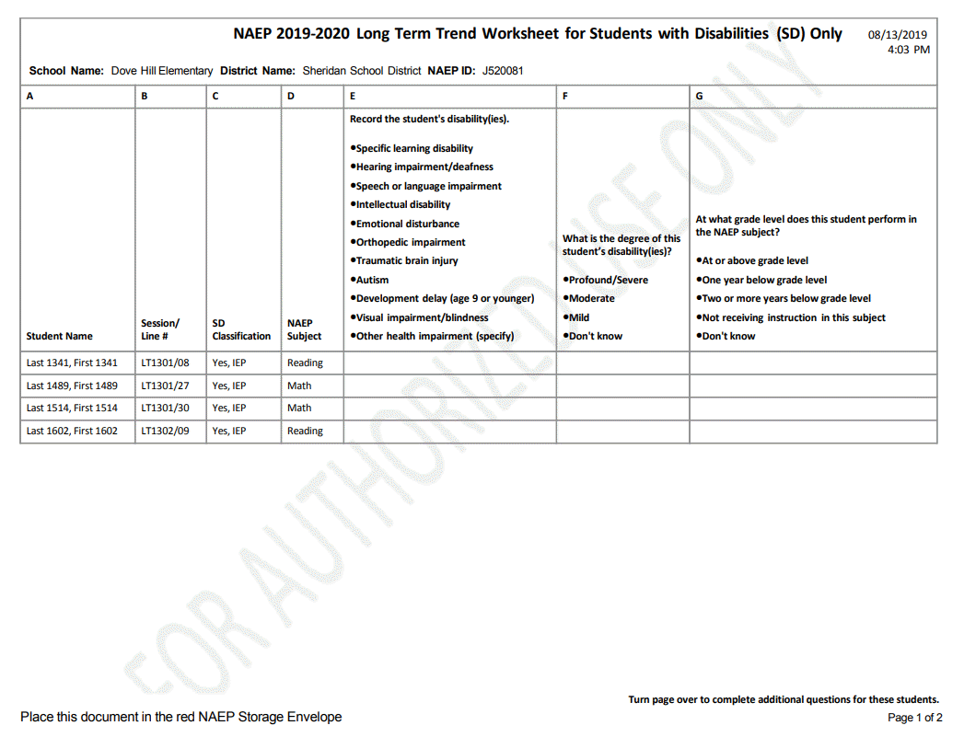

Worksheet Page 2
(Note: “New Moldavia” will be replaced with the respective name of the state)

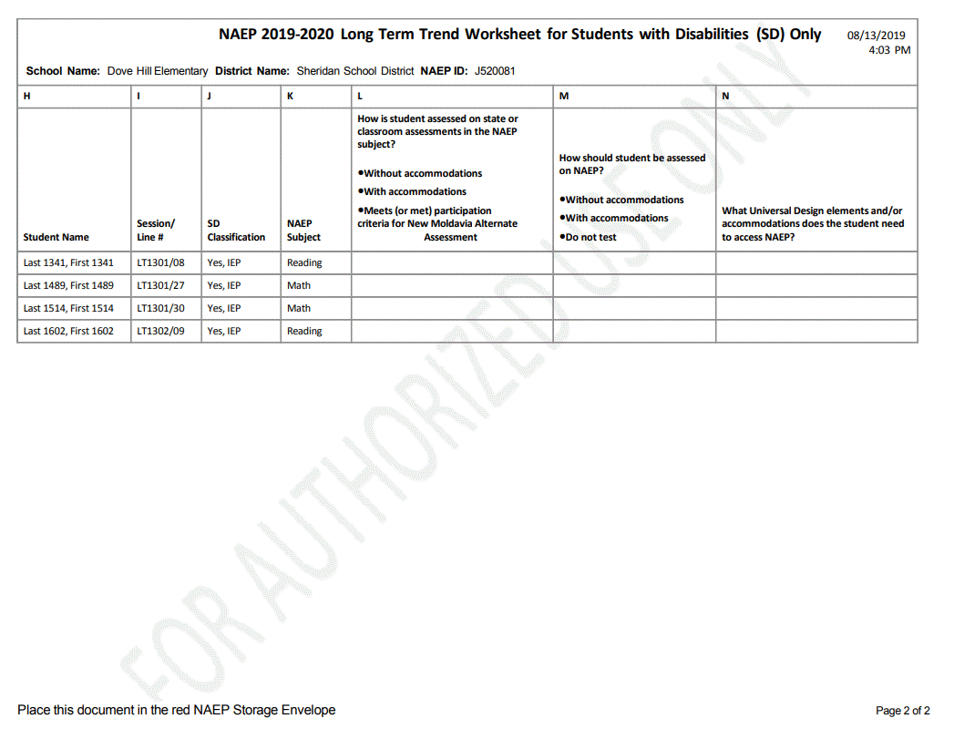

For ELL Only
Worksheet Page 1
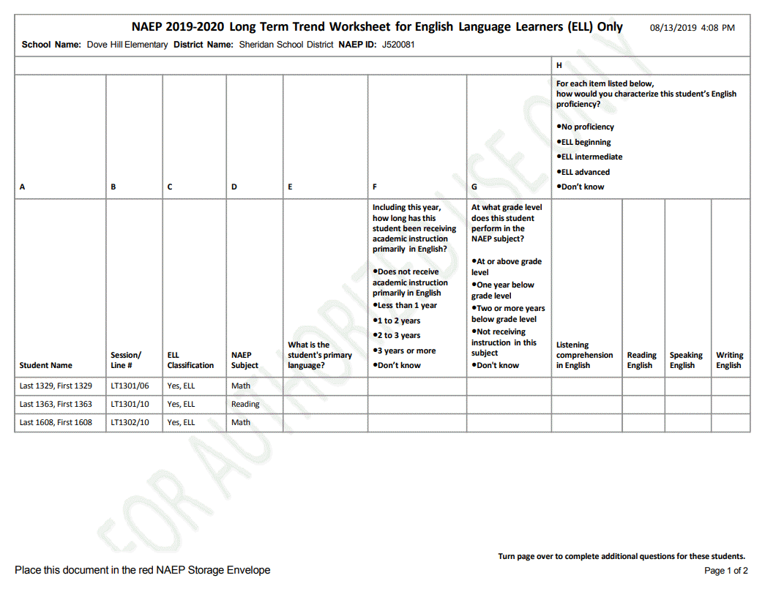

Worksheet Page 2

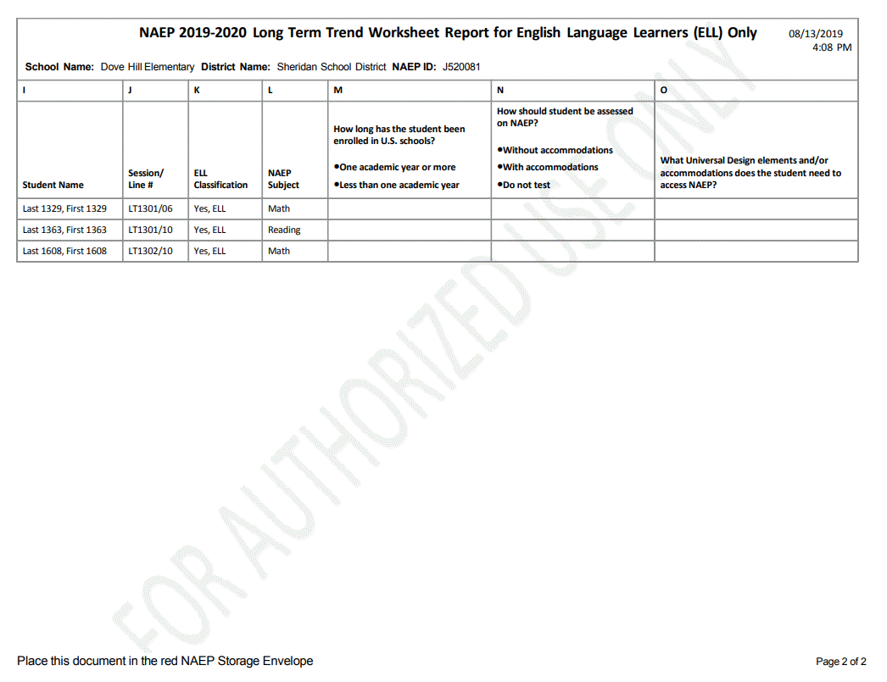

Create Accommodation Sessions (Field Staff Only)
COMP-ACCOM-1
The Submit button will be greyed out until you have green checkmarks for all the following links:
- Provide Information for Students Who Are Both SD and ELL
- Provide Information for SD (IEP or 504 Plan) Only
- Provide Information for ELL Only
Once you select Submit, the system will create accommodation sessions based on the accommodations recorded for each student.
Do not select Submit until you have confirmed the SD/ELL data for each student, as you can only complete this task once.
Screenshot
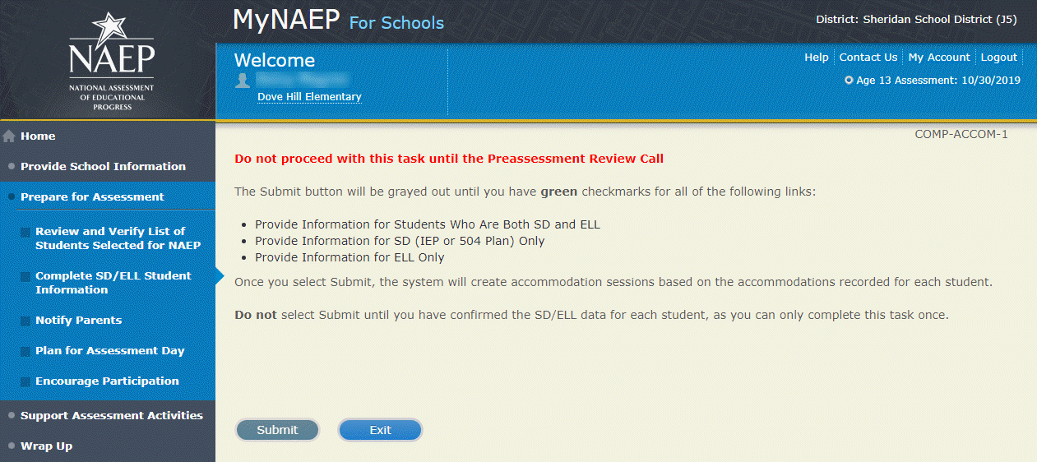

Notify Parents
Note: In this section the school coordinator will download and customize the parent notification letter (see Appendix D3-7 [public schools] and D3-8 [private schools] for the template of the letter), upload the customized letter to the system, and certify the date parents were notified. This is to ensure that parents/legal guardians are notified of their student’s selection to participate in NAEP, which is a requirement of the Reauthorized Elementary and Secondary Education Act (ESEA).
Prepare for Assessment
Notify Parents
All parents and guardians of selected students must be notified in writing before NAEP can conduct the assessment.
Complete the following:
- Watch Notify Parents Tutorial (3:46) (https://bcove.video/2xyrOUA)
- Download Parent/Guardian Notification Template
- Upload Letter
- Verify Parent/Guardian Notification
Additional Resources
- Parent's page on Nation’s Report Card website
- What Every Parent Should Know About NAEP: PDF version
- What Every Parent Should Know About NAEP: Video version
- Sample Questions Booklets
Screenshot
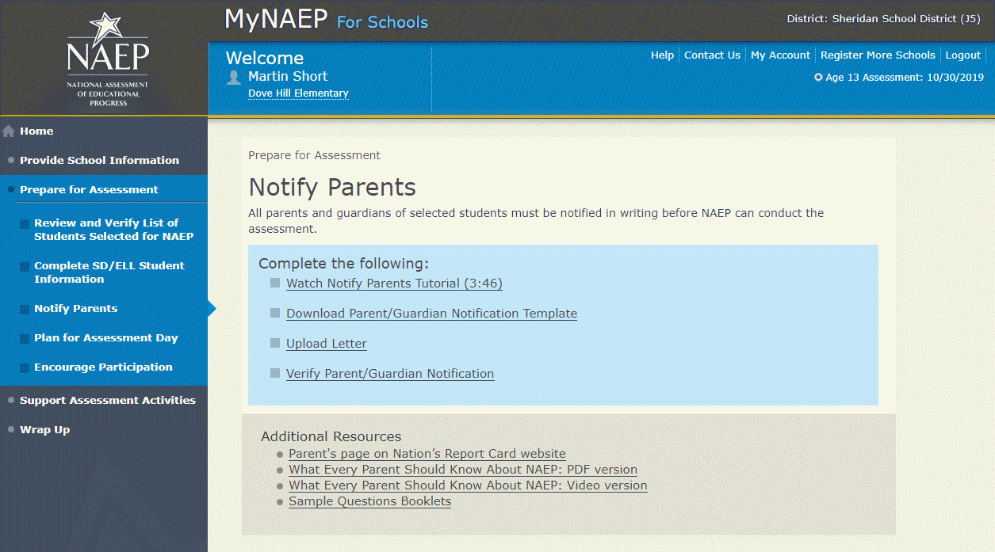

Download Parent/Guardian Notification Template
Download Parent/Guardian Notification Template-PAR-TMP-1
You can download, customize, and distribute the parent notification letter(s) below.
Parent/Guardian Notification Letter (see Appendices D3-7 and D3-8)
Parent/Guardian Notification Letter (Spanish) (see Appendices D3-20 and D3-21)

Here are some suggestions for notifying parents about NAEP:
- Mail/email the letter to parents
- Send the letter home with students
- Include the letter on the school website or in a newsletter
Unable to download the template? Try disabling pop-up blockers or adding mynaep.com as a trusted site to your browser. Still having trouble? Contact the NAEP help desk at 1-800-283-6237.
Screenshot
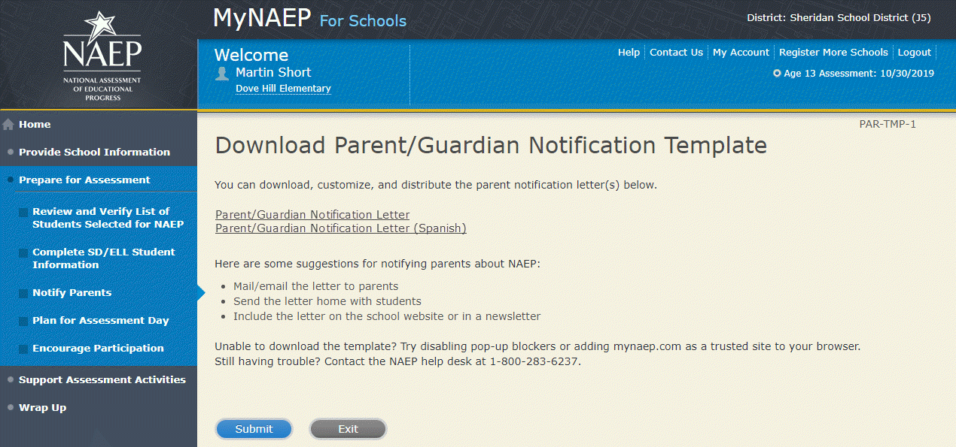

Upload Letter
Upload Letter-PAR-UPLD-1
1. When do you plan on distributing the letter?
2. Please upload the letter that you distributed to parents and guardians. If you distributed the letter in more than one language, just upload the English version.
Select Choose File or Browse... to locate and upload your file.
SC chose to provide hard copy parent letter
Unable to upload your letter? Try removing any large graphics such as school letterhead. Or you can give your NAEP representative a hardcopy on assessment day.
Screenshot
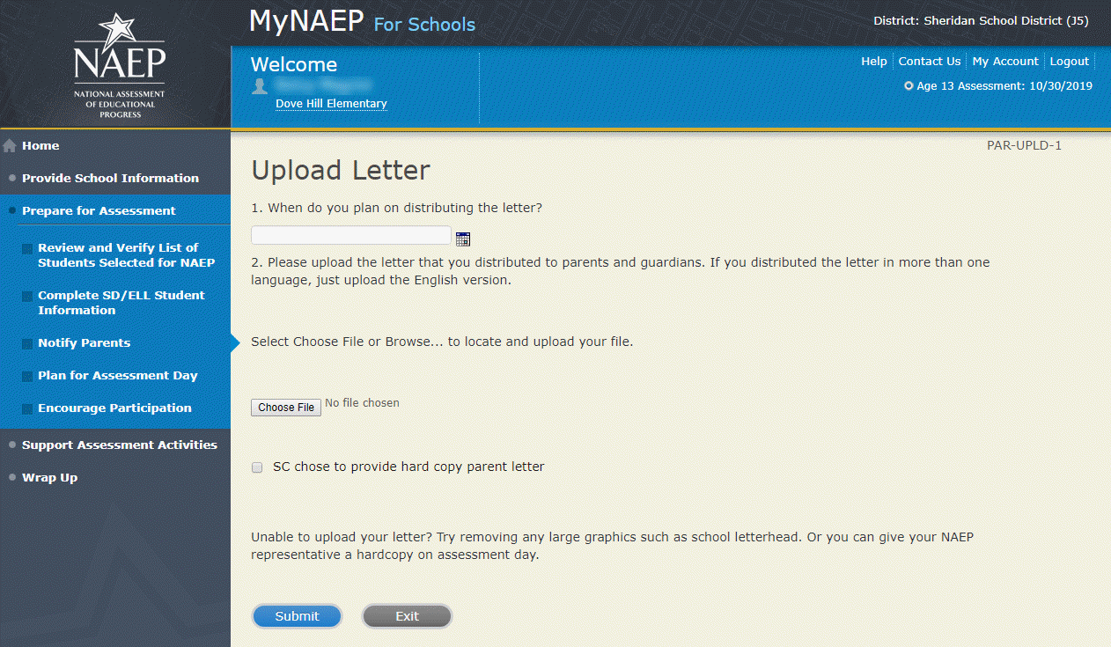

Verify Parent/Guardian Notification
Verify Parent/Guardian Notification-PAR-VER-1
Please tell us a few details about how you notified parents of the assessment.
1. When did you notify parents?
2. How did you notify them?
Mailed/emailed letter to parents
Sent letter home with students
Posted notice in newsletter
Other
*If you answered Other to the above question, please explain.
3. Other than updating the placeholder text, did you make any changes to the letter?
Yes No
4. Who received a notification?
Parents/guardians of sampled students only
Parents/guardians of all age X students

5. Please certify that you notified parents and guardians of the assessment by typing your name in the box.
Screenshot
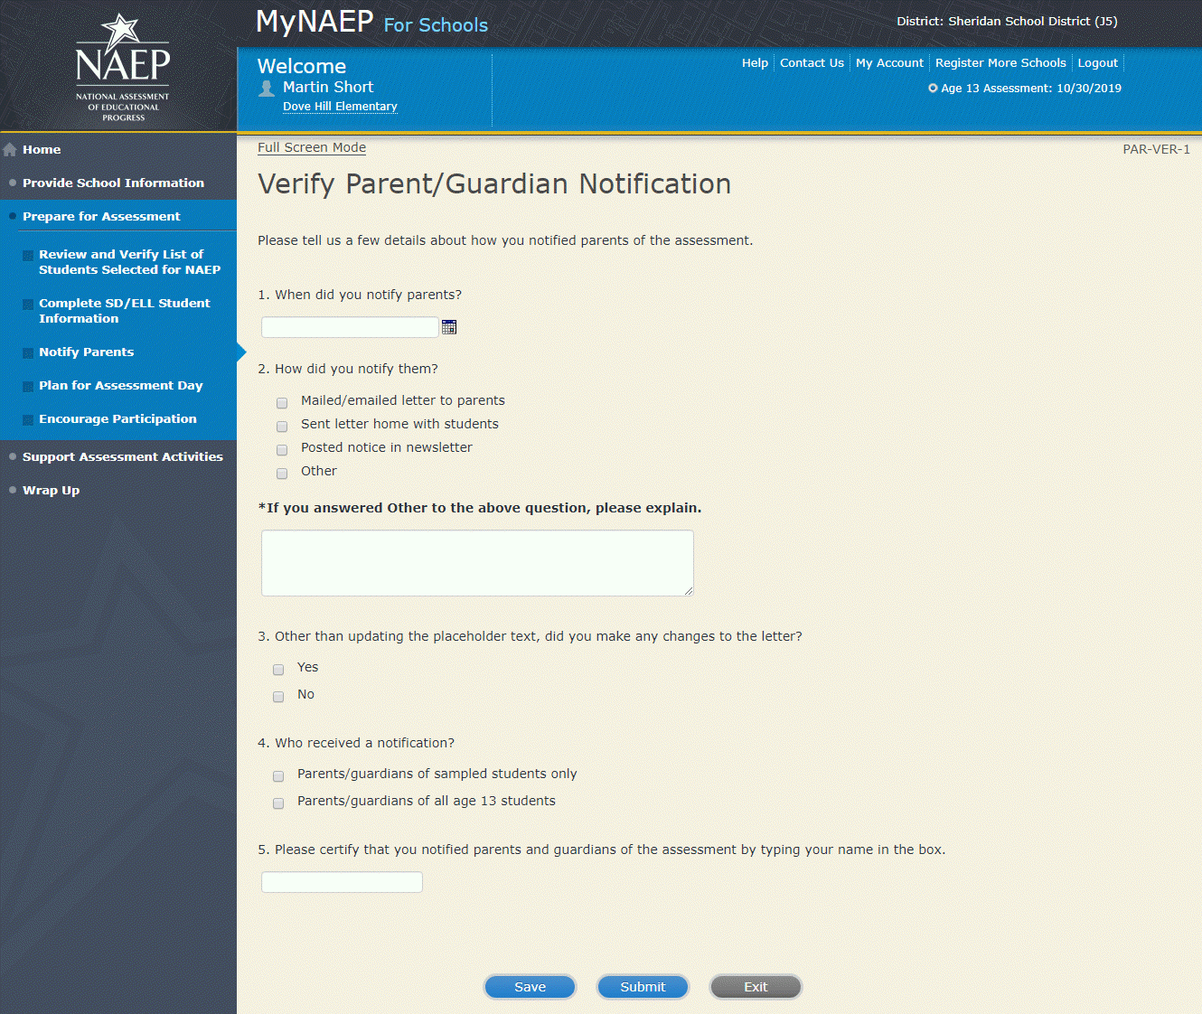

Plan for Assessment Day
Note: In this section the school coordinator will determine assessment session times and locations, share cell phone policy to ensure security of NAEP items, and make a plan to encourage student participation. This is meant to ensure that the school is prepared for a successful administration of NAEP. There will be no digitally based assessments for long-term trend assessments.
Prepare for Assessment
Plan for Assessment Day
In this section, record assessment details and provide logistical instructions for the NAEP team to ensure that assessment day runs smoothly.
Note: If less than 90% of the selected students attend the assessment, the NAEP team may need to return to your school for a makeup assessment at a later date. Your NAEP representative will discuss this with you after the original assessment has been conducted.
Complete the following:
- Watch Plan for Assessment Day Tutorial (4:39) (https://bcove.video/2fDAvDb)
- Record Assessment Details
- Provide NAEP Team Instructions
Additional Resources
- Suggested Testing Room Layouts
Screenshot
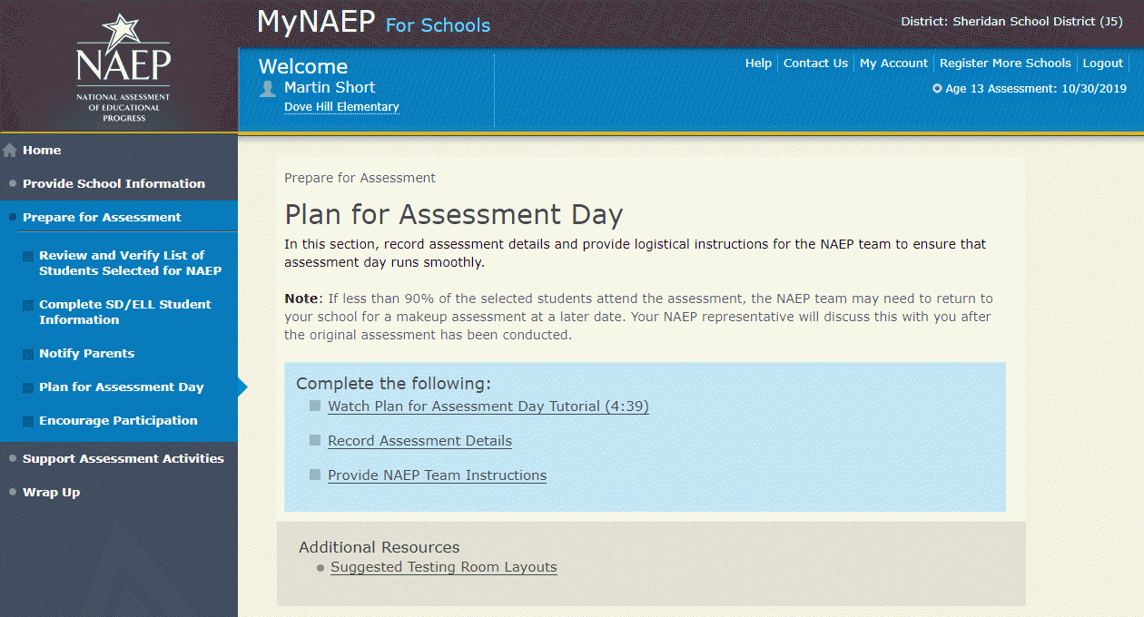

Record Assessment Details
Text for schools with Paper-only sessions:
Students will take NAEP on paper.
Review the information below, then record locations and start times for each session. Sessions can be tested together at the same in the same location.
Testing Locations
Select locations that…
- have enough seats and adequate space for all students
- are free of distractions and interruptions
- have a board available for the NAEP team to write information
- have flat desks or tables

Time Requirements
- Locations should be available 60 minutes before the start time so that the NAEP team can set up.
- Sessions will last about 60 minutes.
Enter the time that age X students take their lunch break, and include the length of their lunch break
Screenshot
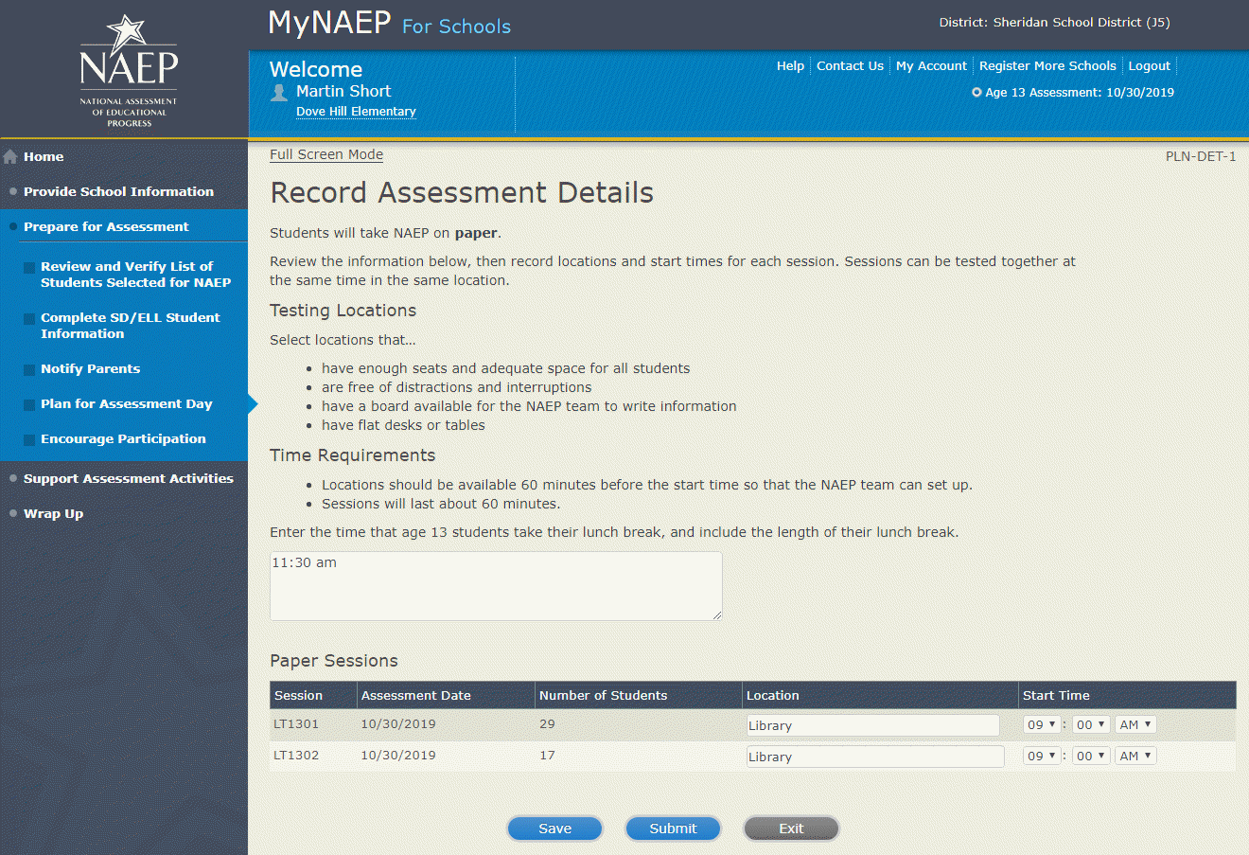
Record Assessment Details-PLN-DET-4
Combined Sessions
You’ve combined one or more sessions together.
To help the NAEP team conduct the assessment as smoothly as possible, please review these guidelines:
- check the Number of Students column and make sure that your assessment location has enough seats
- ask if a school staff member can help monitor room entrances during the assessment
- provide a microphone for the NAEP team to use while giving instructions to the students
Screenshot
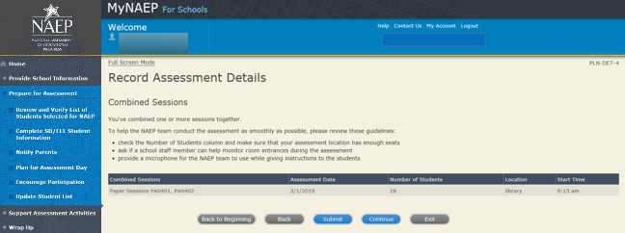

Provide NAEP Team Instructions
Provide NAEP Team Instructions
Before the Assessment-PLN-TEAM-1
- Where should the team park?
- The team will bring their NAEP ID badges and check in at the front office. Do they need to follow any other school protocols?
- Before the assessment, your NAEP representative will need to briefly meet with you. Where will you be?
- How and by what time does your school announce closings or delays?
- The NAEP team wants to be sensitive to any special needs your students may have. Have there been any traumatic events with the students, the school, or the community during the last year?
- Students respond more positively when they know that the school administration supports NAEP. Can the principal or other school staff member take a moment during the daily announcements or before the assessment to introduce NAEP, reinforce its importance, and ask students to do their best?
Yes
No
- NAEP provides appointment cards (available in the Support Assessment Activities section) to remind students of the assessment. You can print out the cards yourself or we can mail them to you. Which do you prefer?
I'll print the cards myself
Please mail the cards to me
I won't be using them
Screenshot
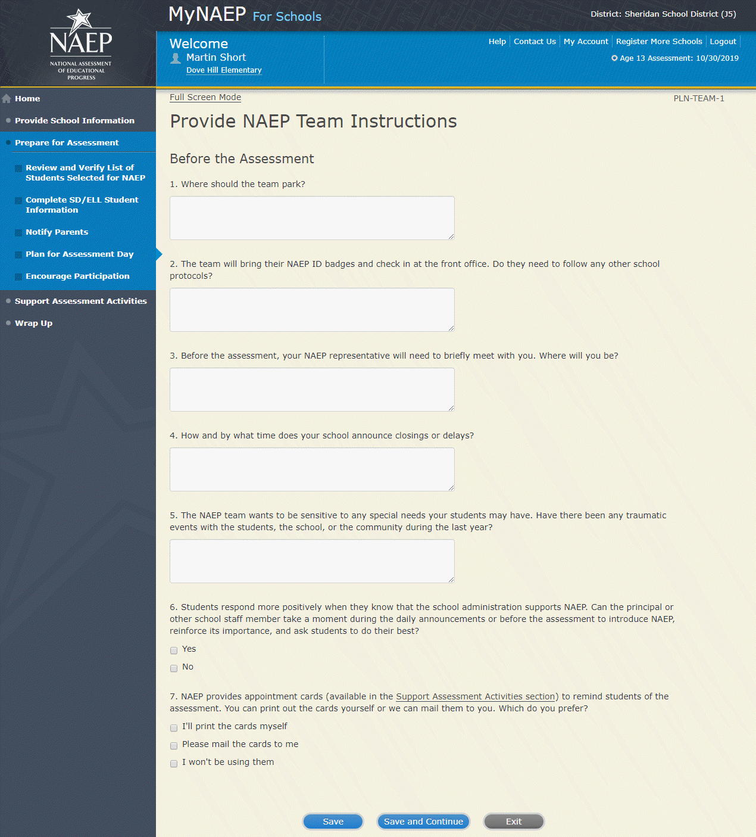

Provide NAEP Team Instructions
During the Assessment-PLN-TEAM-2

1. The law prohibits students from photographing or sharing NAEP questions. Please assist us with one of these security measures:

Notify students that cell phones are banned from the testing location
Notify students that cell phones must be turned off and placed with their belongings
No assistance can be provided

2. In case of an emergency, who should the NAEP team contact for assistance?

3. Is there anything scheduled, such as a fire drill or assembly, that might interrupt the assessment?

4. Are there any procedures or protocols that the NAEP team should follow in the event of an emergency situation such as a lock-down or an extreme weather event?

5. Once the students have begun reading the booklet directions, late students cannot be admitted. What instructions should the NAEP team give to students who arrive too late?

6. How should the NAEP team handle restroom breaks? Do students need hall passes?

7. Is it possible for a school staff member to remain in the room(s) during the assessment? If not, how should NAEP representatives address disruptive students?

Screenshot
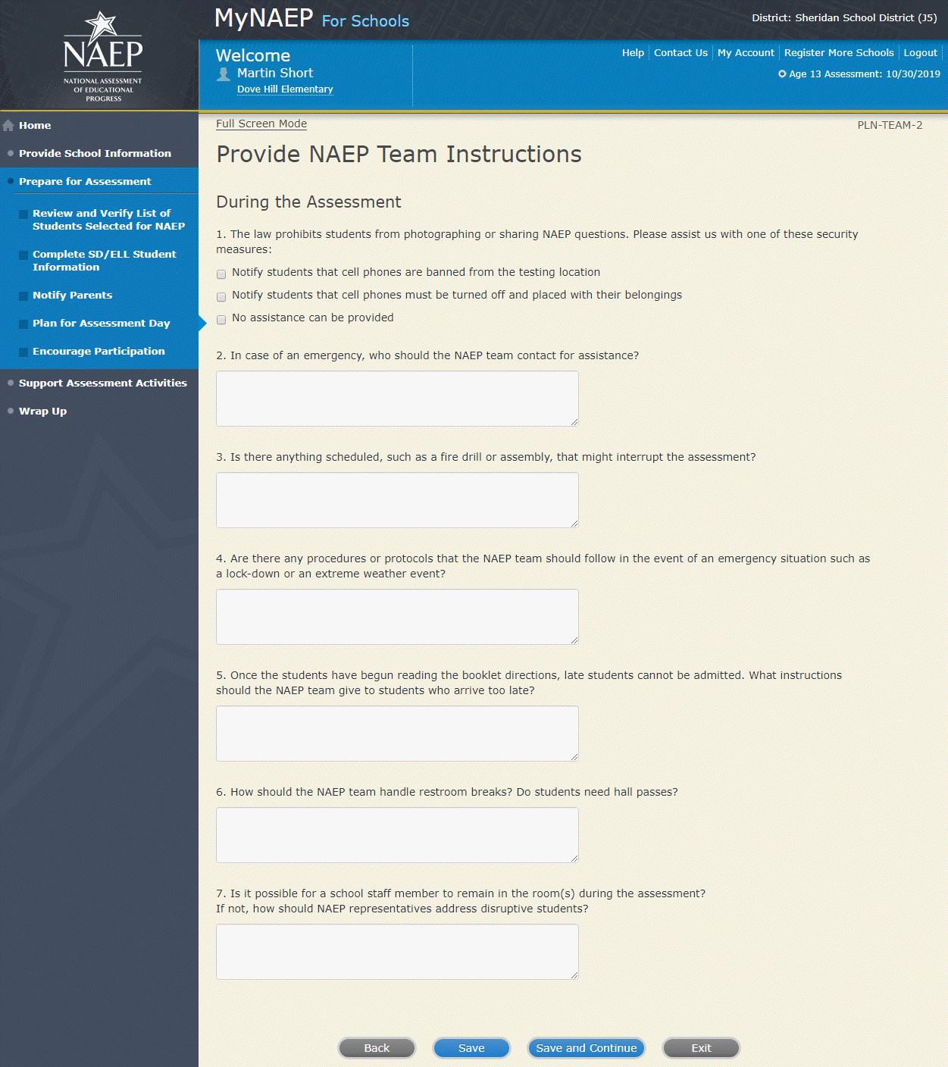

Provide NAEP Team Instructions

After the Assessment-PLN-TEAM-3

1. NAEP grants 90 minutes of community service to students who take the assessment. How would you like to distribute the certificates of community service?

The NAEP team should give the certificates to students after the assessment
The NAEP team should give the certificates to me
We will not be offering certificates of community service to students

2. Students taking the paper assessment must be dismissed all together at the end of each session.

3. How should the NAEP team dismiss students who receive extended time, which may take up to three times as long?

4. Where should the NAEP team send students after the assessment?

5. After the assessment, your NAEP representative will need to briefly meet with you and access the red NAEP storage envelope. Where will you be?
(Note: School coordinators store student and teacher lists in the red NAEP storage envelope. The envelope and its contents are destroyed by the school at the end of the schools year.)
Screenshot
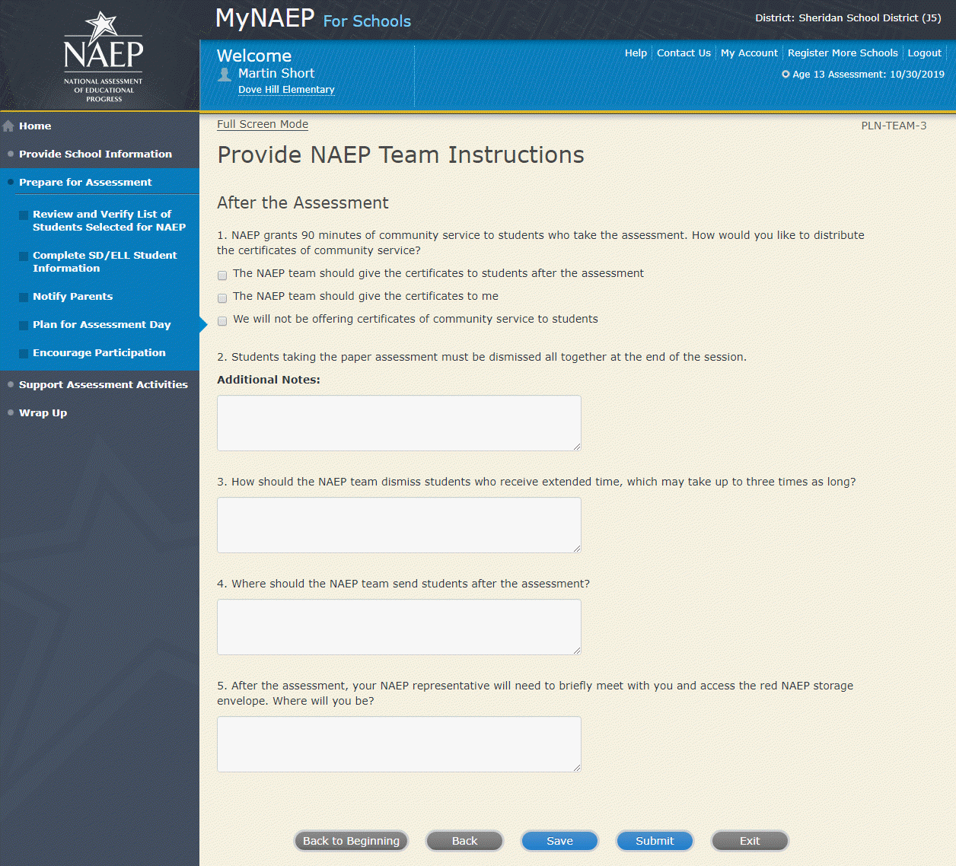

Encourage Participation
Note: In this section the school coordinator can access resources to encourage participation among students to ensure that the administration is successful.

Prepare for Assessment

Encourage Participation

NAEP is successful because of your support, and we want NAEP to be a positive experience for everyone involved at your school. The more that teachers, parents, and students know about NAEP, the more smoothly assessment day will go.

If less than 90% of the selected students attend the assessment, the NAEP team may need to return to your school for a makeup assessment at a later date. Use the resources in this section to encourage students to attend and to do their best on NAEP.
Complete the following:
- Watch Encourage Participation Tutorial (2:06) (https://bcove.video/2xyGZwU)
- Review Resources
- Select Strategies to Encourage Participation
Additional Resources
- Measure Up News for the School Community (see Appendix D3-19)
- Facts for Teachers (see Appendix D3-15)
Screenshot
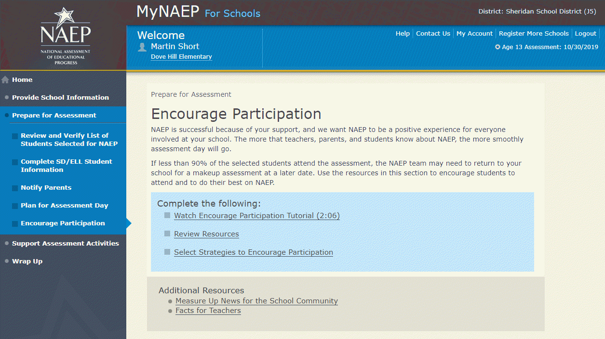

Review Resources
ENC-RES-1
Explore the resources below to promote NAEP in your school. Schools that implement these strategies have higher student participation.

- Notify Students
- Show NAEP Videos
- Introduce Online Resources
- Thank Students for their Participation

When you are finished, select the Submit button.
Screenshot
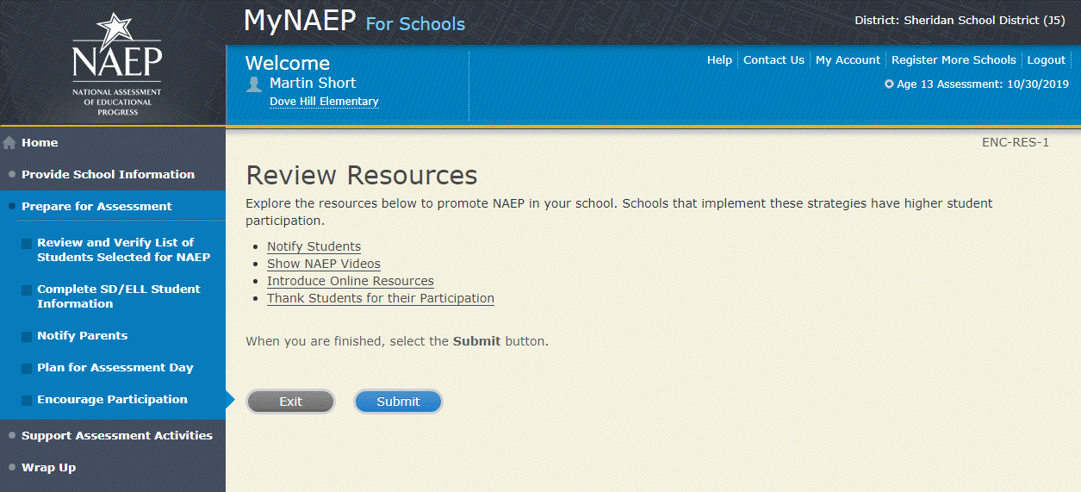

Encourage Participation
Notify Students about NAEP-ENC-STDT-1
It’s important for students to know the importance of NAEP and that they have been selected to represent their peers across the country. Use the templates below to share information about NAEP, its importance, and details about the upcoming assessment.
- Sample Morning Announcements
- Sample Student Notification Letter
- Social Media Posts
Note: See appendix D3-19
Screenshot
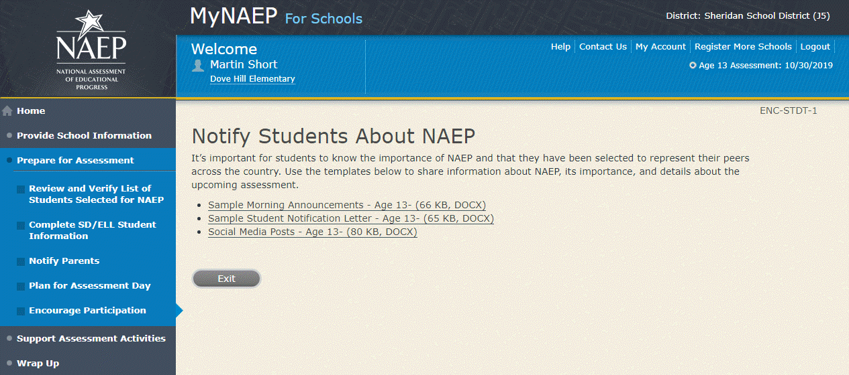

Encourage Participation
Videos-ENC-VID-1
See what real students and teachers have to say about NAEP. These videos share information about how NAEP results are used, and how students and teachers can make a difference through their participation.
- Introducing NAEP to Teachers (4:27) (https://youtu.be/zR1_pUdSlFg)
- Introducing NAEP to Students (4:36) (https://youtu.be/8drjkhe0iQU)
- What Every Parent Should Know About NAEP (4:51) (https://youtu.be/RurH739zdN0)
Screenshot
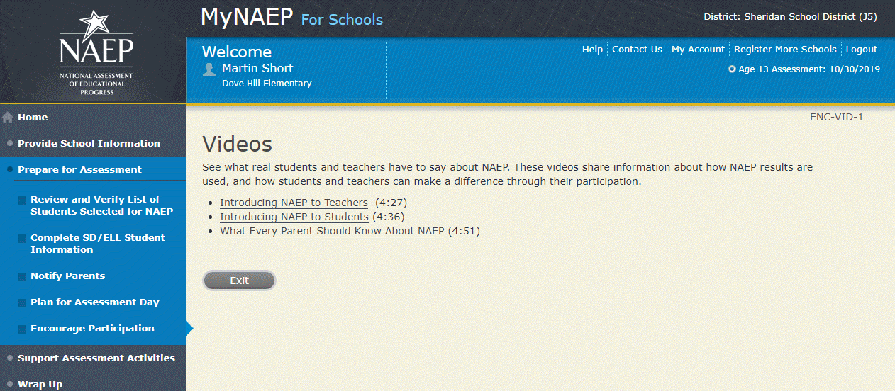
Encourage Participation
NAEP Online-ENC-INOR-1
The Nation's Report Card website has resources for all audiences. (https://nces.ed.gov/nationsreportcard/)
Nation’s Report Card: Student’s page (https://nces.ed.gov/nationsreportcard/students/)
Students selected for NAEP can test themselves and answer real assessment questions (https://nces.ed.gov/nationsreportcard/nqt/) for different subject areas.
Nation’s Report Card: Educator's page (https://nces.ed.gov/nationsreportcard/educators/)
Teachers can create their own tests (https://nces.ed.gov/nationsreportcard/nqt/) using NAEP assessment items, and can also explore NAEP results.
Nation’s Report Card: Parent’s page (https://nces.ed.gov/nationsreportcard/parents/)
Parents can review what participation in NAEP means for their child (https://nces.ed.gov/nationsreportcard/parents/#sec2) and how results from assessments are used.
Screenshot
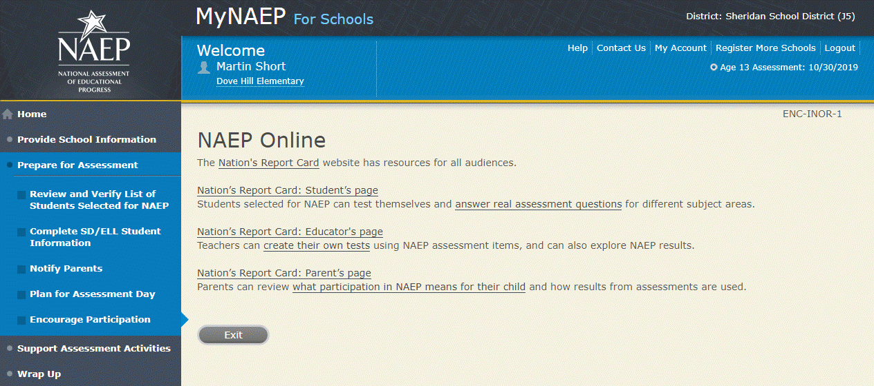

Thank Students for Their Participation
Schools have been very creative in the variety of incentives used to encourage students to “show up” for the NAEP assessment. Many of their strategies did not cost the school anything. Examples of incentives that schools implemented include:
- extra credit;
- reduced-price or free school event tickets;
- raffle of gift certificates; and
- certificate for community service (provided by NAEP)
Work with your principal to consider ways to thank students for their participation.
Screenshot
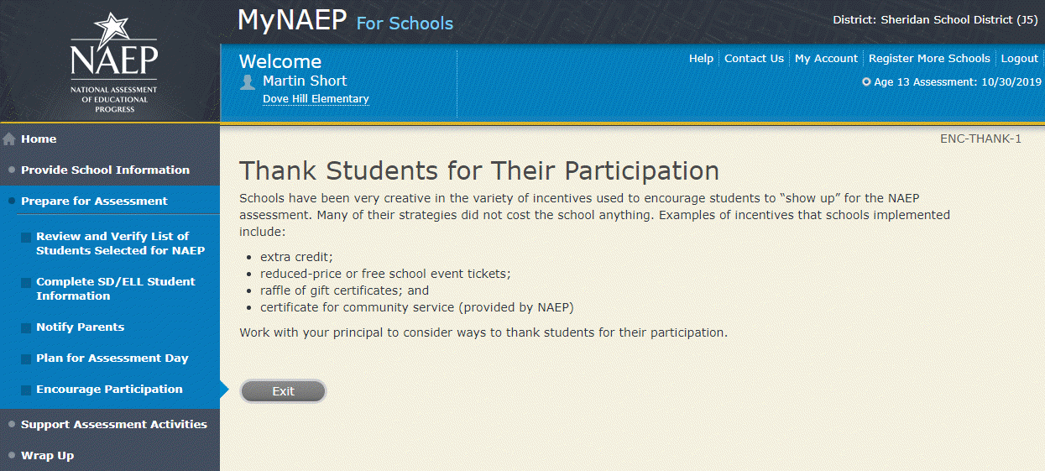

Encourage Participation

Select Strategies to Encourage Participation
ENC-STRAT-1
Which strategies below have you used or do you plan on using at your school? This information helps us develop more effective resources for you.
- Notify students
- Show NAEP videos
- Introduce NAEP online resources
- Thank students for their participation
- Other, specify
- None
Screenshot
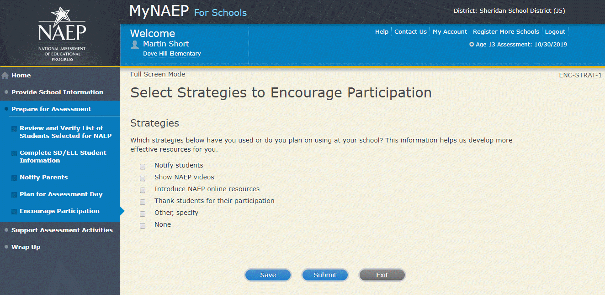

Update Student List
Note: In this section the school coordinator will identify any newly enrolled students since the original list of students was provided in the fall. Schools selected for the age 13 long-term trend assessment will not need to do this task. The school coordinator will upload a current list of students via Excel or review original list and add newly enrolled students. This is meant to ensure all students have an opportunity to be sampled so NAEP can assess a representative sample of students.
Prepare for Assessment
Update Student List
A list of [9/17]-year-old students was submitted in the fall, and NAEP selected students from this list to participate. Any new students, or students who were mistakenly left off this list last fall, must have an opportunity to be selected.
In this section you will upload a list of all currently enrolled [9/17]-year-old students. The updated list should reflect current enrollment.
After you submit the current list, you will receive email notifications when you need to complete additional steps.
Complete the following:
- Watch Update Student List Tutorial (8:29) (https://bcove.video/2xj4v1r)
- Give Access for Student Data Specialist (optional)
- Submit Current List
Additional Resources
- Student List Requirements and Instructions
Screenshot
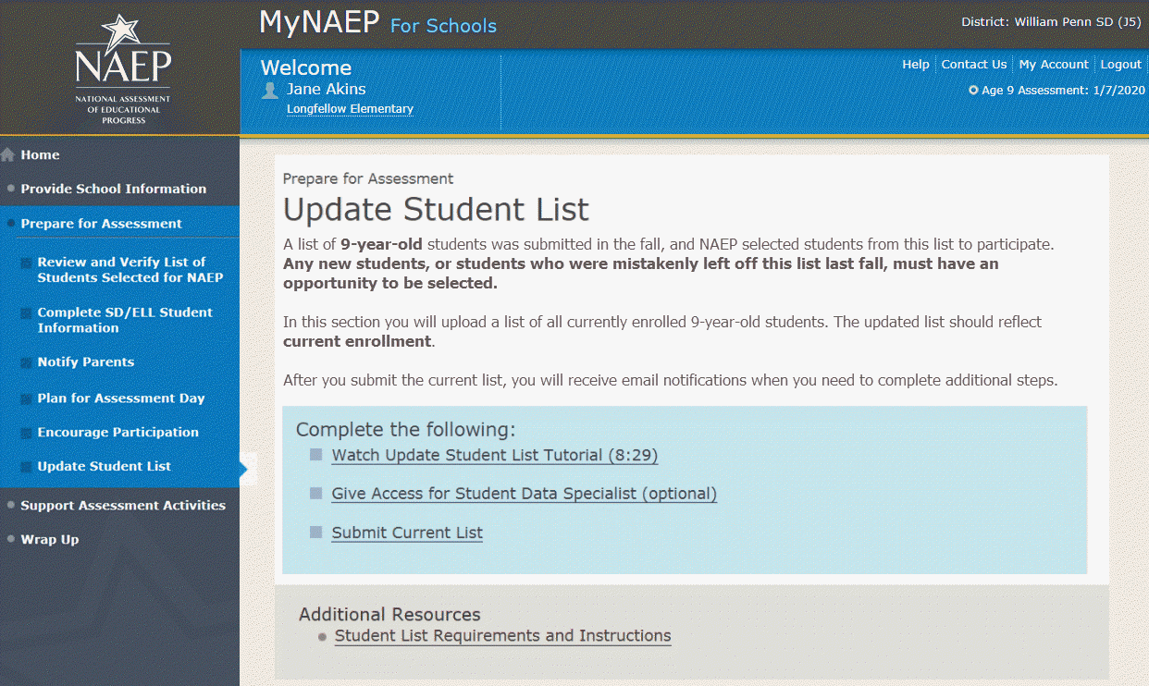
Update Student List

Give Access for Student Data Specialist
INES-SPE 1-1
The person at your school most familiar with creating a report of currently enrolled X-year-old students should submit the current roster. The roster must be an Excel file, and it should include the following information for each student.
- Student ID (optional, no SSNs)
- First name
- Middle name/initial (optional)
- Last name
- Month of birth
- Year of birth
Use the table below if you would like to designate a student data specialist to complete this task.
- After entering the name and email information select Save
- Then select the Send Email button
- Select Submit
Screenshot
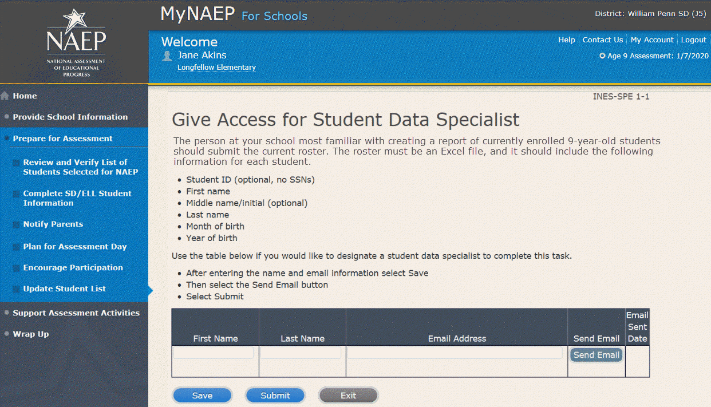

Submit Current List
Submit Current List
Prepare File-USL-SUB-1
NAEP needs a complete and current list of all X-year-old students (not just new students). The list should reflect January 2020 enrollment and will help NAEP identify any students who have enrolled since the fall of 2019. Include all students, even students who are commonly excluded from other testing programs.
To prepare your list:
- Read the instructions.
- Download the Excel template.
- Read tips for formatting the Excel file.
- Select Continue when you are ready to upload your file.
Note: the details for the bullets above can be found in the Additional Resources section of this document under Student List Requirements and Instructions section of this document.
Screenshot
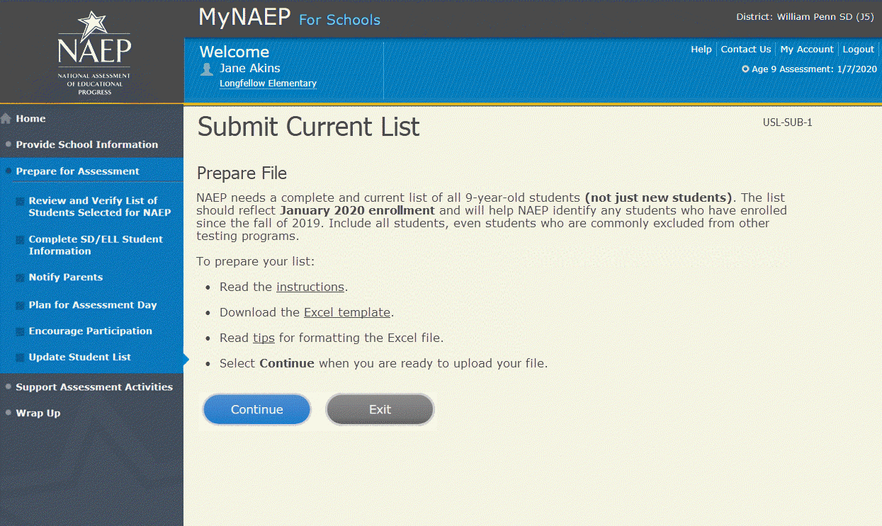
Submit Current List
Upload File-USL-SUB-2
- Does your student data file contain column headers?
- Date list is accurate as of:
(mm/dd/yyyy)
- Select Choose File or Browse to locate and select the file on your computer. This must be an Excel file containing all currently enrolled X-year-old students at your school.
- Select the Upload button.
Screenshot
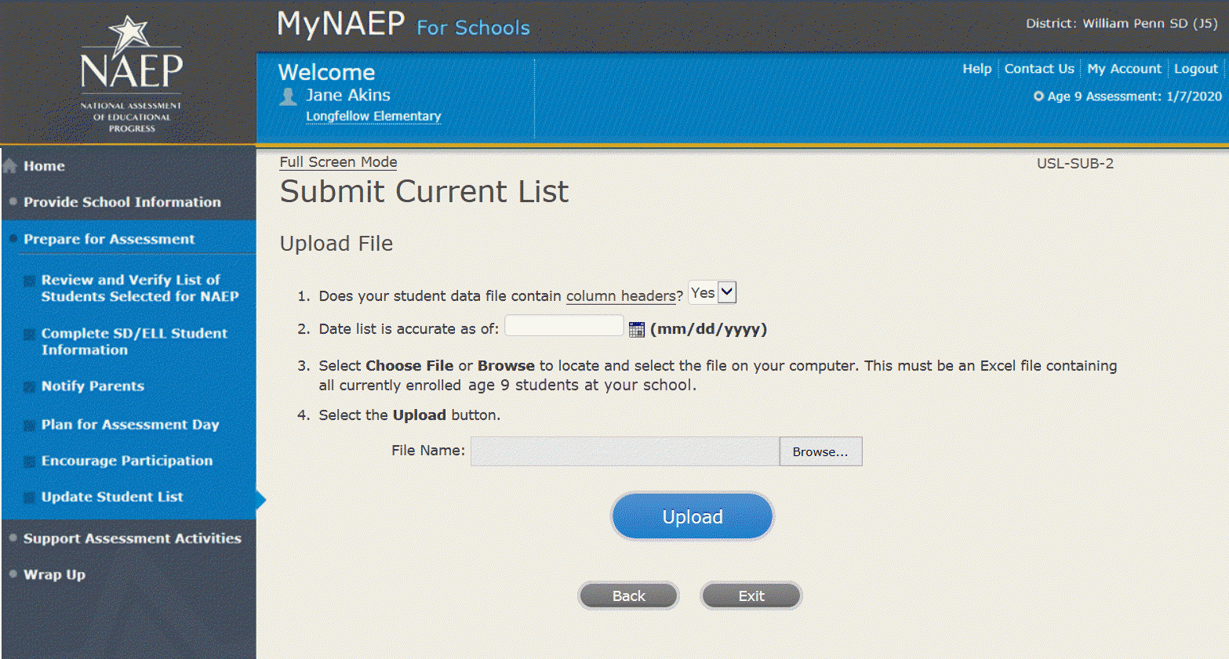
Submit Current List-USL-SUB-3
How is each student name formatted in your Excel file?
Split across multiple columns (regardless of order)
For example:
First Name Last Name
Rosa Parks
or
First Name Middle Name Last Name
Rosa Louise Parks

Contained within a single column (regardless of order)
For example:
Name
Rosa Parks
or
Name
Rosa Louise Parks
Screenshot
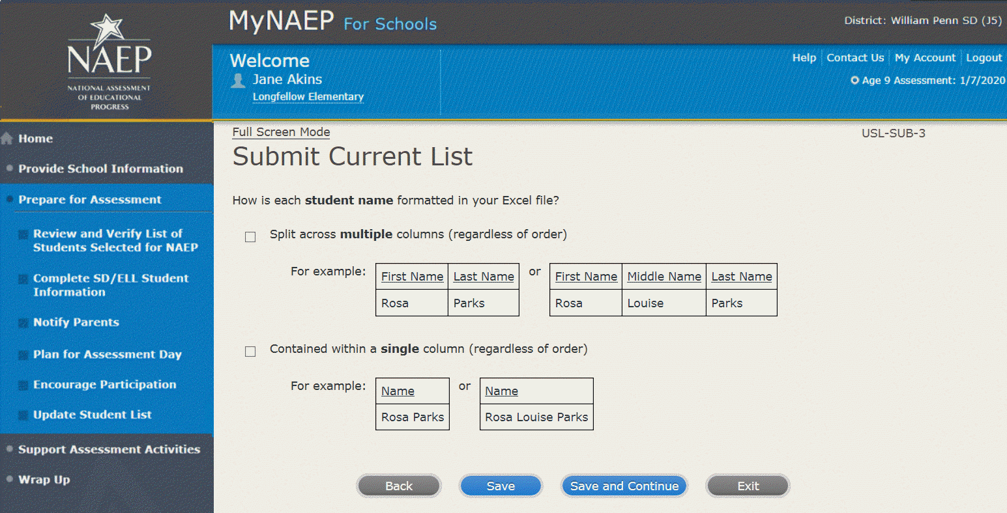
Submit Current List-SCR-SUB-4
How is date of birth formatted in your Excel file?
Split across multiple columns (regardless of order)
For example:
Month Year
1 2015
or
Month Day Year
1 20 2015

Contained within a single column (regardless of order)
For example:
Date of Birth
1/20/2015
Screenshot
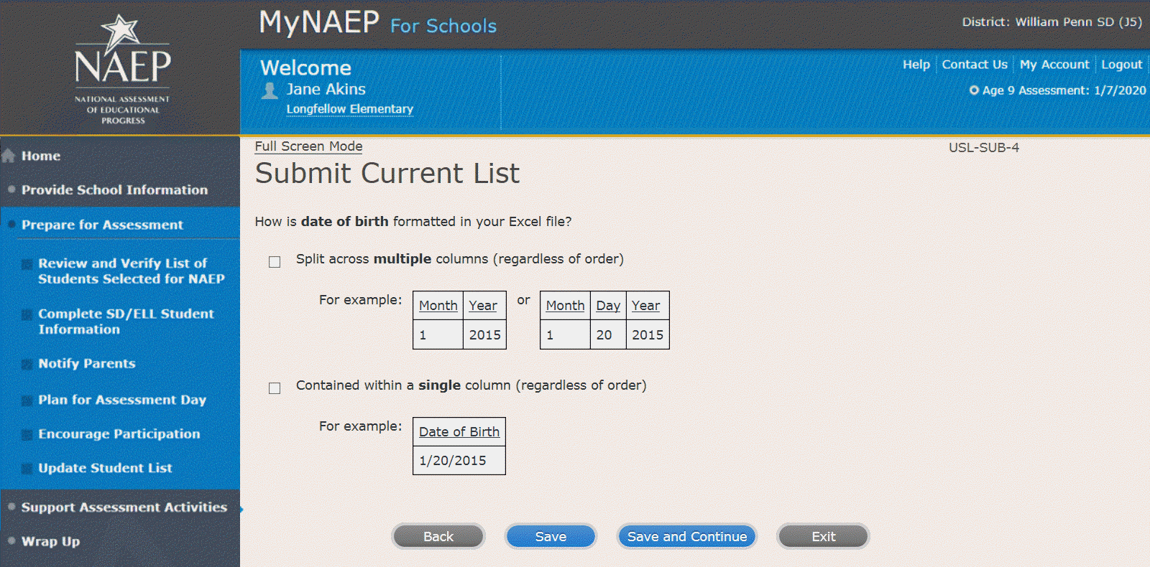
Submit Current List-SCR-SUB-8
How is month of birth formatted in your Excel file?
As a number (1 or 01)
As a word (January) or an abbreviation (Jan.)
Screenshot
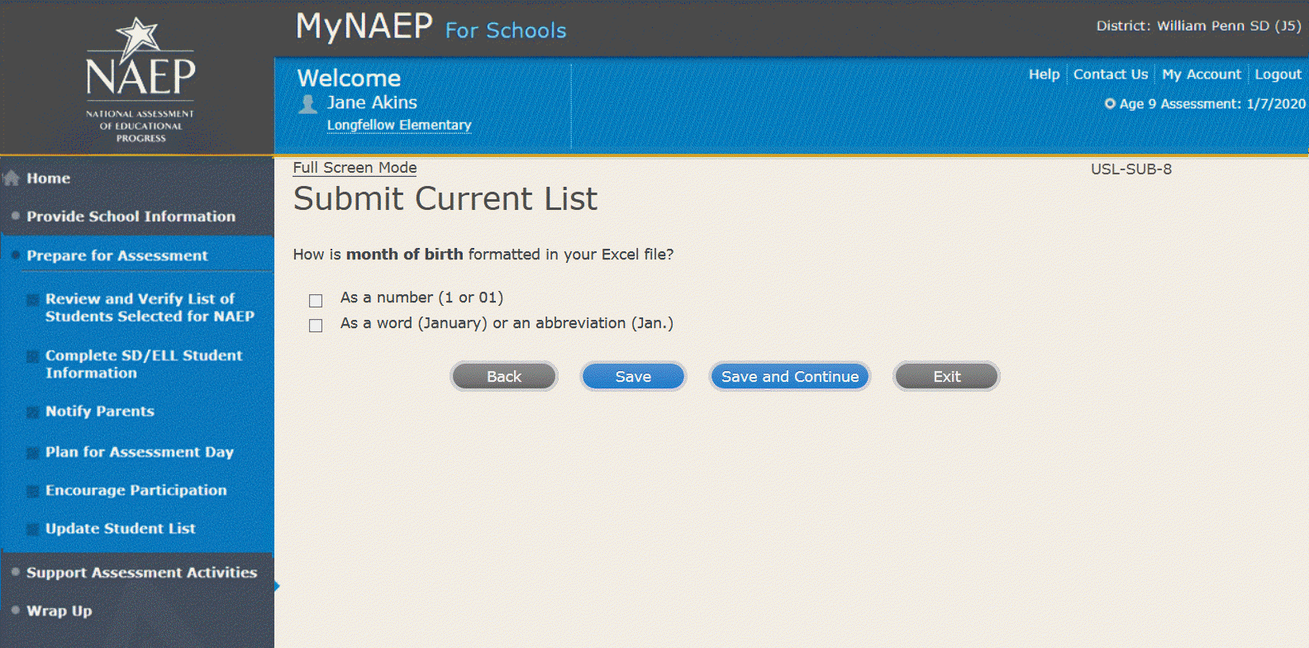

Submit Current List-USL-SUB-9
How is year of birth formatted in your Excel file?
As four digits (2016)
As two digits (16)
Screenshot
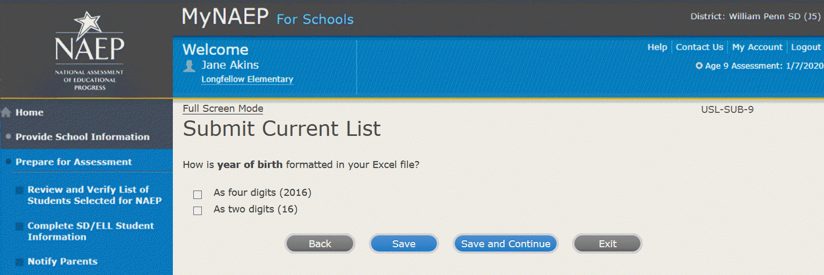

Submit Current List
Identify Your Columns-USL-SUB-5
NAEP needs to know what student data is in each column of your Excel file.
We have matched your column headings (on the left) with our required categories (on the right). For example, if your file has a column called "FName," the system already matched that to our "First Name" category.
- Review the matches in the table below, making any changes by selecting the drop-down menu.
- If your Excel file contains information that NAEP doesn't need (like homeroom), mark those columns as Not Applicable.
Tip: Do the column headings on the left display student data (e.g., Rosa) instead of column headings (e.g., Name)?
- Select the Back to Beginning button.
- On the Upload File screen, specify that your file does not contain column headers by selecting No for question number 1.
Screenshot
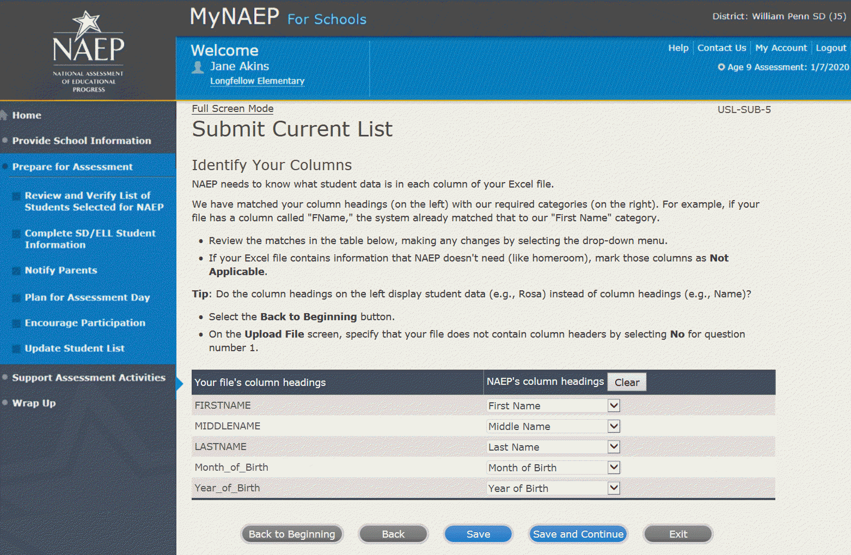

Submit Current List
Final Review-USL-SUB-13
You're almost done!
- Check to make sure that student names are in the appropriate columns and that months and years of birth appear correctly.
- Select the Edit pencil to make changes to individual students.
- If something looks wrong and you need to upload a new file, select Start Over.
- To complete this task, select Submit.
Screenshot
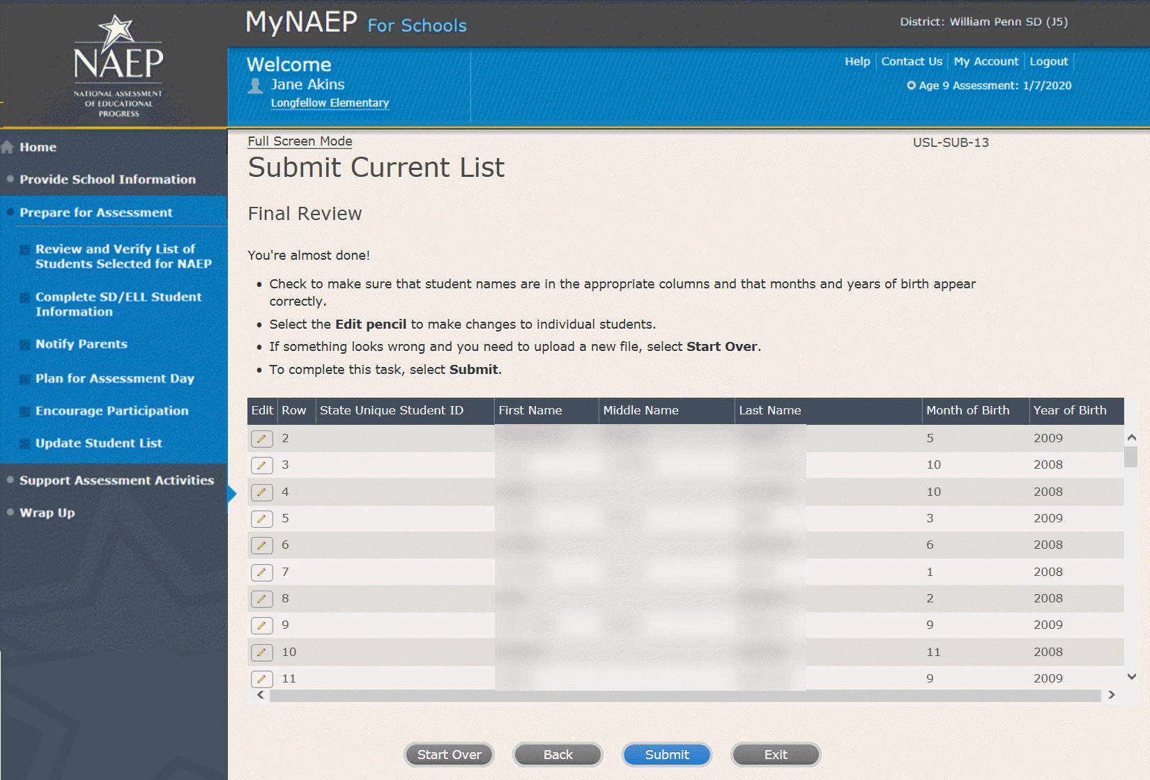
Submit Current List
Thank You – USL-SUB-14
Thank you for submitting your list. You will soon receive an email letting you know if any additional students are selected to participate in NAEP.
Screenshot
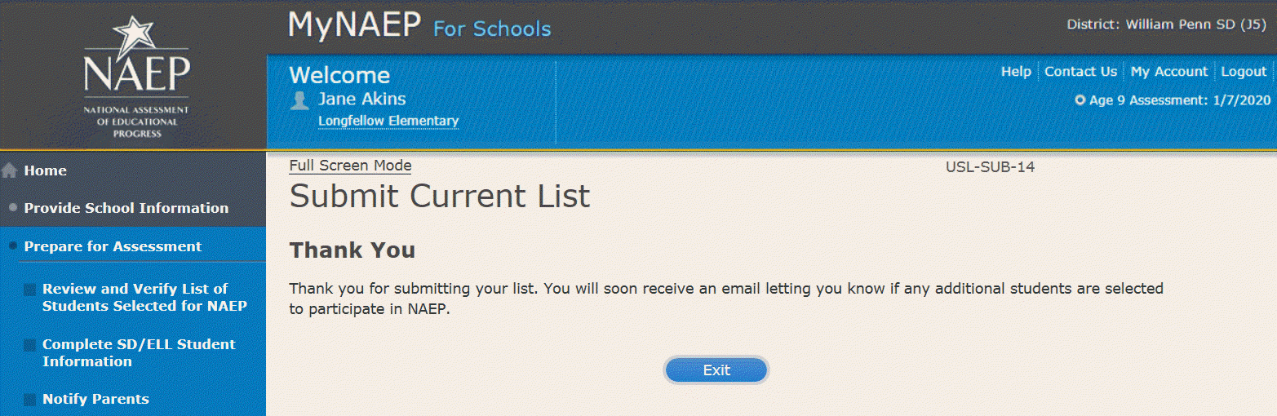

Support Assessment Activities
Support Assessment Activities
Help students remember the date, time, and location of the assessment. Use the link below to print Student Appointment Cards and distribute them to the students.
Circulate the Measure Up newsletter and Teacher Notification Letter. Attach the Listing of Sampled Students to the letter so that teachers can direct students to the correct assessment location. This list is private and should be returned to you and placed in the red NAEP Storage Envelope after the assessment.
Complete the following:
- Print Student Appointment Cards (see Additional Resources section of this document)
- Print Teacher Notification Letter for distribution to teachers (see Additional Resources section of this document)
- Print Listing of Sampled Students
Additional Resources
- Measure Up News for the School Community (see Appendix D3-19)
- Facts for Teachers (see Appendix D3-15)
Screenshot
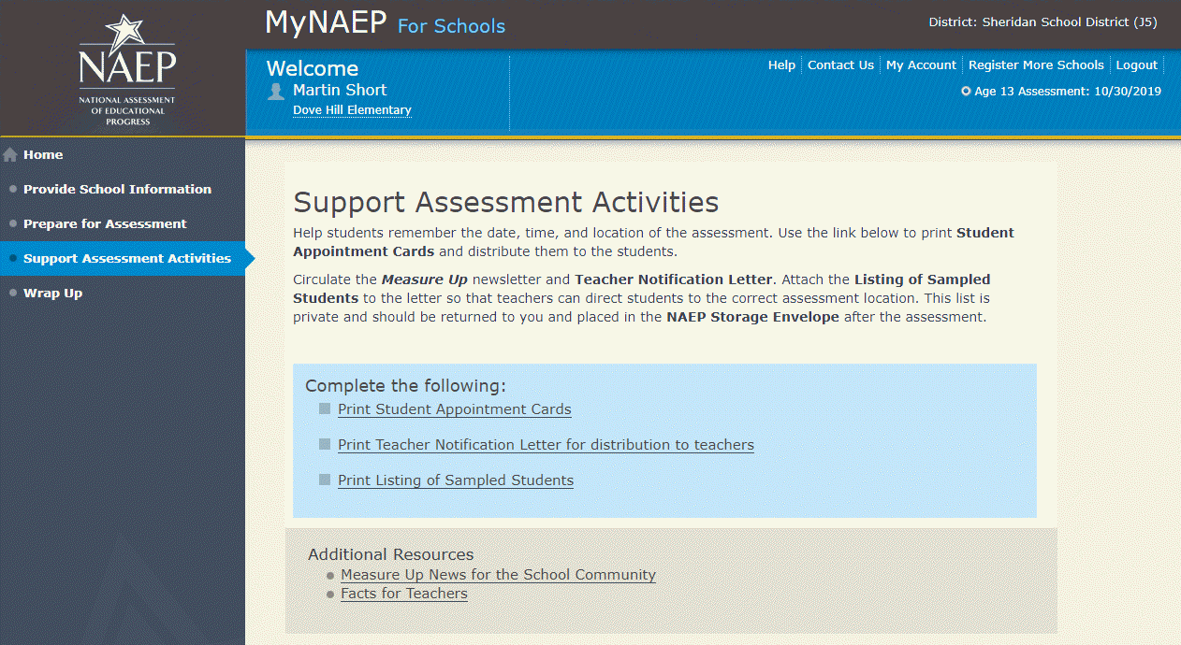

Wrap Up
Wrap Up
The final task remaining for you is to securely store and eventually dispose of all NAEP materials. Please safeguard all materials until the date noted on the red NAEP storage envelope. You will receive an email reminder at that time to destroy the contents of the storage envelope in a secure manner.
Screenshot
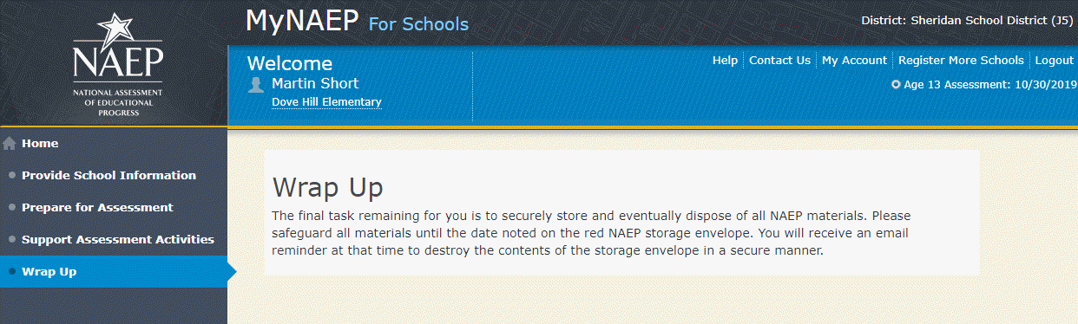
Note: The following content is the text that displays after clicking on the hyperlinks listed in the preceding pages of this document

Additional Resources

Prepare for Assessment

Instructions for the School Coordinator brochure
Instructions for the School Coordinator
Completing Preassessment Activities for NAEP 2019–2020
Thank you for your support of the National Assessment of Educational Progress (NAEP) for 2019-2020. We look forward to working with you to make NAEP a positive experience at your school. This begins with completing activities before the assessment.
For the upcoming assessments, the MyNAEP for Schools website will serve as your primary resource to prepare for the assessment. MyNAEP provides you with an electronic way to complete the preassessment tasks at your own pace. Visit the MyNAEP website at www.mynaep.com to get started. If you have not yet registered for MyNAEP, refer to the School Coordinator Responsibilities: A Guide to MyNAEP brochure you received earlier this fall for instructions, or your NAEP representative can assist you.
Your NAEP representative will follow up with you very soon to review the activities listed in this brochure and answer any questions you may have about completing these tasks. There are short video tutorials for each task, and we recommend reviewing them before completing the tasks.
If you need assistance before then, contact the NAEP help desk at
1-800-283-NAEP (6237) or by email at NAEPHelp@westat.com.
Thank you for your support of the National Assessment of Educational Progress!
December X, 2019 (Note: for age 13, this will read: September X, 2019)
On December X, 2019 (Note: for age 13, this will read: September X, 2019), the sections of Prepare for Assessment on MyNAEP will be available to schools. At that time you can begin to complete the preassessment tasks listed below by selecting the Prepare for Assessment link.
Review and Verify List of Students Selected for NAEP
In this section, you will review the list of students selected for NAEP for accuracy and completeness. This section must be completed before completing the SD/ELL student information.
- Update missing or incorrect student demographic data.
- Update missing or incorrect classifications for students with disabilities (SD), student with 504 plans, and English language learners (ELL).
- Identify any students who cannot take NAEP.
- Indicate if there are students who have been displaced from their regular school by an event such as a fire or hurricane.
Complete SD/ELL Student Information
In this section, you will review the list of students identified as SD and/or ELL and provide information on what accommodations (if any) students require for NAEP.
- Review NAEP inclusion policy.
- Identify up to five specialists at your school to provide information for students with disabilities and English language learners.
- Indicate how each student identified as SD and/or ELL should be assessed on NAEP.
Notify Parents/Guardians
By law, the parents/guardians of the students selected for NAEP must be notified in writing before the assessments can take place. In this section, you are given instructions for notifying parents/guardians about the assessment and will confirm that parents/guardians of the students selected for NAEP have been notified.
- Notify parents/guardians as soon as possible using the Parent/Guardian Notification Letter (see Appendices D3-7, D3-8, D3-20, and D3-21) available to download in this section (available in both English and Spanish).
- Verify parent/guardian notification.
- Upload your Parent/Guardian Notification Letter and indicate when you plan to send the letter.
Plan for Assessment Day
In this section, you will provide information to help the NAEP team plan for assessments at your school.
- Review the student group assignments for testing and provide the start time(s) and testing location(s).
- Answer questions necessary to plan the assessment logistics.
Encourage Participation
In this section, you will review strategies that can help motivate students to participate on NAEP. There are links to videos and other promotional materials.
- Record what strategies you plan to use in your school.
- Note that makeup sessions may be needed if the assessment is canceled due to weather or if attendance at the assessment is less than 90 percent.
Update Student List
In this section, you will update the list of students currently enrolled in the selected age group. NAEP will use this list to identify students who were not included on the original list of students submitted to NAEP in the fall.
- You will be notified if any new students have been selected for NAEP as a result of updating the student list. For any newly selected students, complete the “Provide Demographic Data for Newly Selected Students,” “Complete SD/ELL Information for Newly Selected Students” (if necessary), and “Notify Parents of Newly Selected Students.”
1 week before assessment
Approximately 1 week before your assessment, visit the Support Assessment Activities section.
Support Assessment Activities
In this section, you have access to material for notifying students and faculty about the NAEP assessment.
- Print Student Appointment Cards to distribute to students to notify them of the date, time, and location of the assessment.
- Print the Teacher Notification Letter and distribute to all teachers. This letter provides the date, time, and location for each assessment session.
- Print the List of Students Selected for NAEP and the Measure Up newsletter and distribute them, along with the Teacher Notification Letter, to all teachers for the selected age group.
Thank you for helping us make NAEP in your school a success!
Remember to visit the MyNAEP for Schools website at www.mynaep.com to receive details about the assessment activities in your school.
What Is NAEP?
The National Assessment of Educational Progress (NAEP) is the largest continuing and nationally representative assessment of what our nation’s students know and can do in core subjects. NAEP is congressionally mandated, and was first administered in 1969 to measure student achievement nationally. Teachers, principals, parents, policymakers, and researchers all use NAEP results to assess progress and develop ways to improve education in the United States.
For more information, visit http://nces.ed.gov/nationsreportcard or contact the NAEP help desk at 1-800-283-NAEP (6237) or by email at NAEPHelp@westat.com.

Brochure layout
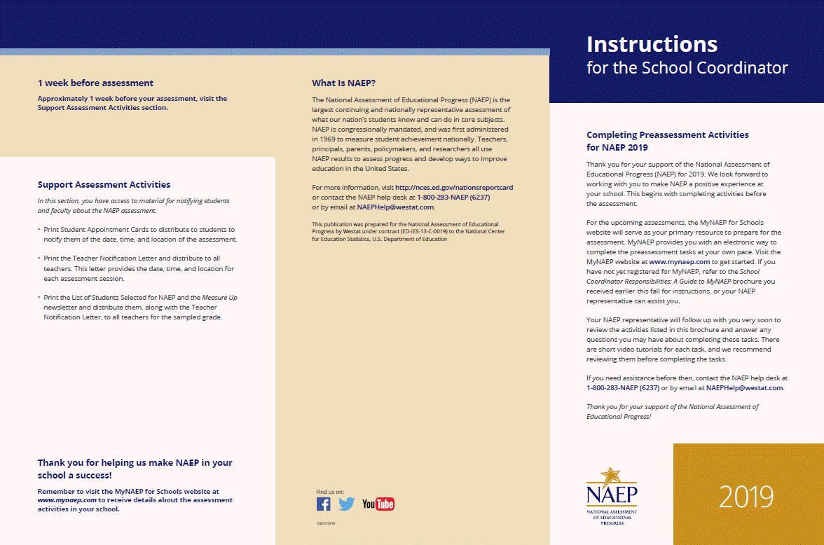
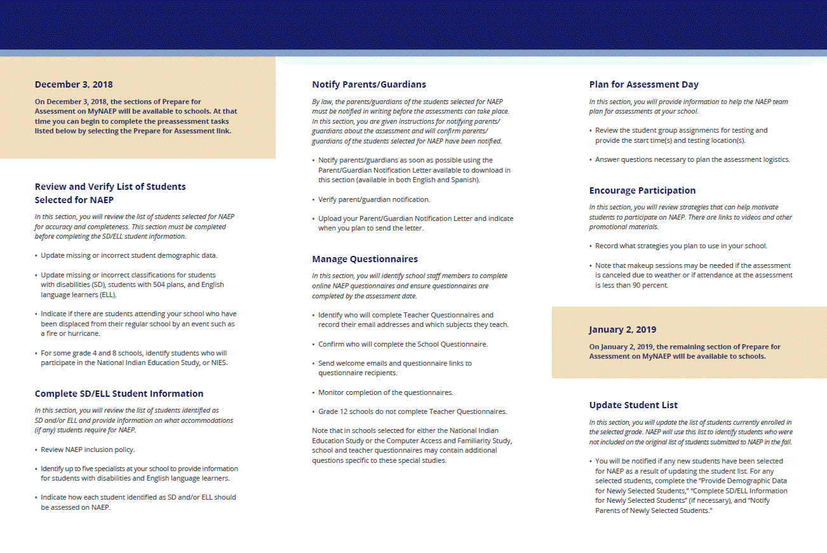

Review and Verify List of Students Selected for NAEP

Information Needed to Review and Verify List of Students Selected for NAEP
Information Needed to Review and Verify List of Students Selected for NAEP
You will review and confirm the following information for each selected student on your list. Please collect this information in advance.
- Age
- Enrollment status (have any students withdrawn?)
- If the student is foreign exchange, or does not attend classes on campus
- Student ID (optional)
- Month of Birth
- Year of Birth
- Gender
- Race/ethnicity
- National School Lunch Program eligibility status – only if the information is shown (reduced price lunch, free lunch, student not eligible)
- Student with disability classification (IEP, 504)
- English Language Learner (Limited English Proficiency) status

Determine if any selected students cannot take NAEP
Please use the reasons in the bulleted list below to determine if any selected students cannot take NAEP.
- Withdrawn
- Graduated
- Expelled
- Does not attend any academic classes in campus
- Home schooled and receives limited services on campus
- Student listed more than once
- Not in selected age group
- Foreign exchange student
- Student deceased
- Long-term illness/homebound (will not be in school during NAEP testing).
- Parent notified about NAEP and refused NAEP testing.
- Student notified about NAEP and refused NAEP testing.
- Student meets (or met) participation criteria for the state alternate assessment (student is currently eligible or was eligible in the past to take the state alternate assessment).
- Student is classified as an English language learner and has been enrolled in U.S. schools less than 1 full academic year before the NAEP assessment and cannot access NAEP.
Review and verify student demographic information
NAEP collects demographic information to report results for student groups. Please collect the information described below for each sampled student.
- Race/Ethnicity:
  - Hispanic, of any race: A person of Mexican, Puerto Rican, Cuban, Central or South American, or other Spanish (but not Portuguese) culture of origin, regardless of race.
  - White, not Hispanic: A person having origins in any of the original peoples of Europe (except Spain), North Africa, or the Middle East.
  - Black or African American, not Hispanic: A person having origins in any of the Black peoples of Africa.
  - Asian, not Hispanic: A person having origins in any of the original peoples of the Far East, Southeast Asia, the Indian Subcontinent, including, for example, Cambodia, China, Japan, India, Korea, Malaysia, Pakistan, the Philippine Islands, Thailand, and Vietnam.
  - American Indian or Alaska Native, not Hispanic: A person having origins in any of the original peoples of North and South America (including Central America), and who maintains tribal affiliation or community attachment.
  - Native Hawaiian or Pacific Islander, not Hispanic: A person having origins in any of the original people of Hawaii, Guam, Samoa, or other Pacific Islands.
  - Two or More Races (Non-Hispanic): A person who identifies with two or more of the non-Hispanic categories above.
- School Lunch Status – if column appears:
  - Student not eligible to participate: Student is not eligible for free or reduced-price lunch.
  - Free lunch: Student is eligible for free lunch. Schools participating in Provisions 2 or 3 of the National School Lunch Program (NSLP) should code all students as “free lunch.”
    - If it is not possible to distinguish between “free” and “reduced price” for some students, code these students as eligible for free lunch.
  - Reduced price lunch: Student is eligible for reduced-price lunch.
  - School not participating: School does not participate in the NSLP. When used, this code must be applied to all students.

Review and verify classifications of Students with Disabilities (SD) and English Language Learners (ELL)
Please indicate each student’s SD/ELL classification with these codes.
- Students with disabilities (SD):
  - Yes, IEP: Student has a formal Individualized Education Plan (IEP) or the student’s IEP is in progress.
  - Yes, 504: Student has a 504 plan and needs accommodations to participate in NAEP (if the student does not need accommodations to be tested on NAEP, classify the student as No, not SD).
  - No, not SD
- English language learners (ELL):
  - Yes, ELL
  - No, Formerly ELL: Student is monitored for state reporting.
  - No, not ELL

Dept. of Agriculture Memo Authorizing Release of NSLP to NAEP

This memo replaces the United States Department of Agriculture (USDA) Letter
Date: School Year 2019–20
To: School Nutrition Program Personnel
From: National Assessment of Educational Progress (NAEP)
Subject: Policy on Limited Disclosure of Children's Eligibility Information to NAEP

As stated in the Eligibility Manual for School Meals (Section 5 - Confidentiality and Disclosure, Disclosure Requirements), school food authorities may disclose, without parent/guardian consent, children’s names and eligibility status (whether they are eligible for free meals or free milk or reduced price meals) to persons directly connected with the administration or enforcement of a Federal or State education program, such as NAEP, as permitted by section 9(b)(6)(A)(ii)(I) of the Richard B. Russell National School Lunch Act.
The relevant section from page 88 of the Eligibility Manual for School Meals is shown below:
Because NAEP is a Federal education program, LEAs may disclose, without parent or guardian consent, children’s names and eligibility status to persons directly connected to the administration or enforcement of NAEP. Additionally, LEAs may disclose children’s names and eligibility status to persons directly connected with the administration or enforcement of State educational assessment programs to the extent the State assessment is part of the NAEP. Other State education programs may access participants' names and eligibility status, without parent or guardian consent. However, in both situations, the program must be established at the State (not local) level.
The term “persons directly connected” for the purpose of disclosure to NAEP includes Federal, State, and local program operators responsible for NAEP administration or compliance, and their contractors. This does not imply that these persons have routine access to participants' eligibility status. There must be a "need to know" relating to the administration or enforcement of a Federal education program or for legitimate NAEP purposes.
The above information is available on the FNS website at https://www.fns.usda.gov/eligibility-manual-school-meals and then select, “Eligibility Manual.”

Complete SD/ELL Student Information

Inclusion on NAEP Fact Sheet
Inclusion on NAEP
Students with Disabilities and English Language Learners
WHAT IS NAEP?
The National Assessment of Educational Progress (NAEP) is the largest continuing and nationally representative assessment of what our nation’s students know and can do in core subjects such as mathematics and reading.
NAEP is congressionally mandated, and was first administered in 1969 to measure student achievement nationally. Teachers, principals, parents, policymakers, and researchers all use NAEP results to assess progress and develop ways to improve education in the United States.
The Importance of Inclusion
The responses of students with disabilities and English language learners on NAEP represent those of hundreds of other similar students. Without them, information about how to best meet the educational needs of these students would be lost. NAEP incorporates inclusive policies and practices into every aspect of the assessment, including selection of students, participation in the assessment administration, and valid and effective accommodations. Such best practices are essential to ensuring an inclusive assessment that yields meaningful NAEP results for all students with disabilities and English language learners. By representing their peers across the nation on NAEP, students with disabilities and English language learners help to ensure that NAEP results can be used to inform efforts to improve educational programs.
To ensure that the National Assessment of Educational Progress (NAEP) reflects the educational progress of all students, students with disabilities and English language learners must be included to the fullest extent possible.
Selection
Students with disabilities and English language learners are selected to participate in NAEP just like any other student. NAEP is administered to a sample of students who represent the student population of the nation as a whole and of individual states and districts participating in the Trial Urban District Assessment (TUDA). Within each selected school and grade to be assessed, students are chosen at random to participate in NAEP. Regardless of race/ethnicity, socioeconomic status, disability, status as an English language learner, or any other factors, every student has the same chance of being chosen.
For more information about NAEP, visit http://nces.ed.gov/nationsreportcard
For More Information Contact your NAEP State Coordinator with specific questions about including students with disabilities and English language learners. Details of the National Assessment Governing Board’s policy on testing and reporting results on students with disabilities and English language learners on NAEP are available at http://www.nagb.org/ publications/inclusion- special-population-naep.pdf. Current NAEP accommodations and inclusion policies are posted on the website at http://nces.ed.gov/nationsreportcard/about/inclusion.asp.
Participation
Many students with disabilities and English language learners are able to participate in the assessment administration alongside their peers.
Participating in NAEP allows students with disabilities and English language learners to experience a large-scale assessment administration without high-stakes consequences. Since NAEP does not produce scores for individual students or results for schools, participation in NAEP is not tied to grades or evaluations of students, teachers, or schools.
Accommodations
Students with disabilities and English language learners are provided with testing accommodations so that they can demonstrate their content knowledge and skills on NAEP. NAEP offers a comprehensive set of accommodations to increase access to testing for students with disabilities and English language learners. To ensure that appropriate accommodations are determined for individual students, NAEP relies on school staff to make inclusion and accommodations decisions for those students selected for the assessment.
The accommodations allowed on NAEP and those allowed in states are often similar, but there may be some differences. Sometimes these differences result from the way that the subject being measured is defined in the NAEP frameworks. For example, NAEP does not allow read-aloud of any part of the NAEP reading test except the instructions, because decoding words is part of what the NAEP framework is measuring.
Your NAEP State Coordinator has developed inclusion guidelines for including students with disabilities and English language learners on NAEP and provided them to schools selected for the assessment. These instructions will highlight any differences between NAEP and your state’s policies and provide guidance on how to include and accommodate sampled students.

Brochure layout
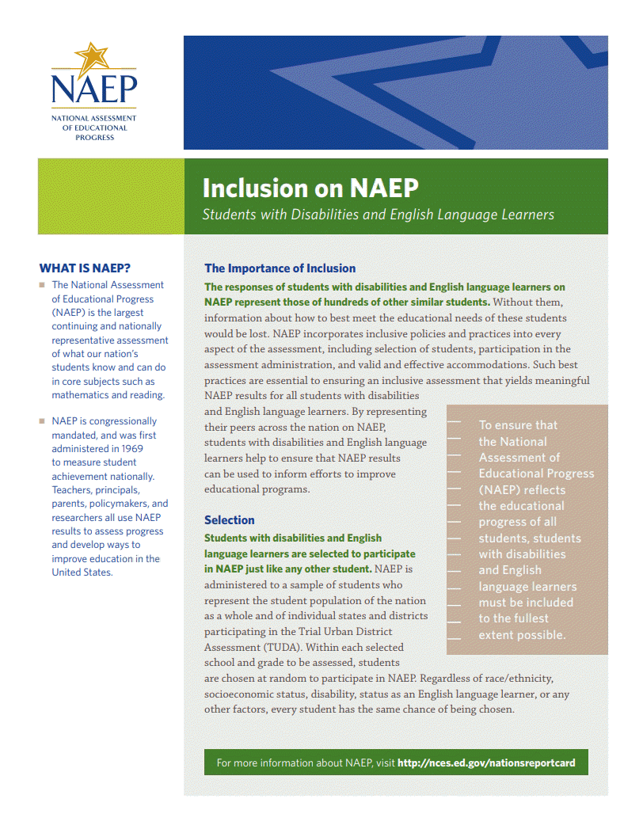

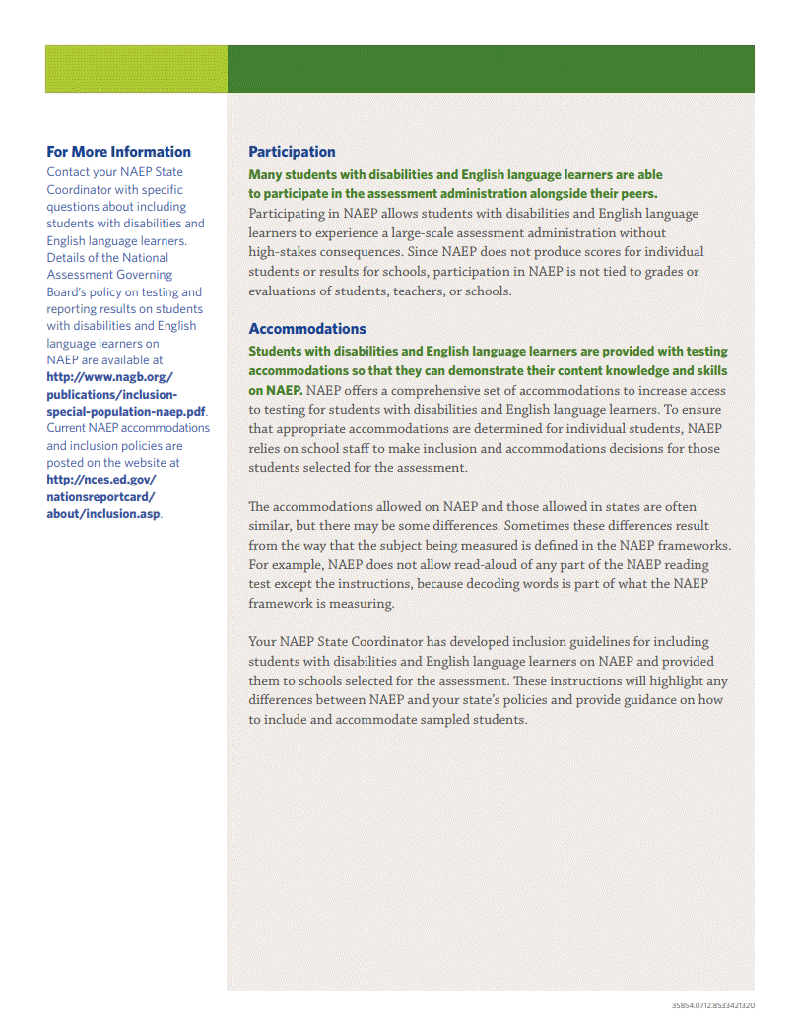

Letter from Department of Education Encouraging Inclusion
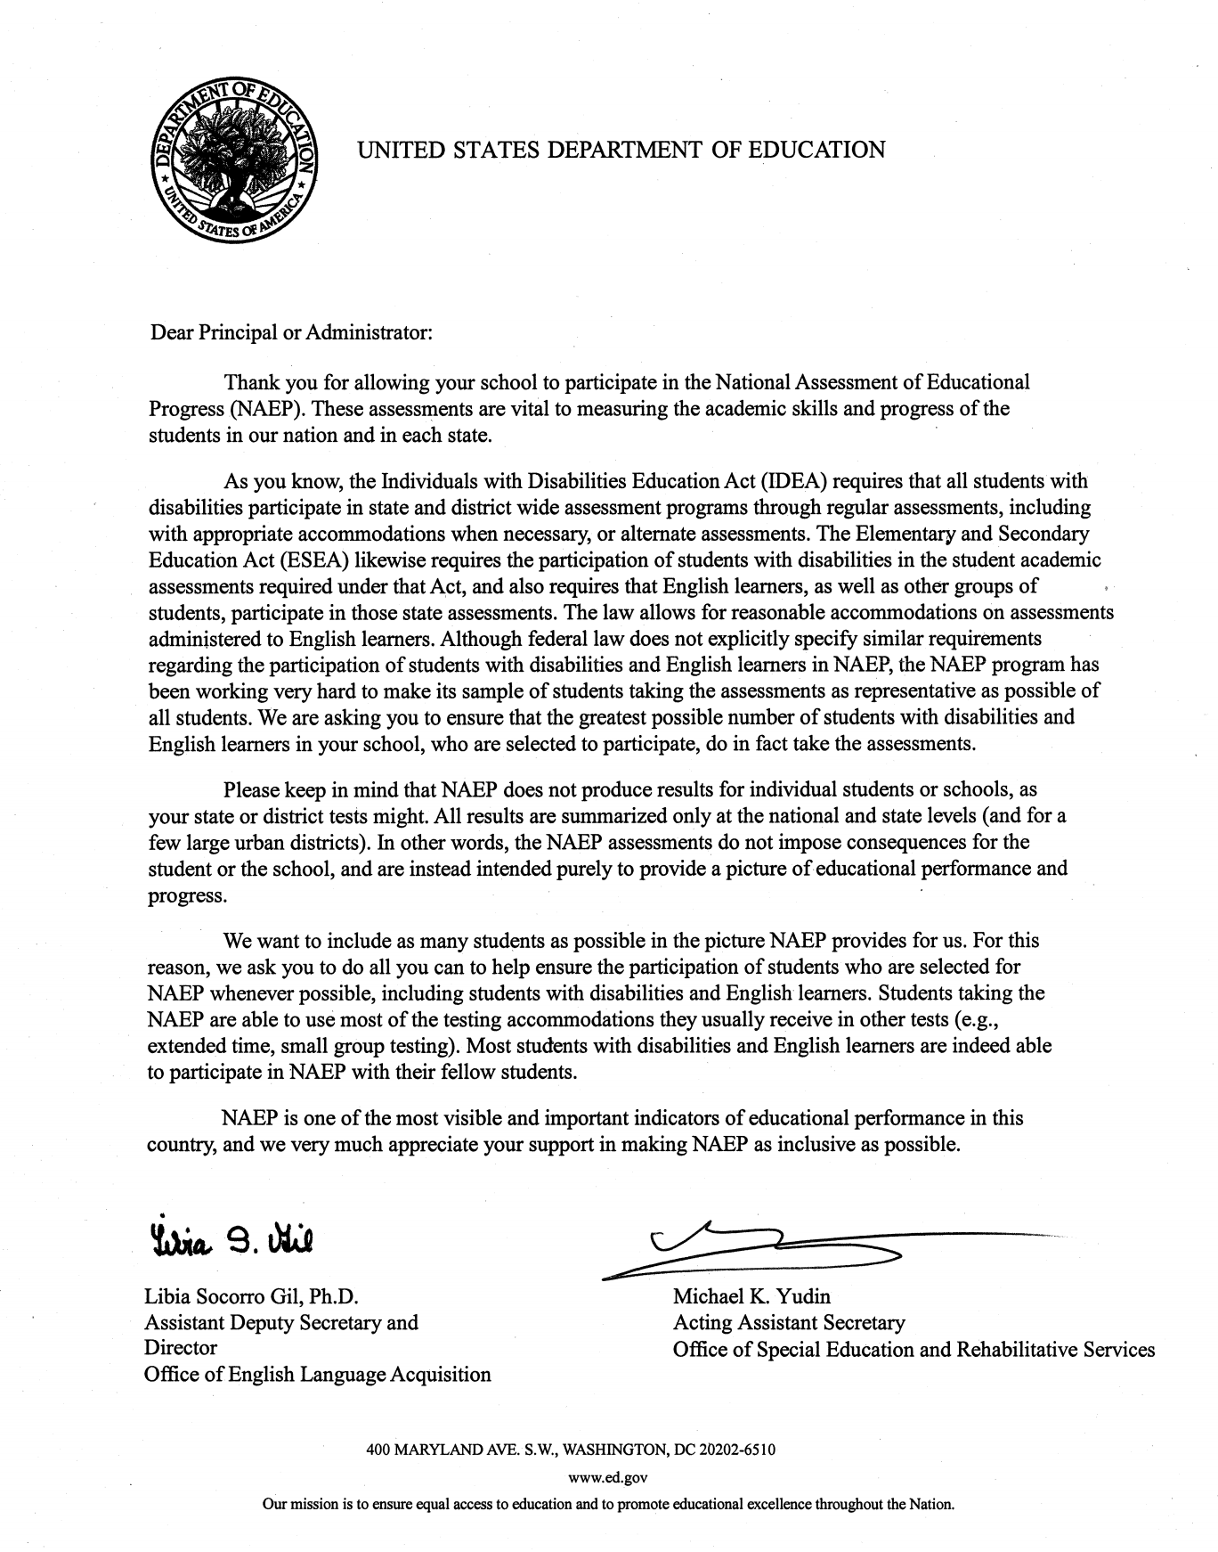

Information Needed to Include SD/ELL Students
Information Needed to Include Students with Disabilities
You will enter the following information for each sampled student classified as a student with disability.
- The IDEA category that best describes the student’s disability. The following categories are used by the Individual with Disabilities Education Act (IDEA).
  - Specific learning disability
  - Hearing impairment/deafness
  - Visual impairment/blindness
  - Speech or language impairment
  - Intellectual disability
  - Emotional disturbance
  - Orthopedic impairment
  - Traumatic brain injury
  - Autism
  - Development delay (age 9 or younger)
  - Other health impairment (specify)
- The degree of each student's disability.
  - Mild
  - Moderate
  - Profound/Severe
- Grade-level performance for the subject to be assessed.
  - At or above grade level
  - One year below grade level
  - Two or more years below grade level
  - Not receiving instruction in the designated subject (math or reading)
- How is the student assessed on the state assessment? If your state does not offer a state assessment, use classroom assessments as a reference point.
  - With accommodations
  - Without accommodations
  - With an alternate assessment, etc.

- Testing accommodations that each student typically receives.
Information Needed to Include English Language Learners
You will enter the following information for each sampled student classified as an English Language Learner (Limited English Proficiency).
- Each student’s primary language.
- How long has each student received academic instruction in English?
  - Does not receive instruction primarily in English
  - Less than 1 year
  - 1 to 2 years
  - 2 to 3 years
  - 3 years or more
- Grade-level performance for the subject to be assessed.
  - At or above grade level
  - One year below grade level
  - Two or more years below grade level
  - Not receiving instruction in the designated subject (math or reading)
- Each student’s English proficiency for listening, reading, speaking and writing.
  - No proficiency
  - Beginning
  - Intermediate
  - Advanced
- How long has each student been enrolled in U.S. schools?
  - Less than 1 full academic year
  - 1 full academic year or more
- Testing accommodations that each student typically receives.

Notify Parents

Parent’s page on Nation’s Report Card website
This resource is a hyperlink to the NCES site: https://nces.ed.gov/nationsreportcard/parents/.
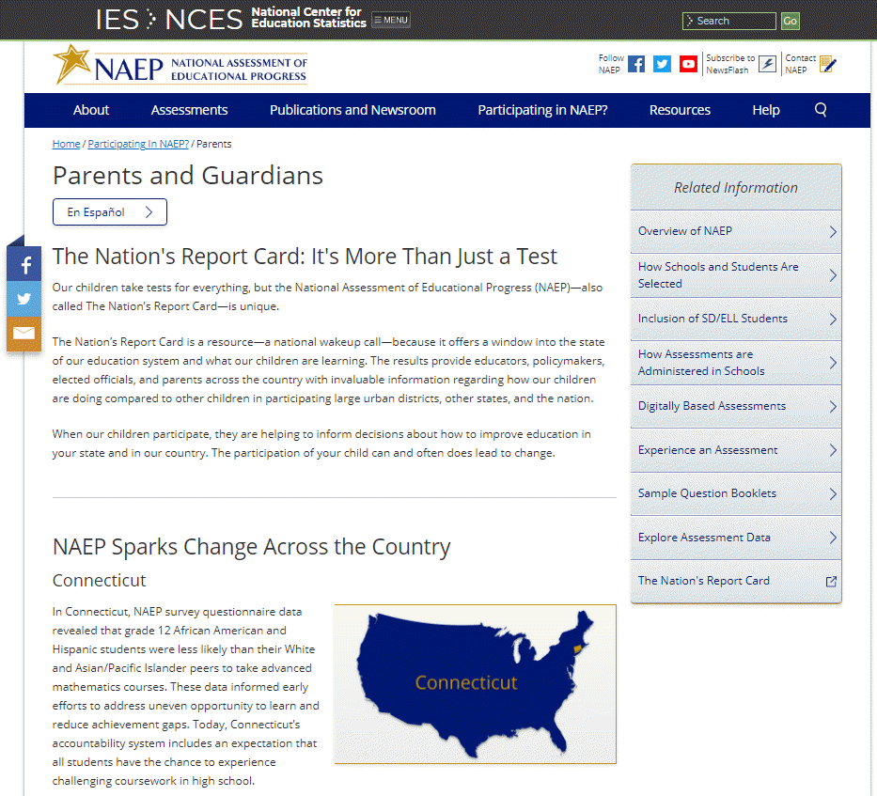

What Every Parent Should Know About NAEP: PDF version
This brochure is available here on the NCES website: http://nces.ed.gov/nationsreportcard/pdf/parents/2012469.pdf.

What Every Parent Should Know About NAEP: Video version
This video is available here on the NCES website: http://nces.ed.gov/nationsreportcard/videos/parentvideo/.

Sample Questions Booklets
This resource is a hyperlink to all the sample questions booklets posted on the NCES site: https://nces.ed.gov/nationsreportcard/about/booklets.aspx.

Plan for Assessment Day

Suggested Testing Room Layouts
Room Layouts for NAEP Paper Sessions
The following pages contain a series of diagrams that illustrate how NAEP staff may set up a room for paper assessments. The diagrams encompass the following setups:
- Classroom Style
- Library or Media Center
- Cafeteria
Your NAEP representative will determine the best arrangement based on the characteristics of the room you identify. If setting up for the assessment requires rearranging any furniture, the NAEP team will put back the furniture when they are finished.
Classroom Style
- Students in rows, facing the same direction
- Good for classrooms
Library or Media Center
- Good for locations where square or round tables are available

Cafeteria

- Good for large rooms with long tables
- If space allows, NAEP staff will put more space between students

Encourage Participation

Measure Up: NAEP News for the School Community
This resource is a hyperlink to the Measure Up newsletter posted on the NCES website:
https://nces.ed.gov/nationsreportcard/subject/participating/pdfs/naepmeasureupforpublicschoolssprsum-2019.pdf


Update Student List

Student List Requirements and Instructions
Instructions for Preparing a Current List of Students
Part I: Requirements
NAEP needs a complete and current list of all students in the selected age group to be assessed (not just new students).
- The list should reflect current enrollment.
- The list should include the correct age group.
  - For age 9 assessments: students who are 9 years old as of 1/1/2020, with birth dates between January–December 2010
  - For age 17 assessments: students who are 17 years old as of 10/1/2020, with birth dates between October 2002–September 2003
- The list will help NAEP identify any students that were not included on the original list submitted in the fall of 2019.
- Include all students, even students who are commonly excluded from other testing programs.
- Your student list must be a Microsoft Excel file (version 95 or later). If your student information is available in a different format, you can simply copy and paste the data into Excel.
- If you need assistance, call the NAEP Help Desk at 1-800-283-6237.
Include the following information for each student in the selected age group.
- Student first name
- Student last name
- Month of birth
- Year of birth
If available, please include…
- Student middle name/initial
- State unique student ID (do not use the student’s Social Security number)
Part II: List Format
You will need to answer questions about your Excel file’s format during the upload process. Will your file have all student information in separate columns? Good! That means you’re using the preferred format, pictured below.
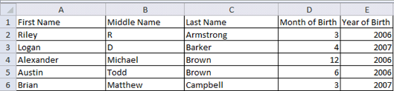
NAEP will also accept student names and birth dates formatted in single columns.
- During the upload, you’ll tell us how student names and birthdates are formatted.
- You will specify the order of student names, whether or not the student name column includes middle names, and how the names are separated (by a space, comma, or other character). Middle names and initials are optional. The example below is last name, first name.
- The same idea applies to birth dates, too. The example below is mm/dd/yyyy.
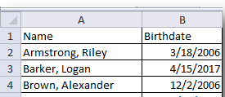

Part III: Pre-upload Checklist
Formatting errors can cause the file upload to fail. Save time by using this pre-upload checklist. If you can check off everything on this list, then you’re ready to upload your file.
- The file was prepared after January 1st and contains all currently enrolled students in the selected age group.

- Blank rows do not start until after the last student record. There are no blank cells or rows within the required student information (blanks for middle names and student IDs are ok).

- The file has only one worksheet with data on it. The extra worksheets are blank.

- The file does not have any footers or images at the bottom.

- The header for my file is in a single row, and there are no images at the top.

- The filename ends with .xls or .xlsx.

- I understand how student names are formatted in my file.

- I understand how month and year of birth are formatted in my file.
Part IV: Special Situations & Tips
- The first row of data in your file will be read as the column headers. Each succeeding row will be considered a student record.

- Use the most current enrollment information available, so that all students have an equal opportunity to be selected for NAEP.

- If more than one age group is being assessed at your school, submit separate Excel files for each age group.

- Year-round schools with multiple tracks of students should not include any students who will be on break on the scheduled assessment date.

- If MyNAEP cannot process your file, try selecting the Back button and revising your answers about how the Excel file is formatted. In the example below, the user checked the wrong box for the number of digits in the birth year. The red text at the top of the screen will display the number of digits in the birth year (in this case, four).

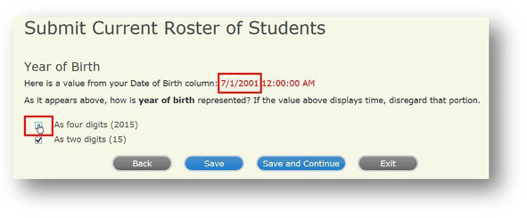

Support Assessment Activities

Teacher Notification Letter
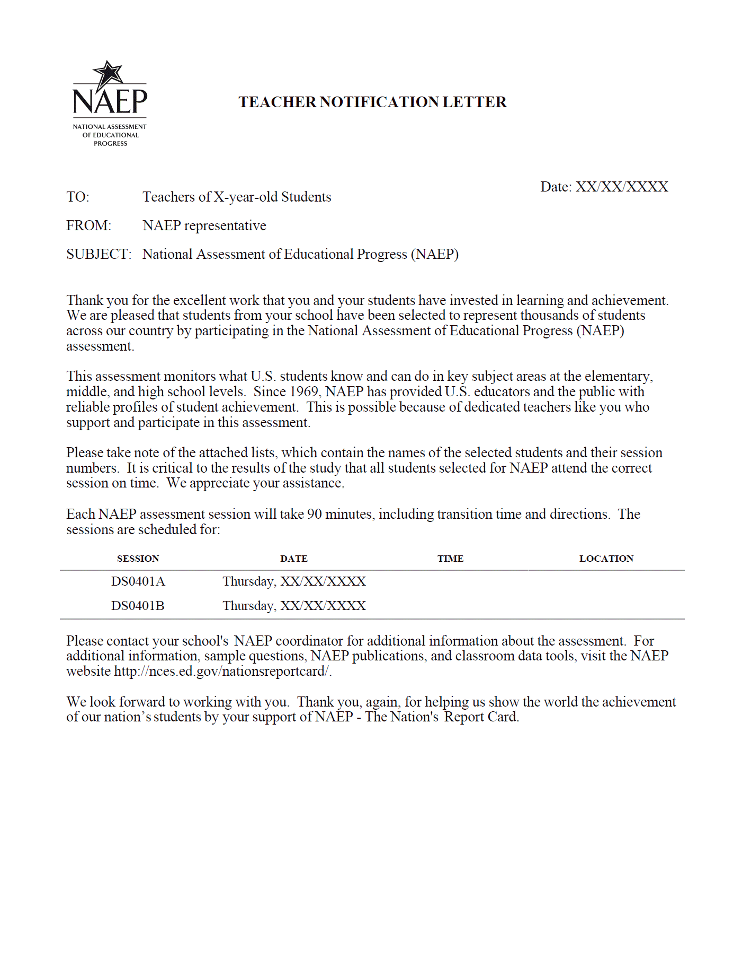

Appointment Cards

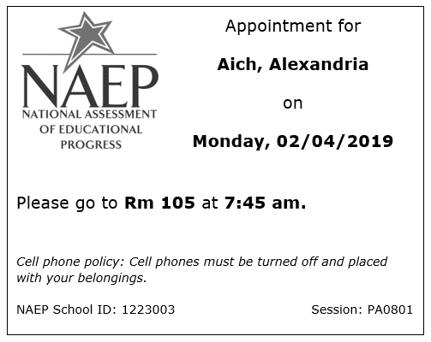

Please note that parents/legal guardians are required to receive notification of student participation but NAEP does not require explicit parental consent (by law, parents/guardians of students selected to participate in NAEP must be notified in writing of their child’s selection prior to the administration of the assessment).

