Pre-Notification Email

Subject: Need Your Help Soon
Description:
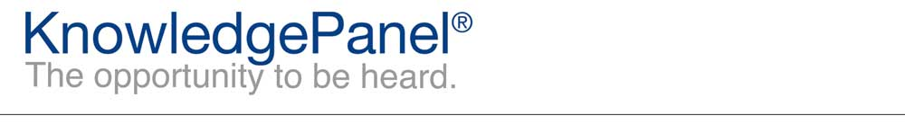

Dear %%firstname%%,
Thanks for being an integral part of KnowledgePanel!
We will need your help in the next few days! Your household has been selected to participate in the National Household Travel Survey for the US Department of Transportation. In the next few days please look for an email referencing the National Household Travel Survey. This survey will ask you and your household members to report their prior day’s trips and travel - we’ll be asking about all the places you and the other members of your household went throughout the day prior to the survey. This survey is used to help get a sense of how Americans are traveling these days and to look at things like how we might improve traffic congestion and travel safety in our communities.
Thank you for your help on this very important survey!
Our Panel Member Support Center is available if you have questions or comments. You can contact us at our toll-free 1-800-782-6899 number, or simply reply to this email. In order to better serve you, please be sure to include reference %%ANO%% in the subject of your message. We are always happy to hear from you!
Thanks,
The KnowledgePanel Team

Participating in KnowledgePanel® gives you the unique opportunity to make your opinions heard among business and policy decision makers. You can express those opinions fully confident that KnowledgePanel is committed to safeguarding your privacy. We will never transfer your personally identifiable information (name, address, phone number) to users of our research without your consent, nor will we ever try to sell you anything.
If you have any questions about our Privacy Policy or practices, you can email us at privacy@knowledgepanel.com.
If you believe you have received this email in error or prefer to opt out from receiving our emails, send a message to KnowledgePanel support at support@knowledgepanel.com or call us toll free at 1-800-782-6899.
© 2019 Ipsos | Panel Relations
1 Upper Pond Rd #D-2, Parsippany, NJ 07054

