Initial Invitation Email

Subject: National Household Travel Survey (%%ANO%%)
Description:
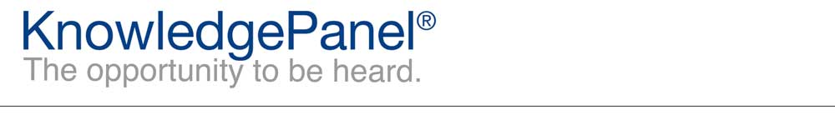

Dear %%firstname%%,
Thanks for being an integral part of KnowledgePanel!
Your household has been selected to participate in the National Household Travel Survey for the US Department of Transportation. As we mentioned in the email we sent you a couple days ago about this survey, we will be interested in gathering information about your and other members of your household’s recent travel. We will walk you through how to record this information for you and other members of your household. This survey is used to help get a sense of how Americans are traveling these days and to look at things like how we might improve traffic congestion and travel safety in our communities. Please complete this very important study at your earliest convenience. The survey can be accessed by clicking the following link:
%%LINK%%
Depending on your email reader, you may need to copy and paste the link into your web browser.
Our Panel Member Support Center is available if you have questions or comments. You can contact us at our toll-free 1-800-782-6899 number, or simply reply to this email. In order to better serve you, please be sure to include reference %%ANO%% in the subject of your message. We are always happy to hear from you!
Thanks,
The KnowledgePanel Team

Participating in KnowledgePanel® gives you the unique opportunity to make your opinions heard among business and policy decision makers. You can express those opinions fully confident that KnowledgePanel is committed to safeguarding your privacy. We will never transfer your personally identifiable information (name, address, phone number) to users of our research without your consent, nor will we ever try to sell you anything.
If you have any questions about our Privacy Policy or practices, you can email us at privacy@knowledgepanel.com.
If you believe you have received this email in error or prefer to opt out from receiving our emails, send a message to KnowledgePanel support at support@knowledgepanel.com or call us toll free at 1-800-782-6899.
© 2019 Ipsos | Panel Relations
1 Upper Pond Rd #D-2, Parsippany, NJ 07054

