MF Request New FHA Number

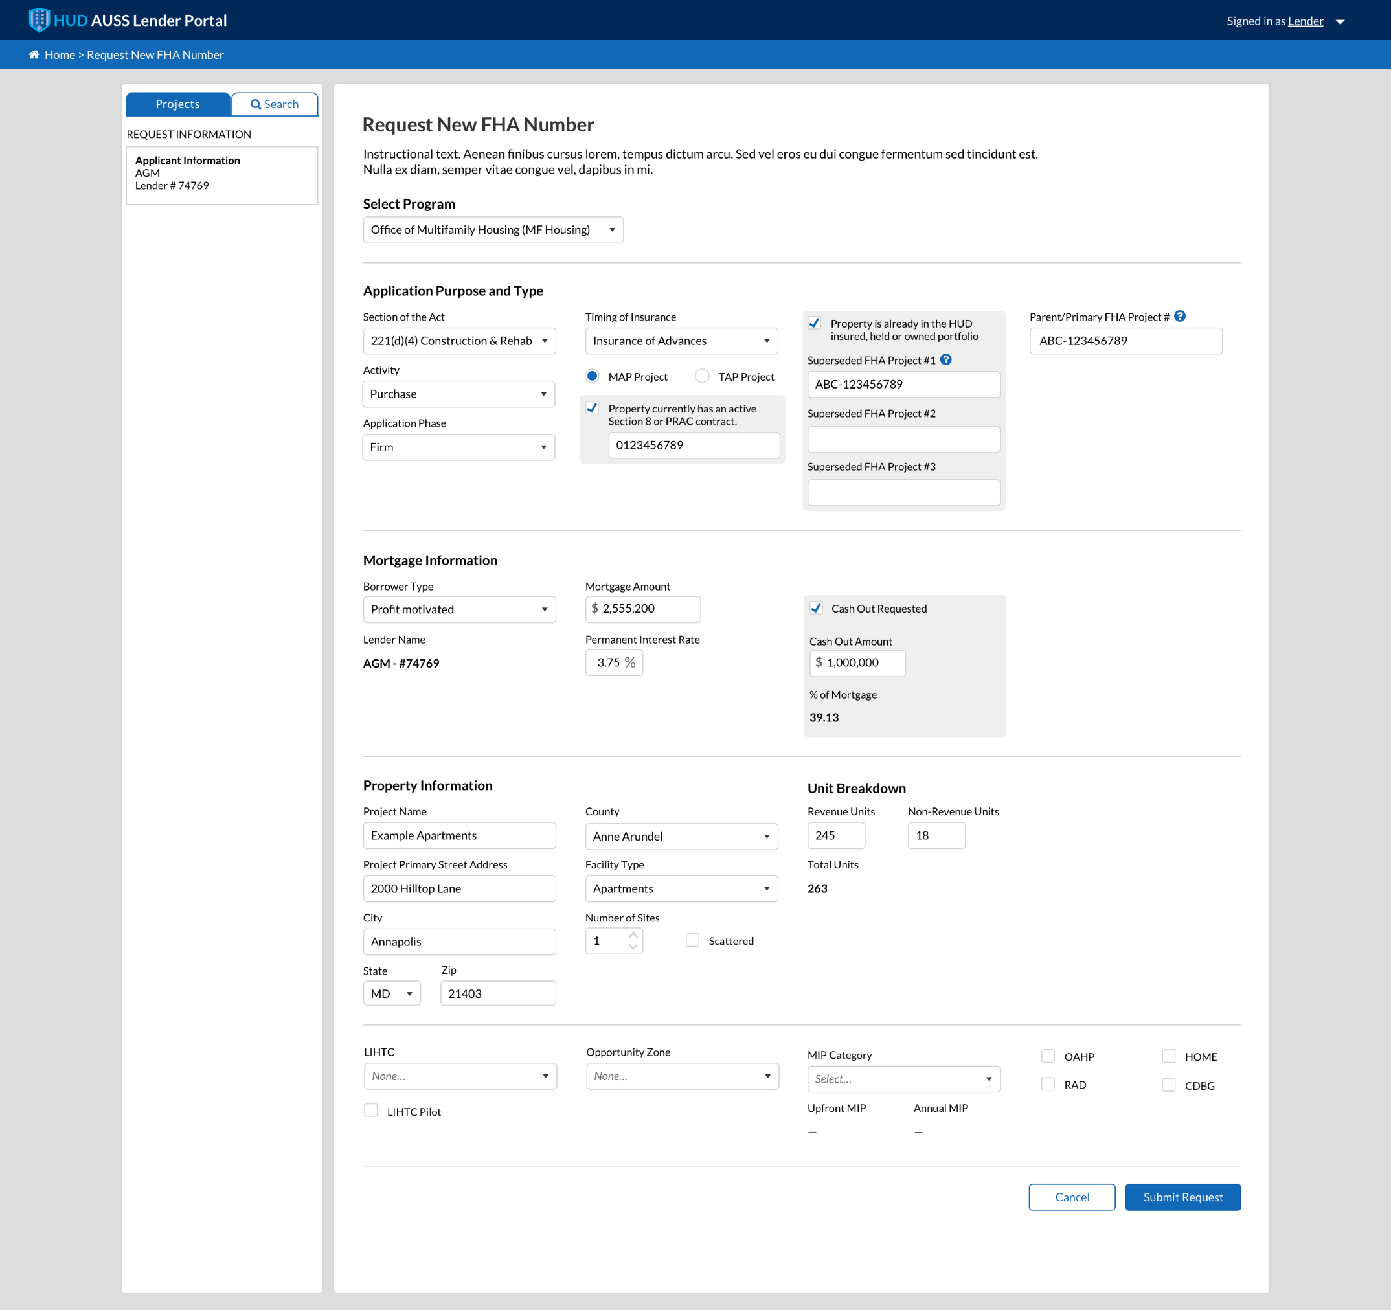
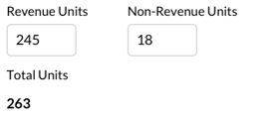
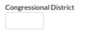
Existing Units
Units Being Added
241(a) Improvement/Addition on 207 Apts
Additions

Field Name | Value
Activity | Purchase
 | Refinance
 | New Construction
 | Rehab
 | Improvements
 | Additions
 | Operating Loss
Timing of Insurance | Insured Upon Completion
 | Insured Advances
Borrower Type | Condominium
 | Investor Sponsor Cooperative
 | Limited Dividend
 | Management Type Cooperative
 | Non-Profit
 | Profit Motivated
 | Public Body
 | Sales Type Cooperative
Facility Type | Asst’d Living
 | Single-Room Occupancy
 | Apartment
 | Coop
 | Condo
 | Mobile Home Park
 | Critical Access Hospital
 | Sole Community Providers
 | Other
LIHTC | None
 | 4% LIHTC / Tax Exempt Bonds
 | 9% LIHTC
Opportunity Zone | None
 | Yes, with Qualified Opportunity Fund
 | Yes, without Qualified Opportunity Fund
MIP Category | Affordable
 | Broadly Affordable
 | Green/Affordable
 | Green/Broadly Affordable
 | Green/Market
 | Market
 | None
**These are combined drop down values for all SOAs. Specific dropdown values are dependent on SOA**

232 Request New FHA Number
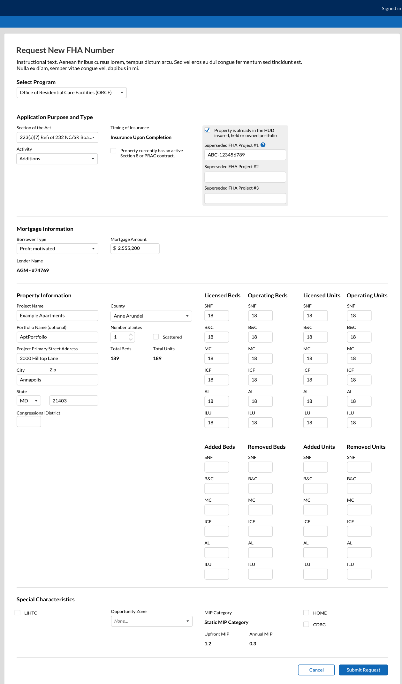
Field Name | Value
Activity | Purchase
 | Refinance
 | New Construction
 | Rehab
 | Improvements
 | Additions
 | Operating Loss
 | Additions+Improvements
 | Additions+Improvements + Equipment
 | Improvements
 | Additions
 | Additions + Equipment
 | Improvements + Equipment
 | Equipment
Timing of Insurance | Insured Upon Completion
 | Insured Advances
Borrower Type | Non-Profit
 | Profit Motivated
Opportunity Zone | None
 | Yes, with Qualified Opportunity Fund
 | Yes, without Qualified Opportunity Fund
**These are combined drop down values for all SOAs. Specific dropdown values are dependent on SOA**

242 Request New FHA Number
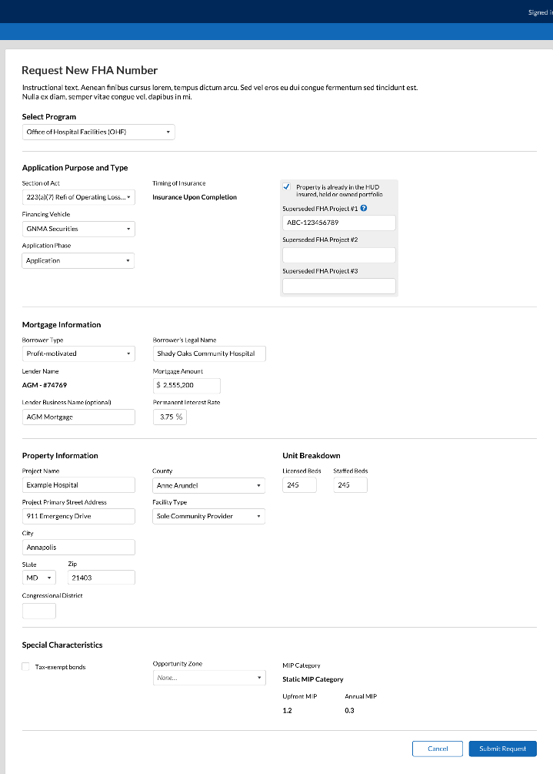

Field Name | Value
Financing Vehicle | Tax-Exempt Bonds
 | GNMA
 | Other
 | Rehab
Timing of Insurance | Insured Upon Completion
 | Insured Advances
Borrower Type | Non-Profit
 | Profit Motivated
 | Public Body
Facility Type | Critical Access Hospital
 | Sole Community Provider
 | Other
**These are combined drop down values for all SOAs. Specific dropdown values are dependent on SOA**

Upload Application Files against Checklist
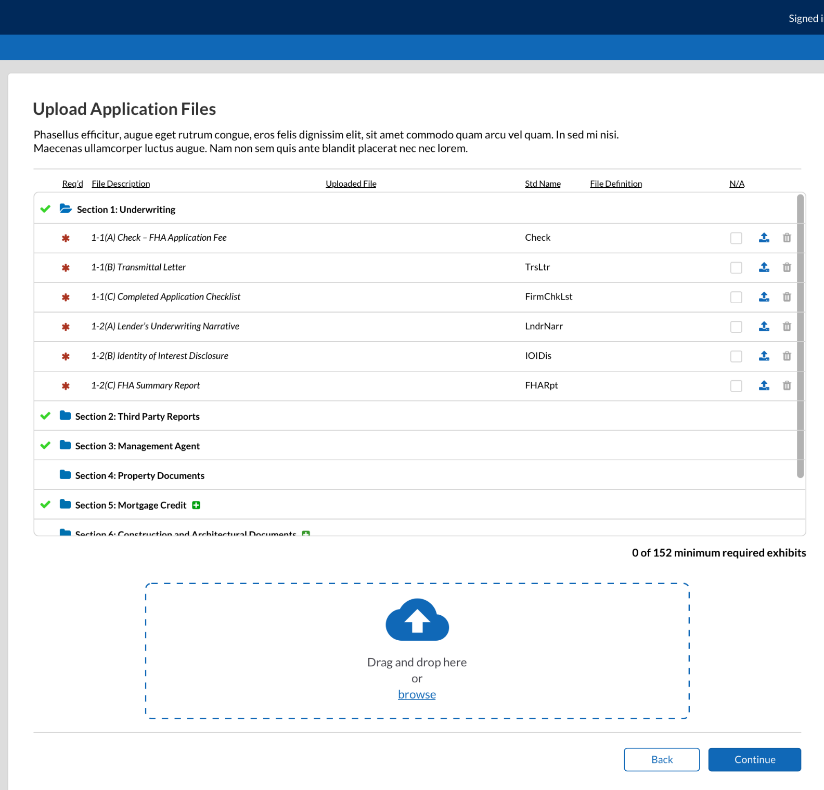

Upload New Concept Package
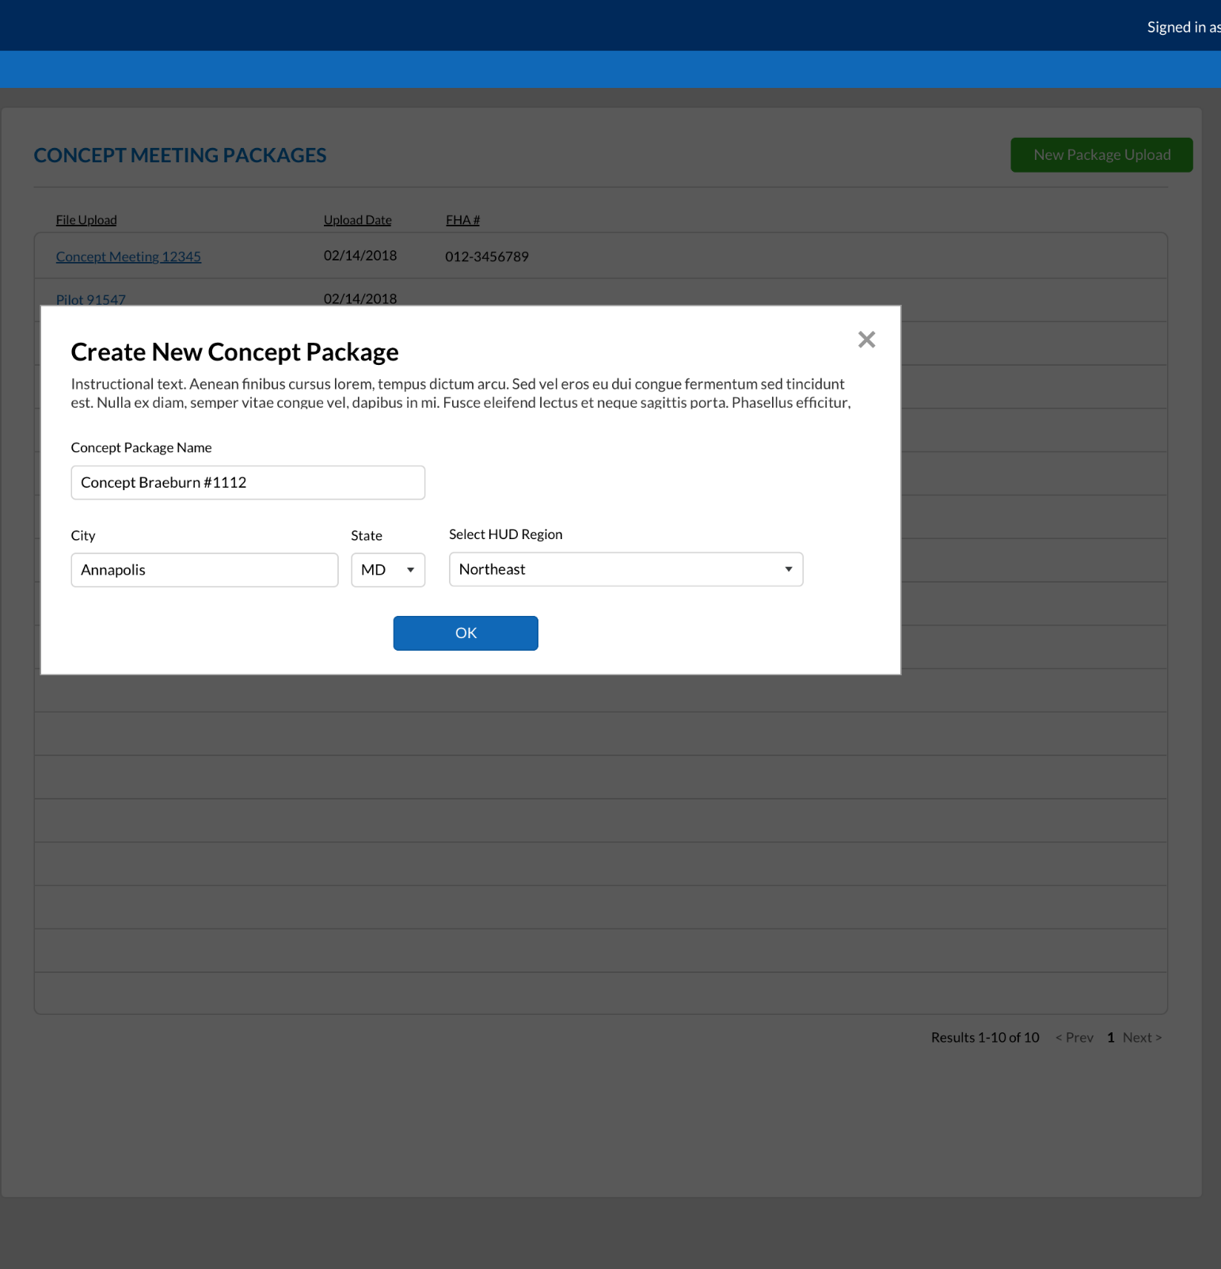

Other Document Type Upload
