MF Request New FHA Number

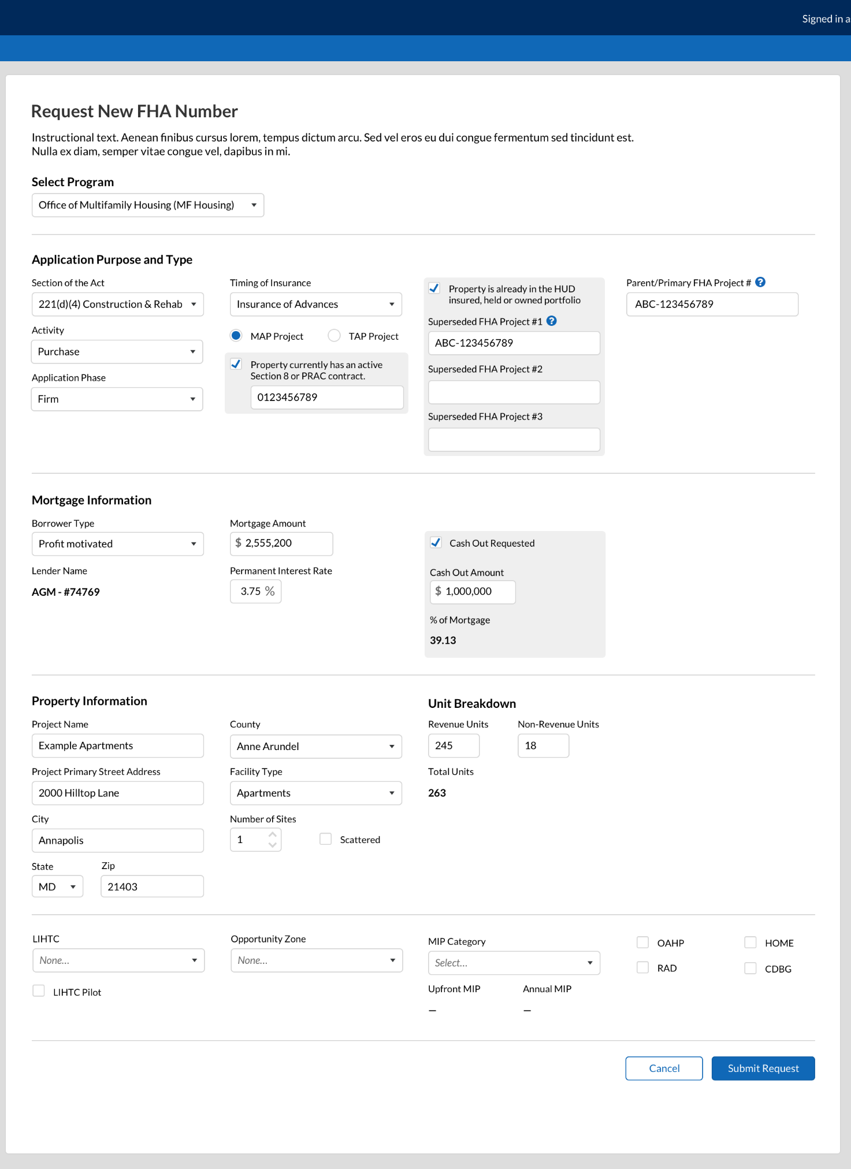
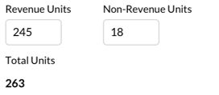
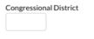
Existing Units
Units Being Added
241(a) Improvement/Addition on 207 Apts
Additions

Field Name | Value
Activity | Purchase
Activity | Refinance
Activity | New Construction
Activity | Rehab
Activity | Improvements
Activity | Additions
Activity | Operating Loss
Timing of Insurance | Insured Upon Completion
Timing of Insurance | Insured Advances
Borrower Type | Condominium
Borrower Type | Investor Sponsor Cooperative
Borrower Type | Limited Dividend
Borrower Type | Management Type Cooperative
Borrower Type | Non-Profit
Borrower Type | Profit Motivated
Borrower Type | Public Body
Borrower Type | Sales Type Cooperative
Facility Type | Asst’d Living
Facility Type | Single-Room Occupancy
Facility Type | Apartment
Facility Type | Coop
Facility Type | Condo
Facility Type | Mobile Home Park
Facility Type | Critical Access Hospital
Facility Type | Sole Community Providers
Facility Type | Other
LIHTC | None
LIHTC | 4% LIHTC / Tax Exempt Bonds
LIHTC | 9% LIHTC
Opportunity Zone | None
Opportunity Zone | Yes, with Qualified Opportunity Fund
Opportunity Zone | Yes, without Qualified Opportunity Fund
MIP Category | Affordable
MIP Category | Broadly Affordable
MIP Category | Green/Affordable
MIP Category | Green/Broadly Affordable
MIP Category | Green/Market
MIP Category | Market
MIP Category | None
**These are combined drop down values for all SOAs. Specific dropdown values are dependent on SOA**

232 Request New FHA Number
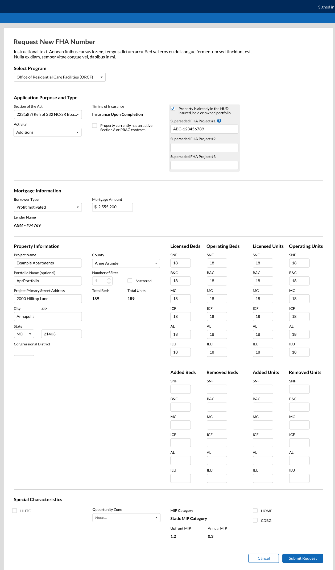
Field Name | Value
Activity | Purchase
Activity | Refinance
Activity | New Construction
Activity | Rehab
Activity | Improvements
Activity | Additions
Activity | Operating Loss
Activity | Additions+Improvements
Activity | Additions+Improvements + Equipment
Activity | Improvements
Activity | Additions
Activity | Additions + Equipment
Activity | Improvements + Equipment
Activity | Equipment
Timing of Insurance | Insured Upon Completion
Timing of Insurance | Insured Advances
Borrower Type | Non-Profit
Borrower Type | Profit Motivated
Opportunity Zone | None
Opportunity Zone | Yes, with Qualified Opportunity Fund
Opportunity Zone | Yes, without Qualified Opportunity Fund
**These are combined drop down values for all SOAs. Specific dropdown values are dependent on SOA**

242 Request New FHA Number
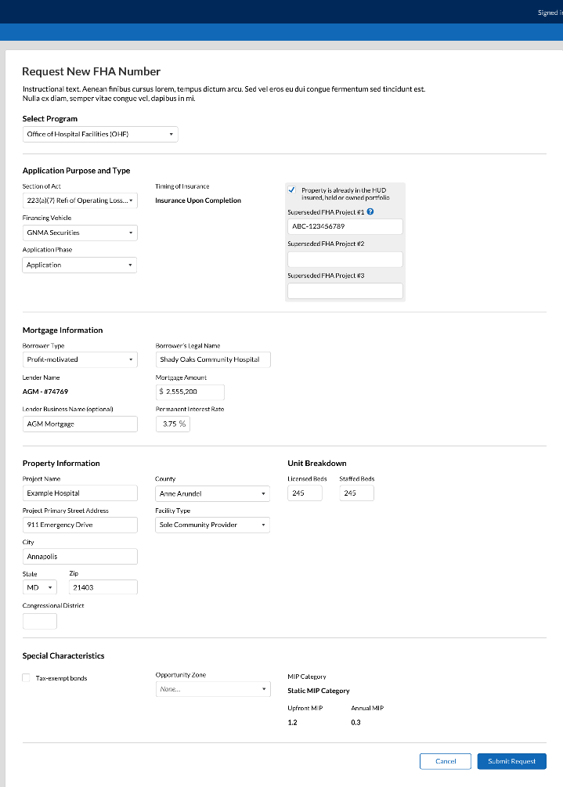

Field Name | Value
Financing Vehicle | Tax-Exempt Bonds
Financing Vehicle | GNMA
Financing Vehicle | Other
Financing Vehicle | Rehab
Timing of Insurance | Insured Upon Completion
Timing of Insurance | Insured Advances
Borrower Type | Non-Profit
Borrower Type | Profit Motivated
Borrower Type | Public Body
Facility Type | Critical Access Hospital
Facility Type | Sole Community Provider
Facility Type | Other
**These are combined drop down values for all SOAs. Specific dropdown values are dependent on SOA**

Upload Application Files against Checklist
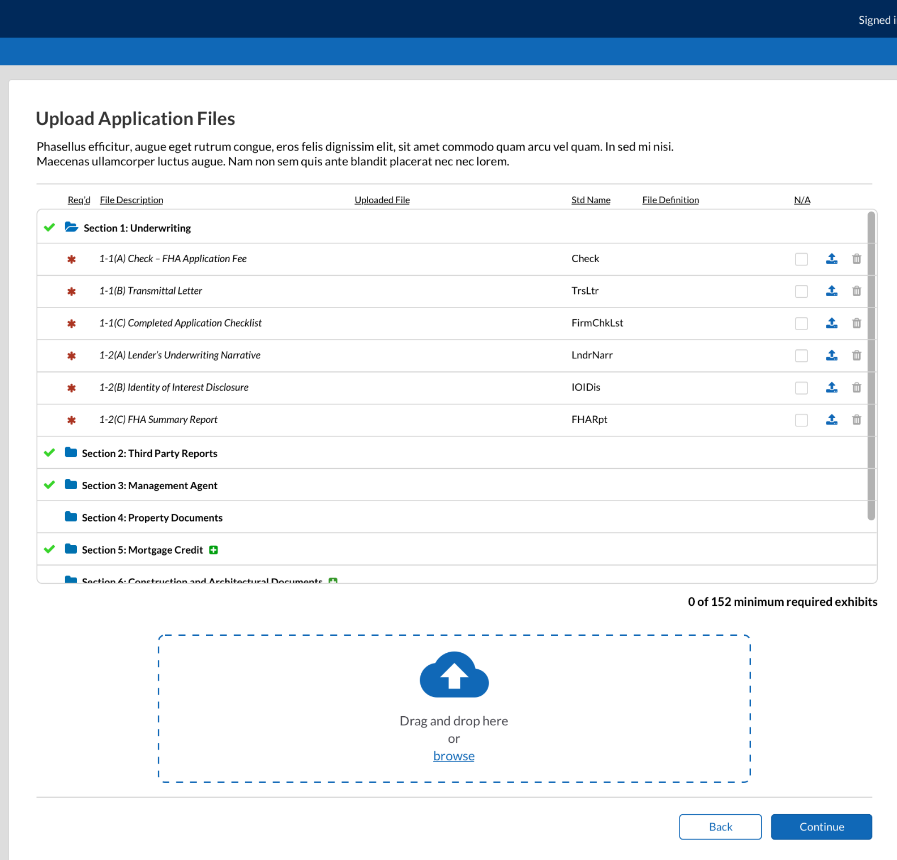

Upload New Concept Package
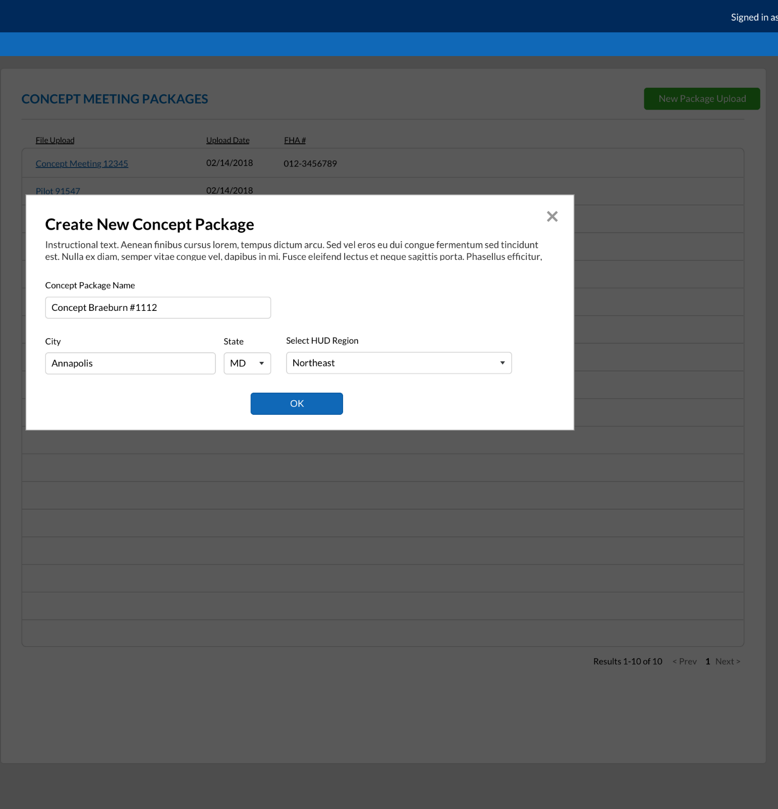

Other Document Type Upload
