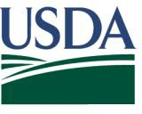

TBD

Dear Agricultural Producer,
United States Department of Agriculture
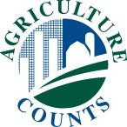
National Agricultural Statistics Service

The U.S. Department of Agriculture’s (USDA) National Agricultural Statistics Service (NASS) is conducting the 2020 Local Food Marketing Practices Survey. Your participation in this survey will help meet the growing need for data on the local foods sector.

Your response is critical, especially given this challenging time. When agricultural stakeholders, local and federal decision-makers, and other data users want to know how this pandemic affected producers and the agricultural industry, it will also help to increase the understanding of this type of business and help evaluate and inform many of the USDA programs that support local food systems, including those provided by:
- Agricultural Marketing Service
- Farm Service Agency
- Food and Nutrition Service
- Risk Management Agency
- Rural Development

Please complete and return your form by May ?, 2021. You may respond in either of the following ways:
- Online at www.agcounts.usda.gov. All you need is the identification number on the enclosed form to begin.
- By mail. Complete the enclosed form and mail it back in the return envelope provided.

To learn more about NASS and the Local Food Marketing Practices Survey, visit www.agcensus.usda.gov. Here you can find answers to frequently asked questions. You can also call (888) 424-7828 or email nass@nass.usda.gov for assistance.
SPECIAL INSTRUCTIONS
Follow these steps if you receive more than one survey questionnaire for the same operation:
- Complete ONLY the GREEN
questionnaire
- Write “DUPLICATE” on the BLUE questionnaire (If the questionnaires are the same color, complete only one and write ‘DUPLICATE’ on the other(s))
- Mail ALL questionnaires back in the same return envelope provided
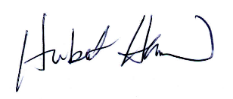
Sincerely,

Hubert Hamer
Administrator, National Agricultural Statistics Service United States Department of Agriculture

Enclosures

