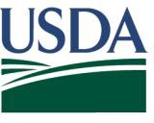

TBD, 2021

Dear Agricultural Producer,

**United States Department of Agriculture**

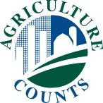National Agricultural Statistics Service

OMB No. 0535-0259: Approval Expires XX/XX/20XX

According to our records, we have not yet received your completed 2020 Local Food Marketing Practices Survey. ***Please take the time to respond now.*** Your participation is vital to help expand the

U.S. Department of Agriculture’s (USDA) National Agricultural Statistics Service (NASS) and the public’s understanding of the local foods sector.

If you have recently responded, thank you. If not, please respond today in either of the following ways:

* **Online** at [www.agcounts.usda.gov.](http://www.agcounts.usda.gov/) All you need is the identification number on the form to begin.
* **By mail.** Complete the form and mail it back in the return envelope provided.

If a response is not received, a representative with USDA’s National Agricultural Statistics Service may follow up with you to gather this information. If you have questions or need assistance, call (888) 424-7828 or email [nass@nass.usda.gov.](mailto:nass@nass.usda.gov)

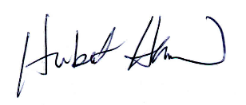Sincerely,

**SPECIAL INSTRUCTIONS**

Follow these steps if you receive more than one survey questionnaire for the **same operation**:

1. Complete ONLY the **GREEN**

questionnaire

1. Write “DUPLICATE” on the **BLUE** questionnaire (If the questionnaires are the same color, complete only one and write ‘DUPLICATE’ on the other(s))
2. Mail ALL questionnaires back in the same return envelope provided

Hubert Hamer

Administrator, National Agricultural Statistics Service United States Department of Agriculture

Enclosures

According to the Paperwork Reduction Act of 1995, an agency may not conduct or sponsor, and a person is not required to respond to a collection of information unless it displays a valid OMB control number. The valid OMB number is 0535-0218. The time required to complete this information collection is estimated to average 30 minutes, including the time for reviewing instructions, searching existing data sources, gathering and maintaining the data needed, and completing and reviewing the collection of information.