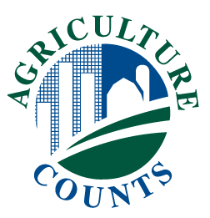
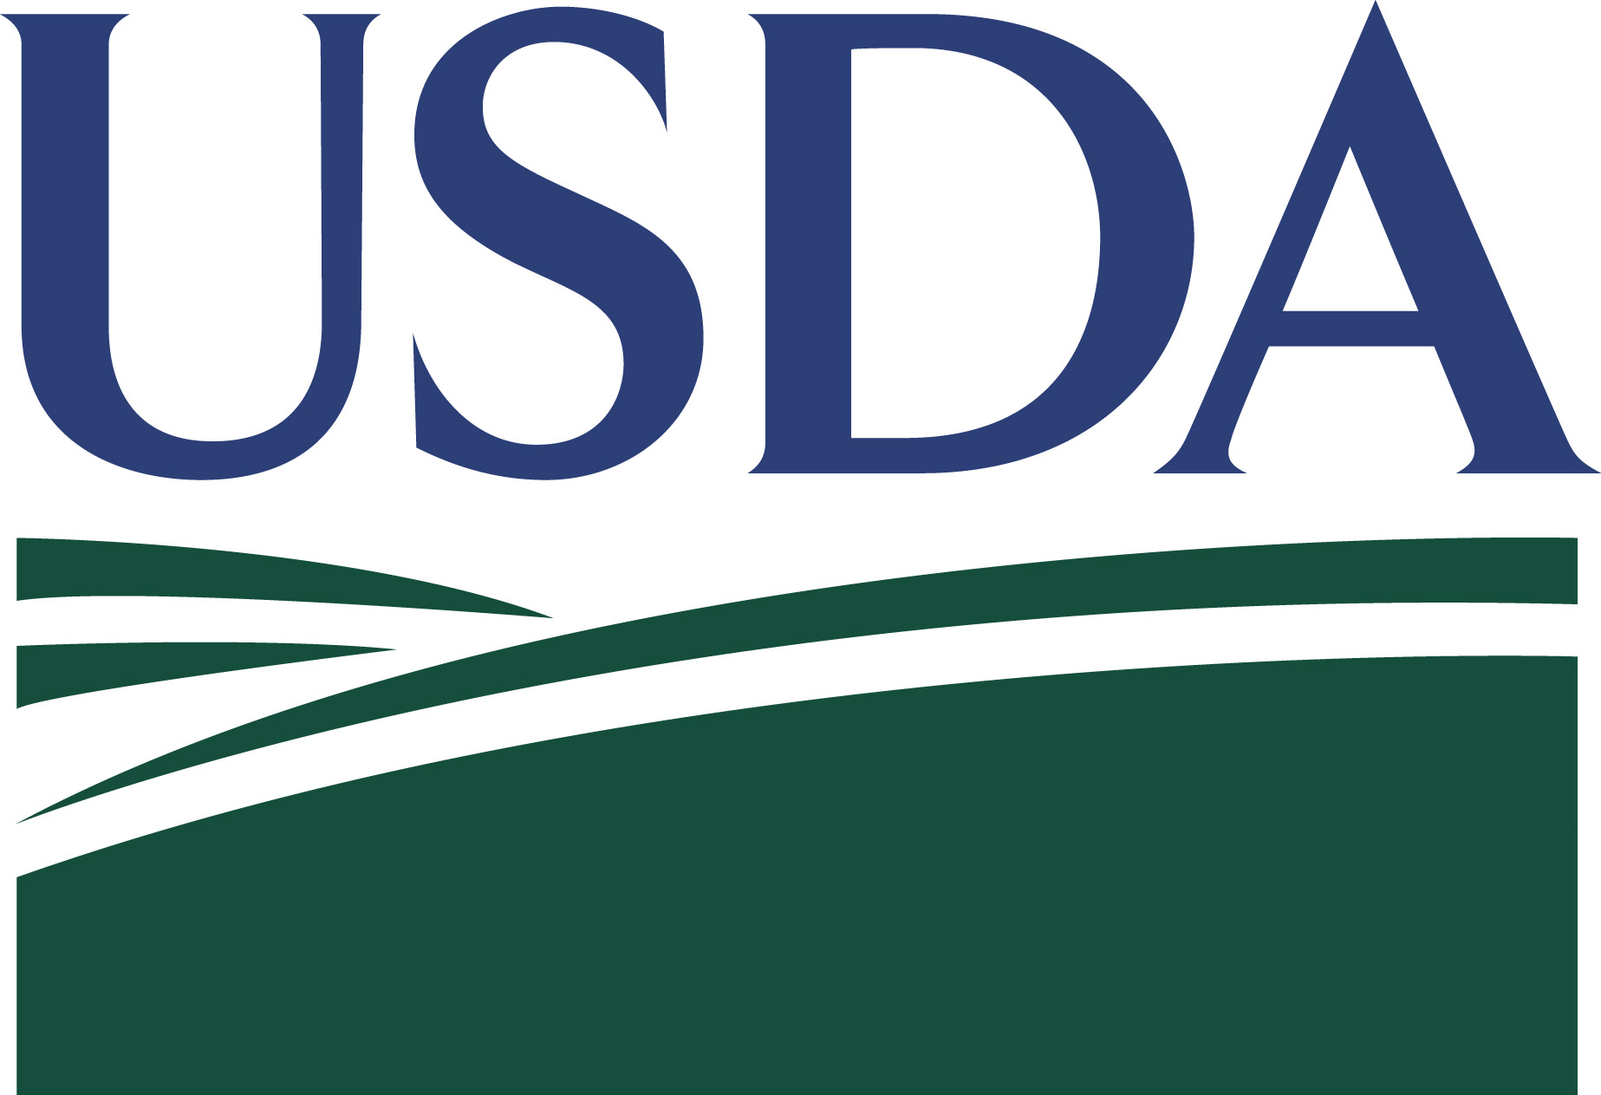
2020 LOCAL FOOD MARKETING PRACTICES SURVEY

United States Department of Agriculture
National Agricultural Statistics Service
This guide gives information on completing your survey form. If you need more help, call 1-888-424-7828, or email nass@nass.usda.gov. The telephone call is free. Once you have completed your survey, please return it in the postage-paid envelope we have provided.

You may respond online at www.agcounts.usda.gov. This method is fast, easy, and secure.

If you do not return your form by February 16th, a second copy will be mailed. If you still do not return a completed form, we will contact you to arrange a telephone or personal interview.

Why should I report? The information to be gathered in the Local Food Marketing Practices Survey is vital to the USDA’s and the public’s understanding of the local foods sector, which in turn informs policymaking and program implementation. The 2018 Farm Bill includes funding for the continuation of the Local Agriculture Market Program, which is administered by the USDA. This survey provides information that will be used by the Farm Service Agency (FSA) to analyze the Noninsured Crop Disaster Assistance Program; the Risk Management Agency (RMA) for their Whole Farm Revenue Protection Program; Rural Development’s (RD) Local Agriculture Markets Program; Food and Nutrition Service’s (FNS) Supplemental Nutrition Assistance Program. The information collected by this survey will also be useful to consumers, other policymakers and stakeholders.

Who Should Report? A reply is needed from EVERYONE who receives a report form, including persons who operated a farm, ranch or other agricultural operation in 2020 as well as those who were not involved in agriculture. More Local Food Marketing Practices Survey information is on the Internet at www.agcensus.usda.gov.
If you were a landlord only and rented out all of your land, complete the front page of the enclosed report form and return it in the preaddressed envelope. If you were a landlord but still operated other land yourself, you should complete the entire report form for that land which you operated.
If you had no land, no livestock, and no agricultural operations, return the report form with a note indicating your status on the front of the form below the address label.
Partial Year Operations - If you stopped farming during 2020, complete the report form for the portion of the year that you did farm. Write “Stopped farming during 2020” and the date you stopped farming below the address area. Mail the completed report form in the return envelope. If the person whose name is on the label was deceased during 2020, complete the form for the portion of the year that was farmed, and write a note.
Involved in More Than One Operation - If you made decisions for more than one operation, you may have received a report form for each operation. Provide information for only the operation name on the label.
Partnership Operation - Complete only ONE form for the entire partnership's agricultural operation and include the entire operation on that one form. If you made day-to-day decisions for more than one partnership operation, complete a report form for each separate operation.
Specialty Commodities - Bees, elk, emus, fish, nursery, maple syrup, etc., are an important part of the agriculture industry. Report for all commodities, regardless of the amount of production or sales you had in 2020.
Received More Than One Report Form for the Same Operation - If you received more than one report form for the same operation, complete only ONE form per operation. Write "DUPLICATE" below the address area of each extra form. Return all forms in the same return envelope with your completed form so that we can correct our records. If you received a green form and a blue form, complete ONLY the green form.

What does the National Agricultural Statistics Service do with the information you provide?
NASS will publish results of 2020 Local Food Marketing Practices survey in the winter of 2021 to provide valuable insight on trends in local food sales in the agricultural economy. Results will be available on the NASS website, www.nass.usda.gov and www.agcensus.usda.gov. Only aggregate level data will be published, so that no individual reports or farm operator information will be disclosed in the summary data. The information will be available to everyone from the general public to your leaders from government, business, and non-profit organizations to have more information when considering local foods policy and program decisions.

How was this address selected?
Your address was scientifically selected to represent other local food producers in your community. As part of a sample, you represent many other people. Food producers from all 50 States have been selected to participate in this very important survey.

Is it safe to provide my information over the Internet?
Yes. The 2020 Local Food Marketing Practices survey is encrypted at all times. Our secure servers ensure the encrypted transmission of data between your browser and the National Agricultural Statistics Service. This means your browser and our server encode or scramble all data using a security key.

What do these terms in the survey mean?
Operation: | A farm or ranch, a piece of land, or a structure where production takes place and an agricultural product is grown or raised.
Produced and Sold: | An agricultural product that is grown or raised by an operation and is also sold by that same operation.
Food: | Edible agricultural products for humans to eat or drink in its current state.
Selling Food Directly: | The first point of sales of the food produced and sold by an operation.
Production Contract: | A verbal or written agreement setting term, conditions, and fees paid by the contractor to the operation for the production of crops or livestock. The contractor owns the product being grown or raised and often provides inputs.
Online Marketplace: | A web-based platform designed for selling goods and processing financial transactions.

What are the four channels for marketing food directly?

Consumers: | (Individuals who purchase your products from farmers’ markets, on-farm stores or farm stands, roadside stands or stores, CSA (Community Supported Agriculture), and online marketplaces.
Retail Markets: | Supermarkets, supercenters, restaurants, caterers, independently owned grocery stores, and food cooperatives
Institutions: | K-12 schools, colleges or universities, hospitals, workplace cafeterias, prisons, and foodbanks
Intermediate Markets: | Businesses or organizations in the middle of the supply chain that market locally- and/or regionally-branded products, such as distributors, food hubs, brokers, auction houses, wholesale and terminal markets, and food processor)

Instructions by Section

Face Page – Answer the questions about whether you produce agricultural products on your farming/ranching operation, and whether you sell food products directly to consumers, retail establishments, institutions or an intermediate market. If you check “NO” to all questions on the face page, please turn to page 18, the last page, fill out your name and phone number, and return the form in the prepaid envelope provided. If you have any questions about the survey, please call 1-888-424-7828, or email nass@nass.usda.gov. Exclude crop and livestock production under production contract.

Section 1-4 Sales – Report the value of edible agricultural products for human consumption this operation produced and sold through the appropriate direct marketing channel. Report only the first point of sale, even if that sale was to another farm or business you also own. Exclude sales of products that were not for human food or drink such as animal feed, wool, nursery and flowers not intended for human consumption. Include sales to USDA through programs that distribute locally (e.g., USDA Food Box Program) as direct sales to an institution. Report sales completed in 2020 regardless of the year production was harvested or raised. Report the gross value of sales before the deduction of expenses, marketing fees, or taxes. Include as sales your estimate of the value of any crop or livestock bartered directly to consumers for services or other goods. Report in whole dollars only. If you sell in more than one direct-to-consumer marketing channel, please report sales of each marketing channel separately in the tables at the end of sections 1-4. Exclude crop and livestock production under production contract.
- Fresh Fruit and Vegetable Sales – Report the value of the fresh fruits and vegetables sold as food for human consumption in 2020 in the appropriate category. Also include crops such as grains, tea, coffee, and any agricultural products that are unprocessed for human consumption in this column. Report the sales in 2020 regardless of the year crops were harvested or raised. Include the value of your landlord’s share of the commodities harvested. Report the gross value before the deduction of expenses or fees.

- Meat, Farmed Seafood, and Egg Sales – Report the value of meat, farmed seafood and eggs sold by this operation for human consumption in 2020. Include food items sold in their unprocessed state, such as farmed clams, oysters, soft-shelled crabs, and bulk sales of honey. Some farms offer hunting or fishing for a fee. If this farm sells only whole game animals or fish, those transactions are not included. If this farm raises the game or fish and processes the game or fish into meat, those transactions are included as value added. Fee hunting and fishing operations on farms are in the category of “other direct-to-consumer markets” in Section 1. Include the value of your landlord’s share of the commodities produced. Report the gross value before the deduction of expenses or fees.

- Milk and Dairy Product Sales – Report the value of milk and dairy products, such as butter, cheese, and yogurt, sold by this operation for human consumption in 2020. Include the value of your landlord’s share of the commodities produced. Report the gross value before the deduction of expenses or fees.

- Other Processed Food Product Sales – are products that have been altered or packaged before being sold to the consumer. Include canned or preserved vegetables, jam, jelly, wine, juice, cider, and meats. Include only those commodities which the initial agricultural commodity was produced on this operation. For example, if wine was produced from grapes purchased from another operation do not include it. If the grapes were produced on this operation, then the value of sales for wine produced from grapes grown on this operation should be reported.

Section 1, item 7 – Include stores or farm stands located on this operation. Exclude stores or farm stands not located on this operation.

Section 1, item 8-9 – If you operate more than one on-farm store report yes in question 8, if any of these stores/stands sells food produced by another operation. In question 9, report for all on-farm stores/stands combined.

Section 1, item 10 – Include stores or farm stands that are not located on this operation. Exclude stores or farm stands located on this operation.

Section 1, item 12-13 – If you operate more than one off-farm store report yes in question 12, if any of these stores/stands sells food produced by another operation. In question 13, report for all off-farm stores/stands combined.

Section 1, item 15 – If you operate more than one off-farm store report for the store with the highest gross value of food sales in 2020.

Section 1, item 16-18 – If you sell to more than one CSA, report yes in question 16. If any of these CSAs sell food produced by another operation, report yes in question 17. In question 18, report for all CSAs combined.

Section 1, item 21 – Report yes if you have ownership in any CSA through which you sold food your operation produced.

Section 1, item 24 – Report yes if you have ownership in any online marketplace through which you sold food your operation produced.

Section 1, items 25 and 28; Section 2, item 8; Section 3, item 10; Section 4, item 6 – Report the first year that this operation used the marketing practice listed. If there have been gaps in the use of
this marketing practice, report the most recent return to the practice if the gap exceeded five years.

Section 5, item 1 – Report by category the total value of all local food sales reported in Sections 1-4. The total reported should represent the sum of items reported in Section 1, item 29, Section 2, item 9, Section 3, item 11, and Section 4, item 7.

Section 5, item 2 – Report the percentage of all local food sales reported in Sections 1-4 by distance from operation. Items 2a, 2b, and 2c must sum to 100%.

Section 5, items 5-6 – Include all land on this operation, not just the portion used for directly marketed production.

Section 5, item 7– Check yes or no in columns 2 and 3 to determine whether any of the crop and livestock categories in column 1 were produced and sold, regardless of marketing channel. Exclude any crops and/or livestock sold under production contract.

Section 5, item 8 – Check the code that represents your total gross value of sales. Exclude value added sales, but include the value of commodities used in value added production.

Section 5, item 9 – Include all farm expenses paid by you and/or your landlord(s) for crops, livestock, or poultry produced on this operation in question 9. Include expenses incurred in 2020 even if they were not paid in 2020. Estimate if exact figures are not known. Include marketing expenses in item 9, which include expenses incurred from value added production. Marketing expenses are also itemized in item 10.

Sections 6 and 7 – Report practices used, particularly program participation, certifications by the USDA or other organizations, and food safety audits/plans used by the whole operation.

Section 8 – Report in this section the characteristics of the persons who make the day to day decisions for your farm or ranch. In item 2, report the total number of persons making day to day decisions, including both the men and women. Do not report as operator’s minor-aged children who work on the farm. In item 3, answer questions about those people for up to 4 operators. If there are more than 4 operators, answer for the 4 that make most of the day-to-day decisions for the operation. For number of years farming, include only years over the age of 16.

Section 9 – Report in this section the impact you perceive COVID-19 has had on your operation for 2020 as compared to 2019. These affects could have included farm sales, online sales, pre-ordering of agricultural products, and marketing expenses.

