Appendix L.
Sample Follow-Up Email to State Agencies

Good Morning,
Thank you for submitting the April WIC participant characteristic data for [STATE]. The diagnostic tables have been prepared and reviewed. Attached you will find some suggestions and questions raised during an evaluation of the tables. Relevant tables have also been included for ease of review.
After you have a chance to review the questions and the tables, we would appreciate your feedback, which you may provide via email or in a brief conference call during which we will answer any questions you may have. Please respond by [DATE] or let me know when we can schedule a conference call within the next week. I can be reached by phone at [ANALYST PHONE] or by email at [ANALYST EMAIL].
Sincerely,
[ANALYST SIGNATURE]

This information is being collected from State agencies to enable the Food and Nutrition Service (FNS) to prepare biennial reports on WIC participant and program characteristics. This is a mandatory collection authorized under 7 CFR §246.25(b)(3). FNS uses the data from these reports to estimate budgets, submit civil rights reporting, identify needs for research, and to develop and review WIC policies and procedures. Under the Privacy Act of 1974 and the System of Record Notice FNS-8 USDA/FNS Studies and Reports, any personally identifying information obtained will be kept private to the extent of the law. According to the Paperwork Reduction Act of 1995, an agency may not conduct or sponsor, and a person is not required to respond to, a collection of information unless it displays a valid OMB control number. The valid OMB control number for this information collection is 0584-0609. The time required to complete this information collection is estimated to average 30 minutes per response, including the time for reviewing instructions, searching existing data sources, gathering and maintaining the data needed, and completing and reviewing the collection of information. Send comments regarding this burden estimate or any other aspect of this collection of information, including suggestions for reducing this burden, to: U.S. Department of Agriculture, Food and Nutrition Services, Office of Policy Support, 3101 Park Center Drive, Room 1014, Alexandria, VA 22302, ATTN: PRA (0584-0609*). Do not return the completed form to this address.
The document below is a sample of the issue memo sent with the follow-up email. The issue memos have copies of diagnostic tables and additional materials attached illustrating each WIC SA’s specific issues in the data.


Memorandum
Date: [DATE]
To: [WIC SA PC CONTACT]
CC: [ADDITIONAL WIC SA STAFF]
From: [ANALYST], Insight Policy Research
Subject: [STATE]’s WIC PC[YEAR] Data Submission

Thank you for submitting the April WIC participant characteristics data for [STATE]. We have thoroughly reviewed the data and would like to discuss some aspects of the submission with you. These issues are described below, and the relevant tables have been attached. Please let me know when we can schedule a conference call to discuss the data submission and any next steps we might take. I can be reached at [ANALYST PHONE] or [ANALYST EMAIL].
Transmittal Worksheet
We noticed [STATE] has not yet submitted the transmittal worksheet. We have attached a copy for your reference. Please submit this information as soon as possible.
Caseload and Participation: Tables 2 and 3
FNS reports [STATE]’s WIC participation level at 16,922. This represents the number of participants in [STATE] who were issued benefits in April [YEAR]. The current caseload reported by [STATE]’s PC2018 data is 18,963. This indicates a nonparticipation rate of 11 percent, which is higher than expected. Is this a typical monthly nonparticipation rate for [STATE]?
The PC2018 data submission includes data for 18,963 participants, while the PC2016 data submission includes information for 21,270 participants. This is a decrease of 11 percent in [STATE]’s caseload (see table 3), which is larger than expected. Is this consistent with what you have seen in [STATE]?
Certification Category by Age: Table 7
Table 7 shows infant and child participants’ ages on the day of certification. We expect most child participants to be certified as children after their first birthday (12 months old). However, table 7 shows over 5 percent of child participants were certified as children at 11 months old. Please describe any policies that would explain this high percentage of 11-month-olds certified as children.
Local Agency Reporting: Table 10 and [STATE]’s WIC LAD
The Local Agency ID is the unique number of the local agency where the participant was certified as eligible for WIC benefits. Table 10 lists the reported caseloads assigned to each of the local agencies within [STATE]. In this table, 15 different agencies that had a caseload reported are not currently identified as agencies in the WIC Local Agency Directory (LAD); these are indicated in red boxes. Should these cases be assigned to other local agencies? We include a copy of [STATE]’s WIC LAD.
15 local agencies did not have a caseload reported; these are indicated in blue boxes. We expect that each local agency reports a caseload. Please observe that the number of local agencies who did not submit a caseload (15) matches the number of local agencies with caseloads but not included in the LAD. Can [STATE] verify if some of the caseloads reported to other agencies belong to the agencies that did not report a caseload?
Participation in Medicaid: Table 28
For PC2018, the data show no WIC participants also participate in Medicaid. Is this a true reflection of participation levels for WIC participants in [STATE] or can [STATE] improve this data reporting?
Income or Income Range – Table 38
No participants have $0 income. Does [STATE] truly have no participants with $0 income, or are there any reasons for this missing data? Moreover, approximately 8 percent of participants reported an income of $1. A numeric value of 1 should indicate an actual dollar amount, not missing data. Please let us know if these income values are $1 or if they may indicate missing values or participants without income.
Nutritional Risk Codes – Tables 41 and 44
Several nutritional risk codes in [STATE]’s data (135Z, 352Z, 411.0, 425.0, and 427.0) were not included on the nutritional risk crosswalk submitted prior to data collection. Do these codes correspond to standard FNS Nutritional Risk codes, or should they be removed from the data?
More than half of infants and children are missing a second nutritional risk code. We expect most infants and children to have more than one nutritional risk code. Please describe any factors or policies that could contribute to these high missing values for infants and children.
Date Breastfeeding Data Collected – Table 84
This table displays data on infants and children who were 6 to 13 months old in April [YEAR]. Within this group, 21 percent of the infants and children who were reported to be currently breastfeeding were between 0 and 4 months of age when breastfeeding data were collected, including 9 percent for whom this information was collected at birth. This indicates that the breastfeeding information is old and will likely provide an inaccurate estimate of breastfeeding duration in [STATE]. Is [STATE] able to report a date that more accurately reflects when the breastfeeding data were collected or confirmed for these infants and children?
Food Package Codes – Table 87a
Food package prescriptions should be reported for all participants (except breastfeeding women and infants who do not receive a food package). Nearly 15 percent of [STATE]’s participants are missing food package code data. Please explain what accounts for these missing data.

Data Worksheet for Transmitting
April 2020 Data Files

WIC Participant and Program Characteristics 2020
April 2020 data submissions should be sent to Insight as soon as possible after April 2020 and no later than July 17, 2020. Only complete data files should be submitted. Therefore, a State agency that expects to receive updated data after April 2020 for income, breastfeeding, participation, or other data fields should submit its data file only after entering this additional information. Include this completed worksheet with the April data submission.
- State agency:
- Name, title, phone number, and email address of the person able to answer questions regarding the State agency’s data submission:
Name:
Title:
Telephone:
Email:
- April data file specifications:
- Number of participant records:
- Maximum record length:
- Was racial/ethnic data reported using the three-digit code, the series of six yes/no questions, or another format? Check only one answer.
Three-digit code provided in guidance
Series of six yes/no questions
Other format (describe):
- Breastfeeding data collection procedures:
- When was breastfeeding data collected? Check all that apply.
At issuance
At certification/recertification
During health care appointments
At nutrition education sessions
Separate telephone or mail inquiry
Other (describe):

- Was breastfeeding data collected? Check only one answer.
Only on infants aged 6 to 13 months in April 2020
On infants aged 6 to 13 months when data are collected
All infants
Other (describe):

- Is breastfeeding data collected routinely or only for the biennial PC reporting? Check only one answer.
Routinely Only for PC reporting
- Does the State agency’s automated data system maintain the most recent breastfeeding information? Check only one answer.
Yes No
- Were food package code translations submitted for the types and amounts of WIC foods prescribed? Check only one answer.
Food package translations . . .
Are enclosed
Were already sent
Will be sent under separate cover
- Were food code data submitted using food package codes, an item/quantity format, or another format?
Food package codes (up to 14 codes with no more than 10 digits per code)
Item-quantity format
Other format (describe):
- Was food package type reported using the specified codes 1 through 28 or another format?
Used specified codes 1 through 28
Other format (describe):
Supplemental Dataset items submitted for PC2020:
Date of first WIC certification
Education level
Number in household on WIC
Date previous pregnancy ended
Total number of pregnancies
Total number of live births
Prepregnancy weight
Weight gain during pregnancy
Birth weight
Birth length
Participation in Food Distribution Program on Indian Reservations
- Were Service Site IDs reported in the data?
Yes No
- Management Information System (MIS) details:
- Please provide the name of the MIS used to collect and submit the PC2020 data.

- Has the State agency changed its MIS since the PC2018 data collection? If yes, please provide the name of the previous and current MIS.

- Other information:

Please send files and documentation to Insight’s Secure File Transfer Protocol (FTP) site. Instructions follow; these will be provided separately to the State agency along with username and password:
- Insight recommends sending files through our SFTP site.
- Navigate to https://connect.insightpolicyresearch.com.
- Enter your username (will be provided separately).
- Enter your password (will be provided separately).
- Upload the file.
Email questions to PC2020@insightpolicyresearch.com
By submitting your WIC PC data, you certify that these data are complete and accurate
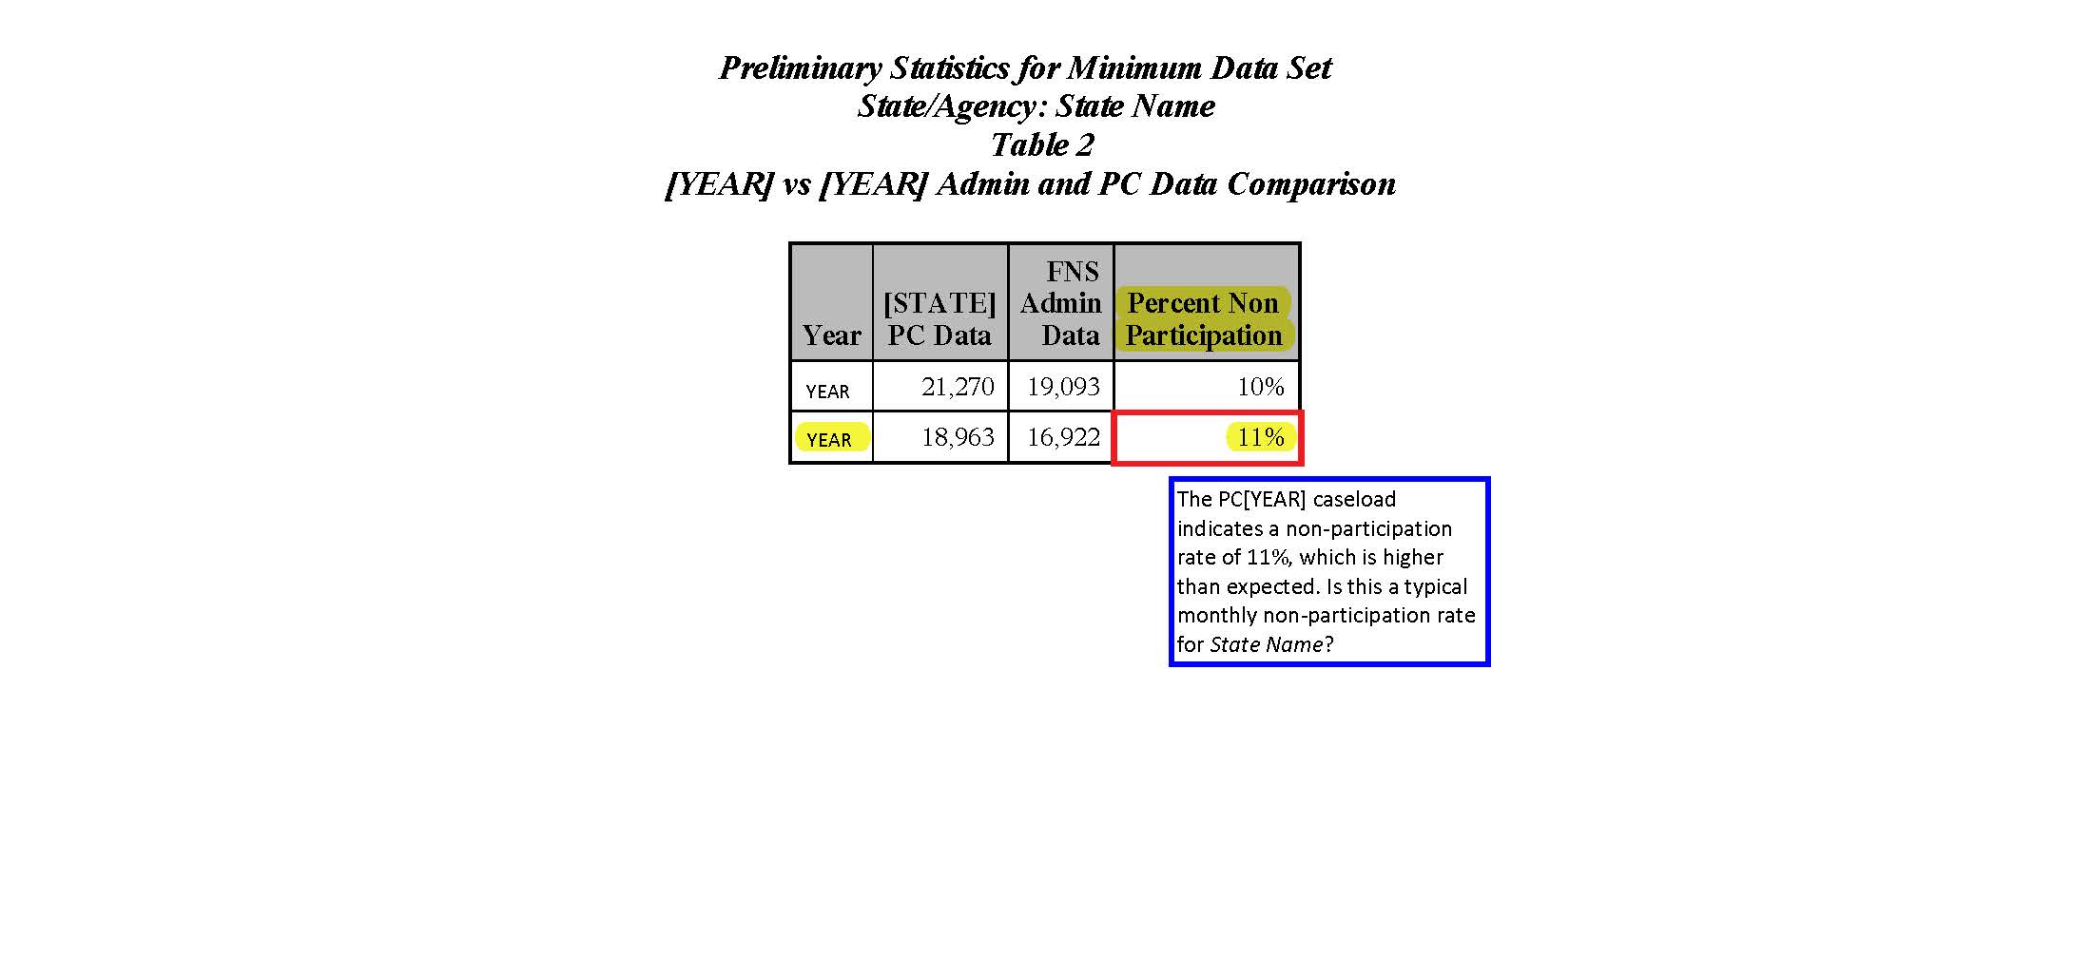

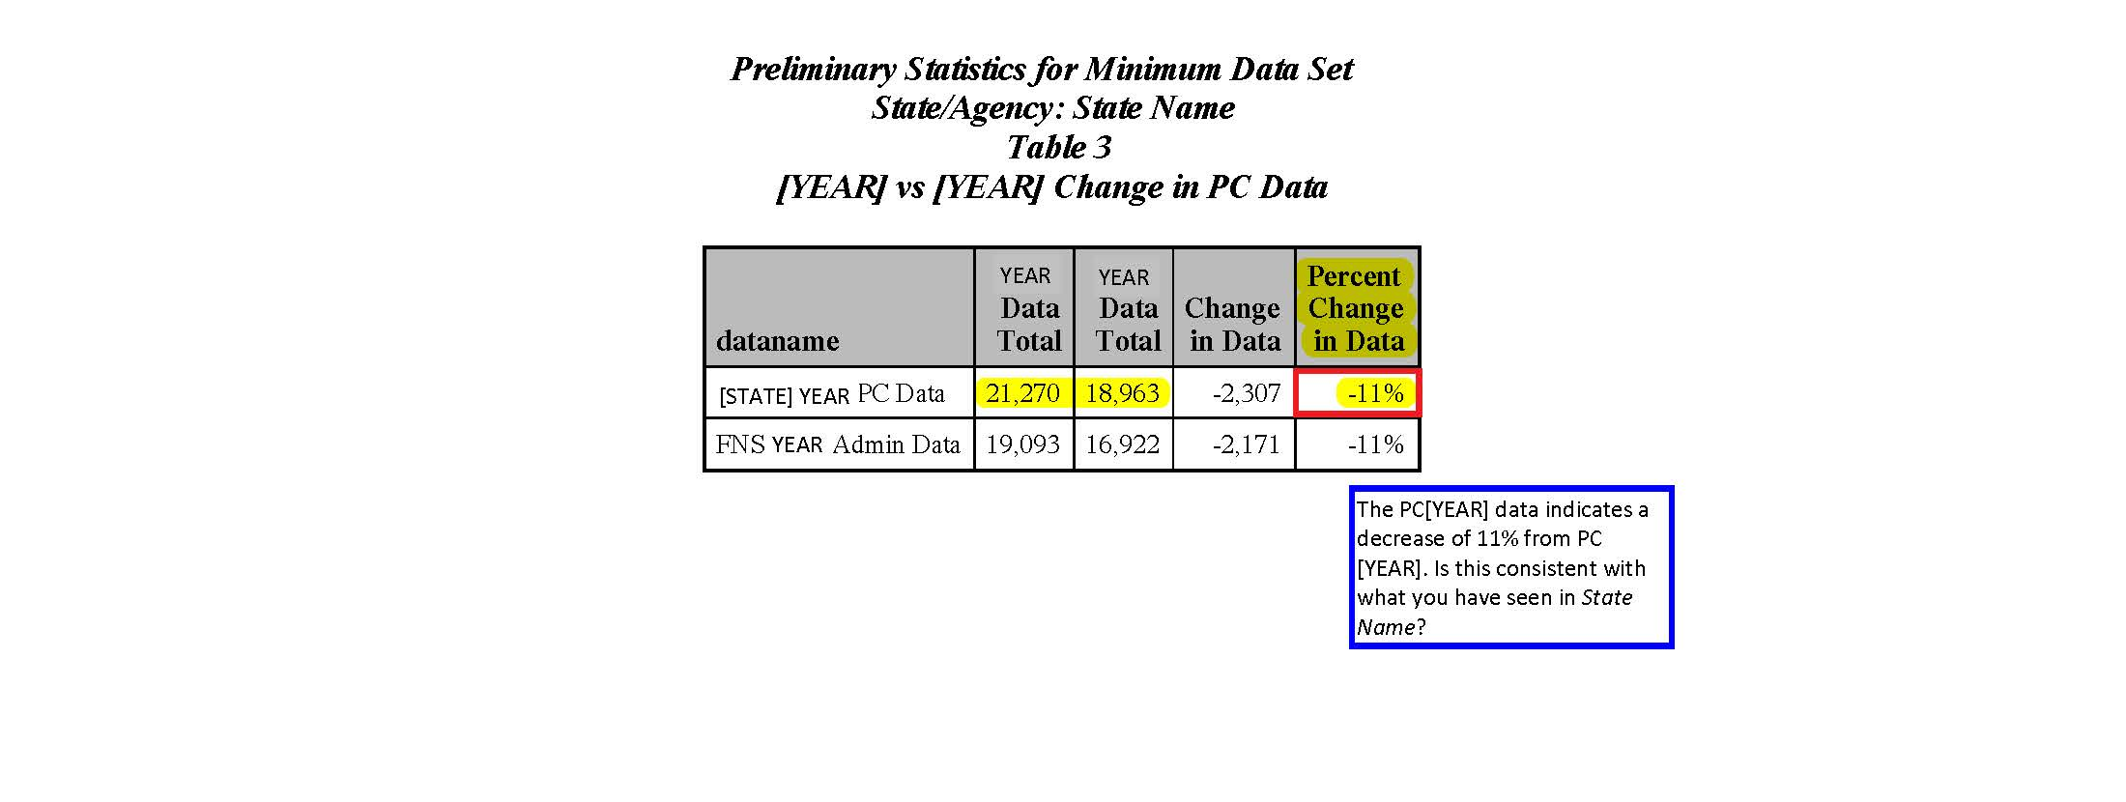

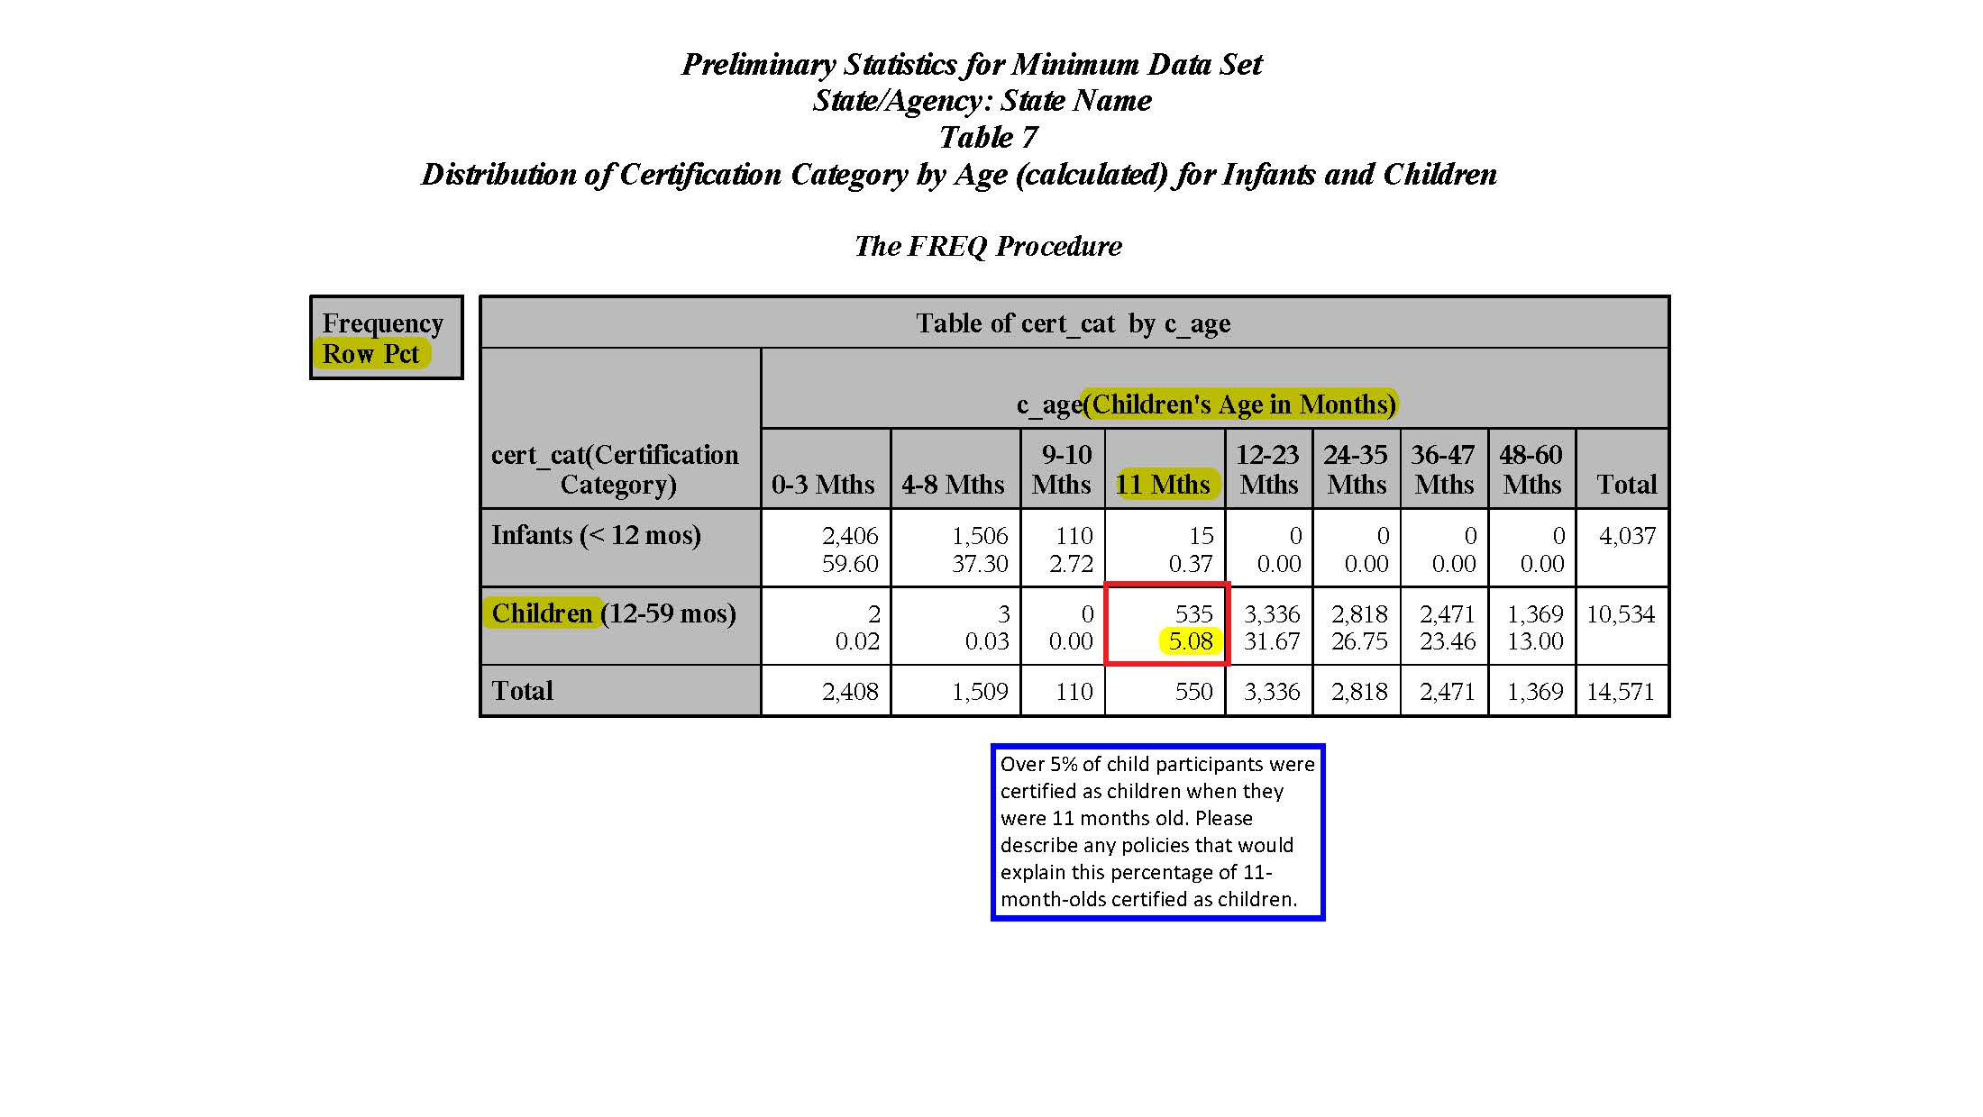

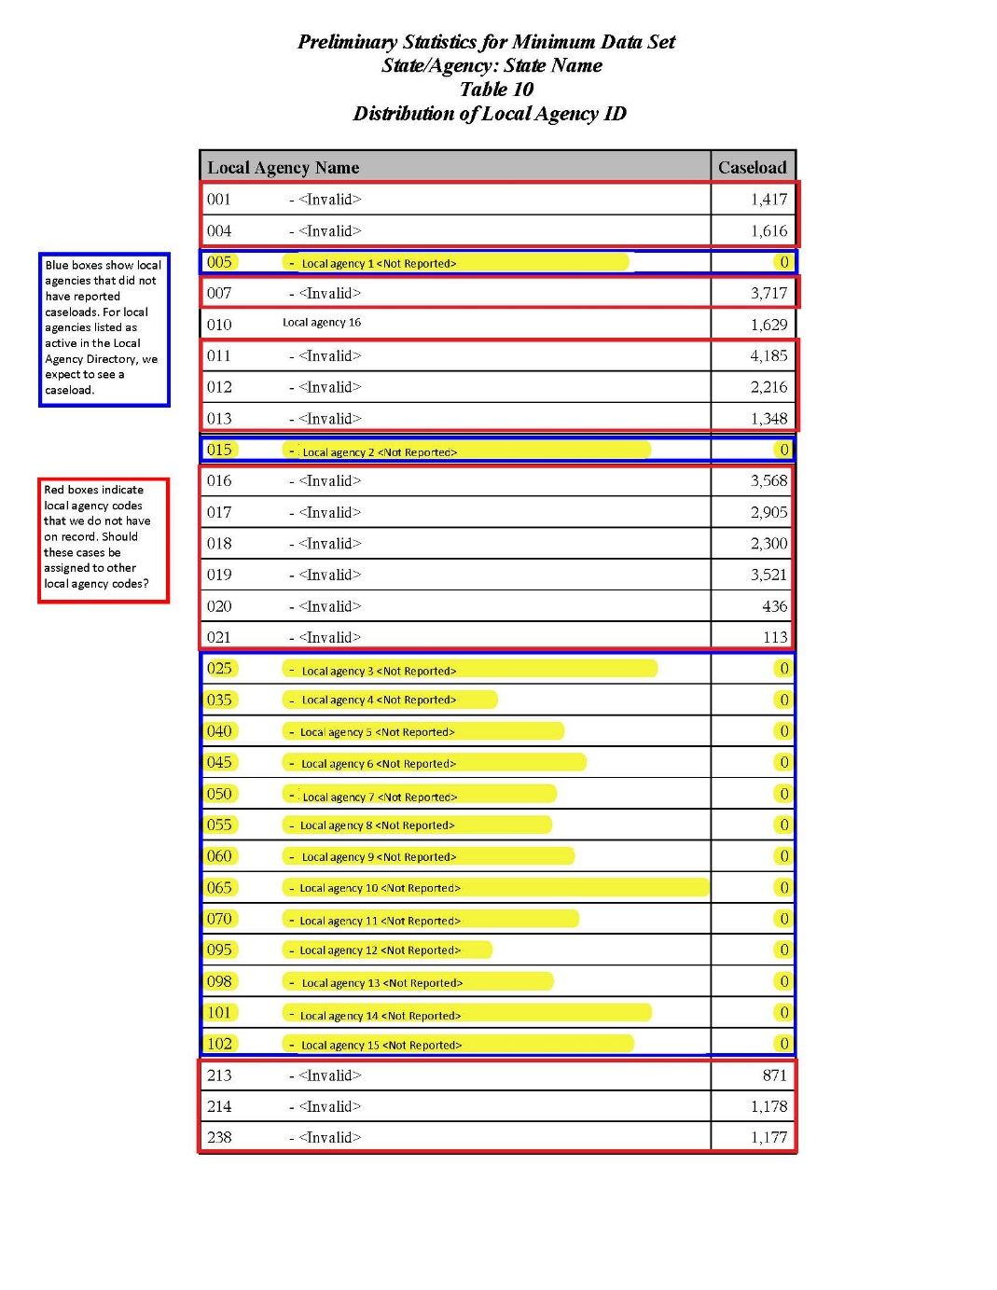

[STATE] WIC LAD
Local Agency Number | Local Agency Name
005 | Local agency 1
010 | Local agency 16
015 | Local agency 2
025 | Local agency 3
035 | Local agency 4
040 | Local agency 5
045 | Local agency 6
050 | Local agency 7
055 | Local agency 8
060 | Local agency 9
065 | Local agency 10
070 | Local agency 11
095 | Local agency 12
098 | Local agency 13
101 | Local agency 14
102 | Local agency 15

