SUPPORTING STATEMENT
U.S. Department of Commerce
National Oceanic & Atmospheric Administration
Marine Recreational Fishing Expenditure Survey
OMB Control No. 0648-0693

B. COLLECTIONS OF INFORMATION EMPLOYING STATISTICAL METHODS

1. Describe (including a numerical estimate) the potential respondent universe and any sampling or other respondent selection method to be used. Data on the number of entities (e.g., establishments, State and local governmental units, households, or persons) in the universe and the corresponding sample are to be provided in tabular form. The tabulation must also include expected response rates for the collection as a whole. If the collection has been conducted before, provide the actual response rate achieved.

The data collection is aimed at saltwater or “marine” recreational anglers in the coastal states within the contiguous U.S., Hawaii, and Alaska who have taken saltwater fishing trips in a 12 month period and spent money on either trip related expenditures or durable goods expenditures (e.g. those items that last for more than one trip). The survey will be conducted in two phases. One phase will focus on trip expenditures and the second on annual durable good expenditures. To accurately capture trip based expenditures, there is a need for a sample of “angler trips” – where an angler trip is defined as any or all of a 24 hour period spent fishing. The best sampling frame for angler trips is based on anglers intercepted during or after a fishing trip. To capture the population of anglers making trips, the trip expenditure phase of the survey will use an add-on set of questions to the basic angler intercept survey conducted by NOAA Fisheries and approved under OMB Control No. 0648-0659 (APAIS survey) along the Atlantic and Gulf Coasts (Maine to Mississippi). The APAIS is stratified to produce estimates for each of three fishing modes: shore trips, private boat trips, and for-hire (e.g. charter and headboat trips). Trip expenditure estimates will be produced separately for the three modes of fishing.

For states that do not participate in the APAIS, we will use NOAA Fisheries’ National Registry of Saltwater Anglers along with state angler license frames for the trip portion of the expenditure survey and for all states for the durable goods portion of the survey. These license files have contact information for anglers who purchased a saltwater fishing license, including mailing address, phone numbers, emails in some cases, license types, angler names. Each state will have its own sample frame and there will be three strata for each mode of fishing (for-hire, private boat, and shore). For Hawaii, in addition to the National Registry of Saltwater Anglers (which has very few anglers in the state registered), registered private boat owners who indicated on the boat license that they use their boat for recreational fishing will be used as a sample frame for private angling trips. Angler intercepts will be done with charter anglers in Hawaii to collect mail and email contact info for the mail/web instrument. as described in more detail in Supporting Statement A. The total number of licenses forming the sample frame for trip expenditures is approximately 3.96 million. For the Highly Migratory Species (HMS) trip expenditures, the HMS recreational permit files will be used that has contact information for permit holders. The sample size for HMS will be stratified into 4 regions (New England, Mid-Atlantic, Southeast Atlantic, and Gulf of Mexico). For the durable good portion of the survey, respondents will be stratified by state of fishing license and by residents and non-residents or stratified by regions within the HMS permit frame. The sampling frames will be cleaned to remove duplicates. Total number of licenses across all states other than Hawaii total around 7.8 million. Table 1 describes data on each stakeholder entity.

Across all states in the APAIS sample, response rates for the 2016/2017 intercept based trip expenditure phase of the survey was 76%. For the license based state samples, AAPOR3 response rates from the most recent survey implementation for a dual web/mail mode averaged around 28% after taking into account refusals, undeliverable surveys, deceased, and ineligible/assumed ineligible anglers (those who had not gone saltwater fishing during survey time frame).

Table 1. Intercept based sample
Column A.  Respondent Entity | Column B.  Number of Entries in Sampling Frame (number of MRIP APAIS interviews per year) | Column C.  Response rate from previous economic add-on surveys to APAIS | Column D.  Expected number of respondents  (Column B * 75.593%)
Trip Expenditures, Intercept survey for states from Maine to Alabama. | 86,891 | 76%* | 65,684
*Rounded value.
Table 2. Web/mail based sample
Column A.  Respondent Entity | Column B.  Number of Entries in Sampling Frame | Column C.  Minimum observations required to estimate true population value using proportional sampling rate for each strata² (see Equation 1) | Column D.  Sample size required under assumption of 28% response rate  (Column C / 28%) – Number mailed out | Column E.  Sample size with 15% Buffer  (Column D * 115%) – Number mailed out with buffer
Trip Expenditures web/mail (CA, OR, WA, TX, LA, AK, HI)¹ | 3,963,259 | 5,838 | 20,850 | 23,978
HMS Trip Expenditures | 19,738 | 1,112 | 3,971 | 4,567
Durable Good expenditures (22 states and HMS)³ | 7,806,176 | 12,788 | 45,671 | 52,522
Total | 11,789,173 | 19,738 | 70,492 | 81,067
¹ n = 278 is the minimum number of observations required for true population estimate per strata. Assumes 3 trip modes/strata per state and 4 regional strata for HMS trips.
² proportional sampling rate per strata = 0.0638%.
³ Two strata per state, residents and non-residents.

2. Describe the procedures for the collection, including: the statistical methodology for stratification and sample selection; the estimation procedure; the degree of accuracy
needed for the purpose described in the justification; any unusual problems requiring specialized sampling procedures; and any use of periodic (less frequent than annual) data collection cycles to reduce burden.

For the intercept based trip expenditure portion of the survey, the sampling design will follow the procedures described for the APAIS survey approved under OMB Control No. 0648-0659, which is a multi-stage, stratified cluster sampling design that is based on fishing effort at available public access fishing sites within coastal counties within coastal states. The sample is stratified by state, two-month wave, type of day (weekday or weekend) and fishing mode (for-hire boats, private boats, and shore). The primary sampling unit is a specific site-day combination within a state and wave. For the shore mode, secondary sampling units are anglers; for the boat modes, secondary sampling units are boat trips and tertiary units are anglers. For more information on the statistical design, please see the supporting statement for OMB Control No. 0648-0659, included as a supplementary document. All anglers 16 years of age and older who complete the basic catch portion of the APAIS are eligible for the economic add-on.

A stratified random sample will be used to draw the sample population from the angler license frames for the durable good portion of the survey and for the trip expenditure portion of the survey for those states which do not participate in the angler intercept surveys. The allocation method for each of the l strata (Respondent Entity) will be a proportional allocation (n₁/N₁ = n₂/N₂…n_{l} /N_{l} ). This allocation method is appropriate when unequal variances for each stratum are assumed, which NOAA Fisheries assumes to be true for stakeholder entities in the frame (Rice 1995). Note that each state is represented within each l strata. The survey instrument provided is an example of a state specific survey (only variation among states is the state name and reference to the state of expenditure). Following Equation 1 (Yamane 1967) approximately 278 observations are required to represent the true value for a population of > 100,000, assuming a +/- 6% precision rate,

Equation 1. 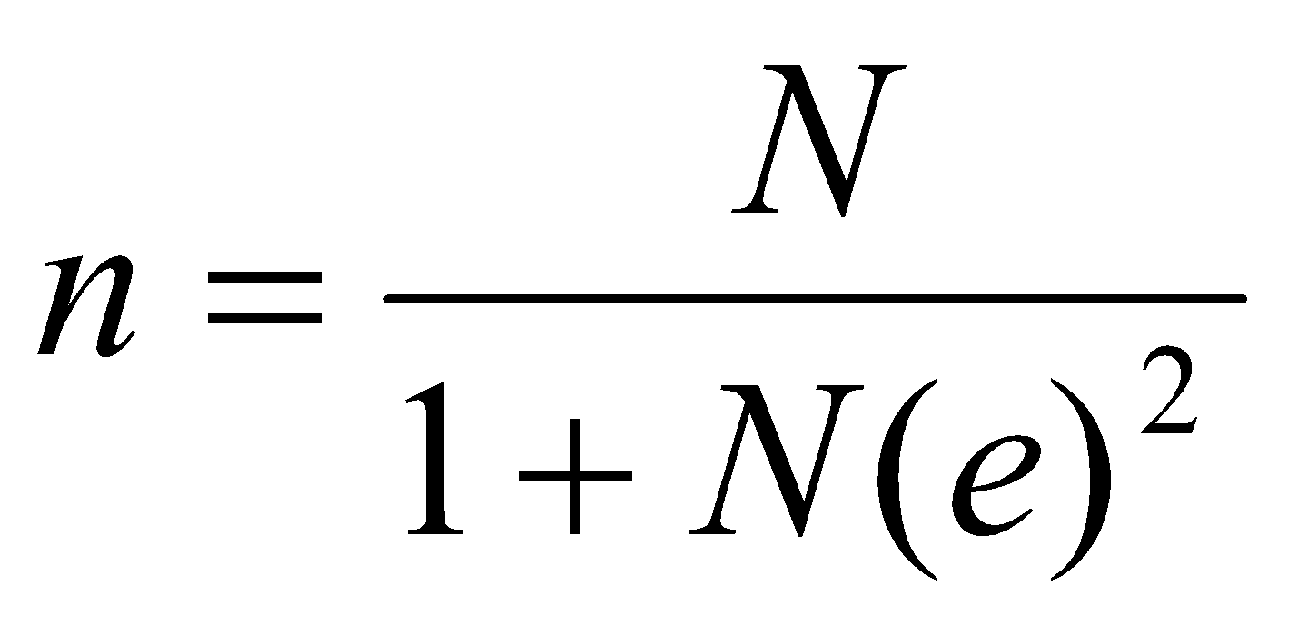
Equation 1, Example. 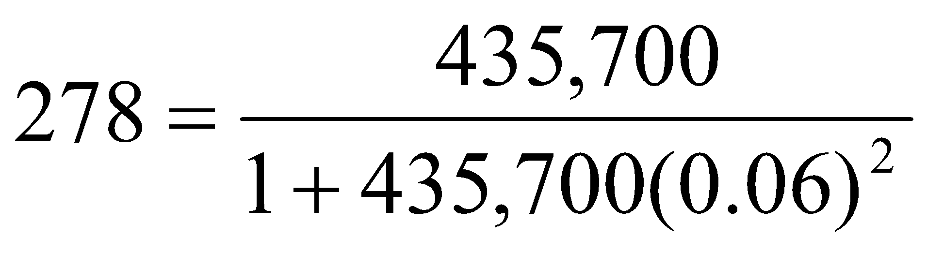

where n is the sample size, N is the population size, and e is the level of precision required. The equation assumes a confidence interval of 95% and maximum variability in the sample (.50). An observation unit is an individual respondent who took a fishing trip (in any of the three trip modes for the trip expenditure portion, or a resident or non-resident who spent money in the state on durable goods for the durable good portion). The example shows the calculations given a hypothetical population size of N=435,700.To ensure proportional allocation among the strata and to ensure that the minimum number of observations is met for each strata (278 observations) requires a sampling rate of 0.0638% (278/435,700 = 0.0638%). Applying this rate to each stratum (state/fishing mode and state/resident status) results in a combined sample of observations (Table 2).We assume a 76% response rate for the trip expenditure APAIS add-on survey (Table 1). For the web/mail surveys, we assume an average 28% response rate nationwide.

Data collection protocol for web/mail samples (both trip and durable) is as follows:
Phase 1: Email invitation and email reminders (after about three days and one week) for anglers with email addresses available in the license files
Phase 2: Mail push-to-web letter and reminder postcard after about one week for anglers without email addresses and a sub-sample of those not responding to the email invitations
Phase 3: Mail survey questionnaire after about two weeks of sending invitation letter for a subsample of those anglers without email addresses and not responding to the push to web and optional reminder letter after about one week.

The survey design will take advantage of lower-cost data collection methods for email/web versus mail only while still providing coverage of both anglers with email addresses and those without. Anglers with email addresses will only receive contacts during Phases 1 and 2 and anglers with no email addresses will only receive contacts in Phases 2 and 3. The expected cost of collecting data from the mail group is about four times the cost of collecting data from the email group. Considering this, the sample allocation will maximize the sample size for the email group and lower the sample size for the mail group. This email group oversample will be balanced with any corresponding design effects on standard errors using survey weights. The optimal allocation will be designed to ensure that the mail group will be represented in the final sample.

This collection is a periodic, recurring data collection every 3 years.

3. Describe the methods used to maximize response rates and to deal with nonresponse. The accuracy and reliability of the information collected must be shown to be adequate for the intended uses. For collections based on sampling, a special justification must be provided if they will not yield "reliable" data that can be generalized to the universe studied.

Historically for this survey, non-response is primarily a concern for that part of the survey that uses a web/mail design, rather than the in-person intercept design. To ensure the best possible responses, NOAA Fisheries contracts with survey research firms to conduct the survey and who have experts in survey design and sampling on staff. They use the most recent state-of-the-art protocols such as those described in ‘The Tailored Design Method’ (Dillman, 2000). Protocols include multiple contacts via email and/or mail that can include: (1) an email/letter informing the respondent that they have been selected for the survey with links to the online survey and that describes the reason for the survey and the importance of filling out the survey; (2) email reminders and/or post-card follow up thanking respondents who returned their survey and reminding respondents to complete their survey if they have not already done so; (3) a final mailing including a cover letter and survey instrument and one additional optional postcard reminder or text message. The tailored design method is designed to maximize response rates, and components of the design have been scientifically tested and determined to increase response rates for mail surveys (Dillman, 2000). NOAA Fisheries has previously conducted a non-response test as part of these surveys in order to determine any effects from non-response and has not found any statistically significant differences between responders and non-responders in terms of household income, demographics, fishing experience, or age. Design of the online survey for optimal use by both mobile devices and desktops is considered and implemented so that non-response for technical reasons is minimized. A dedicated email address and phone number is set up for technical help with the survey each time the survey is conducted as an additional measure.

4. Describe any tests of procedures or methods to be undertaken. Tests are encouraged as effective means to refine collections, but if ten or more test respondents are involved OMB must give prior approval.

No testing is planned as there are no significant changes to the design or implementation from prior years.
5. Provide the name and telephone number of individuals consulted on the statistical aspects of the design, and the name of the agency unit, contractor(s), grantee(s), or other person(s) who will actually collect and/or analyze the information for the agency.

Sampling design, survey administration, data analysis and report writing:

Sabrina Lovell, Economist, NOAA Fisheries, Office of Science and Technology, 301-427-8153

Scott Steinback, Economist, NOAA Fisheries, Northeast Fisheries Science Center, 508-495-2371

Cliff Hutt, NOAA Fisheries, Office of Sustainable Fisheries, Atlantic Highly Migratory Species Management Division, 301-427-8503

Management
Rita Curtis, NOAA Fisheries, Division Chief, Economics and Human Dimensions, Office of Science and Technology, 301-427-8122

Consultation on APAIS and general statistical analysis:
John Foster, NOAA Fisheries, Office of Science and Technology, 301-427-8130
Tom Sminkey, NOAA Fisheries, Office of Science and Technology, 301-427-8177

Contractors, previous surveys:
Randy Zuwallack, Statistician, ICF Inc., Randy.ZuWallack@icf.com
Heather Driscoll, Project Director, ICF Inc, Heather.driscoll@icf.com

References

Dillman, D., 2000. Mail and Internet Surveys. The Tailored Design Method, John Wiley and Sons, Inc., New York, New York.

Rice, J., 1995. Mathematical Statistics and Data Analysis, Second Edition, Wadsworth Publishing Company, Belmont, California.

Yamane, Taro, 1967. Statistics, An Introductory Analysis, 2nd Ed., New York: Harper and Row.

Lovell, Sabrina, Scott Steinback and James Hilger, 2013. The Economic Contribution of Marine Angler Expenditures in the United States, 2011. U.S. Dept. of Commerce, NOAA Tech Memo. NMFS-F/SPO-134.
Sabrina J. Lovell, James Hilger, Scott Steinback, and Clifford Hutt. 2016. The Economic Contribution of Marine Angler Expenditures on Durable Goods in the United States, 2014. U.S. Dep. Commerce, NOAA Tech. Memo. NMFS-F/SPO-165, 72 p.
Lovell, Sabrina, James Hilger, Emily Rollins, Noelle A. Olsen, and Scott Steinback. 2020. The Economic Contribution of Marine Angler Expenditures on Fishing Trips in the United States, 2017. U.S. Dep. Commerce, NOAA Tech. Memo. NMFS-F/SPO-201, 80 p.

