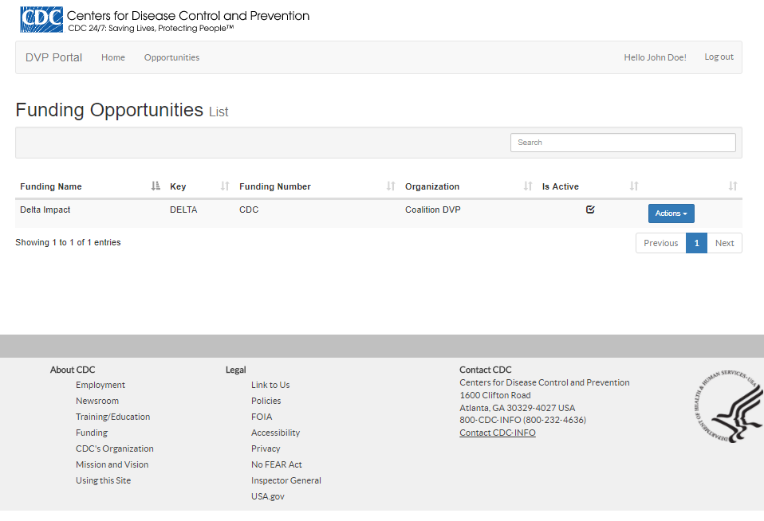
Figure 1 Funding Opportunities List
Selecting a Funding Opportunity which you have access to and viewing its available forms

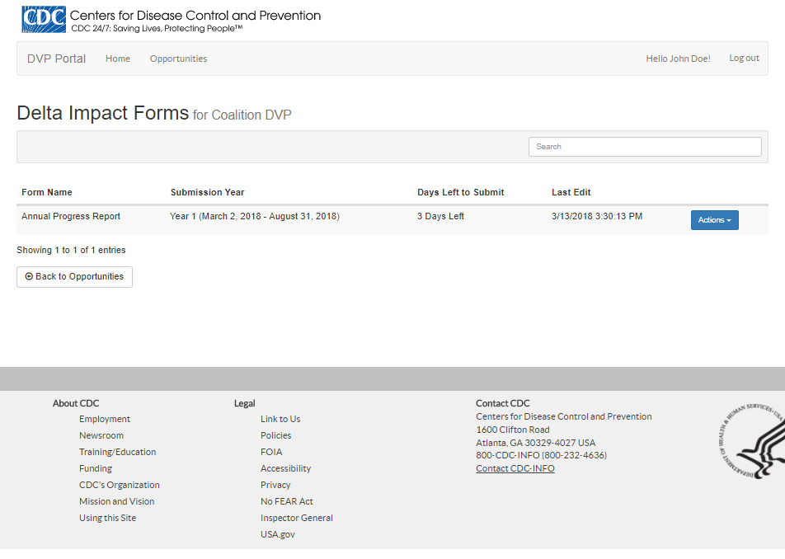
Figure 2 Delta Impact Forms List

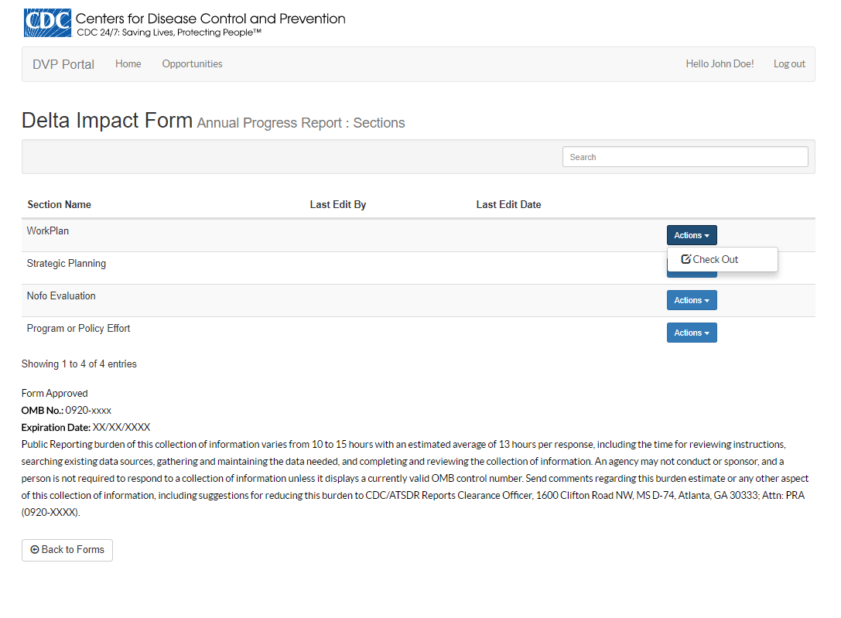
Figure 3 Annual Progress Report: Form Sections List
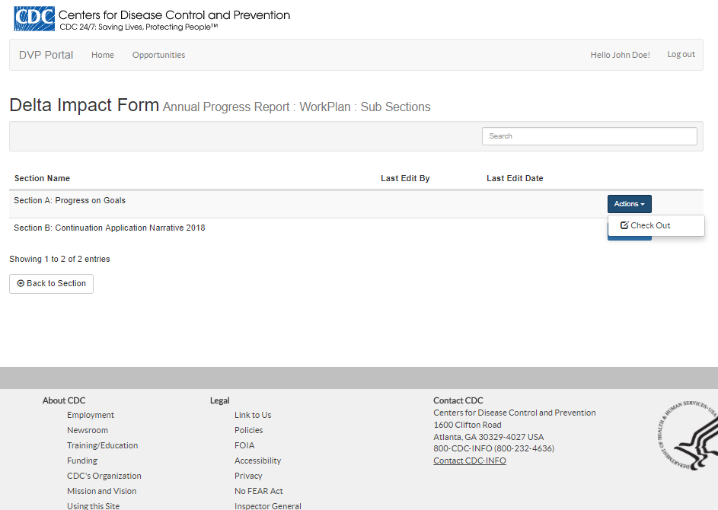
Figure 4 Annual Progress Report: Workplan: Sub-Sections List
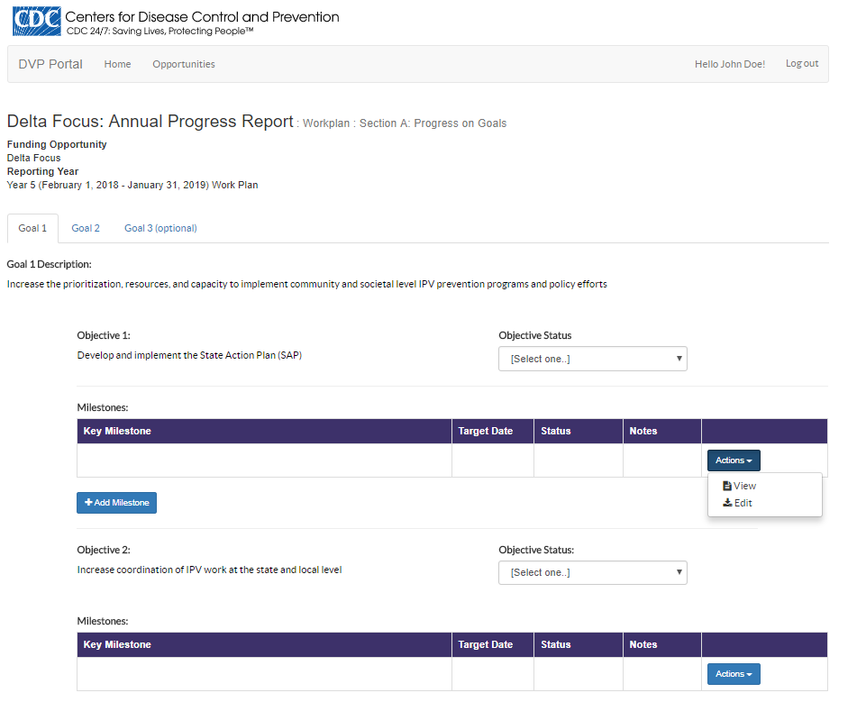
Figure 5 Annual Progress Report: Workplan: Section A: Progress on Goals: Goal 1

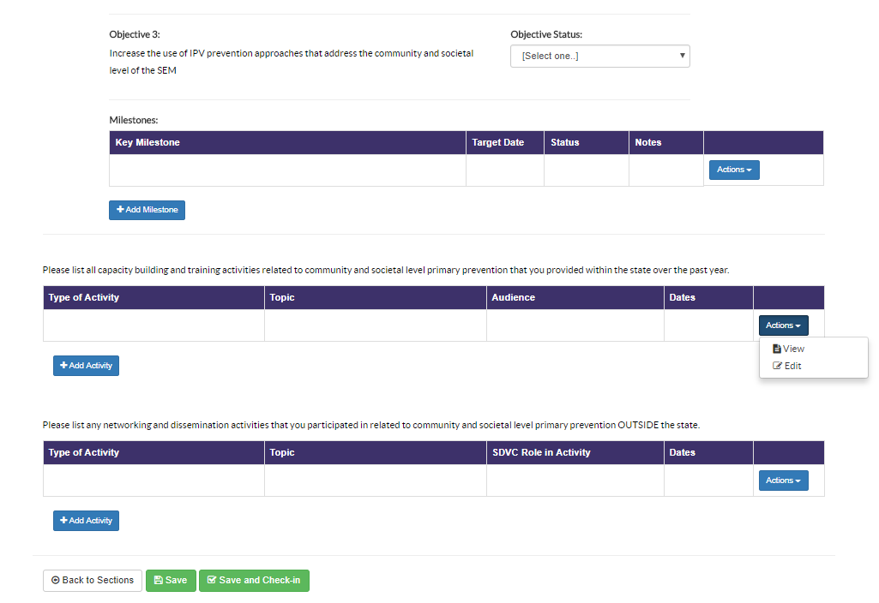
Figure 6 Annual Progress Report: Workplan: Section A: Progress on Goals: Goal 1 Continued

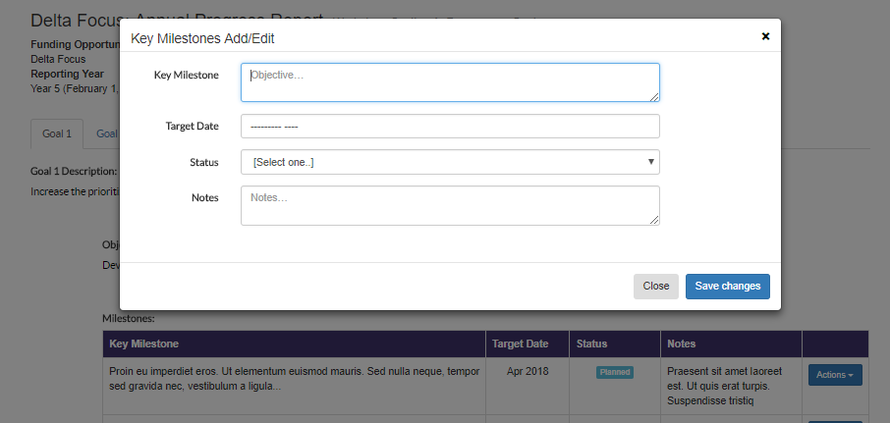
Figure 7 Annual Progress Report: Workplan: Section A: Progress on Goals: Add/Edit Milestone

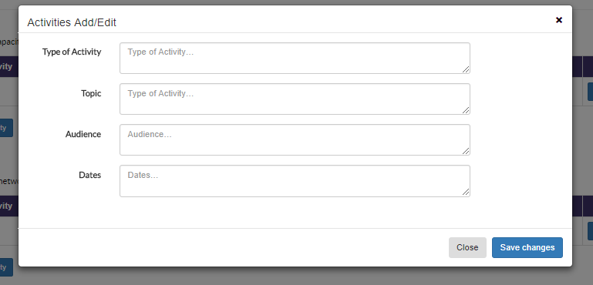
Figure 8 Annual Progress Report: Workplan: Section A: Progress on Goals: Add/Edit Activity “Capacity building and training..”

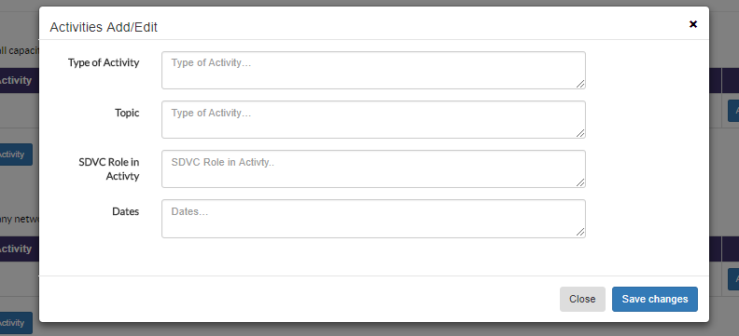
Figure 9 Annual Progress Report: Workplan: Section A: Progress on Goals: Add/Edit Activity "OUTSIDE the State”

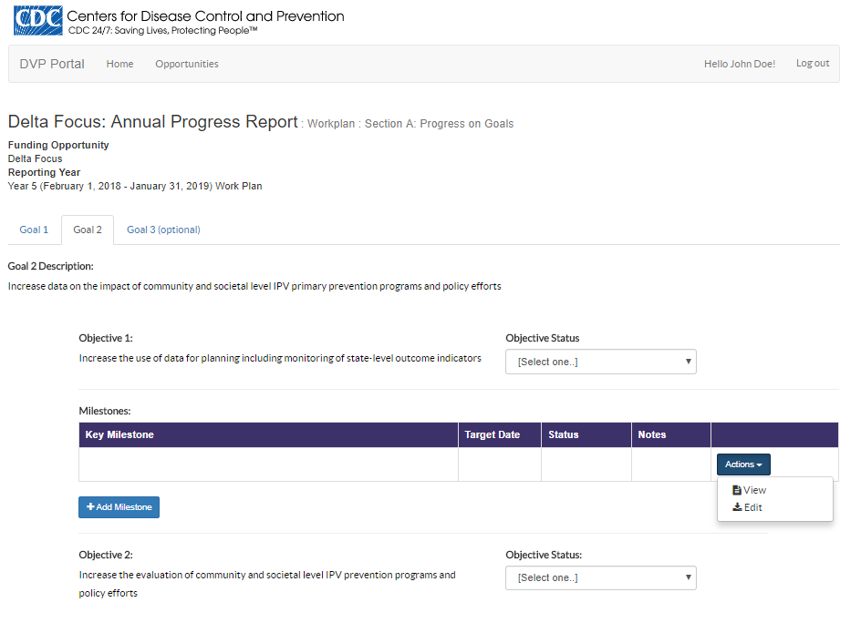
Figure 10 Annual Progress Report: Workplan: Section A: Progress on Goals: Goal 2

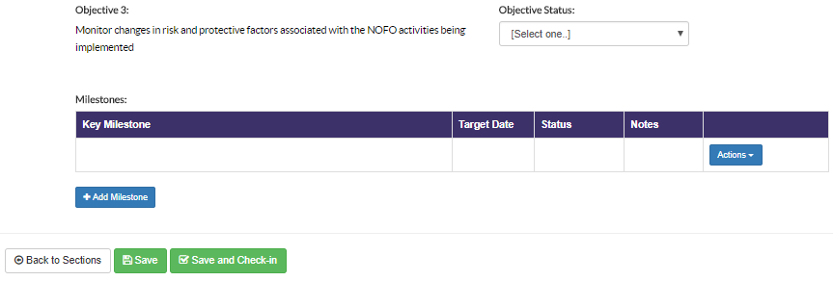
Figure 11 Annual Progress Report: Workplan: Section A: Progress on Goals: Goal 2 Continued
Figure 12 Annual Progress Report: Workplan: Section A: Progress on Goals: Add/Edit Milestone
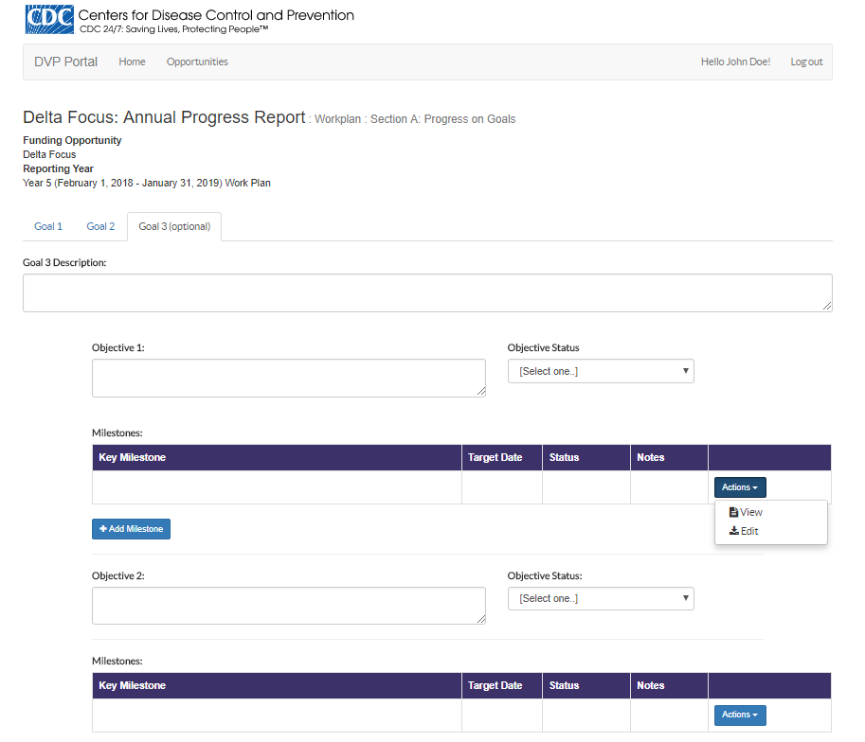
Figure 13 Annual Progress Report: Workplan: Section A: Progress on Goals: Goal 3

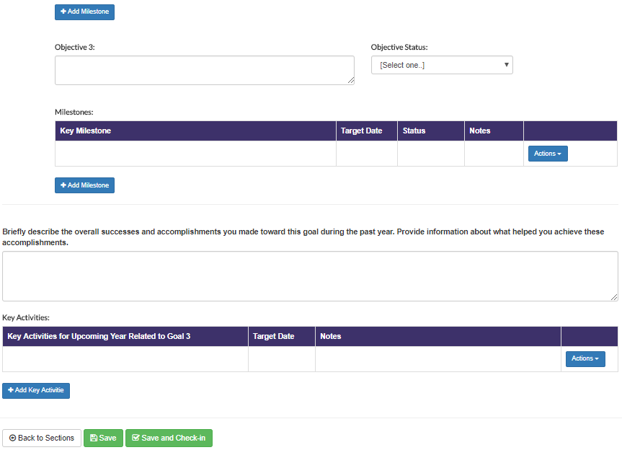
Figure 14 Annual Progress Report: Workplan: Section A: Progress on Goals: Goal 3 Continued

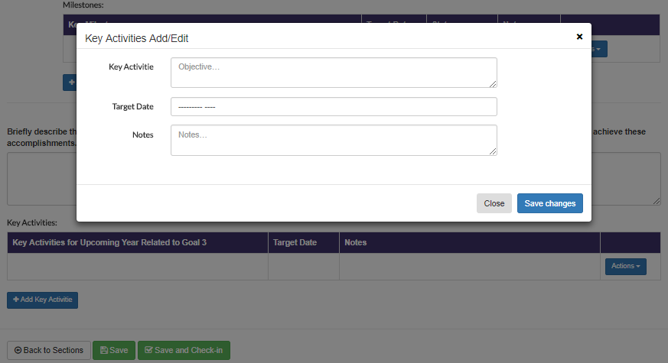
Figure 15 Annual Progress Report: Workplan: Section A: Progress on Goals: Add/Edit Key Activites

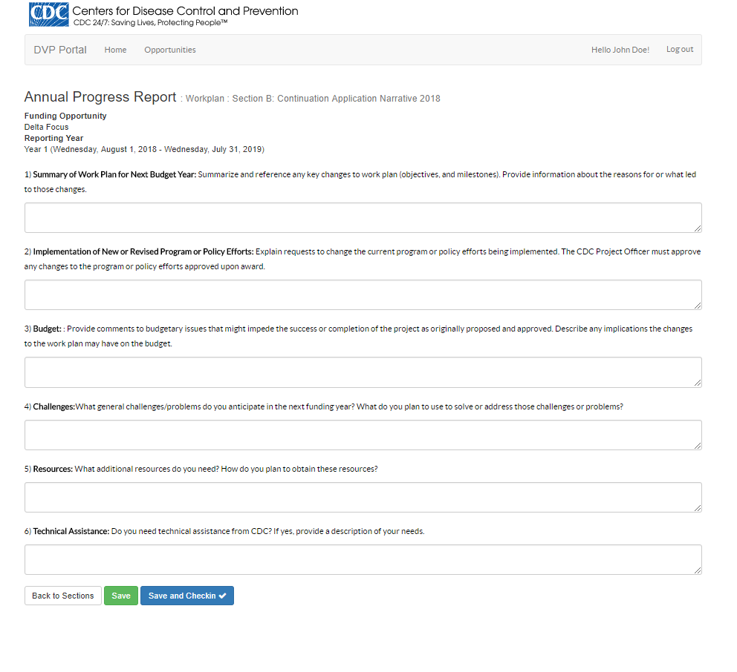
Figure 16 Annual Progress Report: Workplan: Section B: Continuation Application Narrative 2018

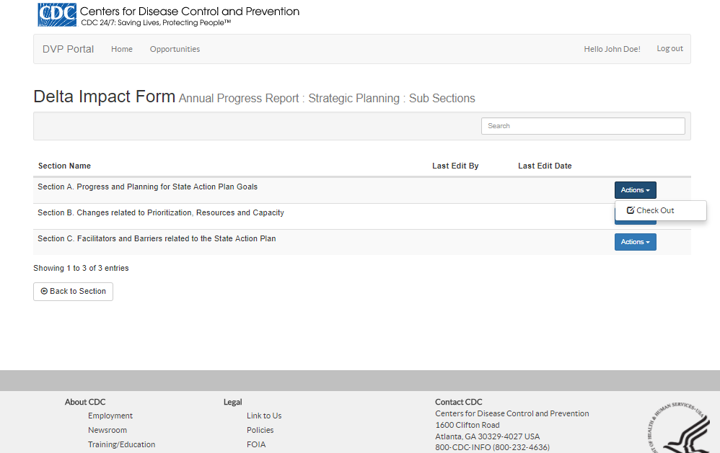
Figure 17 Annual Progress Report: Strategic Planning: Sub-Sections List

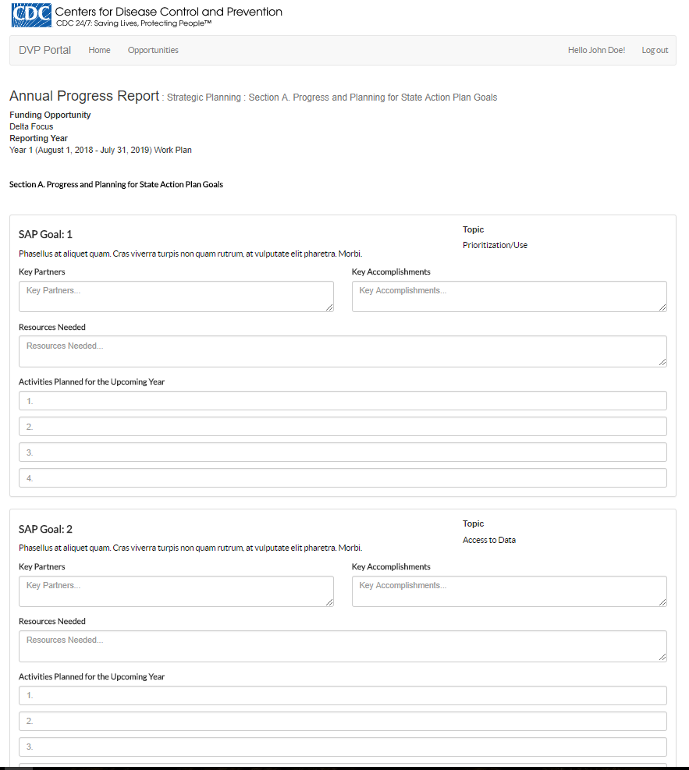
Figure 18 Annual Progress Report: Strategic Planning: Section A: Progress and Planning for State Action Plan Goals

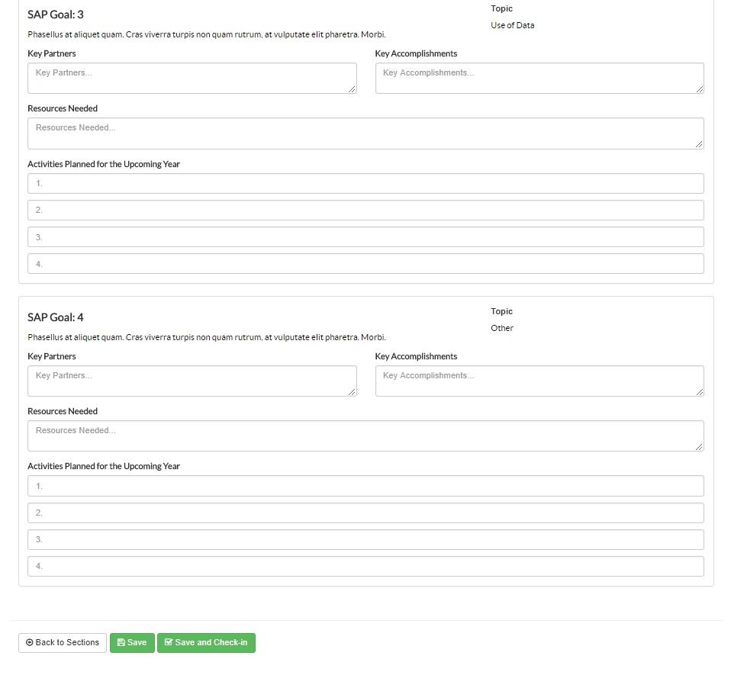
Figure 19 Annual Progress Report: Strategic Planning: Section A: Progress and Planning for State Action Plan Goals Continued

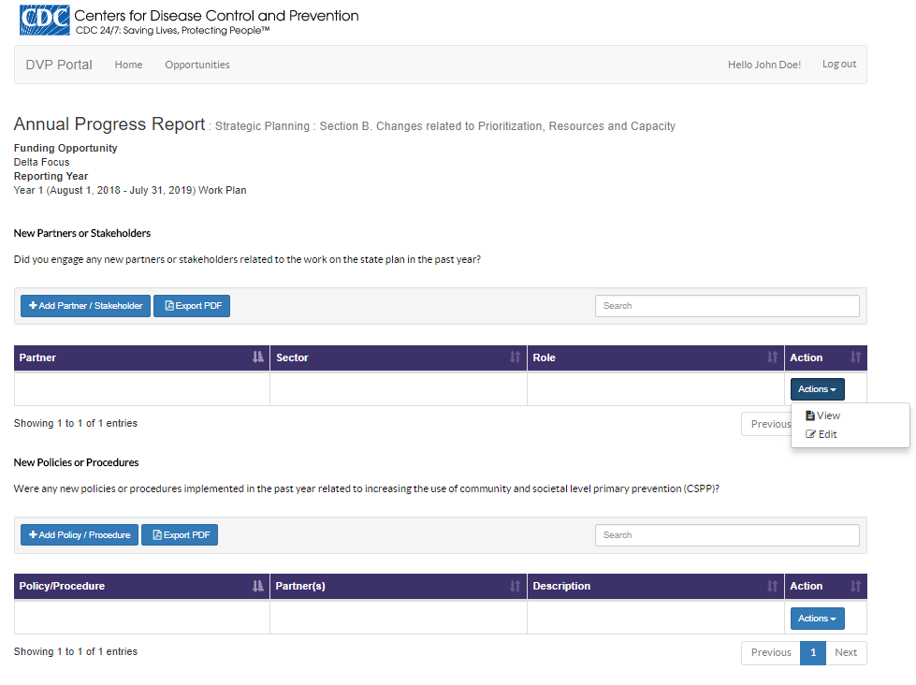
Figure 20 Annual Progress Report: Strategic Planning: Section B: Changes related to Prioritization, Resources and Capacity

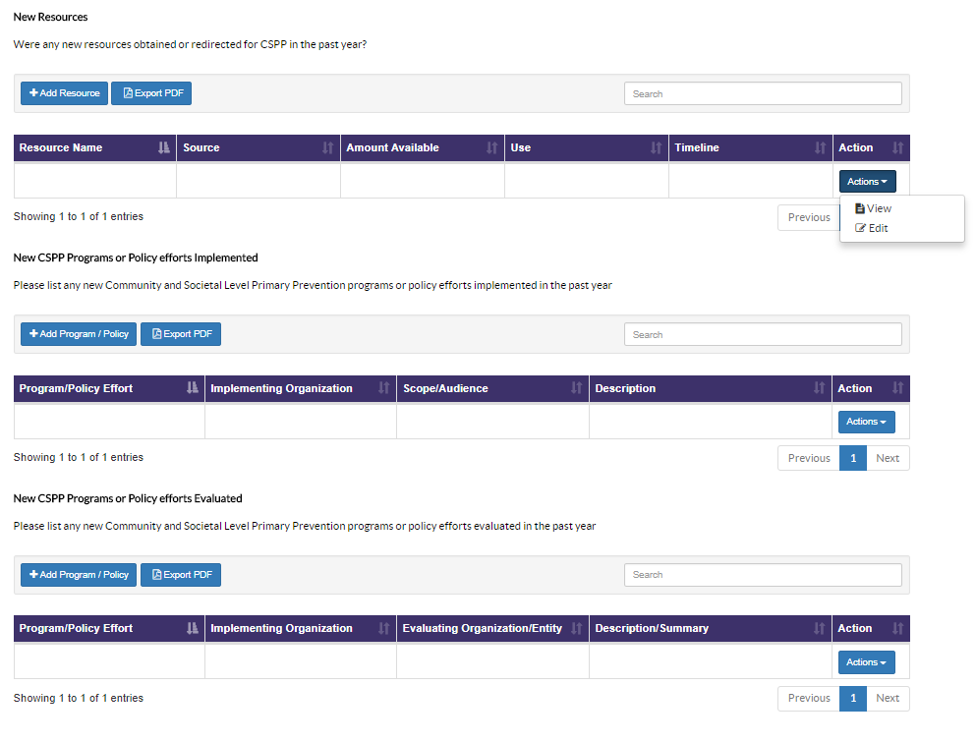
Figure 21 Annual Progress Report: Strategic Planning: Section B: Changes related to Prioritization, Resources and Capacity Continued

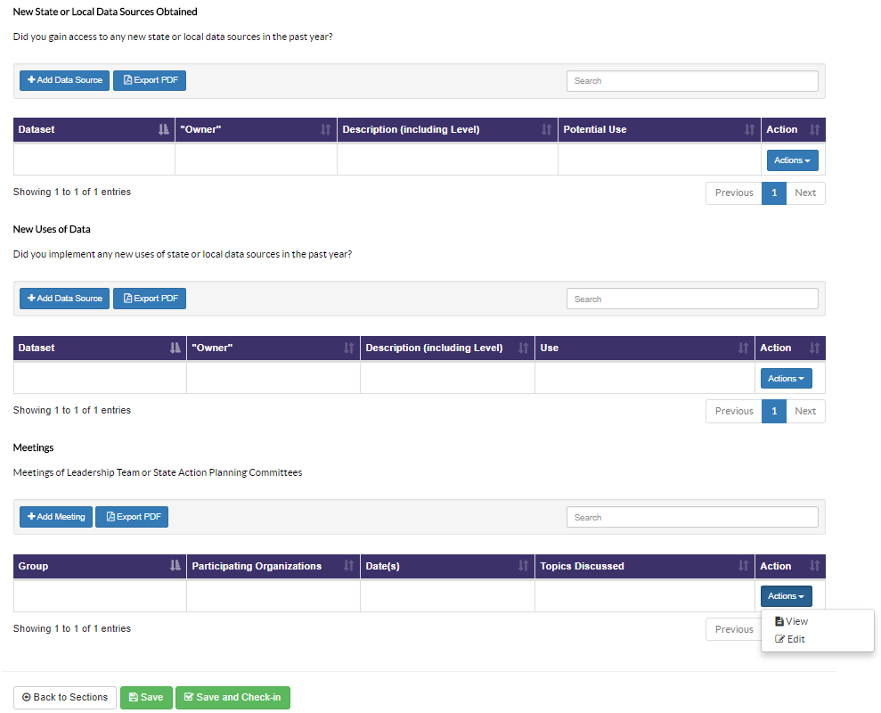
Figure 22 Annual Progress Report: Strategic Planning: Section B: Changes related to Prioritization, Resources and Capacity Continued

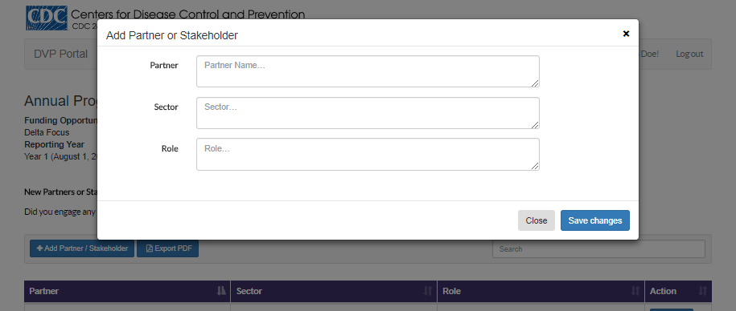
Figure 23 Annual Progress Report: Strategic Planning: Section B: Changes related to Prioritization, Resources and Capacity: Partner StakeHolder Add/Edit

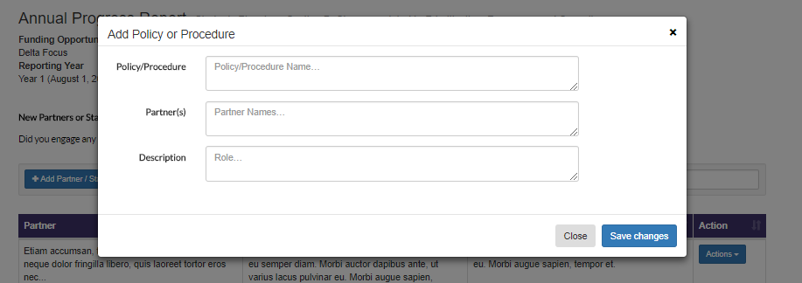
Figure 24 Annual Progress Report: Strategic Planning: Section B: Changes related to Prioritization, Resources and Capacity: Policy Procedure Add/Edit

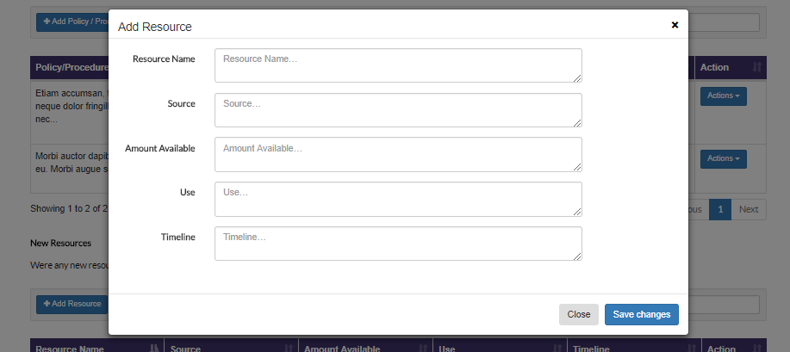
Figure 25 Annual Progress Report: Strategic Planning: Section B: Changes related to Prioritization, Resources and Capacity: Resource Add/Edit

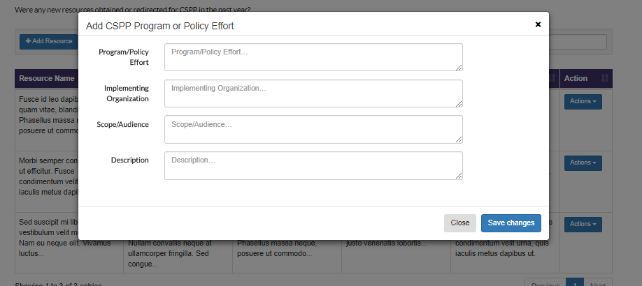
Figure 26 Annual Progress Report: Strategic Planning: Section B: Changes related to Prioritization, Resources and Capacity: CSPP Program or Policy Effort Add/Edit

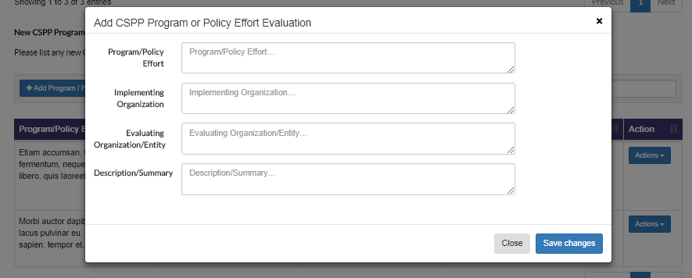
Figure 27 Annual Progress Report: Strategic Planning: Section B: Changes related to Prioritization, Resources and Capacity: CSPP Program or Policy Effort Evaluation Add/Edit

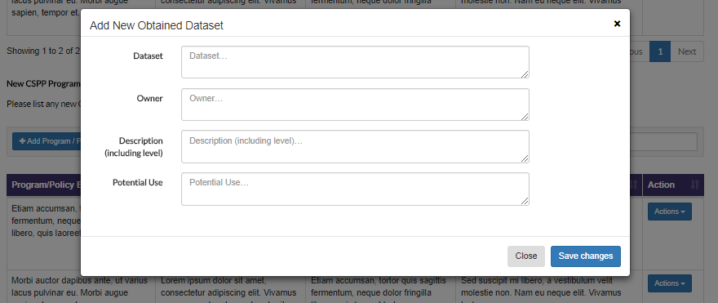
Figure 28 Annual Progress Report: Strategic Planning: Section B: Changes related to Prioritization, Resources and Capacity: New Data source obtained Add/Edit

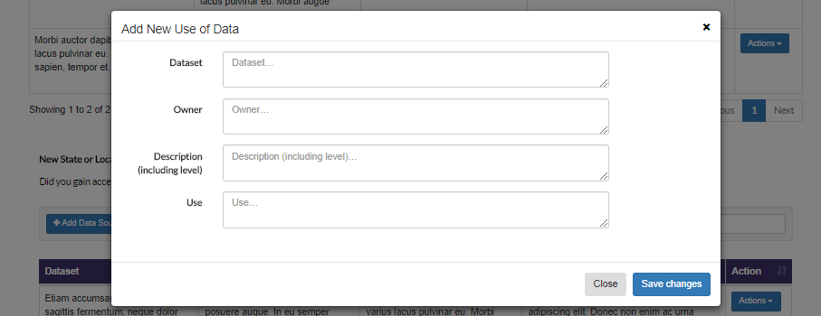
Figure 29 Annual Progress Report: Strategic Planning: Section B: Changes related to Prioritization, Resources and Capacity: New Use of Data Add/Edit

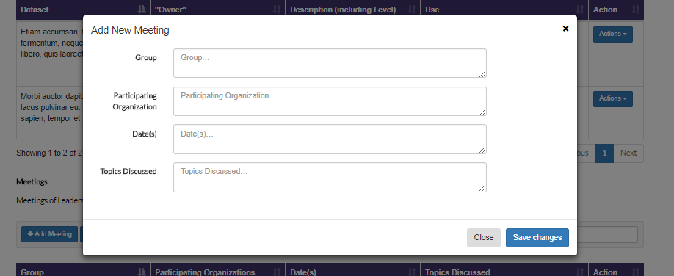
Figure 30 Annual Progress Report: Strategic Planning: Section B: Changes related to Prioritization, Resources and Capacity: New Meeting Add/Edit

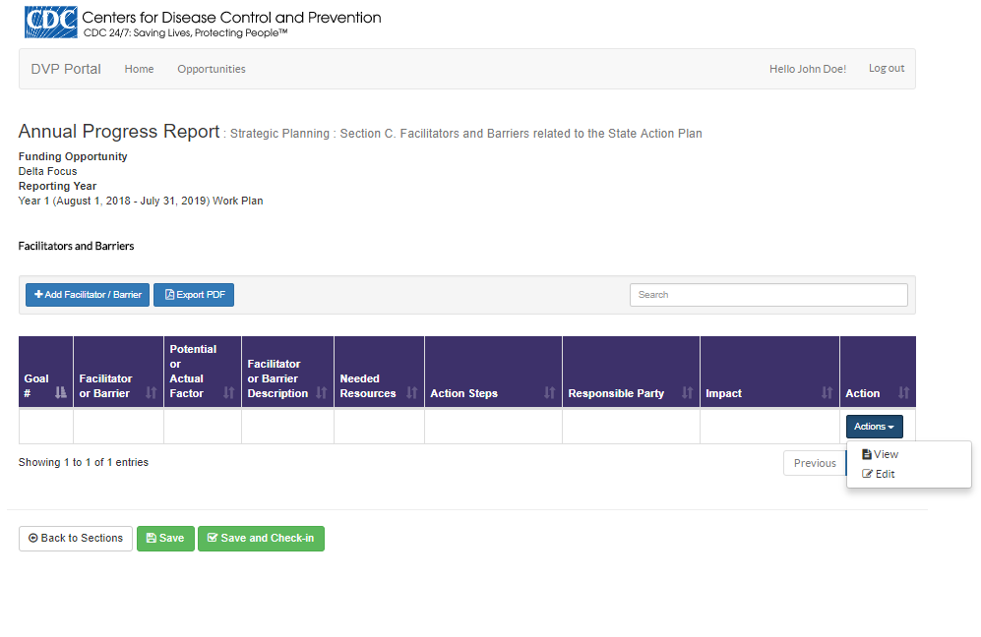
Figure 31 Annual Progress Report: Strategic Planning: Section C: Facilitators and Barriers related to the State Action Plan

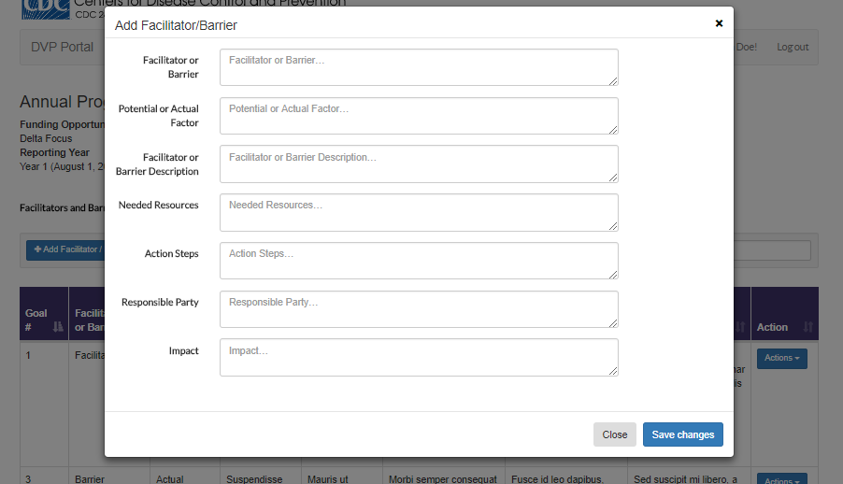
Figure 32 Annual Progress Report: Strategic Planning: Section C: Facilitators and Barriers related to the State Action Plan: New Facilitator/Barrier Add/Edit

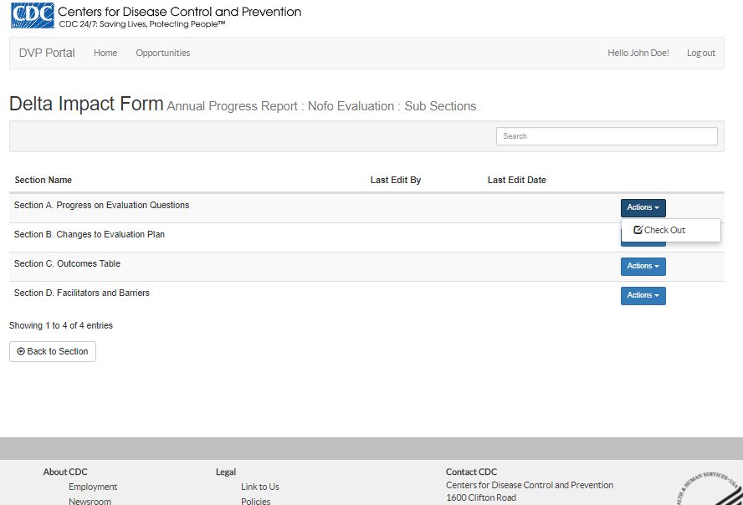
Figure 33 Annual Progress Report: Nofo Evaluation: Sub-Sections

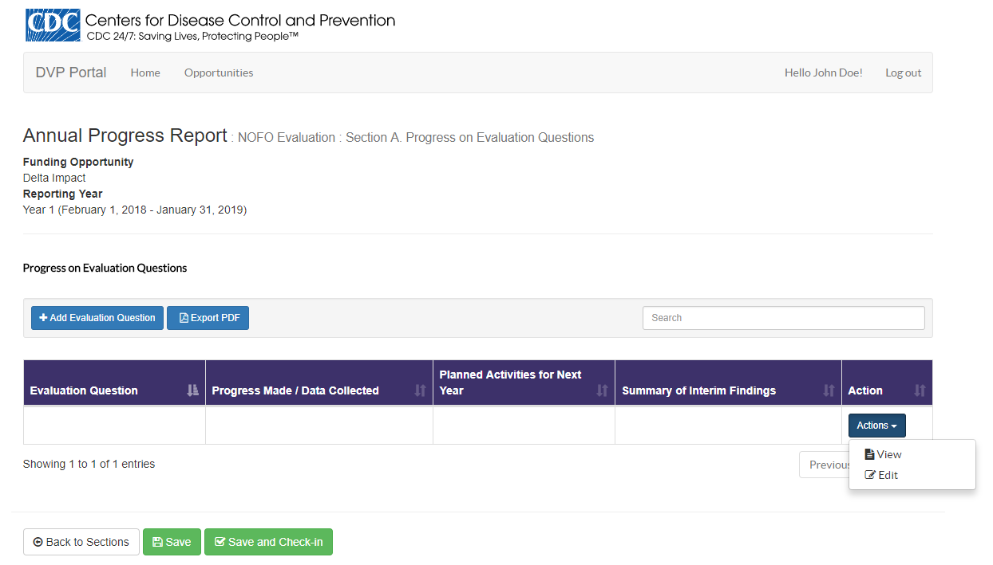
Figure 34 Annual Progress Report: Nofo Evaluation: Section A: Progress on Evaluation Questions

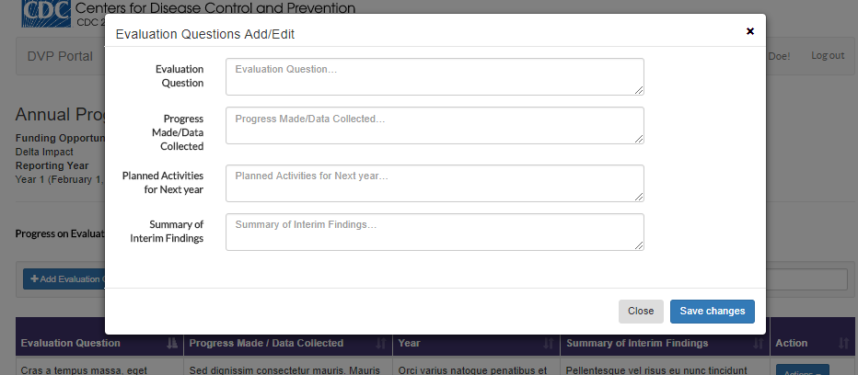
Figure 35 Annual Progress Report: Nofo Evaluation: Section A: Progress on Evaluation Questions: Add/Edit

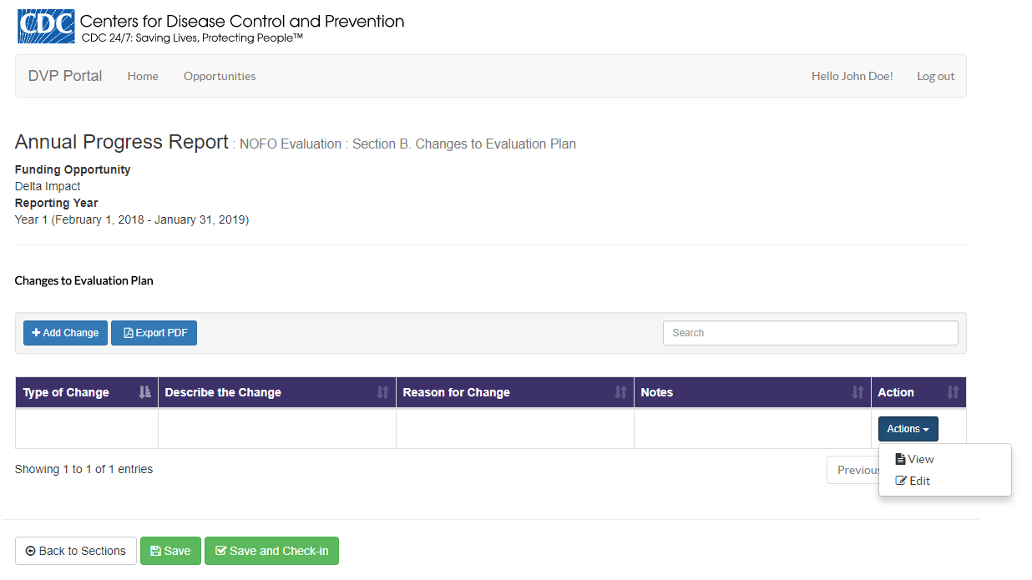
Figure 36 Annual Progress Report: Nofo Evaluation: Section B: Changes to Evaluation Plan

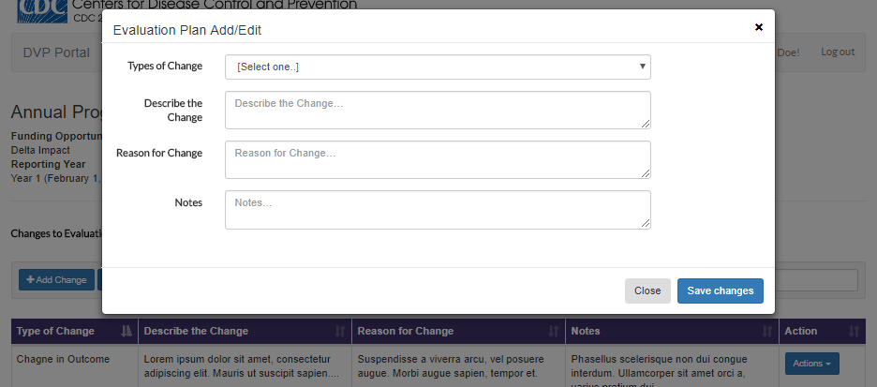
Figure 37 Annual Progress Report: Nofo Evaluation: Section B: Changes to Evaluation Plan: Add/Edit

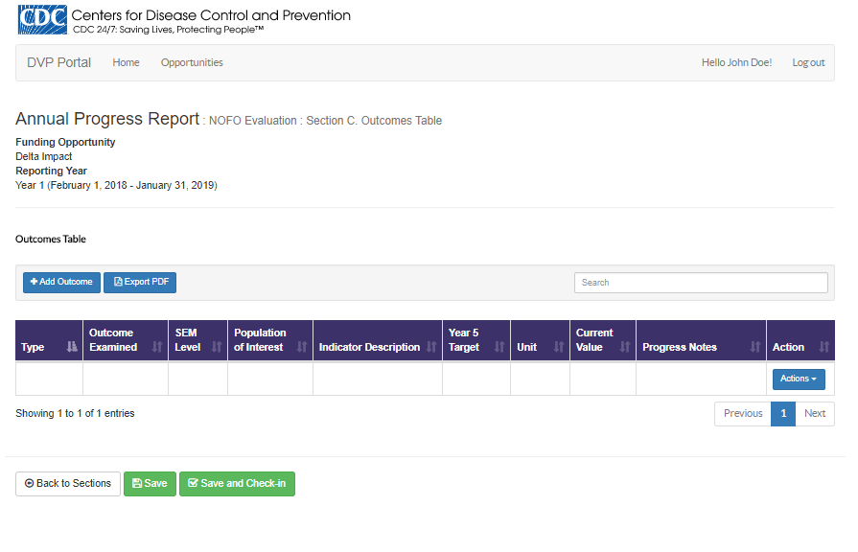
Figure 38 Annual Progress Report: Nofo Evaluation: Section C: Outcomes

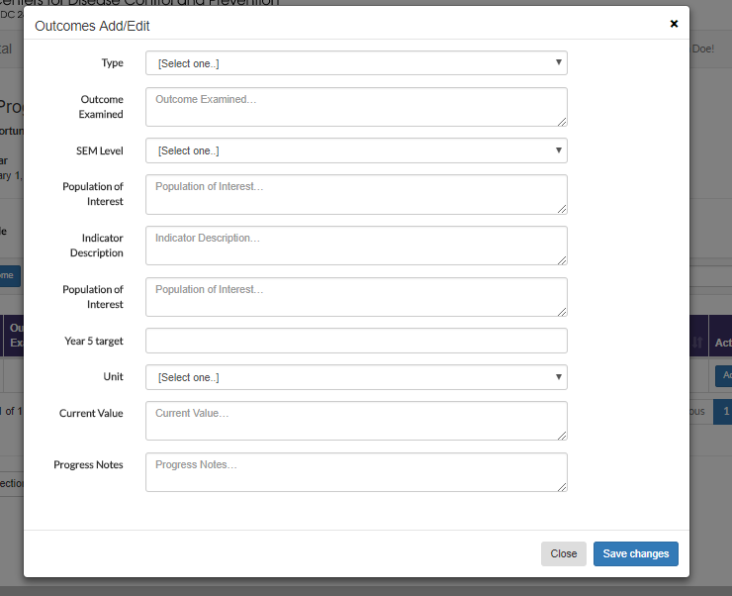
Figure 39 Annual Progress Report: Nofo Evaluation: Section C: Outcomes: Add/Edit

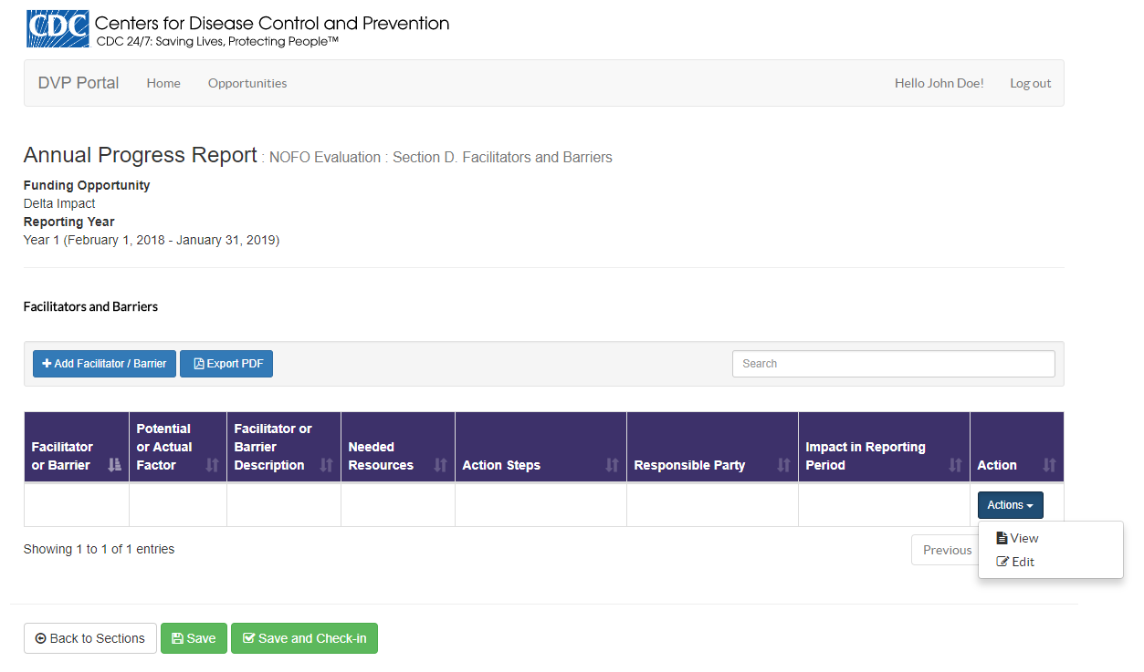
Figure 40 Annual Progress Report: Nofo Evaluation: Section D: Facilitators and Barriers

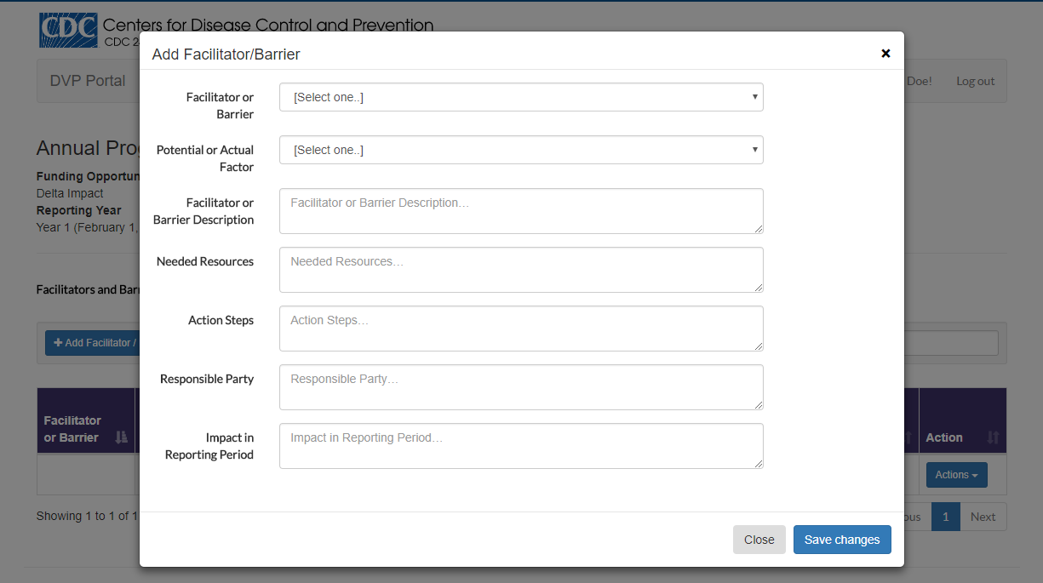
Figure 41 Annual Progress Report: Nofo Evaluation: Section D: Facilitators and Barriers: Add/Edit

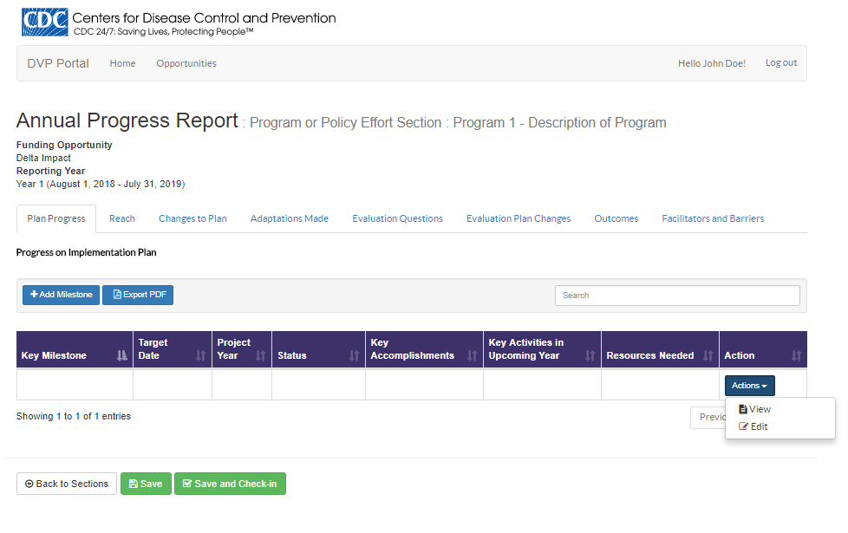
Figure 42 Annual Progress Report: Program and Policy Effort Section: Plan Progress

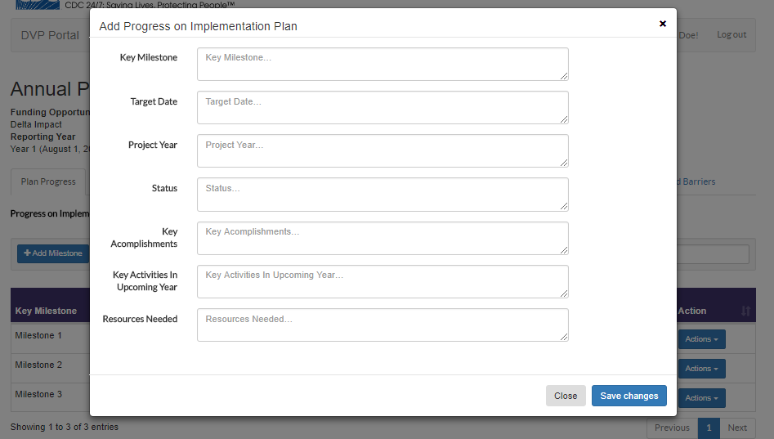
Figure 43 Annual Progress Report: Program and Policy Effort Section: Plan Progress: Add/Edit
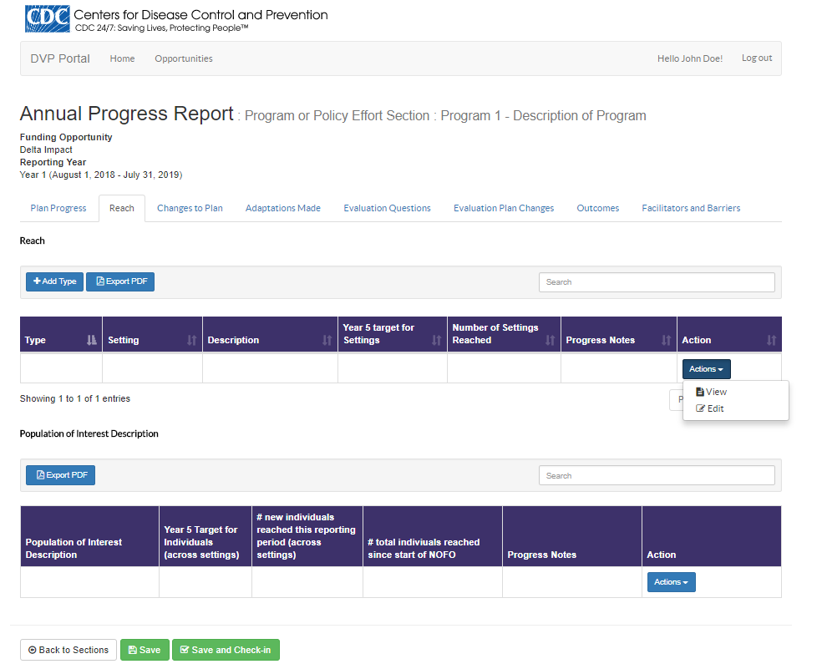
Figure 44 Annual Progress Report: Program and Policy Effort Section: Reach
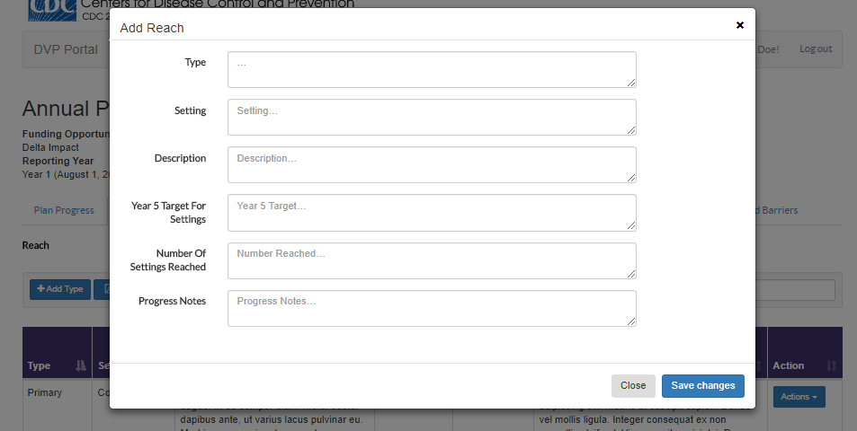
Figure 45 Annual Progress Report: Program and Policy Effort Section: Reach: Add/Edit

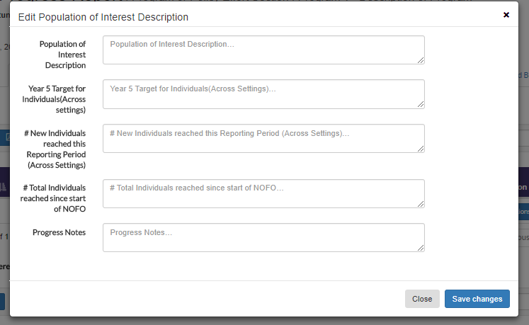
Figure 46 Annual Progress Report: Program and Policy Effort Section: Reach: Add/Edit

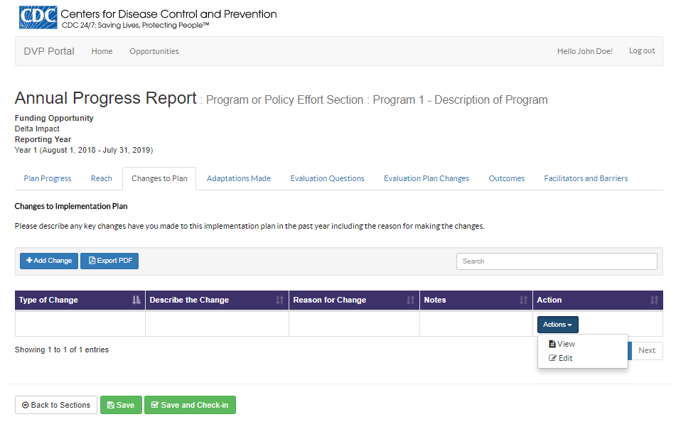
Figure 47 Annual Progress Report: Program and Policy Effort Section: Changes to Plan

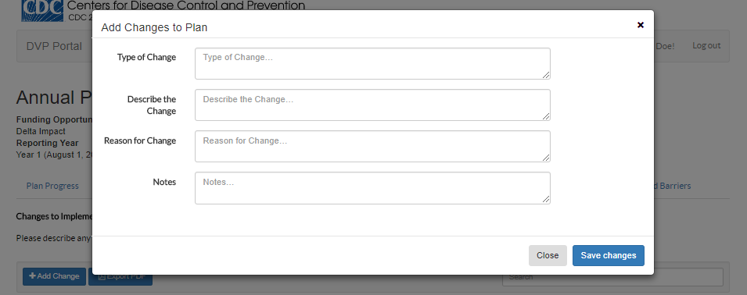
Figure 48 Annual Progress Report: Program and Policy Effort Section: Changes to Plan: Add/Edit

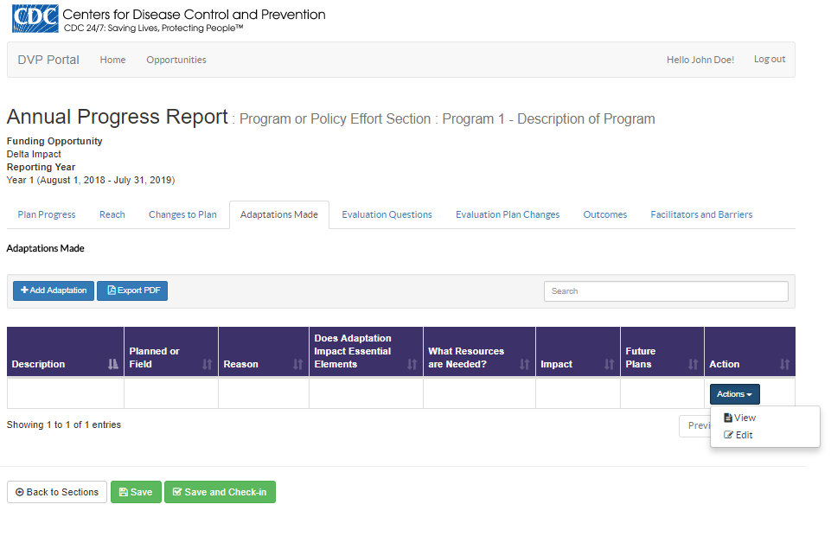
Figure 49 Annual Progress Report: Program and Policy Effort Section: Adaptations Made
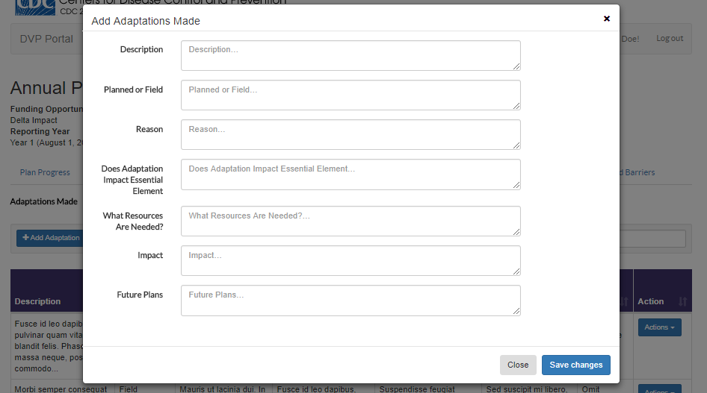
Figure 50 Annual Progress Report: Program and Policy Effort Section: Adaptations Made: Add/Edit

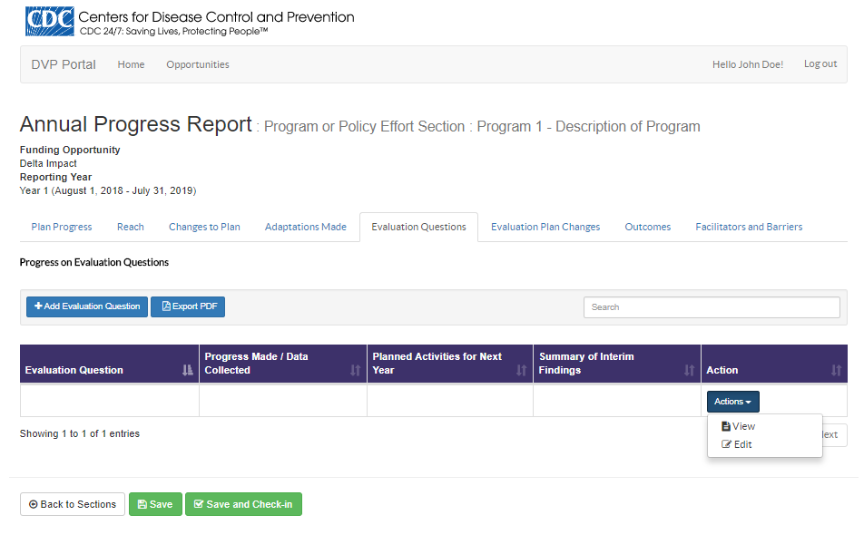
Figure 51 Annual Progress Report: Program and Policy Effort Section: Evaluation Questions

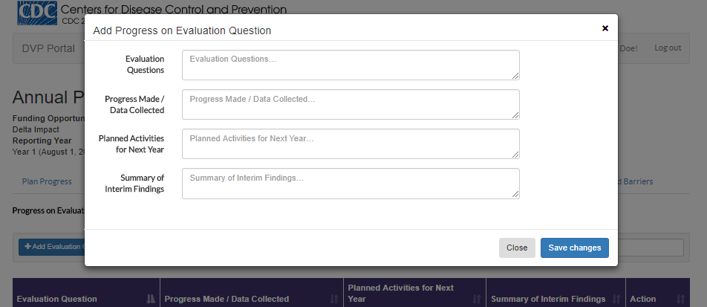
Figure 52 Annual Progress Report: Program and Policy Effort Section: Evaluation Questions: Add/Edit

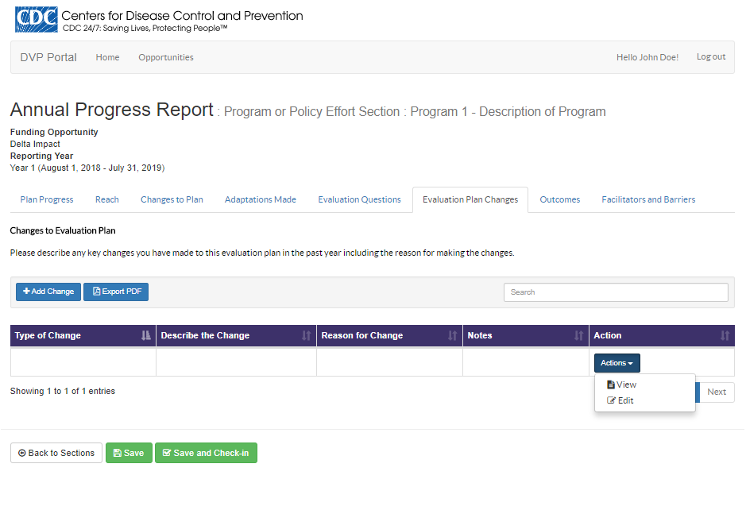
Figure 53 Annual Progress Report: Program and Policy Effort Section: Evaluation Plan Changes

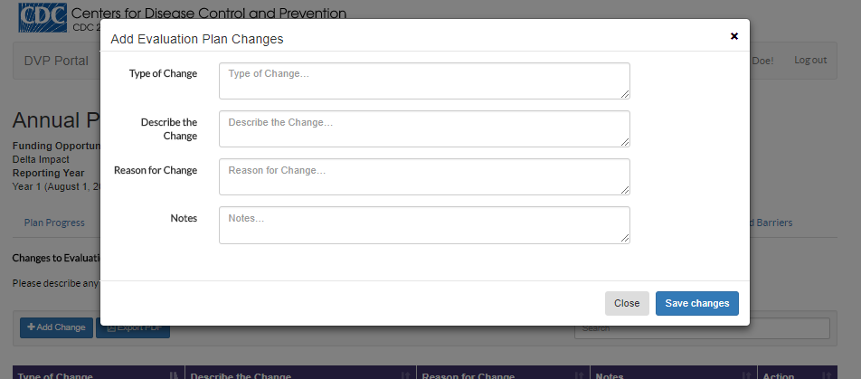
Figure 54 Annual Progress Report: Program and Policy Effort Section: Evaluation Plan Changes: Add/Edit
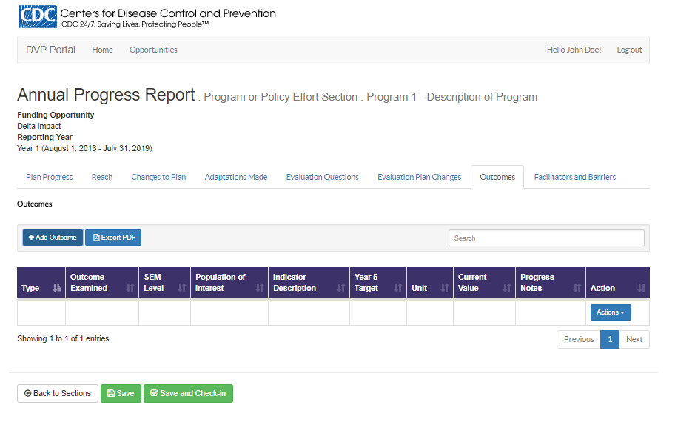
Figure 55 Annual Progress Report: Program and Policy Effort Section: Outcomes
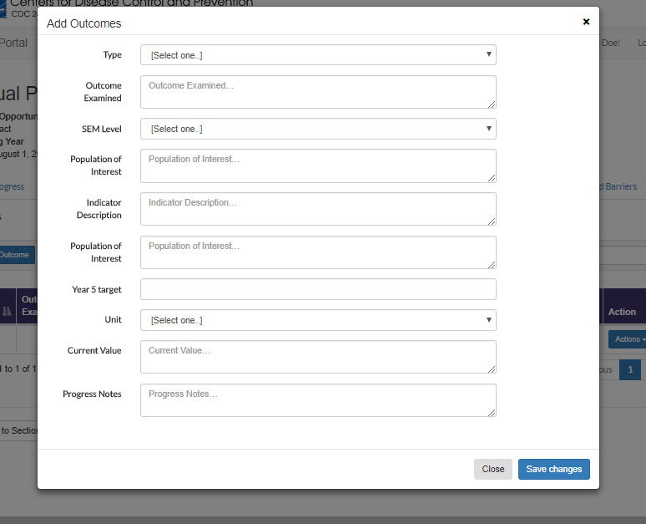
Figure 56 Annual Progress Report: Program and Policy Effort Section: Outcomes: Add/Edit

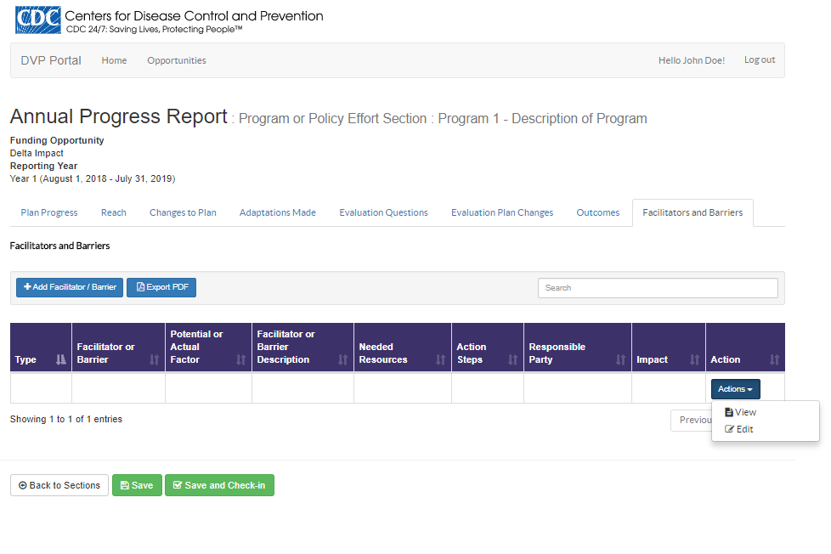
Figure 57 Annual Progress Report: Program and Policy Effort Section: Facilitators and Barriers

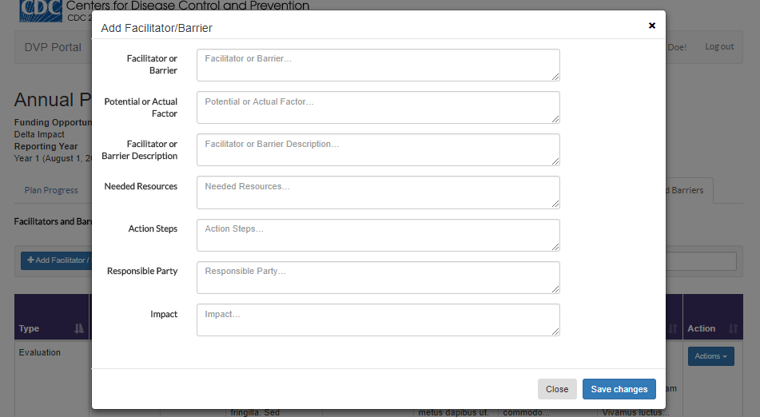
Figure 58 Annual Progress Report: Program and Policy Effort Section: Facilitators and Barriers: Add/Edit

