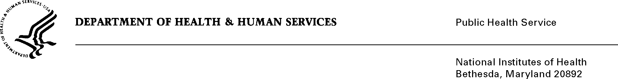

DATE: April 27, 2020

TO: Quinn Hirsch

Office of Management and Budget (OMB)

Reports Clearance Officer, DHHS

FROM: Mikia P. Currie

Chief, Project Clearance Branch

SUBJECT: Change Request to a Currently Approved Form

(OMB # 0925-0001, Expiration Date 2/28/2023)

This is a request for OMB to approve a non-substantial modification to Form PHS 6031 Payback Agreement of OMB # 0925-0001.

The change to PHS 6031 Payback Agreement:

* updated language under Payback Requirements section to provide clarifying guidance on the service requirement and how individuals may satisfy the obligation, (see red-line strikethrough attached)

Your full consideration is appreciated.

**Attachment A:**  **PHS 6031 Payback Agreement**